CHECK 1

int R;

void setup()

{

Serial.begin(9600);

pinMode(13,OUTPUT);

Serial.print("Hello,World");

}

void loop()

{

if(Serial.available())

{

R= Serial.read();

if(R=='1'){

digitalWrite(13,HIGH);

Serial.print("LED ON");

}

else if(R=='0'){

digitalWrite(13,LOW);

Serial.print("LED OFF");

}

}

}

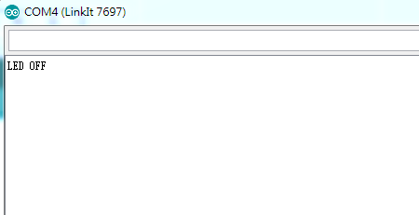

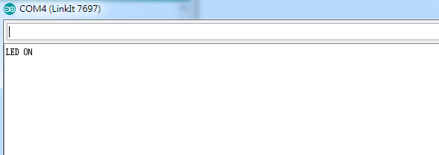

CHECK2

int i;

float v;

int Analogin=0;

void setup()

{

Serial.begin(9600);

pinMode(A0,INPUT);

}

void loop()

{

for(i=0;i<=5;i++)

{

Analogin=(0.7*Analogin)+(0.3*analogRead(A0));

}

v=Analogin*2.5/4095;

Serial.print("v=");

Serial.print(v);

delay(500);

}

|  |  |  |
| --- | --- | --- |
| 實際電壓(v) | AnalogRead讀值 | 推測電壓(v) |
| 0 | 0.00 | 0 |
| 0.5 | 0.41 | 0.5 |
| 1 | 0.75 | 1 |
| 1.5 | 1.22 | 1.5 |
| 2 | 1.78 | 2 |
| 2.5 | 2.11 | 2.5 |

Check point 3

void setup()

{

Serial.begin(9600);

}

float sensorValue=0,sensorVoltage,R1;

void loop()

{

for(int i=0;i<=5;i++)

{

sensorValue=(0.7*sensorValue)+(0.3*analogRead(A0));

}

sensorVoltage=sensorValue*2.5/4095;

R1=sensorVoltage*1070000/2.5;

Serial.println("R1");

Serial.println(R1);

Serial.println("sensorVoltage");

Serial.println(sensorVoltage);

Serial.println("sensorValue");

Serial.println(sensorValue);

delay(1000);

}

|  |  |  |  |  |
| --- | --- | --- | --- | --- |
| 可變電阻量測值(歐姆) | AnalogRead讀值 | 推測電壓(v) | 推測電阻值(歐姆) | SerialMonitor輸出 |
| 3K | 13 | 0.01 | 3K |  |
| 95K | 364.97 | 0.22 | 95K |  |
| 210K | 807.37 | 0.49 | 210K |  |
| 77K | 296.06 | 0.18 | 77K |  |
| 242K | 929.16 | 0.57 | 242K |  |
| 313K | 1200.95 | 0.73 | 313K |  |

Check 4

void setup()

{

Serial.begin(9600);

}

float sensorValue=0,sensorVoltage,R1;

void loop()

{

for(int i=0;i<=5;i++)

{

sensorValue=(0.7*sensorValue)+(0.3*analogRead(A0));

}

sensorVoltage=sensorValue*2.5/4095;

R1=sensorVoltage*40000/2.5;

Serial.println("R1");

Serial.println(R1);

Serial.println("sensorVoltage");

Serial.println(sensorVoltage);

Serial.println("sensorValue");

Serial.println(sensorValue);

delay(1000);

}

|  |  |  |  |
| --- | --- | --- | --- |
| AnalogRead讀值 | 推測電壓 | 推測電阻值 | SerialMonitor |
| 49.51 | 0.03 | 483.57 |  |
| 52.59 | 0.03 | 513.65 |  |
| 46.32 | 0.03 | 452.49 |  |
| 53.94 | 0.03 | 526.87 |  |
| 41.07 | 0.03 | 401.2 |  |
| 47.01 | 0.03 | 459.23 |  |