**Project 1: Explore Weather Trends**

*Reported by Yinghao Zhang*

1. **Outline**
   1. ***Step 1*: Extract the data**

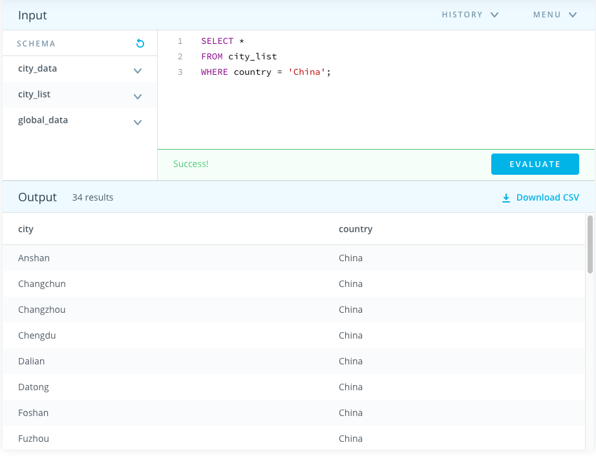In this step, I used SQL to extract the data I need from the database. First, I searched for the nearest big city where I am living. So, I ran the following code and decided to choose Chengdu, China.

Figure 1: The SQL script and output for choosing a city

Then I downloaded the city_data where the city is Chengdu and global_data as csv files by running the following code.

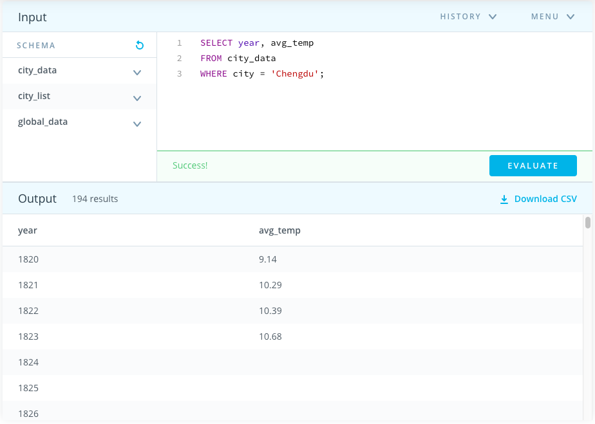

Figure 2: the SQL script and output of Chengdu

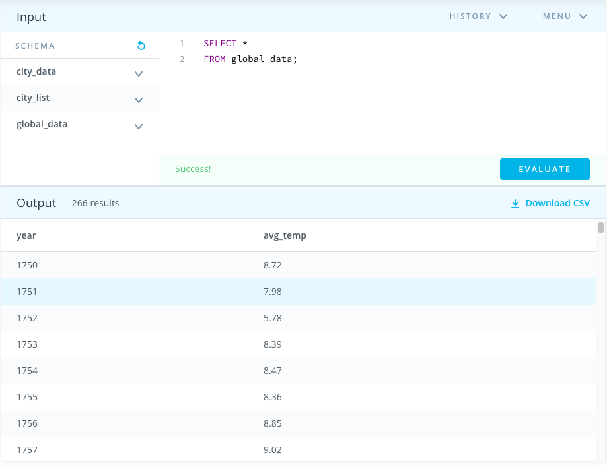

Figure 3: The SQL script and output of global data

* 1. ***Step 2*: Calculate the moving average**

Then, I used Microsoft Excel to open up these two csv files and combined the data into one file. I created two new columns named 7-year MA, one for each dataset respectively, to calculate the 7-year moving average. The first 7-year MA is calculated by using the AVERAGE() function calculating AVERAGE(B3:B9) and AVERAGE(F3:F9). Then I dragged the cell down to the end of the data to calculate the remaining 7-year MA. All errors are replaced by null values.



Figure 4: The calculation of average moving for each dataset

* 1. ***Step 3*: Create a line chart**

Thirdly, the line chart is created by using the chart function in Excel. The key consideration is how to give the title to each axis to make information clear. The result is shown in *Section 2*.

* 1. ***Step 4*: Make observations**

Finally, the observation was given by answering some specific questions.

1. **Line Chart**

Figure 5: The line chart of the 7-year moving average in Chengdu and globe

1. **Observations**

Here are some observations made from the line chart:

* In global view, from 1750-1850, the average temperature faced fluctuation around 8℃. The temperature was stable from 1850 to 1920. After 1920, the average temperature increased to around 10℃ in 2015.
* From 1820 to 2013, the average temperature in Chengdu faced rapid fluctuation but was rising in overall.
* Overall, the average temperature in Chengdu is higher than the global level.
* In another city called Melbourne Australia, the overall average temperature is higher than Chengdu and is increasing to around 14.5℃ in 2013.

Figure 6: The line chart of the 7-year moving average in Melbourne