**Debriefing**

**Perception of breathing in the human brain**

Project-Participation-ID: __________________

Time __________________

Date: __________________

**Stimulus Learning**

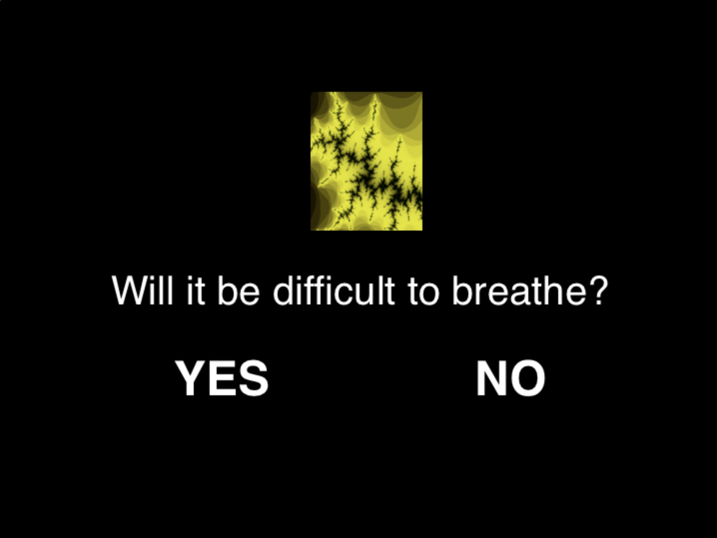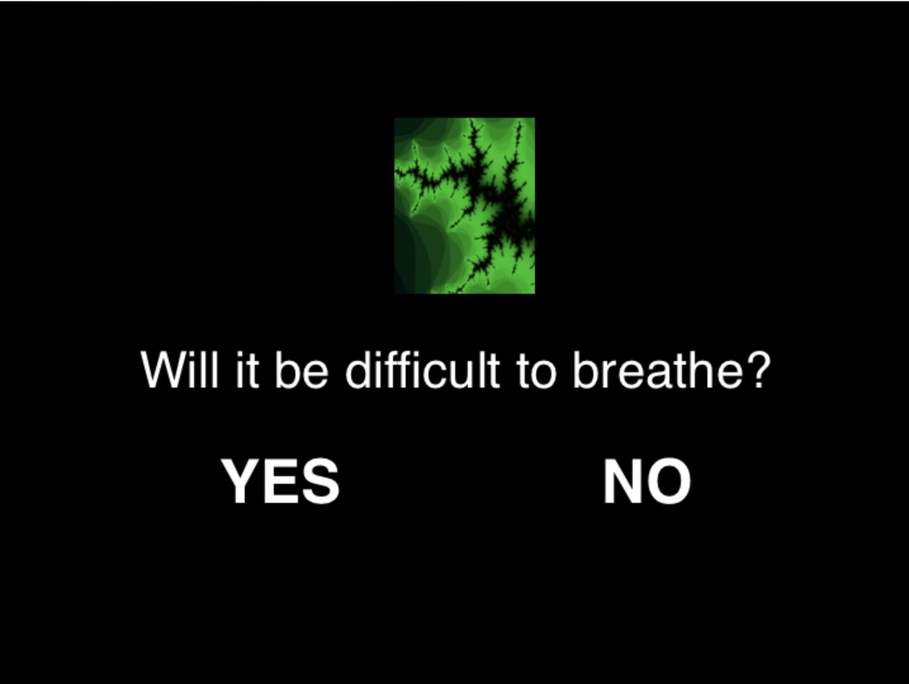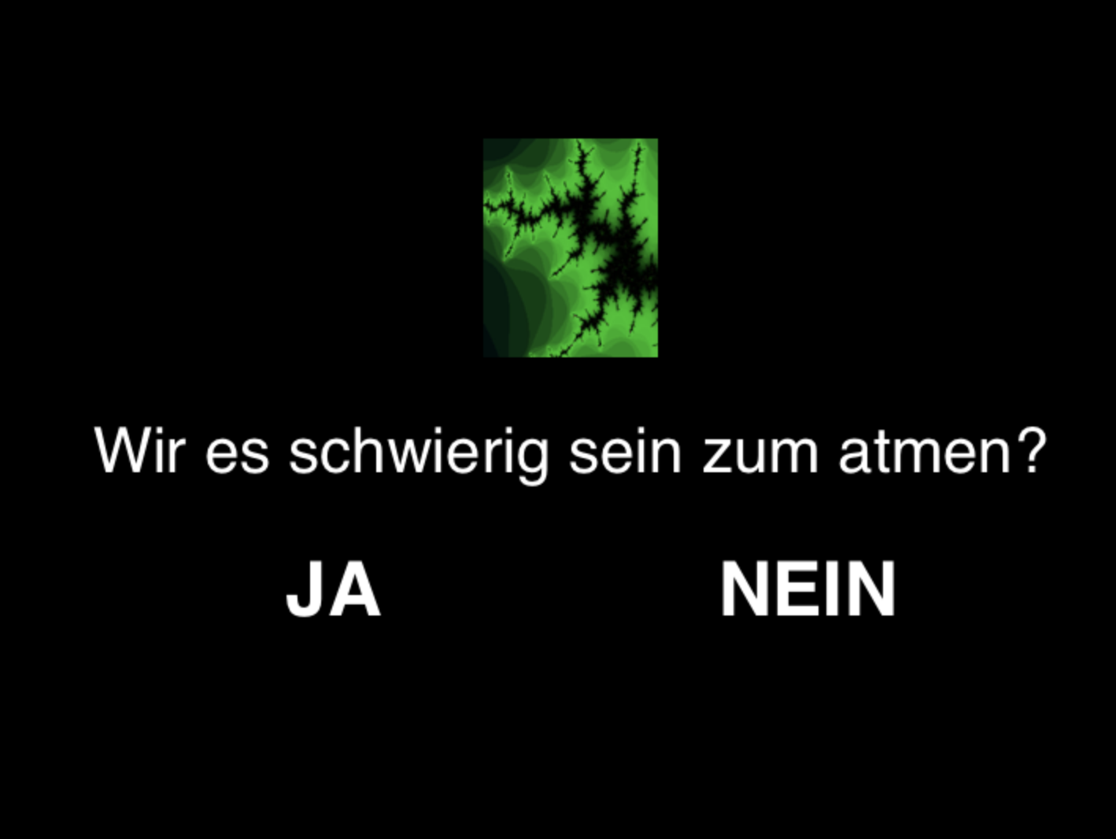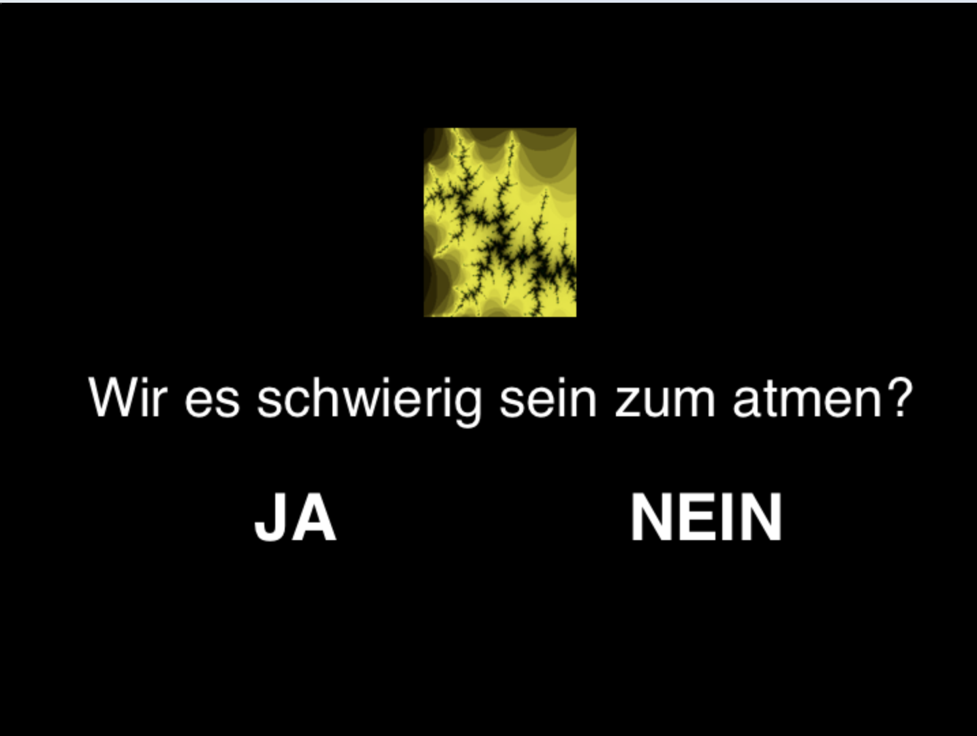

1. How would you rate the difficulty of the task?

0--------------0--------------0--------------0--------------0--------------0--------------0

Not at all Moderately Very

difficult difficult difficult

2. Describe how you solved the task:

Did you apply any systematic strategy?

Yes O

No O

If yes, please describe:

3. Did you feel that there was a particular pattern in the stimulus sequence?

Yes O

Np O

If yes, please describe:

4. Did you find it difficult to stay focused throughout the task? Were there times when they got tired? How often did that happen and when approximately?

5. How comfortable did you feel on the breathing device?

6. Did being on the breathing system ever make you feel afraid?

If yes, how afraid did you feel: Please rate from 1 (not at all afraid) to 10 (extremely afraid)?

7. Any further comments:

Thank you for your answers and for participating in our study!