**\*\*1、重新搭建框架，要求按学长演示的来（框架），分析清楚客户需求！**

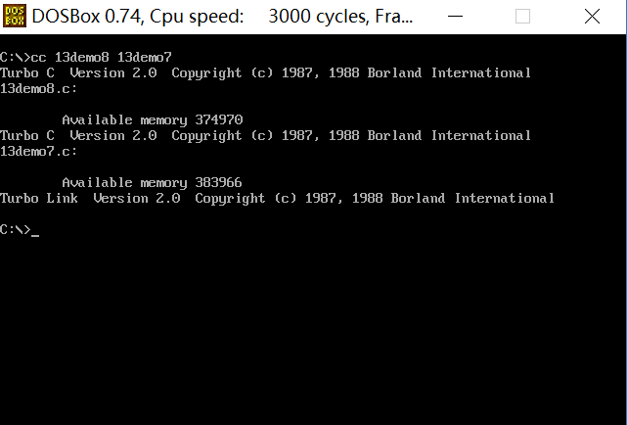

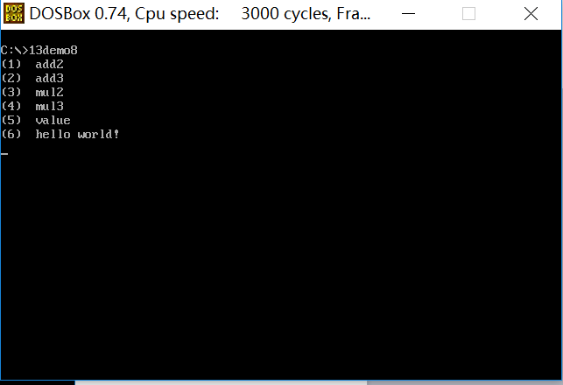

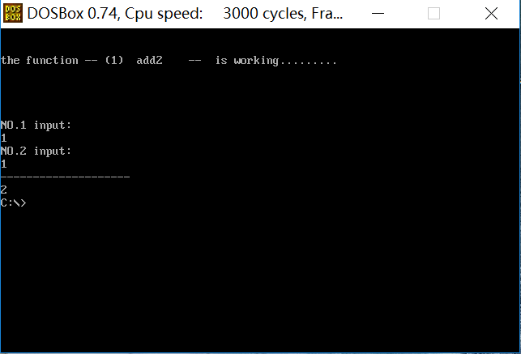

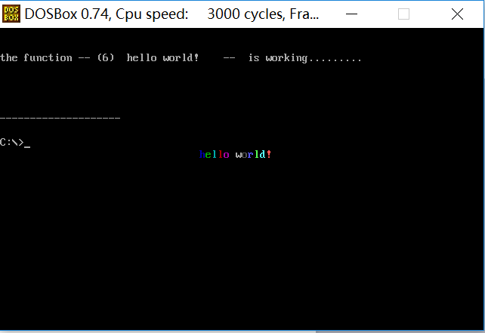

开发工具程序cc.c：

#include <stdio.h>

#include <string.h>

#include <stdlib.h>

int main(int n,char \*\*arg)

{

int i;

char a[20] = "tcc -c ";

char b[80] = "tlink c0s main ";

char c[5] = ",";

char d[20] = " ,,cs.lib ";

char e[20] = "tcc -c ";

char f[5] = " ";

for(i = 0;arg[1][i]!='\0';i++)

{

if(arg[1][i] == '.')

{

arg[1][i] = '\0';

}

}

for(i = 0;arg[2][i]!='\0';i++)

{

if(arg[2][i] == '.')

{

arg[2][i] = '\0';

}

}

strcat(a,arg[1]);

system(a);

strcat(e,arg[2]);

system(e);

strcat(b,arg[1]);

strcat(b,f);

strcat(b,arg[2]);

strcat(b,c);

strcat(b,arg[1]);

strcat(b,d);

system(b);

return 0;

}

程序main.c:

#include "13demo6.h"

int a;

void menu(manage\* cpfmanage)

{

int b,i;

char ch;

for(a = 0;a < cpfmanage->fnum;a++)

{

b =strlen(cpfmanage->item[a].text);

if(b > 20 || b <0)

{

printf("error");

return;

}

printf("%s\n",cpfmanage->item[a].text);

}

do

{

ch = getch();

for(a = 0;cpfmanage->item[a].key != ch && a < cpfmanage->fnum ;a++);

}while(a == cpfmanage->fnum);

system("cls");

printf("\n\n");

printf("the function -- %s -- is working.........\n\n\n\n\n",cpfmanage->item[a].text);

for( i = 0;i<cpfmanage->item[a].pnum;i++ )

{

printf("NO.%d input: \n",i+1);

gets(str1[i]);

}

printf("--------------------\n");

}

void init()

{

menu(&fmanage);

}

main()

{

init();

change();

}

程序13demo6.h:

typedef struct

{

const char\* text;

char key;

void\* func;

int pnum;

}list;

typedef struct mg

{

list\* item;

void (\*doing)(struct mg\*);

int fnum;

}manage;

extern int a;

extern list flist[];

extern manage fmanage;

extern char str1[3][20];

void menu(manage\* cpfmanage);

extern void choose(manage\* cpfmanage);

void init();

extern void change();

extern int add2(int,int);

extern int add3(int,int,int);

extern int mul2(int,int);

extern int mul3(int,int,int);

extern int value(int);

extern void f1();

extern void putstr(char\*);

程序13demo7.c:

#include "13demo6.h"

int add2(int a,int b)

{

return a+b;

}

int add3(int a,int b,int c)

{

return a+b+c;

}

int mul2(int a,int b)

{

return a\*b;

}

int mul3(int a,int b,int c)

{

return a\*b\*c;

}

int value(int a)

{

return a;

}

void f1()

{

putstr("hello world!");

}

void putstr(char\* str)

{

int far\* scr =(int far\*)(0xb8000000+160\*10+33\*2);

int n;

for(n = 0;str[n];n++)

{

scr[n] = str[n]+(n+1)\*0x100;

}

}

程序13demo8.c:

#include "13demo6.h"

char str1[3][20];

char text1[20] = "(1) add2";

char text2[20] = "(2) add3";

char text3[20] = "(3) mul2";

char text4[20] = "(4) mul3";

char text5[20] = "(5) value";

char text6[20] = "(6) hello world!";

list flist[] = {

{ text1,'1', (void\*)add2,2 },

{ text2,'2', (void\*)add3,3 },

{ text3,'3', (void\*)mul2,2 },

{ text4,'4', (void\*)mul3,3 },

{ text5,'5', (void\*)value,1},

{ text6,'6', (void\*)f1 ,0 }

};

manage fmanage ={

flist,

menu,

sizeof(flist)/sizeof(list)

};

void change()

{

choose(&fmanage);

}

void choose(manage\* cpfmanage)

{

switch(cpfmanage->item[a].pnum)

{

case 1:

printf("%d",( \*(int (\*)(int))cpfmanage->item[a].func)(atoi(str1[0])) );

break;

case 2:

printf("%d",( \*(int (\*)(int,int) )cpfmanage->item[a].func)(atoi(str1[0]),atoi(str1[1])) );

break;

case 3:

printf("%d",( \*(int (\*)(int,int,int) )cpfmanage->item[a].func)(atoi(str1[0]),atoi(str1[1]),atoi(str1[2])) );

break;

case 0:

default:

( \*(void (\*)() )cpfmanage->item[a].func)() ;

break;

}

}

调用格式：

1. 将cc.c程序经tcc编译链接生成cc.exe开发工具程序；
2. 用“tcc -c”命令将main.c程序编译为main.obj文件；
3. 输入“cc 13demo8 13demo7”命令；
4. 执行“13demo8”。

文件的属性：

1. main.c文件编译为main.obj，不对外公开；
2. cc.c文件编译生成新开发工具cc.exe，不对外公开；
3. 13demo7.c文件由负责开发个性子函数，如二元加法、三元加法等函数的一名程序员进行统一地增删修改等操作，不对用户开放；
4. 13demo8.c文件由负责开发菜单新增函数选项并且逻辑处理调用几元参数的另一名程序员进行编写，不对用户开放；
5. 13demo6.h文件内容向用户开放。