病友圈

圈子主表（圈子的id，圈子的名称，基本介绍，患友数，专家数，话题数，版主id）

circle ( circle_id, circle_name, circle_intro, circle_suffer_number, circle_expert_number, circle_topic_number, circle_owner_id)

分区主表（分区的id，分区的名称）

partition ( partition_id, partition_name)

话题主表（话题id，分区id，圈子id，话题标题，发表日期，浏览数，回复数，话题内容，版主的id）

topic ( topic_id, partition_id, circle_id, topic_title, topic_date, topic_views, topic_reply_number, topic_content, topic_owner_id)

患者主表（用户id，username，等级，身份，性别，年龄，其他信息，粉丝数）

patient ( patient_id, patient_username, patient_level, patient_iden, patient_age, patient_other, patient_fan_number)

疾病用户联合表（疾病id，用户id）

illness_user (illness_id, patient_id)

回复主表（回复id，话题id，用户id，回复内容，回复时间，跟贴id，跟贴用户id，跟贴内容，跟贴时间）

reply(reply_id, topic_id, patient_id, reply_content, reply_time, reply_follow_patient_id, reply_follow_content, reply_follow_date)

疾病主表（疾病id，所在圈子id，疾病名称，患友数，医生数，话题数）

illness(illness_id, circle_id, illness_name, illness_patient_numbser, illness_doctor_number, illness_topic_number)

专家主表（专家id，关注数，粉丝数，职位，介绍，圈子数）

expert(expert_id, expert_star_number, expert_follow_number, expert_position, expert_intro, expert_circle_number)

专家擅长的疾病（专家id，擅长疾病id）

expert_illness (expert_id, illness_id)

专家所在圈子（专家id，所在圈子id）

expert_circle ( expert_id, circle_id)

家庭医生

科室主表（科室id，科室名称）

department ( department_id, department_name )

医生主表（医生id，医生姓名，医生职称，所在单位，擅长，简介，荣誉，综合评分，包周价钱，包月价钱，医术高明数，耐心细致数，妙手回春数，yishu一班数，非常满意数，专业数，很有帮助数，不够详细数，累计签约家庭数，累计帮助用户数，科室id）

family_doctor(f_doctor_id, f_doctor_name, f_doctor_position, f_doctor_hospital, f_doctor_skilled，f_doctor_intro, f_doctor_honor, f_doctor_all_score, f­_doctor_week, f_doctor_month, f_doctor_A, f_doctor_B，f_doctor_C, f_doctor_D, f_doctor_E, f_doctor_F, f_doctor_G, f_doctor_H, f_doctor_I, f_doctor_family_number, f_doctor_patient_number, department_id)

评价表（评价id，患者id，医生id，评价时间，评分，评价内容）

evaluate(evaluate_id, patient_id, f_doctor_id, evaluate_date, evaluate_score, evaluate_content)

购买记录表（购买记录id，医生id，患者名称，服务类型，购买数量，价格，成交日期）

family_doctor_sell (f_sell_id, f_doctor_id, patient_name, f_sell_type, f_sell_price, f_sell_date)

药品信息

药品主表（药品id，药品名称，批准文号，生产企业，功能主治，用法用量，相关疾病，通用名称，不良反应，禁忌，注意事项，成分，药物相互作用，用前咨询数，用后评价数，是否处方药，是否中成药，是否医保，是否国产）

medicine(medicine_id, medicine_name, medicine_license_number, medicine_madeby, medicine_attending, medicine_usage, medicine_related_illness, medicine_general_name, medicine_adr, medicine_avoid, medicine_notice, medicine_component, medicine_interactions, medicine_consult_number, medicine_evaluate_number, medicine_prescribed, medicine_chinese, medicine_insurance, medicine_made_in_china)

疾病表（疾病id，疾病名称，药品数）

m_illness (m_illness_id, m_illness_name, m_illness_number)

药瓶疾病联合表（药品id，疾病id）

medicine_illness(m_illness_id, medicine_id)

用后评价（评价id，药品id，评价星级，评价内容，医生诊断疾病，用户所在地区，评价时间，有问必答部分的id）

m_evaluate(m_evaluate_id, medicine_id, m_evaluate_level, m_evaluate_content, m_evaluate_illness, m_evaluate_location, m_evaluate_date, 帖子id)

用前咨询（咨询id，username，药瓶id，咨询内容，回复内容，回复者name，回复者职称，有问必答部分的id）

m_consult( m_consult_id, m_consult_name, medicine_id, m_consult_content, m_consult_reply_content, m_consult_reply_name, m_consult_reply_title, 帖子id)

医平台

话题主表（话题id，标题，内容，回复数，点赞数，发帖者id（url），浏览数，关注话题数，话题，发帖者类型，话题发表时间）

y_topic ( y_topic_id, y_topic_title, y_topic_reply_number, y_topic_like_number, y_topic_owner_url, y_topic_view_number, y_topic_follow_number, y_topic_type, y_topic_owner_type, y_topic_date)

回复主表（回复id，话题id，医生id，回复内容，被赞数，回复时间，跟贴内容，跟贴医生id，跟贴时间）

y_reply (y_reply_id, y_topic_id, y_doctor_id, y_reply_content, y_reply_like_number, y_reply_date, y_reply_follow_content, y_reply_follow_doctor_id, y_reply_follow_date)

医生主表（医生id，医生url，医生姓名，职称，科室，经验等级，最佳回复，帮助的用户，信誉值，用户感谢，粉丝用户，擅长疾病，所在医院，个人简介）

y_doctor (y_doctor_id, y_doctor_url, y_doctor_name, y_doctor_title, y_doctor_department, y_doctor_experience_level, y_doctor_best_reply, y_doctor_help_patients, y_doctor_reputation, y_doctor_thanks, y_doctor_fan_number, y_doctor_excel, y_doctor_hospital, y_doctor_intro)

有问必答***

问答贴主表（帖子id，科室id1，科室id2，发帖者id，发帖者性别，发帖者年龄，发帖时间，发帖内容，回复数）

a_topic ( a_topic_id, department_id_1,department_id_2, a_topic_owner_id, a_topic_owner_sex, a_topic_owner_age, a_topic_date, a_topic_content, a_topic_reply_number)

回复表（回复id，帖子id，回复时间，回复者id（有可能不是医生），回复内容，有用数，回复是否被采纳，跟贴内容，跟贴用户id，跟贴时间）

a_reply(a_reply_id, a_topic_id, a_reply_date, a_reply_owner_id, a_reply_content, a_reply_help_number, a_reply_adopt, a_reply_follow_content, a_reply_follow_owner_id, a_reply_follow_date)

医生表（医生id，医生url，医生类型，关注数，动态数，粉丝1数，粉丝2数）

a_doctor( a_doctor_id, a_doctor_url, a_doctor_type, a_doctor_follow_number, a_doctor_news_number, a_doctor_fan_number_1, a_doctor_fan_number_2)

专家频道

医院主表（医院id，医院名字，医院介绍，医院地址, 医院电话，图文咨询在线专家数，可预约挂号专家数，成功预约人次，科室数，专家数）

hospital( hospital_id, hospital_name, hospital_intro, hospital_address, hospital_phone, hospital_image_online_number, hospital_register_number, hospital_appointment, hospital_department_number, hospital_expert_number)

科室表（科室id，医院id，是否重点科室，医生数，图文咨询，可预约挂号专家数，成功预约挂号数，可电话咨询专家数，成功电话咨询数）

e_department(e_department_id, hospital_id, e_department_key, e_edepartment_doc_number, e_department_image, e_department_register_number, e_department_appointment_number, e_department_phone_consult_number, e_department_phone_consult_success_number)

疾病主表（疾病id，疾病名称）

e_illness( e_illness_id, e_illness_name)

疾病医生人数（疾病id，科室id，医院id，医生人数）

e_illness_doctor( e_illness_id, e_department_id, e_hospital_id, e_illness_doctor_number)

专家主表（专家id，专家姓名，专家职称，医院，所在科室，擅长，执业经历，疗效满意度，态度满意度，个人网站url，咨询范围，成功预约人数，总访问量，总文章，总咨询，好评，就医经验，上次在线，开通时间，已回复咨询数，预约门诊成功数，已获得投票数，电话咨询详情，电话咨询帮助患者数，图文咨询详情，图文资讯帮助患者数，预约加号详情，预约加号帮助患者数，专家门诊时间，电话咨询价钱）

e_expert (e_expert_id, e_expert_name, e_expert_title, e_expert_hospital, e_expert_department, e_expert_excel, e_expert_experience, e_expert_curative_level, e_expert_attitude_level, e_expert_url, e_expert_consult_scope, e_expert_appointment, e_expert_visits, e_expert_article_number, e_expert_consult_number, e_expert_praise, e_expert_exp, e_expert_last_online_time, e_expert_join_time, e_expert_reply_number, e_expert_appointment_success_number, e_expert_vote_number, e_expert_phone_consult_details, e_expert_phone_consult_help, e_expert_image_consult, e_expert_image_consult_help, e_expert_add_appointment, e_expert_add_appoinment_number, e_expert_time, e_expert_phone_consult_price)

投票表（投票id，医生id，疾病名称，票数）

e_vote(e_vote_id, e_expert_id, e_vote_illness_name, e_vote_number)

咨询主表（咨询id，咨询者id，医生id，所患疾病，病情描述，曾经治疗情况和效果，想得到怎样的帮助，咨询时间，问题分析，意见建议，回复时间，推荐数，不推荐数）

e_consult(e_consult_id, e_consult_owner_id, e_expert_id, e_consult_illness, e_consult_illness_detail, e_consult_previous, e_consult_want_help, e_consult_date, e_consult_analysis, e_consult_suggest, e_consult_reply_date, e_consult_like_number, e_consult_dislike_number)

回复表（回复id，咨询id，回复内容，回复时间，回复用户id）

e_reply( e_reply_id, e_consult_id, e_reply_content, e_reply_date, e_reply_owner_id)

文章主表（文章id，作者，发表时间，文章内容，阅读数，推荐数，不推荐数）

e_article (e_article_id, e_expert_id, e_article_date, e_article_content, e_article_read, e_article_like, e_article_dislike)

文章标签（文章标签id，文章标签名字）

e_tag(e_ tag_id, e _tag_name);

文章-标签（文章id，标签id）

e_article_tag(e_article_id, e_tag_id);

预约（专家id，疾病就诊范围，患者地区限制，患者就诊要求）

e_appointment (e_expert_id, e_appointment_range， e_appointment_region, e_appointment_require)

预约订单（订单id，所在省市，专家id，所患疾病，预约门诊时间，门诊类型）

e_order (e_order_id, e_order_location, e_expert_id, e_order_illness, e_order_time, e_order_type)

--- 电话咨询（电话咨询的url里面包含了专家的id）

电话咨询订单（订单id，专家id， 患者id，疾病，订单详情）

e_phone_consult_order( e_phone_consult_order_id, e_expert_id, e_phone_consult_order_patient_id, e_phone_consult_order_details)

就医经验（就医经验id，专家id，患者id，患者地区，疾病，疗效，态度，评价时间，评价详情，推荐数）

e_experience( e_experience_id, e_expert_id, e_experience_patient_id, e_experience_region, e_experience_illness, e_experience_effect, e_experience_attitude, e_experience_date, e_experience_content, e_experience_like_number)

ER图

病友圈

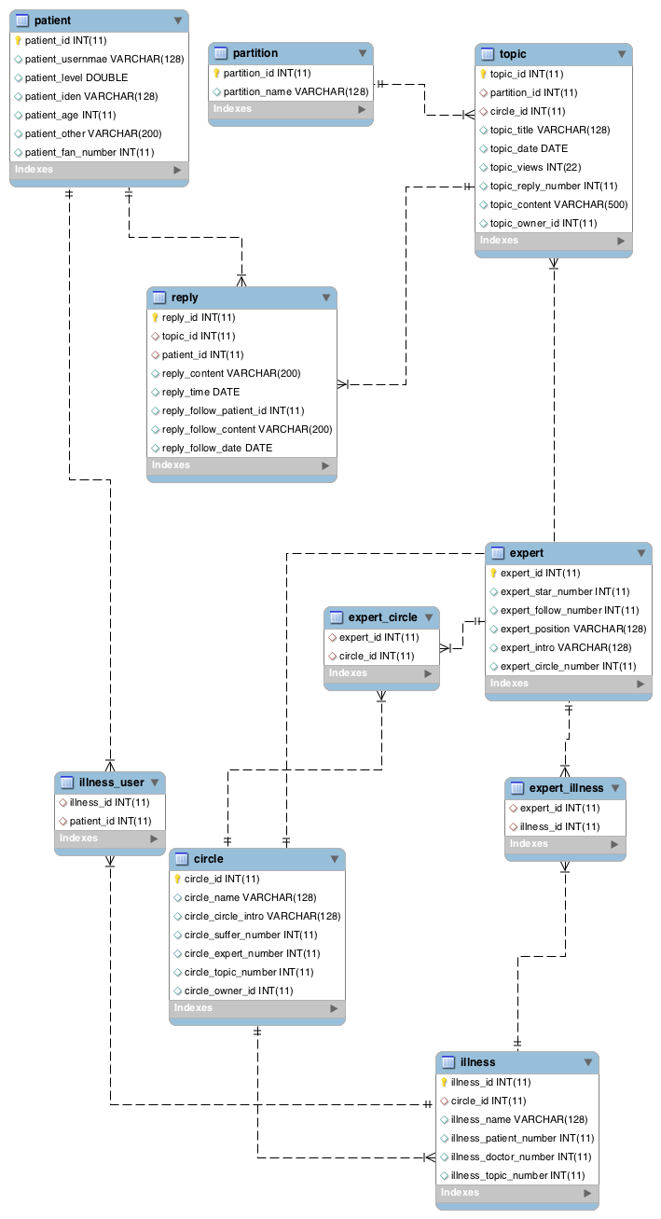

药品信息

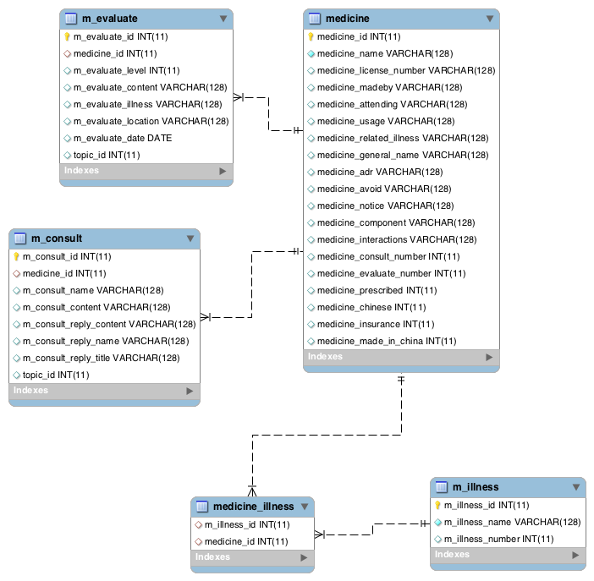

家庭医生

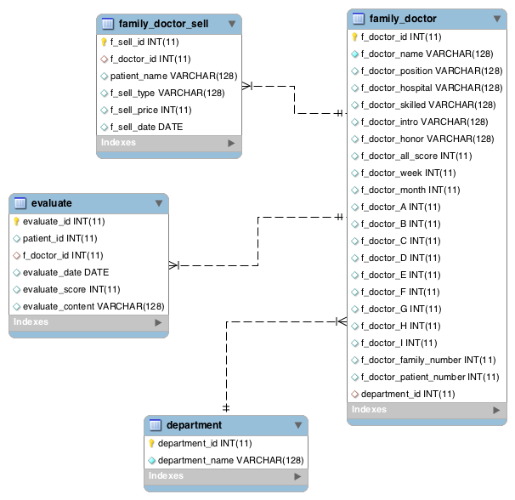

医平台

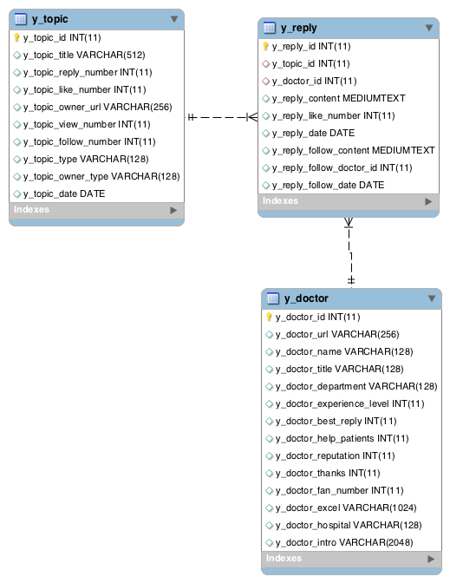

有问必答

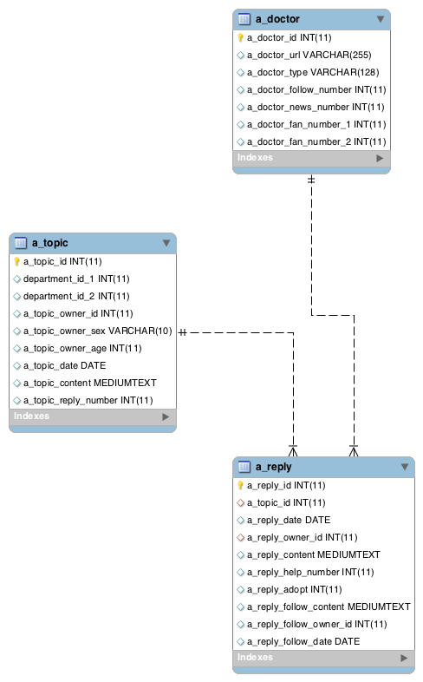

专家频道

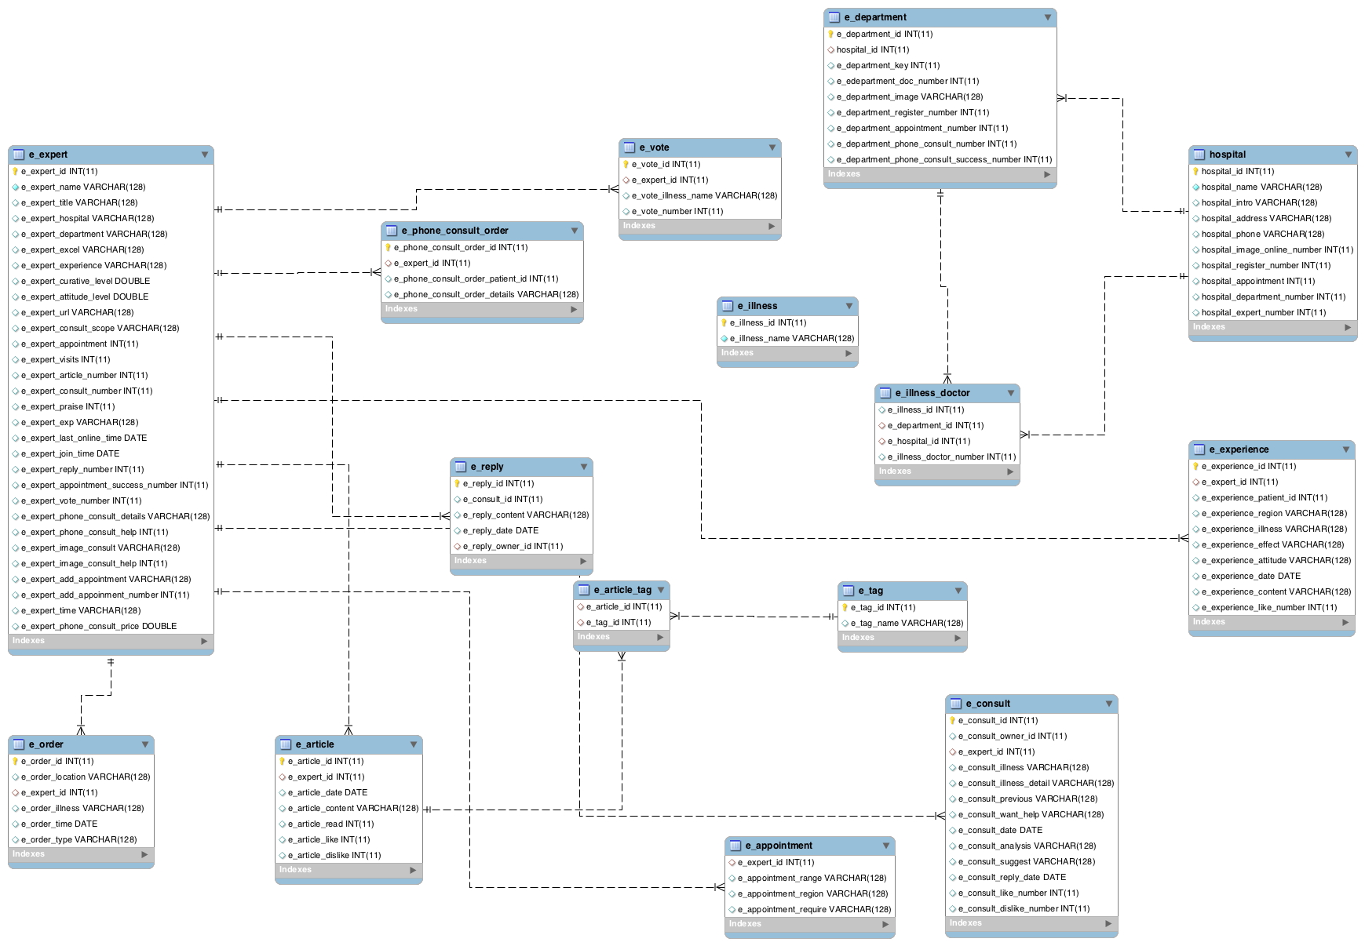

另外：需要修改的几个地方

1. 这样建表是将六个不同的板块分隔开来，将他们放到不同的库里面；实际上，可能会出现跨库外键的情况，所以还得将他们都放到同一个数据库里；
2. 王利安师兄说的单独更新的几个表还没有弄好；
3. 医生的种类区分、医生照片的爬取以及表的分割和更新频率需要进一步完善。
4. 具体建表的sql语句在 <https://github.com/yingjieyao/xywy-spider>

时间仓促，设计不周的地方随时联系。(姚英杰：yyjhit@sina.com)