Team Name: B-tree

Team Members: Xian Qu, Jingyuan Zhang, Yinglao Liu

Project Name: Eat Healthy

**UML Diagram**

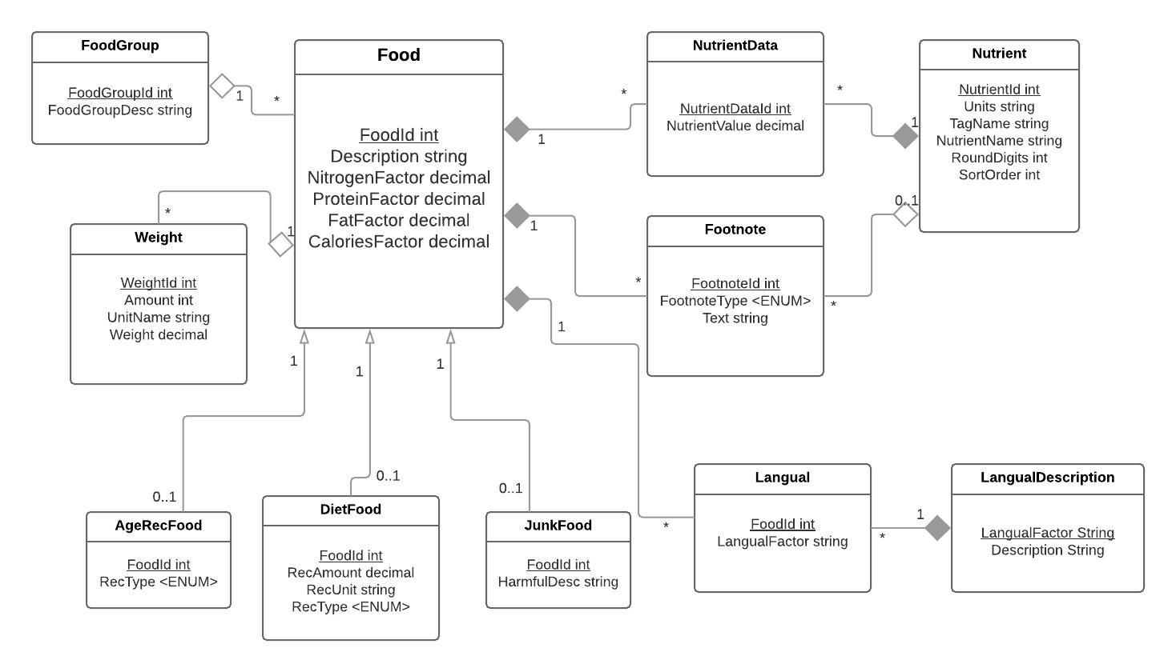

**CREATE TABLE**

# Create the schema if necessary.

CREATE SCHEMA IF NOT EXISTS FoodApp;

USE FoodApp;

DROP TABLE IF EXISTS Langual;

DROP TABLE IF EXISTS LangualDescription;

DROP TABLE IF EXISTS FootNote;

DROP TABLE IF EXISTS NutrientData;

DROP TABLE IF EXISTS Nutrient;

DROP TABLE IF EXISTS Weight;

DROP TABLE IF EXISTS Unit;

DROP TABLE IF EXISTS Junk;

DROP TABLE IF EXISTS DietFood;

DROP TABLE IF EXISTS AgeRecFood;

DROP TABLE IF EXISTS Food;

DROP TABLE IF EXISTS FoodGroup;

CREATE TABLE FoodGroup (

FoodGroupId int not null,

FoodGroupDesc text not null,

CONSTRAINT pk_FoodGroup_FoodGroupId PRIMARY KEY (FoodGroupId)

);

create table Food(

FoodId int not null,

FoodGroupId int,

Description text,

N_Factor float(4,2),

PRO_Factor float(4,2),

FAT_Factor float(4,2),

CHO_Factor float(4,2),

constraint pk_Food_FoodId primary key (FoodId),

constraint fk_Food_FoodGroupId foreign key (FoodGroupId)

references FoodGroup(FoodGroupId)

on update cascade on delete set null

);

create table AgeRecFood (

FoodId int,

RecType enum('Infant', 'Elderly', 'Pregnant'),

constraint pk_AgeRecFood_FoodId primary key (FoodId),

constraint fk_AgeRecFood_FoodId foreign key (FoodId)

references Food(FoodId) ON UPDATE CASCADE ON DELETE CASCADE

);

create table DietFood (

FoodId int,

RecAmount decimal,

RecUnit varchar(255),

constraint pk_DietFood_FoodId primary key (FoodId),

constraint fk_DietFood_FoodId foreign key (FoodId)

references Food(FoodId) ON UPDATE CASCADE ON DELETE CASCADE

);

create table JunkFood (

FoodId int,

HarmfulDesc varchar(255),

constraint pk_JunkFood_FoodId primary key (FoodId),

constraint fk_JunkFood_FoodId foreign key (FoodId)

references Food(FoodId) ON UPDATE CASCADE ON DELETE CASCADE

);

create table Weight(

WeightId int auto_increment,

FoodId int not null,

Amount float(8,4) not null,

Unit text not null,

WeightInGram float(8,4) not null,

constraint pk_Weight_weightId primary key(WeightId),

constraint fk_Weight_NDB_NO foreign key(FoodId)

references Food(FoodId)

on update cascade on delete cascade

);

create table Nutrient(

NutrientId int,

Unit varchar(255),

TagName varchar(255),

Description text,

constraint pk_Nutrient_NutrientId primary key(NutrientId));

create table NutrientData(

NutrientDataId int auto_increment,

FoodId int not null,

NutrientId int not null,

NutrientValue float(15,8),

constraint pk_NutrientData_NutrientDataId primary key(NutrientDataId),

constraint fk_NutrientData_FoodId foreign key(FoodId)

references Food(FoodId)

on update cascade on delete cascade,

constraint fk_NutrientData_NutrientId foreign key(NutrientId)

references Nutrient(NutrientId)

on update cascade on delete cascade

);

create table Footnote(

FootnoteId int auto_increment,

FoodId int,

FootnoteType enum('D', 'M', 'N'),

NutrientId int,

FootnoteText text,

constraint pk_Footnote_FootnoteId primary key(FootnoteId),

constraint fk_Footnote_NutrientId foreign key(NutrientId)

references Nutrient(Nutrientid)

on update cascade on delete set null,

constraint fk_Footnote_FoodId foreign key(FoodId)

references Food(FoodId)

);

# D: adds information to the food description

# M: adds information to the measure description

# N: provides additional information on a nutrient value

create table LangualDescription(

Factor varchar(255),

Description text,

constraint pk_LangualDescription_Factor primary key(Factor)

);

create table Langual(

LangualId int auto_increment,

FoodId int,

Factor varchar(255),

constraint pk_Langual_LangualId primary key (LangualId),

constraint fk_Langual_Factor foreign key (Factor)

references LangualDescription(Factor)

on update cascade on delete cascade,

constraint fk_Langual_FoodId foreign key (FoodId)

references Food(FoodId)

on update cascade on delete cascade

);

**INSERT TABLE**

use FoodApp;

delete from foodgroup;

LOAD DATA INFILE 'C:\\ProgramData\\MySQL\\MySQL Server 5.7\\Uploads\\FD_GROUP.csv'

INTO TABLE foodgroup

FIELDS TERMINATED BY ','

ENCLOSED BY '"'

LINES TERMINATED BY '\r\n'

IGNORE 1 LINES

(@col1, @col2)

set FoodGroupId = @col1, FoodGroupDesc = @col2;

delete from food;

LOAD DATA INFILE 'C:\\ProgramData\\MySQL\\MySQL Server 5.7\\Uploads\\FOOD_DES.csv'

INTO TABLE food

FIELDS TERMINATED BY ','

ENCLOSED BY '"'

LINES TERMINATED BY '\r\n'

IGNORE 1 LINES

(@col1, @col2, @col3, @col4, @col5, @col6, @col7, @col8,

@col9, @col10, @col11, @col12, @col13, @col14)

set FoodId = @col1, FoodGroupId = @col2, Description = @col3,

N_Factor = if(@col11 = '', null, @col11),

PRO_Factor = if(@col12 = '', null, @col12) ,

FAT_Factor = if(@col13 = '', null, @col13) ,

CHO_Factor = if(@col14 = '', null, @col14) ;

delete from weight;

LOAD DATA INFILE 'C:\\ProgramData\\MySQL\\MySQL Server 5.7\\Uploads\\WEIGHT.csv'

into table weight

FIELDS TERMINATED BY ','

OPTIONALLY ENCLOSED BY '"'

LINES TERMINATED BY '\r\n'

IGNORE 1 LINES

(@col1, @col2, @col3, @col4, @col5, @col6, @col7)

set FoodId = @col1, Amount = @col3, Unit = @col4, WeightInGram = @col5;

delete from nutrient;

LOAD DATA INFILE 'C:\\ProgramData\\MySQL\\MySQL Server 5.7\\Uploads\\NUTR_DEF.csv'

into table nutrient

FIELDS TERMINATED BY ','

OPTIONALLY ENCLOSED BY '"'

LINES TERMINATED BY '\r\n'

IGNORE 1 LINES

(@col1, @col2, @col3, @col4, @col5, @col6)

set NutrientId = @col1, Unit = @col2, TagName = @col3, Description = @col4;

;

delete from NutrientData;

LOAD DATA INFILE 'C:\\ProgramData\\MySQL\\MySQL Server 5.7\\Uploads\\NUT_DATA.csv'

INTO TABLE NutrientData

FIELDS TERMINATED BY ','

ENCLOSED BY '"'

LINES TERMINATED BY '\r\n'

IGNORE 1 LINES

(@col1, @col2, @col3, @col4, @col5, @col6, @col7, @col8,

@col9, @col10, @col11, @col12, @col13, @col14, @col15, @col16, @col17)

set FoodId = @col1,

NutrientId = @col2,

NutrientValue = @col3;

delete from Footnote;

LOAD DATA INFILE 'C:\\ProgramData\\MySQL\\MySQL Server 5.7\\Uploads\\FOOTNOTE.csv'

INTO TABLE Footnote

FIELDS TERMINATED BY ','

ENCLOSED BY '"'

LINES TERMINATED BY '\r\n'

IGNORE 1 LINES

(@col1, @col2, @col3, @col4, @col5)

set FoodId = @col1,

NutrientId = if(@col4 = '', null, @col4),

FootnoteType= @col3,

FootnoteText = @col5;

delete from LangualDescription;

LOAD DATA INFILE 'C:\\ProgramData\\MySQL\\MySQL Server 5.7\\Uploads\\LANGDESC.csv'

INTO TABLE LangualDescription

FIELDS TERMINATED BY ','

ENCLOSED BY '"'

LINES TERMINATED BY '\r\n'

IGNORE 1 LINES;

delete from Langual;

LOAD DATA INFILE 'C:\\ProgramData\\MySQL\\MySQL Server 5.7\\Uploads\\LANGUAL.csv'

INTO TABLE Langual

FIELDS TERMINATED BY ','

ENCLOSED BY '"'

LINES TERMINATED BY '\r\n'

IGNORE 1 LINES

(@col1, @col2)

set FoodId = @col1, Factor = @col2;

**Table Row Counts**

**Totally 705761 row of records of eight classes are inserted . Row counts for each table could be consulted in the following screenshot.**

**Research is being done on how to categorize the inherited classes of “AgeRecFood”, “DietFood”, and “JunkFood”, whose data is not inserted yet.**

