Environmental problems have always been an issue that cannot be ignored in the development process of all countries. However, the mode of development at the expense of the environment still exists. Let’s take EU as an example. The picture below shows EU’s investment for environmental protection from 2006 to 2019. We can see that both government and corporation investment for EP displayed a decreasing trend during the period, which reflects that they care less and less on the environmental protection.

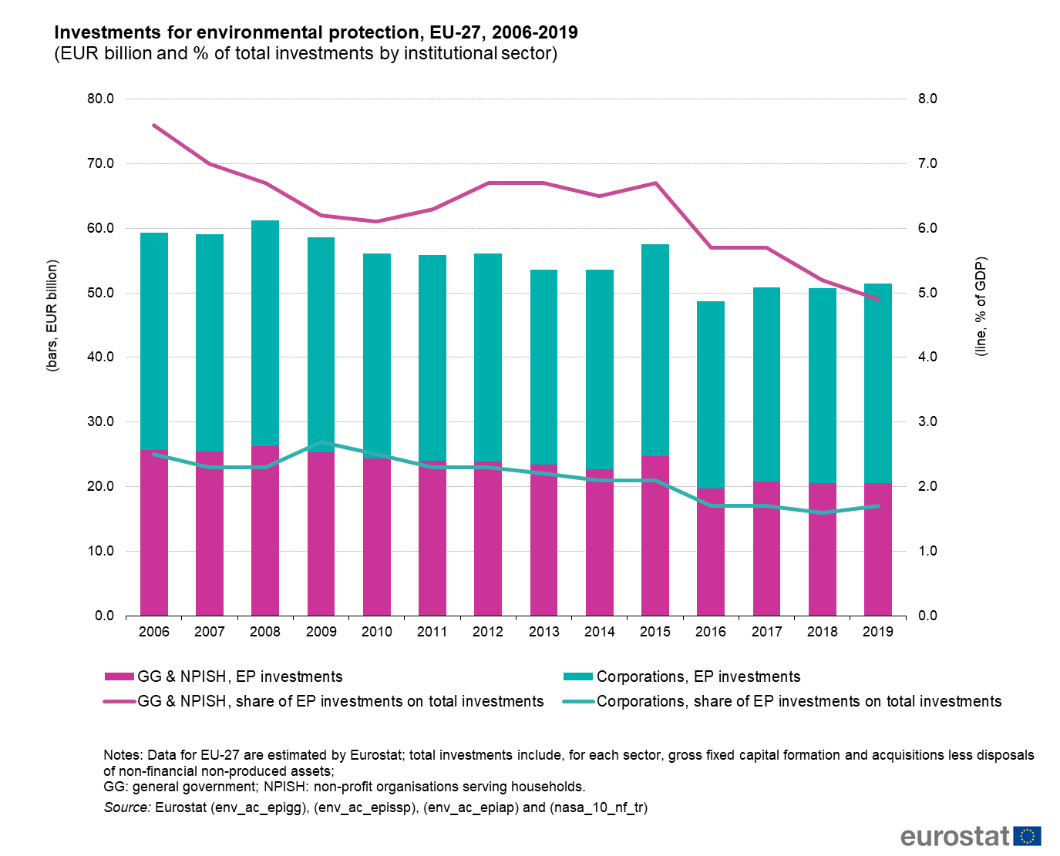

However, the related impacts of climate changes are terrible and disastrous. The picture below shows that nearly 821 million undernourished partly due to drought, 35 million people affected by flood, 2 million people displaced by weather-linked disease, and the like. Hence, environmental protection is indeed imminent and in great need.

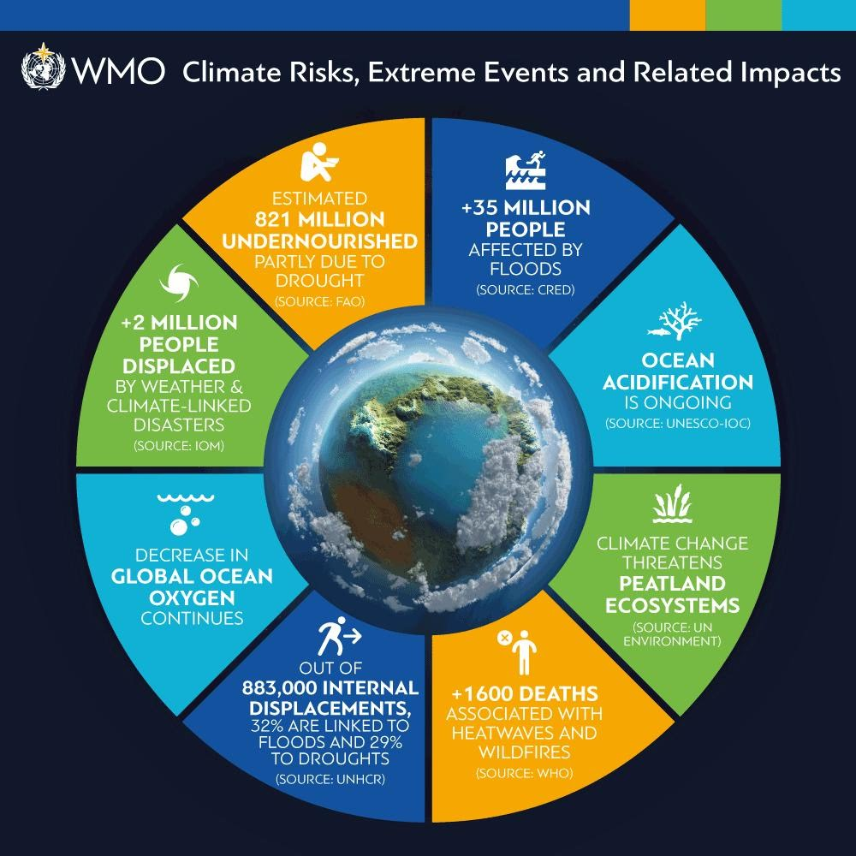

In December 2019, the COVID-19 pandemic was reported. Due to it, I was cooped up at home for nearly 4 months, which was definitely a tedious period. However, every time when I watched the bluer sky and breathed the fresher air, my restless mind would be at peace. So I become curious about how the pandemic has affected the environment. The global environment may get a break because of the outbreak.

Therefore, I want to research how the COVID-19 has affected the environment and predict the future environmental situation with these impacts. To be more specific, I plan to select three key time points, which are the beginning of the pandemic, the stay-at-home decree issued, and the work resumption, and five countries to represent five continents in the world. I will also analyze the environment through air quality index, water quality index, and weather. Environmental policies will also be included to see whether they changed before and after the outbreak.

Questions shown below will be answered to help come to the final conclusions.

• How did the air quality change?

• Which air quality index varied widely?

• What types of activities were responsible for these indexes?

• How did the water quality change?

• Which water quality index varied widely?

• What types of activities were responsible for these indexes?

• How did the weather change?

• Why did the weather change so?

• What types of activities were responsible for these weather changes?

• Have the environmental protection policies of these five countries been affected by the epidemic and cannot be implemented?

• Have these countries introduced new policies to protect the environment after the outbreak

Is nature recovering while humanity stays at home? Most of people may assume the answer to be “Yes.”, as they enjoyed the fresher air and bluer sky during this special break. But my answer is “Partly.”, which can be demonstrated by not only the intuition, but the following analysis.

First of all, figure out whether there is a relationship between the pandemic and the environment. In other words, we need to verify whether the COVID-19 has an impact on the environment before digging deeper. This can be accomplished by the association rule mining analysis, as what the interactive plot shows below.

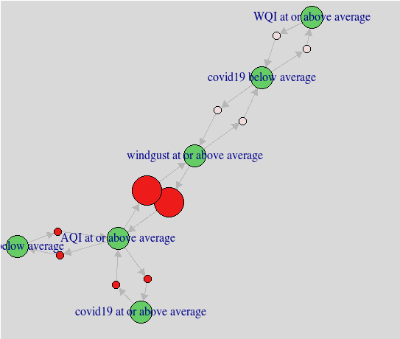

INTERACTIVE PLOT

The arrow of COVID-19 bubble points to the air quality, water quality, and weather bubble, which means that these four genres are closely associated with each other. Moreover, according to the COVID-19 rules, we can find that the class “More confirmed cases of COVID-19” has the strongest relationship with “AQI at or above average”, which reflects that countries with more confirmed cases were most likely to have a higher air quality.

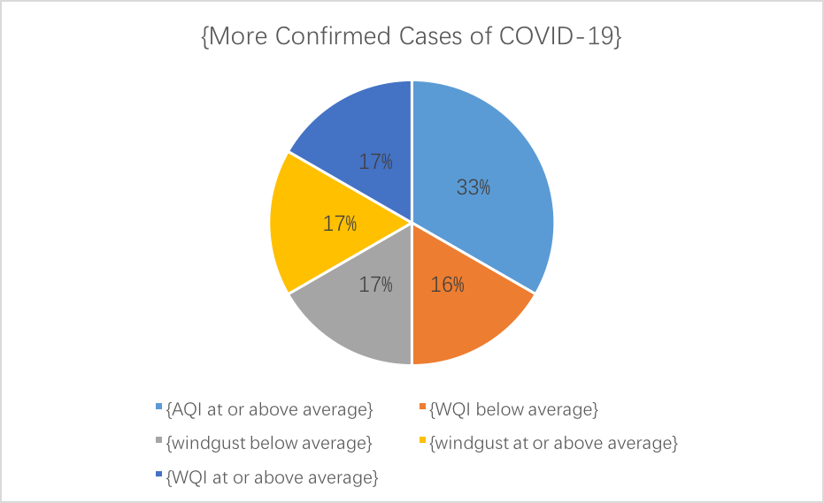

COVID-19 rules

After demonstrating that the pandemic did affect the environment, we come to the next question “How did it impact?” To make the broad question easier, we divide it into three parts: how did the epidemic impact the air quality, how did it affect the water quality, and what is impact on the weather.

For the first question about the air quality, by comparing the air quality indexes in 2017-2019, we can find that there is a large decrease of value for these indexes in 2020, when 41.4% of them are below 50 and 47.1% are between 51-100. None of them are above 150. However, in 2017-2019, only 8.7% indexes were less than 50, and nearly 15% indexes were above 150. Therefore, a clear improvement on air quality can be seen in 2020. What’s more, according to the decision tree modeling analysis, we can infer that countries, which were greatly affected by the COVID-19, were very likely to have an air quality level above average, whereas the countries with relatively small death toll would have an air quality level below average. This situation may be caused by the reality that most of heavy industry factories stopped production due to the epidemic, and car emissions reduced rapidly owing to the stay-at-home decree, so finally the air pollution declined.

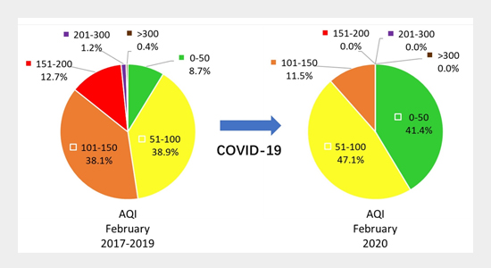

For the second question about the water quality, let’s take China as an instance. Below is a picture showing the national surface water quality from 2015 to 2019 in China. We can find that the water quality has improved year by year. However, in 2020, the data reflects that the water quality in China has not improved greatly as we expected. One of the causes may be the COVID-19. According to the decision tree modeling analysis, we can infer that countries, which had a small number of confirmed cases of COVID-19, were very likely to have water quality level above average, whereas the countries with large confirmed cases would have water quality level below average. China had the largest number of confirmed cases until August 2020, which means that more areas in China had been affected by the epidemic so that more people had to stay at home and more domestic wastewater had been resulted in, so its water quality cannot improve as expected.

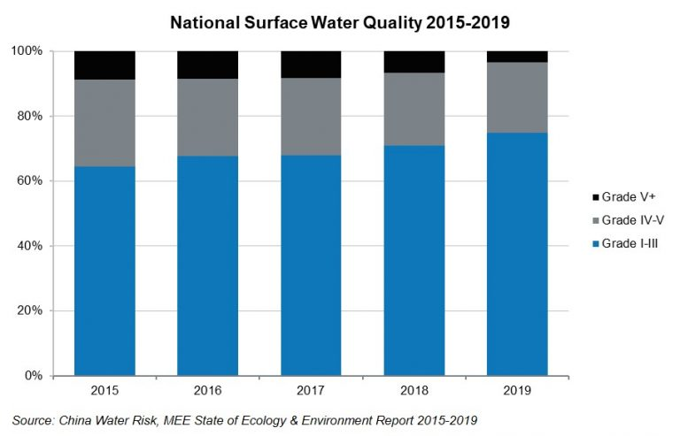

For the third question about the weather, we can first take temperature as an index to figure out the change. The plot below displays the temperature difference from 20th century average since 1880. Sadly though, we have to admit that the world is getting warmer. However, we can see that the rate of warming has slowed down in 2020, which may be contributed by COVID-19. According to the decision tree modeling analysis, it shows that countries, which had a large number of patients who died of COVID-19, were very likely to have lower temperature than average, whereas the countries with small death toll would have the contradictory situation. Admittedly, this difference may be partly caused by the reality that these countries are in different seasons, when the outbreak occurred, but we can still recognize the impact of COVID-19 on the temperature as the model includes most of countries that were in the same season.

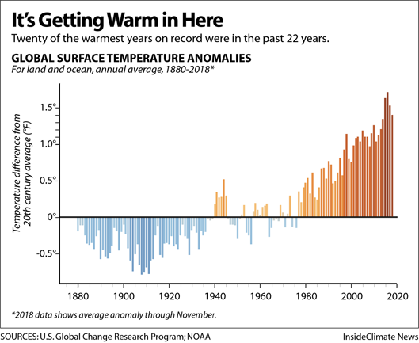

All in all, COVID-19 has a positive impact on the air quality and climate change, but a negative impact on the water quality.

After knowing how the epidemic affect the environment, we then can figure out whether the environmental policies change according to these impacts.

By collecting the latest news about the global environment and environmental policies, and performing the decision trees modeling analysis, we found that they are more likely to connect with “nations”, “dedications”, “united “, “Innovative”, and “challenges”. Hence, we can infer that the environmental policies recognize that the environmental protection is a big challenge now, and requires not only separate nations’ dedications, but the world union and innovation to solve it.

In addition, the random forest trees show that the top ten important features in environment-related news are “direct”, "matter", "far", "coordin", "immedi", "diseas", "care", "deadli", "happen", and "dure". Hence, we can infer that the environmental policies also recognize that environmental problem is a direct and immediate problem. It happens for a long duration and may cause more and more diseases and deaths. To remedy the situation, we need to take more care on the environment and adhere to environmental protection measures.

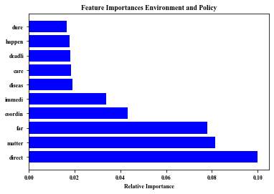

In conclusion, the good news is that the environment is indeed partly recovering during this time. However, the bad news is that the benefits from cleaner air to birdsong newly audible as cars and planes went quiet may be temporary. The best way to keep this good change going is to unite with the world, take the world’s strength to innovate protection measures, and implement these measures with perseverance.