Covid-19 death

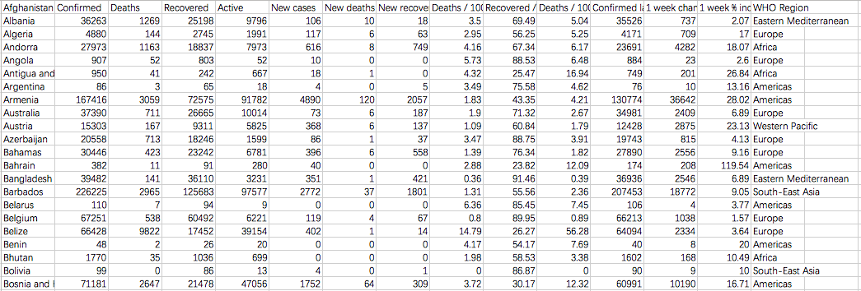

<https://www.kaggle.com/imdevskp/corona-virus-report?select=covid_19_clean_complete.csv>

The COVID-19 Air Quality Worldwide Data

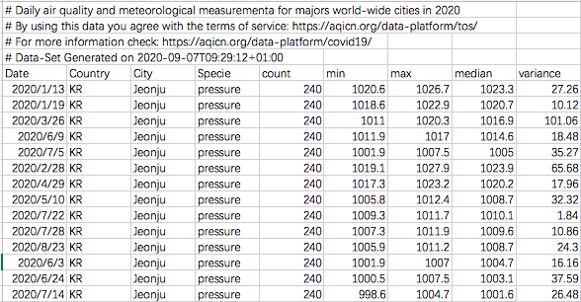

<https://aqicn.org/data-platform/covid19/verify/ea74fbf2-527f-4735-a8cc-124a9cf02c8e>

water quality in England

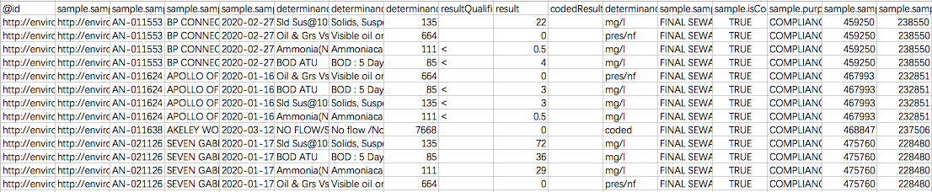

<https://environment.data.gov.uk/water-quality/view/download/new>

water quality in USA

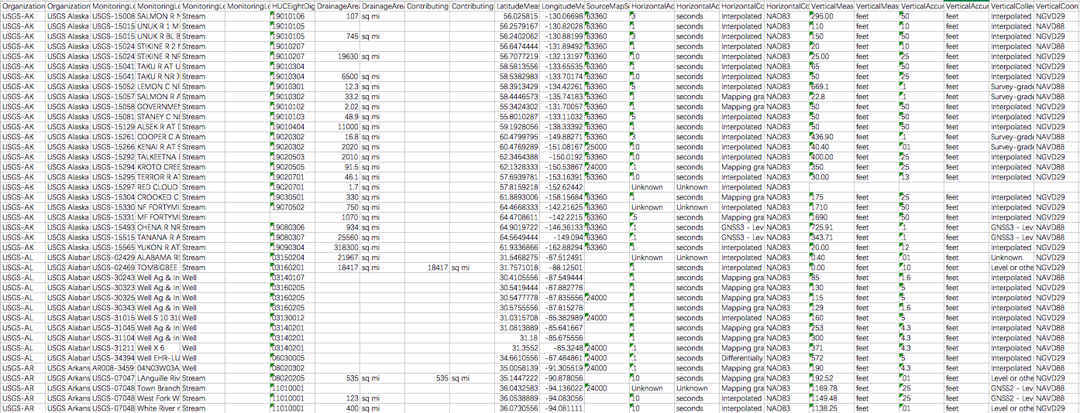

<https://www.waterqualitydata.us/portal/#countrycode=US&startDateLo=01-01-2020&startDateHi=09-07-2020&mimeType=xlsx>

water quality in Australia

<https://data.sa.gov.au/data/api/1/util/snippet/api_info.html?resource_id=92501fd8-0327-437c-99e0-7a24a9c03053>

<https://docs.ckan.org/en/latest/api/index.html>

Water Quality performance results July 2020

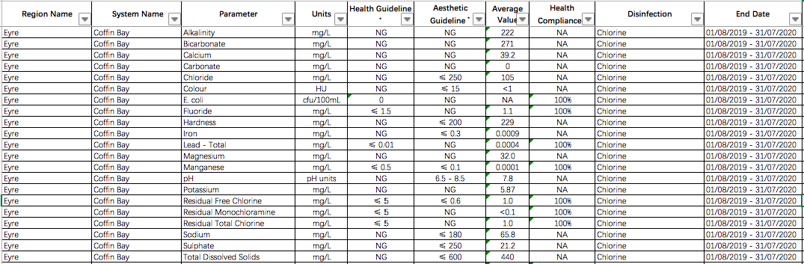

Water Quality performance results June 2020

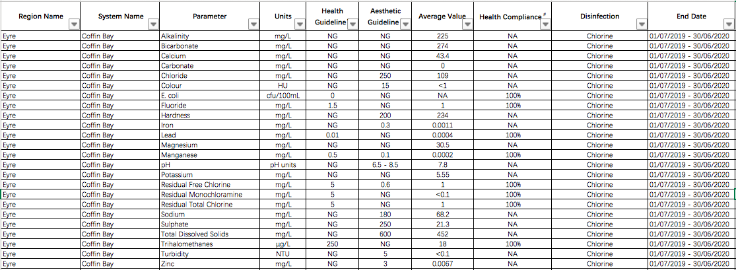

Water Quality performance results May 2020

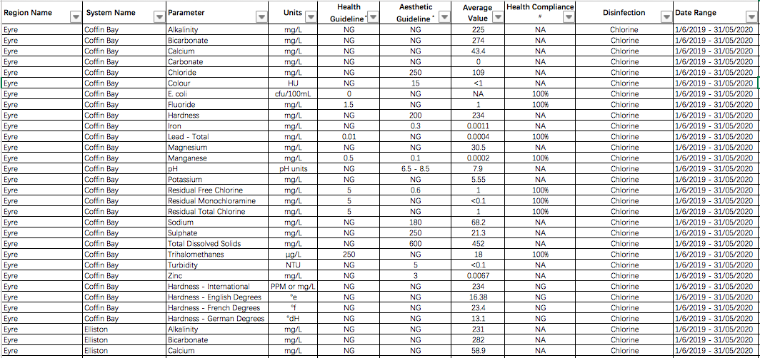

Water Quality performance results April 2020

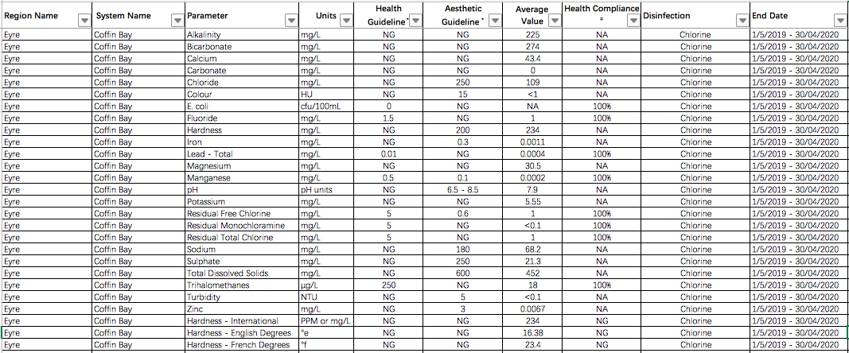

Water Quality performance results March 2020

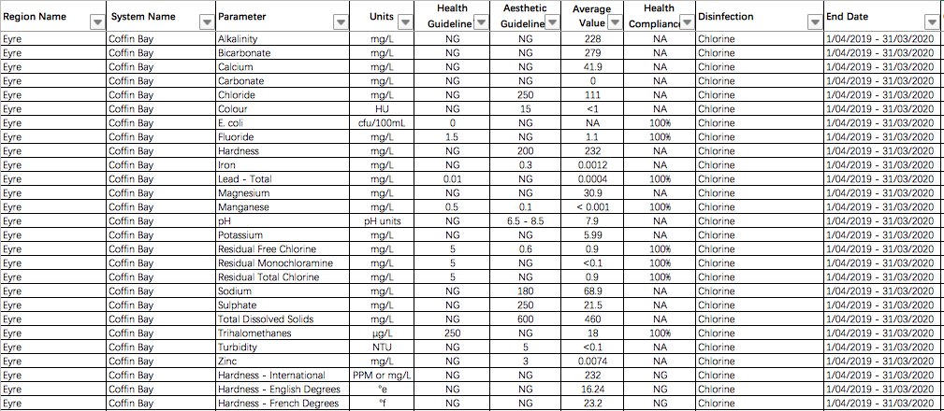

Water Quality performance results February 2020

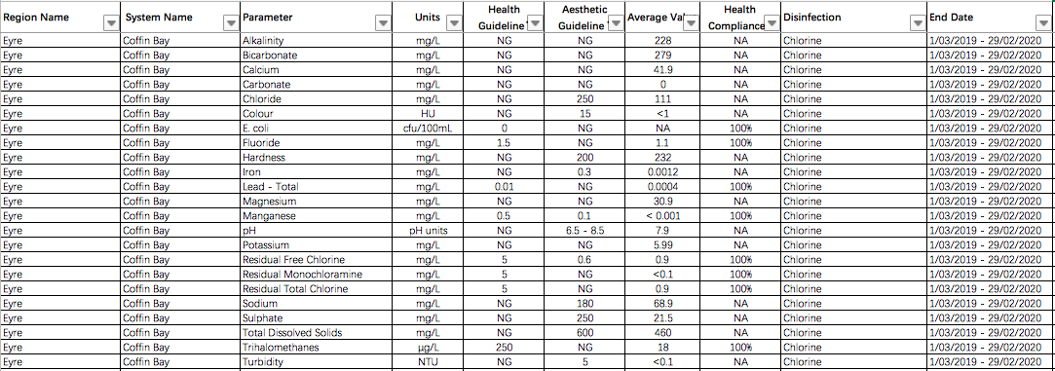

Water Quality performance results January 2020

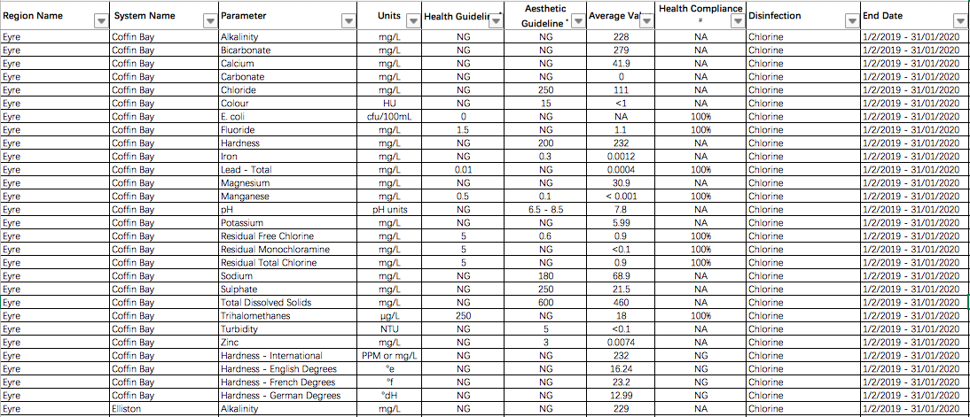

water quality in Egypt

water quality in China—text data

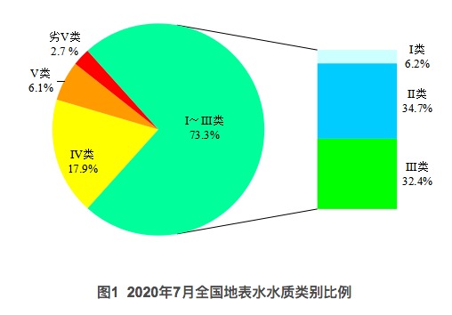

<https://www.mee.gov.cn/xxgk2018/xxgk/xxgk15/202008/t20200814_793708.html>

The COVID-19 weather Worldwide Data

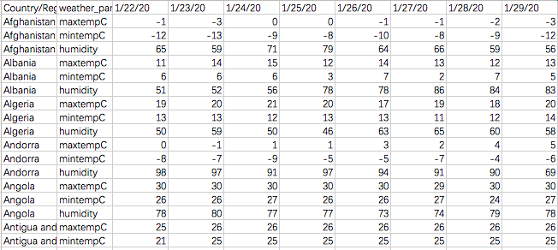

<https://www.kaggle.com/ksudhir/weather-data-countries-covid19>