# Spring Boot项目创建步骤

## 安装STS开发软件

## 创建项目：

右击-new -other

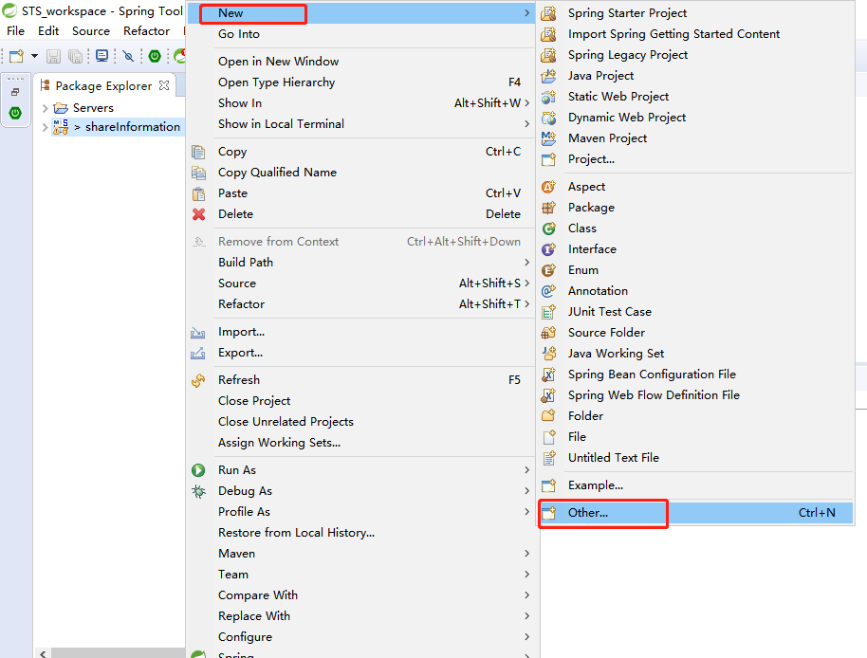

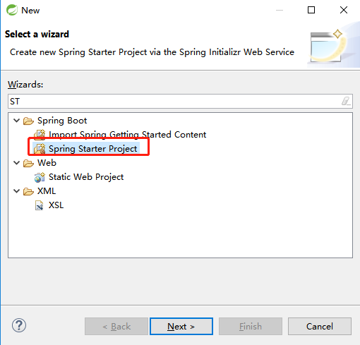

注意：要联网。不然项目出不来，如下图：

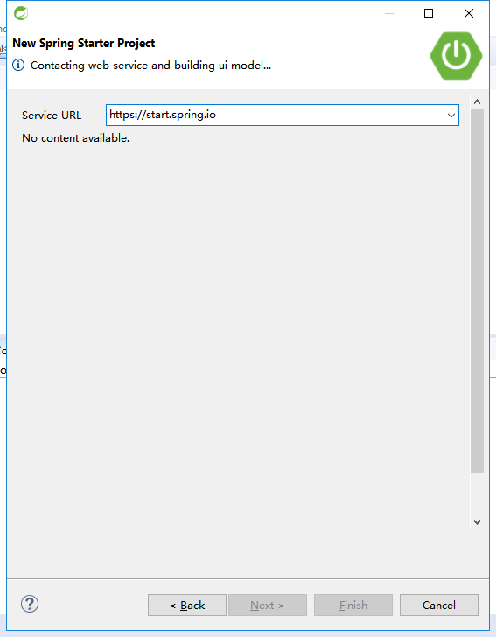

正常的如下图：

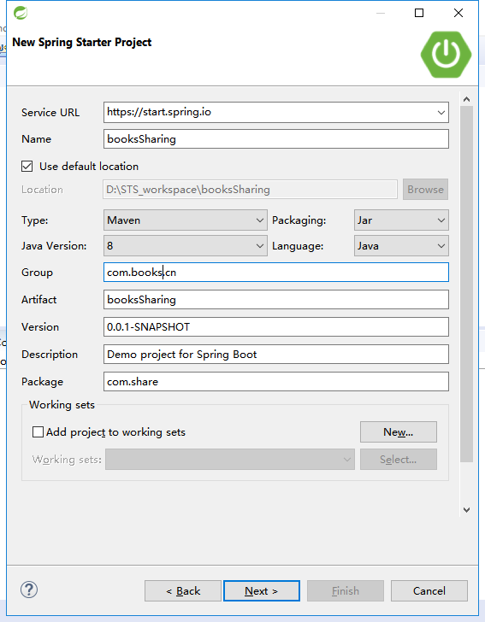

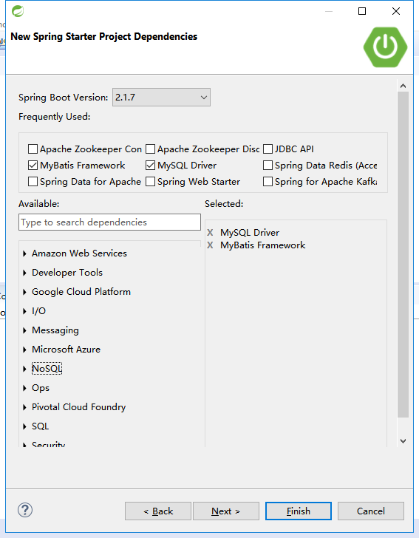

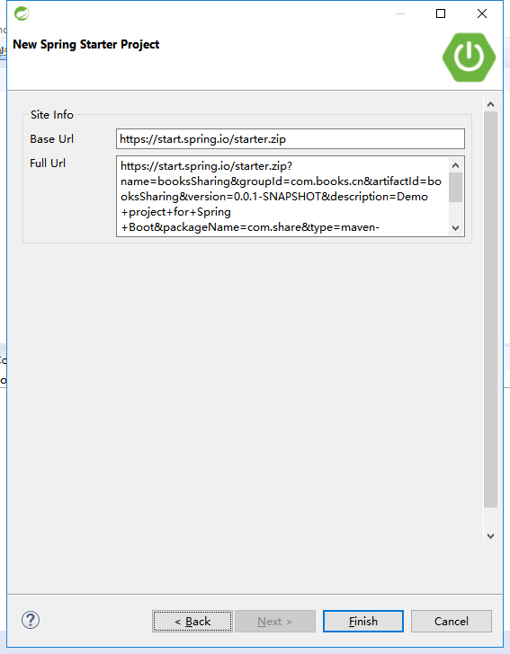

## 问题解决：

### unknown error

成功搭建成功后，查看pom.xml有一个 Unknown error的异常：

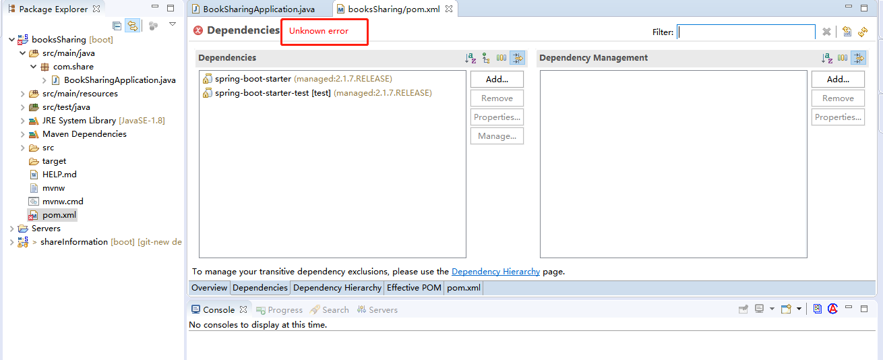

解决方法：添加如下：

|  |
| --- |
| <maven-jar-plugin.version>3.1.1</maven-jar-plugin.version> |

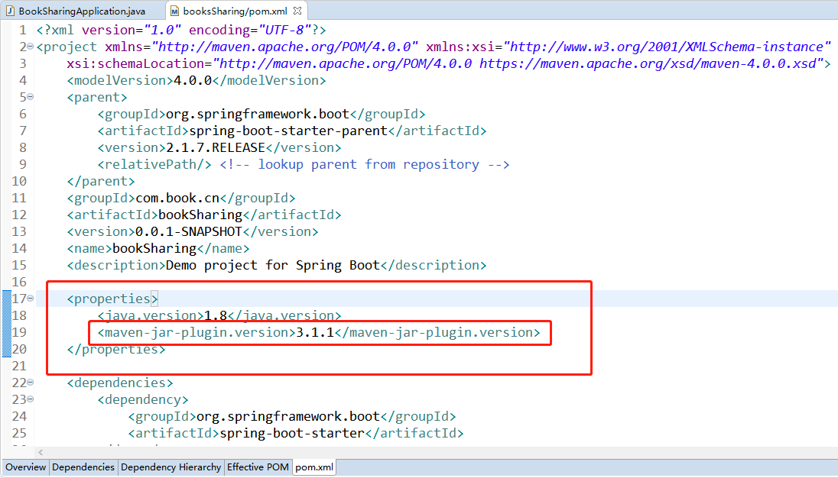

## pom.xml

|  |
| --- |
| <?xml version=*"1.0"* encoding=*"UTF-8"*?>  <project xmlns=*"http://maven.apache.org/POM/4.0.0"* xmlns:xsi=*"http://www.w3.org/2001/XMLSchema-instance"*  xsi:schemaLocation=*"http://maven.apache.org/POM/4.0.0 https://maven.apache.org/xsd/maven-4.0.0.xsd"*>  <modelVersion>4.0.0</modelVersion>  <parent>  <groupId>org.springframework.boot</groupId>  <artifactId>spring-boot-starter-parent</artifactId>  <version>2.1.7.RELEASE</version>  <relativePath/> <!-- lookup parent from repository -->  </parent>  <groupId>com.book.cn</groupId>  <artifactId>bookSharing</artifactId>  <version>0.0.1-SNAPSHOT</version>  <name>bookSharing</name>  <description>Demo project for Spring Boot</description>  <properties>  <java.version>1.8</java.version>  <maven-jar-plugin.version>3.1.1</maven-jar-plugin.version>  </properties>  <dependencies>  <dependency>  <groupId>org.springframework.boot</groupId>  <artifactId>spring-boot-starter-web</artifactId>  </dependency>    <!-- https://mvnrepository.com -->  <!-- 添加MongoDB的依赖配置 -->  <dependency>  <groupId>org.springframework.boot</groupId>  <artifactId>spring-boot-starter-data-mongodb</artifactId>  </dependency>  <dependency>  <groupId>mysql</groupId>  <artifactId>mysql-connector-java</artifactId>  <scope>runtime</scope>  </dependency>  <dependency>  <groupId>org.springframework.boot</groupId>  <artifactId>spring-boot-starter-jdbc</artifactId>  </dependency>  <dependency>  <groupId>org.springframework.boot</groupId>  <artifactId>spring-boot-starter-test</artifactId>  <scope>test</scope>  </dependency>  <dependency>  <groupId>com.baomidou</groupId>  <artifactId>mybatis-plus-boot-starter</artifactId>  <version>2.3</version>  </dependency>  <!-- mybatisplus与springboot整合 -->  <dependency>  <groupId>com.baomidou</groupId>  <artifactId>mybatisplus-spring-boot-starter</artifactId>  <version>1.0.5</version>  </dependency>  <!-- MP 核心库 -->  <dependency>  <groupId>com.baomidou</groupId>  <artifactId>mybatis-plus</artifactId>  <version>2.1.8</version>  </dependency>  <dependency>  <groupId>org.mybatis.spring.boot</groupId>  <artifactId>mybatis-spring-boot-starter</artifactId>  <version>2.0.1</version>  </dependency>  <!-- 模板引擎 代码生成 -->  <dependency>  <groupId>org.apache.velocity</groupId>  <artifactId>velocity</artifactId>  <version>1.7</version>  </dependency>  <!-- Thymeleaf组件-->  <dependency>  <groupId>org.springframework.boot</groupId>  <artifactId>spring-boot-starter-thymeleaf</artifactId>  </dependency>  <!-- 解决：org.apache.ibatis.binding.BindingException: -->  <dependency>  <groupId>org.springframework.boot</groupId>  <artifactId>spring-boot-starter-actuator</artifactId>  </dependency>  <!-- 解决：org.apache.ibatis.binding.BindingException: end -->  <!-- 添加json解析 -->  <dependency>  <groupId>org.json</groupId>  <artifactId>json</artifactId>  <version>20180130</version>  </dependency>  <!-- 添加json解析 end -->    <!-- 微信分享 start -->  <!-- com.alibaba.fastjson.JSONObject -->  <dependency>  <groupId>com.alibaba</groupId>  <artifactId>fastjson</artifactId>  <version>1.2.58</version>  </dependency>  <!-- StringUtils.join -->  <dependency>  <groupId>org.apache.commons</groupId>  <artifactId>commons-lang3</artifactId>  <version>3.8.1</version>  </dependency>  <!-- DigestUtils.sha1Hex -->  <dependency>  <groupId>commons-codec</groupId>  <artifactId>commons-codec</artifactId>  <version>1.10</version>  </dependency>  <!-- https://mvnrepository.com/artifact/commons-beanutils/commons-beanutils -->  <dependency>  <groupId>commons-beanutils</groupId>  <artifactId>commons-beanutils</artifactId>  <version>1.9.2</version>  </dependency>  <!-- https://mvnrepository.com/artifact/org.apache.commons/commons-collections4 -->  <dependency>  <groupId>org.apache.commons</groupId>  <artifactId>commons-collections4</artifactId>  <version>4.1</version>  </dependency>  <!-- https://mvnrepository.com/artifact/commons-logging/commons-logging -->  <dependency>  <groupId>commons-logging</groupId>  <artifactId>commons-logging</artifactId>  <version>1.2</version>  </dependency>  <!-- https://mvnrepository.com/artifact/net.sf.ezmorph/ezmorph -->  <dependency>  <groupId>net.sf.ezmorph</groupId>  <artifactId>ezmorph</artifactId>  <version>1.0.6</version>  </dependency>  <!-- https://mvnrepository.com/artifact/net.sf.json-lib/json-lib -->  <dependency>  <groupId>net.sf.json-lib</groupId>  <artifactId>json-lib</artifactId>  <version>2.4</version>  <classifier>jdk15</classifier> <!-- 看这里，去maven仓库找加载这个包的时候，是没有这句话的，这句话，一定要加，要不然，也是会报错的，还有一个就是，一定要加 jdk15 加其他的也不行，不要问我为什么，我也不知到 -->  </dependency>  </dependencies>  <build>  <plugins>  <plugin>  <groupId>org.springframework.boot</groupId>  <artifactId>spring-boot-maven-plugin</artifactId>  </plugin>  </plugins>  </build>  </project> |

**修改后的xml**

**只能启动tomcat了。。。。**

|  |
| --- |
| <?xml version=*"1.0"* encoding=*"UTF-8"*?>  <project xmlns=*"http://maven.apache.org/POM/4.0.0"* xmlns:xsi=*"http://www.w3.org/2001/XMLSchema-instance"*  xsi:schemaLocation=*"http://maven.apache.org/POM/4.0.0 https://maven.apache.org/xsd/maven-4.0.0.xsd"*>  <modelVersion>4.0.0</modelVersion>  <parent>  <groupId>org.springframework.boot</groupId>  <artifactId>spring-boot-starter-parent</artifactId>  <version>2.1.7.RELEASE</version>  <relativePath/> <!-- lookup parent from repository -->  </parent>  <groupId>com.book.cn</groupId>  <artifactId>bookSharing</artifactId>  <version>0.0.1-SNAPSHOT</version>  <packaging>war</packaging>    <name>bookSharing</name>  <description>Demo project for Spring Boot</description>      <properties>  <java.version>1.8</java.version>  <maven-jar-plugin.version>3.1.1</maven-jar-plugin.version>  </properties>  <dependencies>  <!--支持web模块-->  <dependency>  <groupId>org.springframework.boot</groupId>  <artifactId>spring-boot-starter-web</artifactId>  </dependency>    <!-- https://mvnrepository.com -->  <!-- 添加MongoDB的依赖配置 -->  <dependency>  <groupId>org.springframework.boot</groupId>  <artifactId>spring-boot-starter-data-mongodb</artifactId>  </dependency>  <dependency>  <groupId>mysql</groupId>  <artifactId>mysql-connector-java</artifactId>  <scope>runtime</scope>  </dependency>  <dependency>  <groupId>org.springframework.boot</groupId>  <artifactId>spring-boot-starter-jdbc</artifactId>  </dependency>  <dependency>  <groupId>org.springframework.boot</groupId>  <artifactId>spring-boot-starter-test</artifactId>  <scope>test</scope>  </dependency>  <dependency>  <groupId>com.baomidou</groupId>  <artifactId>mybatis-plus-boot-starter</artifactId>  <version>2.3</version>  </dependency>  <!-- mybatisplus与springboot整合 -->  <dependency>  <groupId>com.baomidou</groupId>  <artifactId>mybatisplus-spring-boot-starter</artifactId>  <version>1.0.5</version>  </dependency>  <!-- MP 核心库 -->  <dependency>  <groupId>com.baomidou</groupId>  <artifactId>mybatis-plus</artifactId>  <version>2.1.8</version>  </dependency>  <dependency>  <groupId>org.mybatis.spring.boot</groupId>  <artifactId>mybatis-spring-boot-starter</artifactId>  <version>2.0.1</version>  </dependency>  <!-- 模板引擎 代码生成 -->  <dependency>  <groupId>org.apache.velocity</groupId>  <artifactId>velocity</artifactId>  <version>1.7</version>  </dependency>  <!-- Thymeleaf组件-->  <dependency>  <groupId>org.springframework.boot</groupId>  <artifactId>spring-boot-starter-thymeleaf</artifactId>  </dependency>  <!-- 解决：org.apache.ibatis.binding.BindingException: -->  <dependency>  <groupId>org.springframework.boot</groupId>  <artifactId>spring-boot-starter-actuator</artifactId>  </dependency>  <!-- 解决：org.apache.ibatis.binding.BindingException: end -->  <!--引入NekoHTML，配合spring.thymeleaf.mode=LEGACYHTML5使用，使Thymeleaf 可以解析非严格html格式的文档-->  <dependency>  <groupId>net.sourceforge.nekohtml</groupId>  <artifactId>nekohtml</artifactId>  <version>1.9.22</version>  </dependency>  <!-- 添加json解析 -->  <dependency>  <groupId>org.json</groupId>  <artifactId>json</artifactId>  <version>20180130</version>  </dependency>  <!-- 添加json解析 end -->    <!-- 微信分享 start -->  <!-- com.alibaba.fastjson.JSONObject -->  <dependency>  <groupId>com.alibaba</groupId>  <artifactId>fastjson</artifactId>  <version>1.2.58</version>  </dependency>  <!-- StringUtils.join -->  <dependency>  <groupId>org.apache.commons</groupId>  <artifactId>commons-lang3</artifactId>  <version>3.8.1</version>  </dependency>  <!-- DigestUtils.sha1Hex -->  <dependency>  <groupId>commons-codec</groupId>  <artifactId>commons-codec</artifactId>  <version>1.10</version>  </dependency>  <!-- https://mvnrepository.com/artifact/commons-beanutils/commons-beanutils -->  <dependency>  <groupId>commons-beanutils</groupId>  <artifactId>commons-beanutils</artifactId>  <version>1.9.2</version>  </dependency>  <!-- https://mvnrepository.com/artifact/org.apache.commons/commons-collections4 -->  <dependency>  <groupId>org.apache.commons</groupId>  <artifactId>commons-collections4</artifactId>  <version>4.1</version>  </dependency>  <!-- https://mvnrepository.com/artifact/commons-logging/commons-logging -->  <dependency>  <groupId>commons-logging</groupId>  <artifactId>commons-logging</artifactId>  <version>1.2</version>  </dependency>  <!-- https://mvnrepository.com/artifact/net.sf.ezmorph/ezmorph -->  <dependency>  <groupId>net.sf.ezmorph</groupId>  <artifactId>ezmorph</artifactId>  <version>1.0.6</version>  </dependency>  <!-- https://mvnrepository.com/artifact/net.sf.json-lib/json-lib -->  <dependency>  <groupId>net.sf.json-lib</groupId>  <artifactId>json-lib</artifactId>  <version>2.4</version>  <classifier>jdk15</classifier> <!-- 看这里，去maven仓库找加载这个包的时候，是没有这句话的，这句话，一定要加，要不然，也是会报错的，还有一个就是，一定要加 jdk15 加其他的也不行，不要问我为什么，我也不知到 -->  </dependency>      <!--jsp页面使用jstl标签 -->  <dependency>  <groupId>javax.servlet</groupId>  <artifactId>jstl</artifactId>  </dependency>    <!--用于编译jsp -->  <dependency>  <groupId>javax.servlet</groupId>  <artifactId>javax.servlet-api</artifactId>  <version>3.1.0</version>  <scope>provided</scope>  </dependency>  <!-- 外部使用tomcat 可访问jsp页面 -->  <dependency>  <groupId>org.apache.tomcat.embed</groupId>  <artifactId>tomcat-embed-jasper</artifactId>  <scope>provided</scope>  </dependency>    </dependencies>  <build>  <plugins>  <plugin>  <groupId>org.springframework.boot</groupId>  <artifactId>spring-boot-maven-plugin</artifactId>  </plugin>  <!--过滤单元测试不通过，maven打包就停止编译 -->  <plugin>  <groupId>org.apache.maven.plugins</groupId>  <artifactId>maven-surefire-plugin</artifactId>  <configuration>  <testFailureIgnore>true</testFailureIgnore>  </configuration>  </plugin>  </plugins>  </build>  </project> |

## 构建项目

### 问题：**构建项目，build失败。**

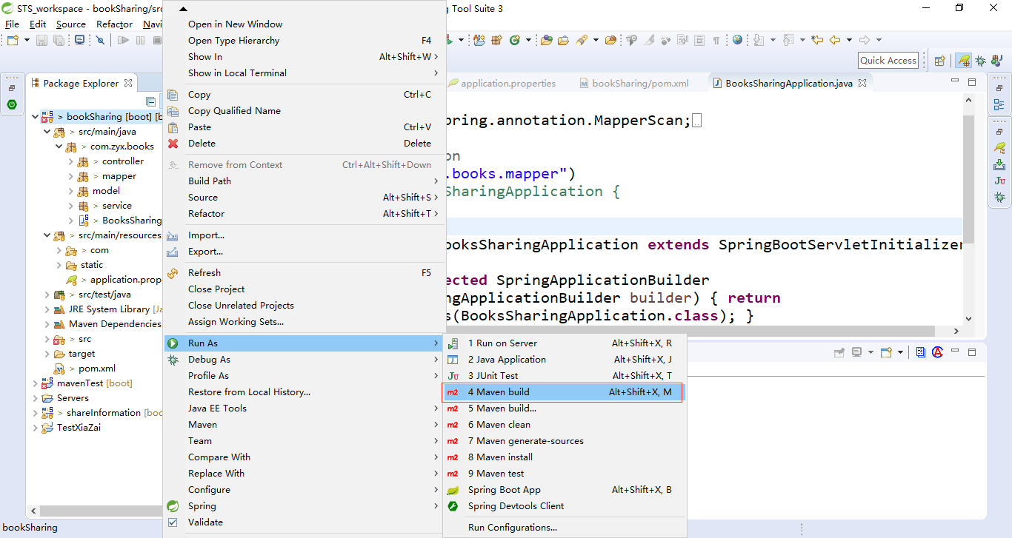

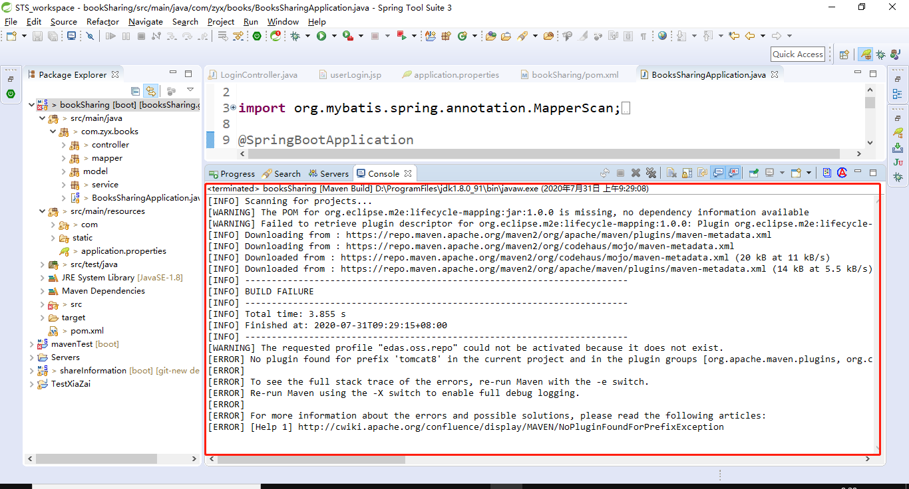

### 解决方案：

Step1：clean你的工程：顶部菜单【Project】-->【Clean】

Step2：选中工程，右键菜单【Maven】-->【Update Project】，然后等等等等

Step3：选中工程，右键菜单【Run As】-->【Maven build】（选第二个maven build），【Goals】填：package

或者，忽略test的：【Goals】填：package -Dmaven.test.skip=true

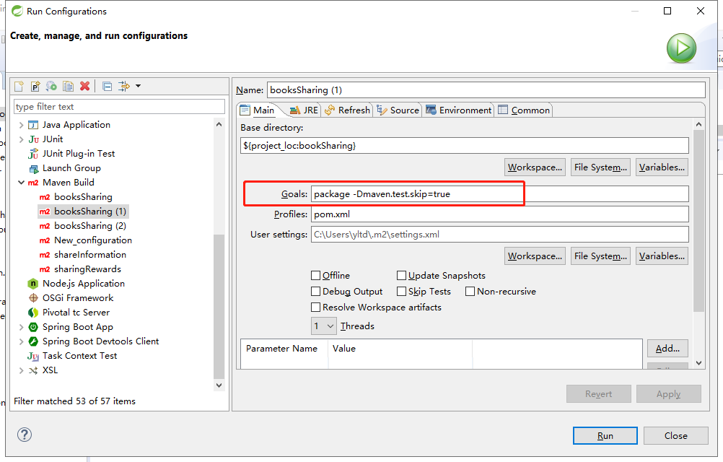

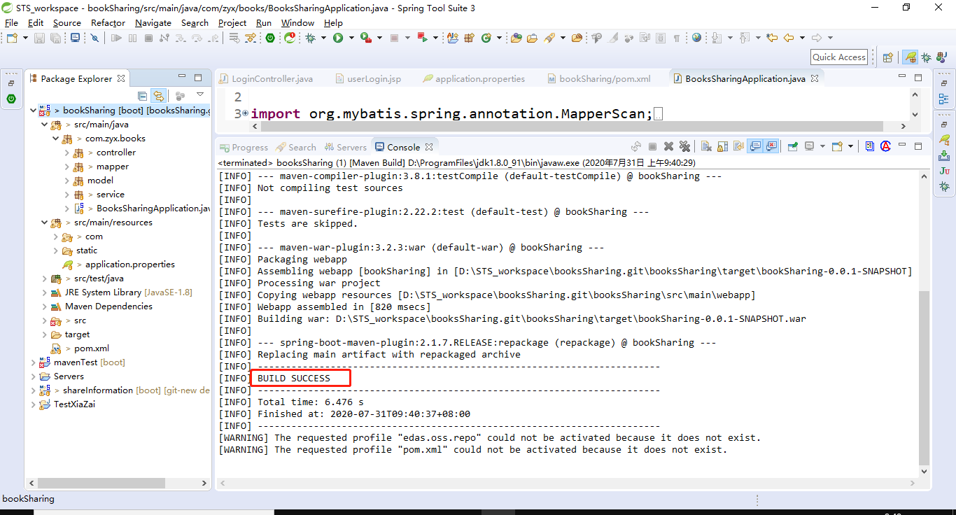

## 项目打包

### 问题：**Install 时 test包下报错：**

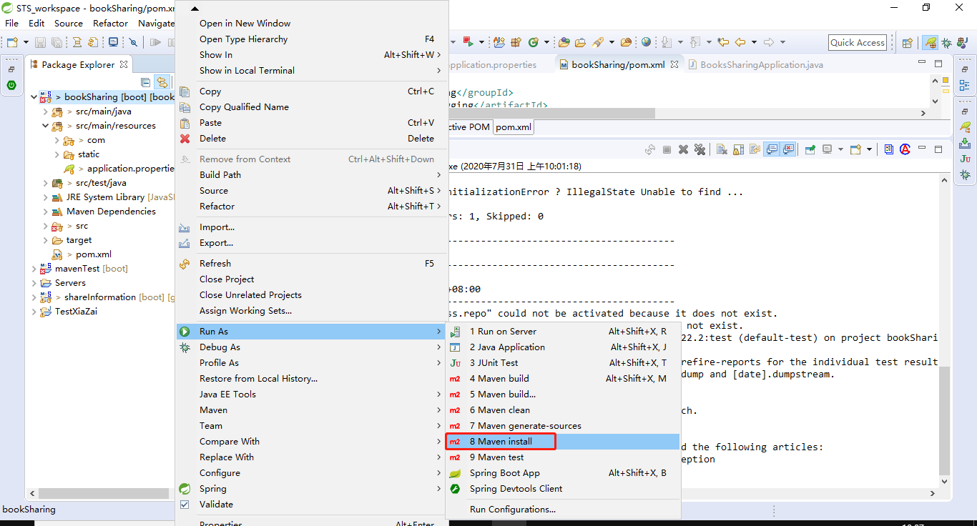

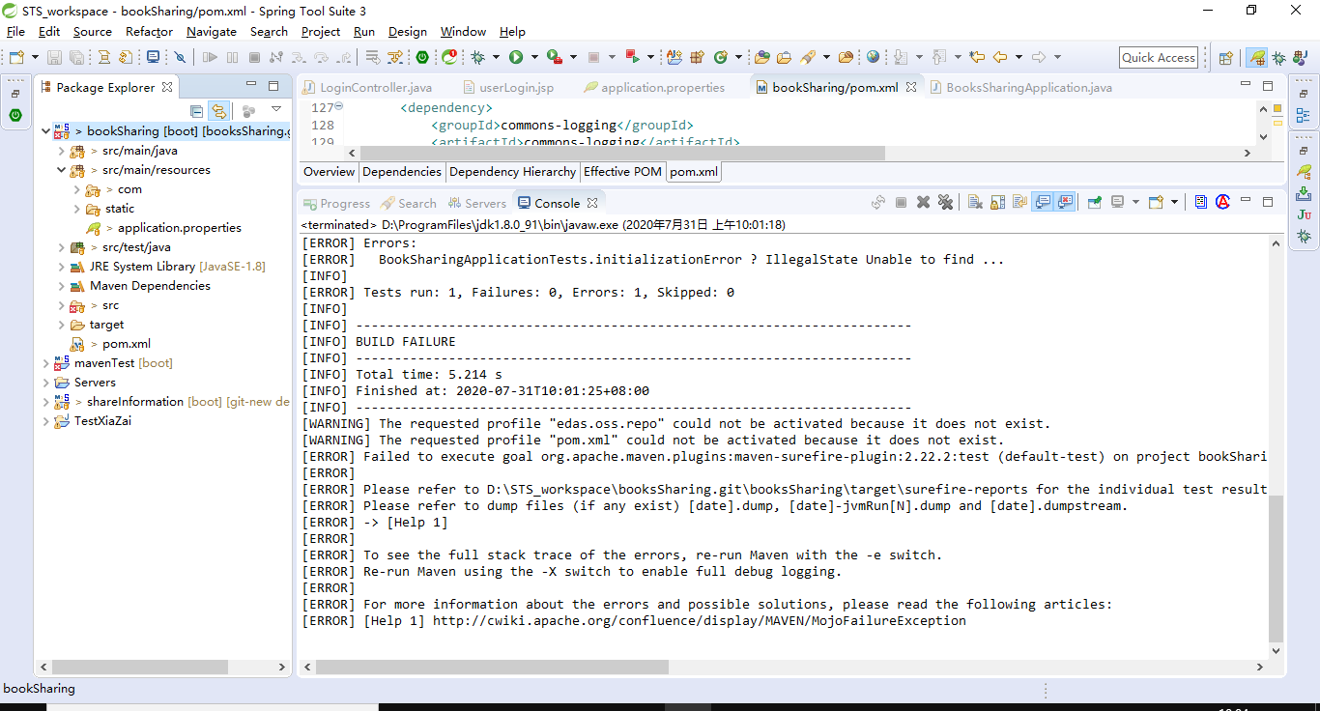

### 解决方案：

在pom.xml中配置过滤掉test

|  |
| --- |
| <!--过滤单元测试不通过，maven打包就停止编译 -->  <plugin>  <groupId>org.apache.maven.plugins</groupId>  <artifactId>maven-surefire-plugin</artifactId>  <configuration>  <testFailureIgnore>true</testFailureIgnore>  </configuration>  </plugin> |

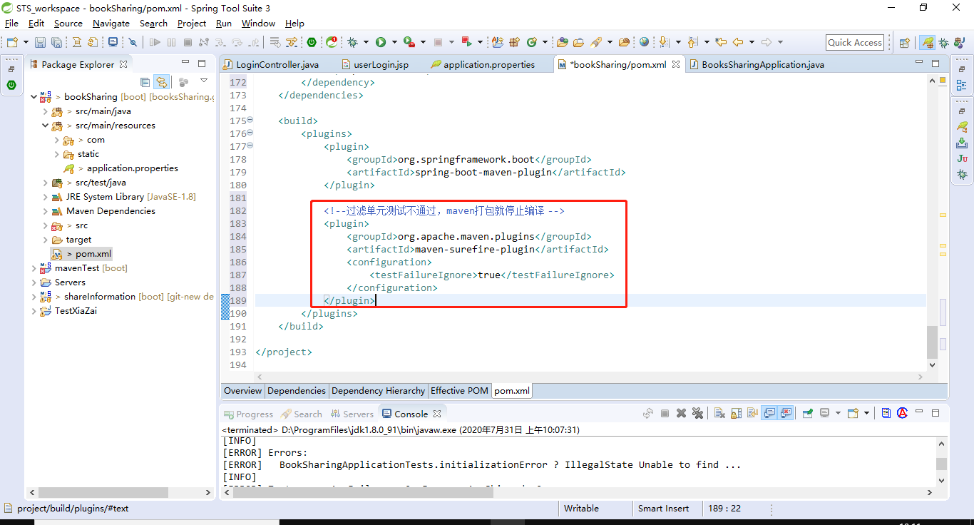

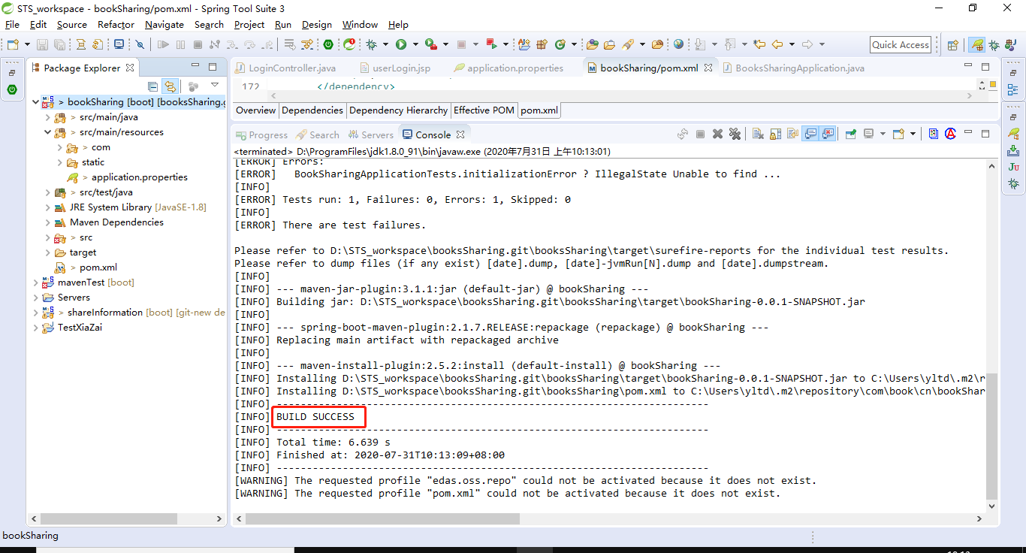

## 项目外启动tomcat

### 问题：**Project facet Cloud Foundry Standalone Application version 1.0 is not supported.**

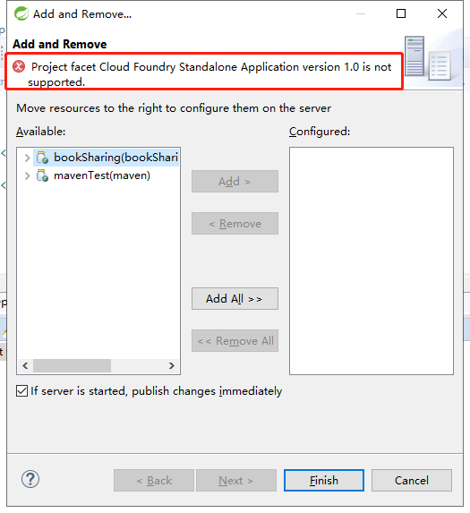

### 解决方案：

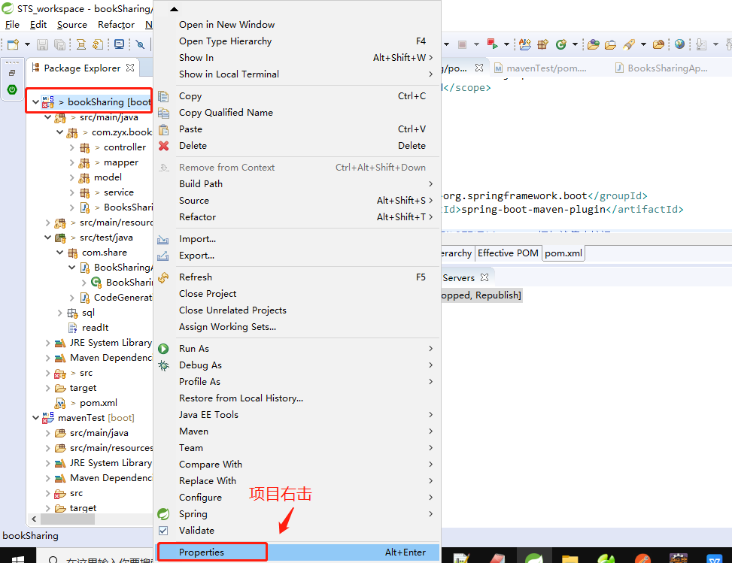 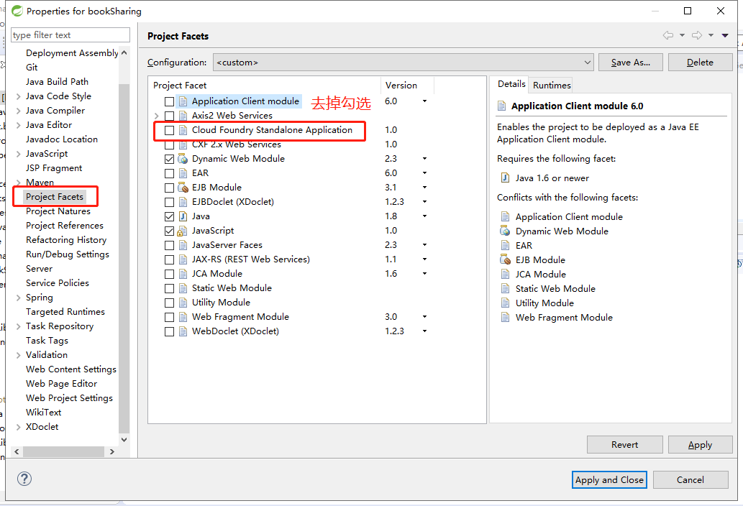

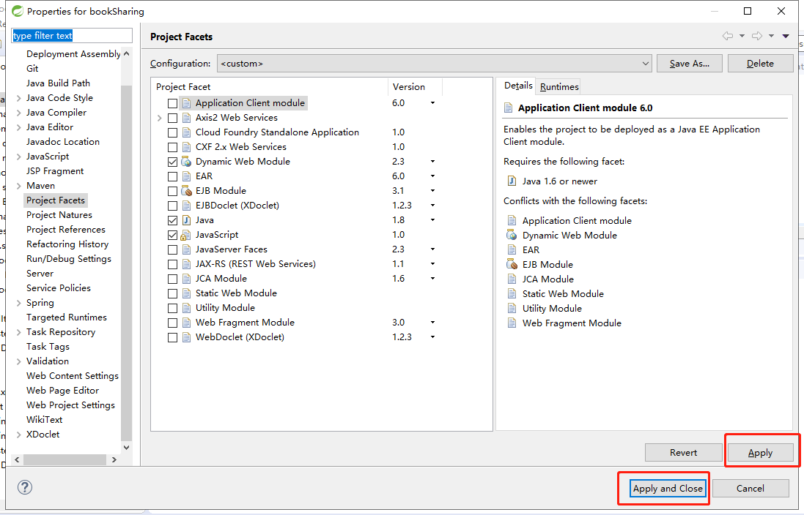

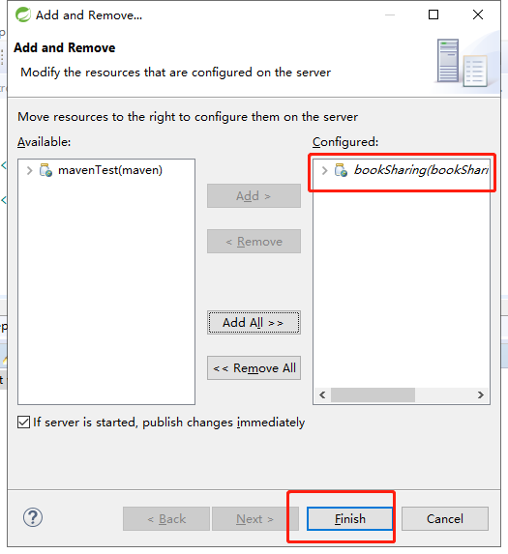

### 问题：**启动外部tomcat不加载项目**

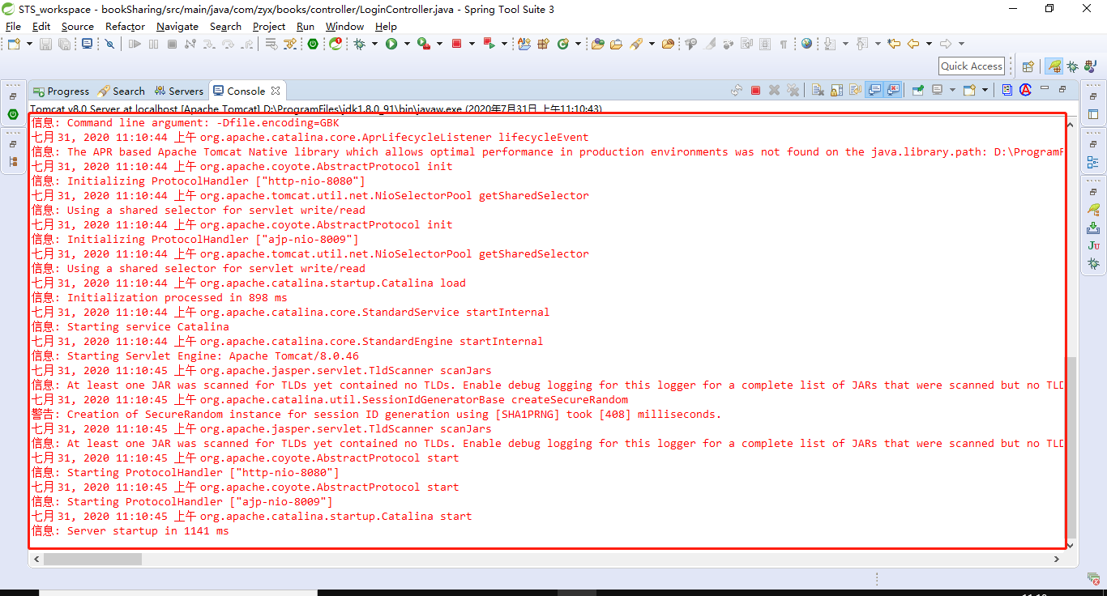

### 问题解决方案：

右击项目：properties - Deployment Assembly -add添加

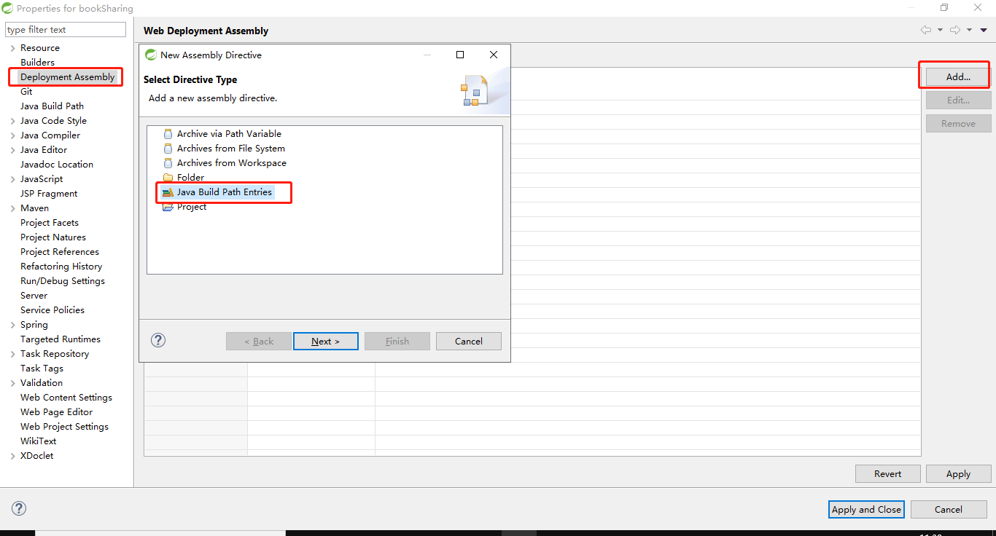

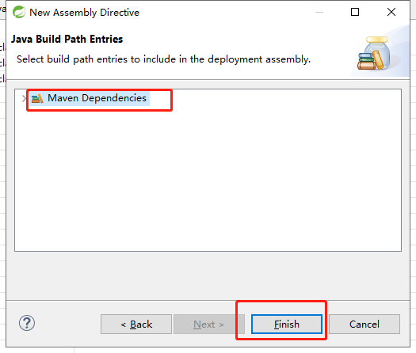

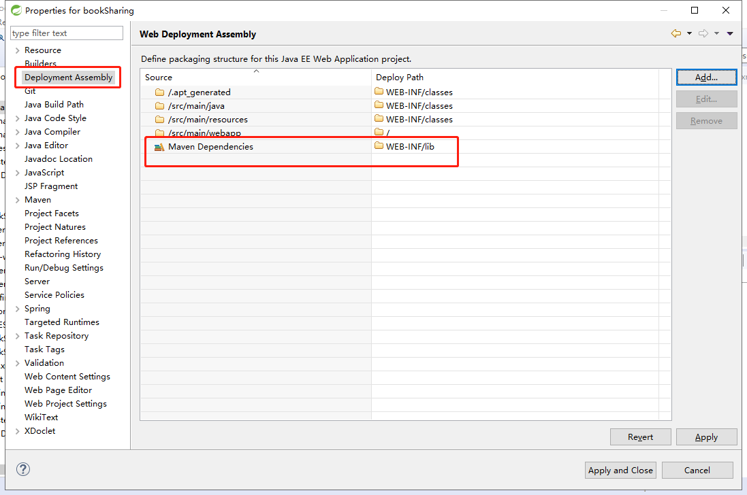

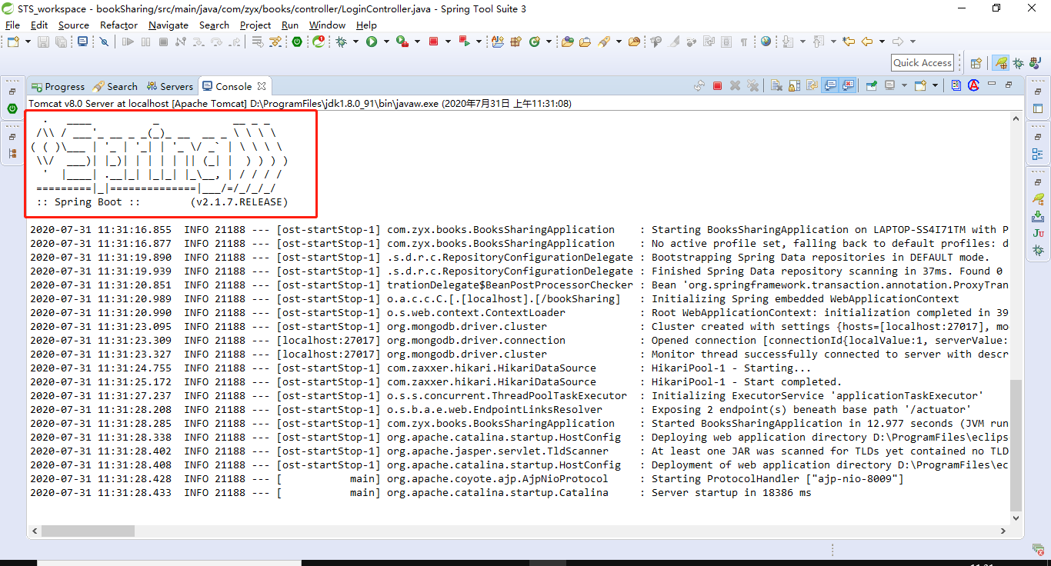

## 访问项目

### 问题：**2020-07-31 10:23:40.233 ERROR 3052 --- [nio-8080-exec-7]**

**o.a.c.c.C.[Tomcat].[localhost] : Exception Processing ErrorPage[errorCode=0, location=/error]**

**java.lang.NoSuchMethodError: javax.servlet.http.HttpServletRequest.getHttpServletMapping()Ljavax/servlet/http/HttpServletMapping;**

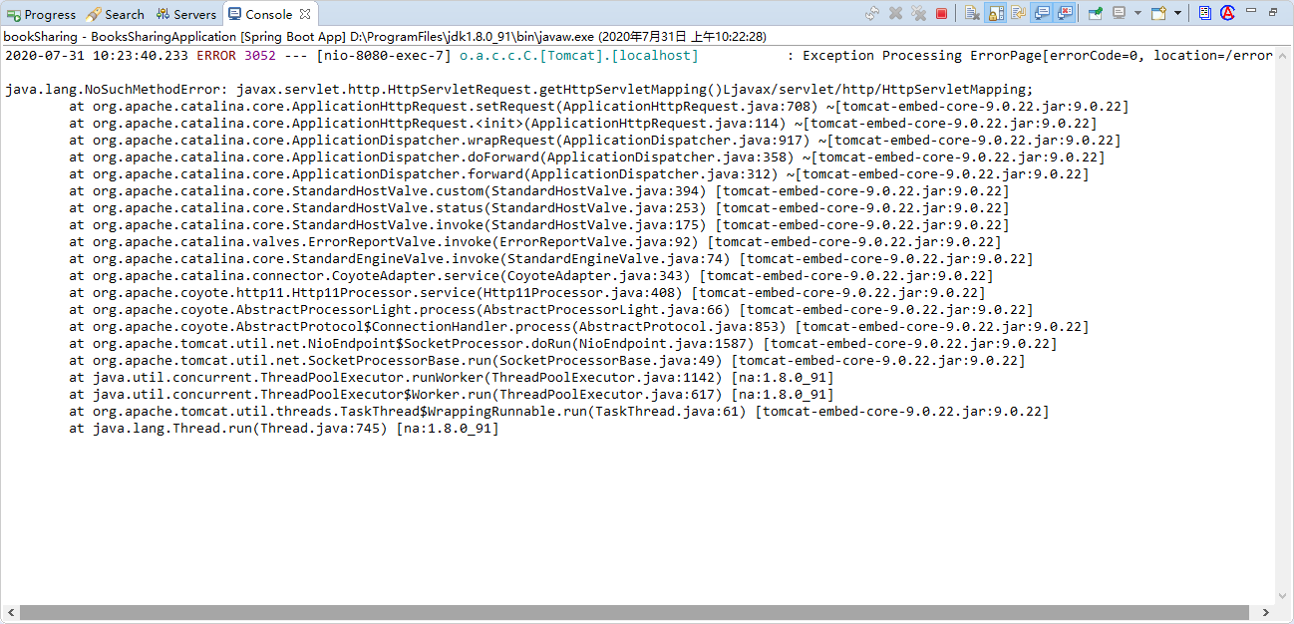

问题原因：

可能是访问后缀没写

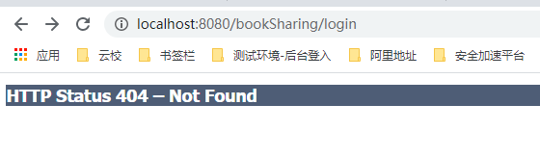

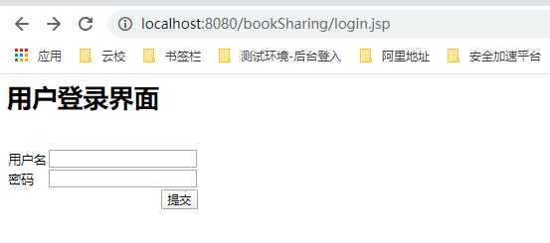

**[THYMELEAF][http-nio-8080-exec-7] Exception processing template "userLogin": Error resolving template [userLogin], template might not exist or might not be accessible by any of the configured Template Resolvers**

**org.thymeleaf.exceptions.TemplateInputException: Error resolving template [userLogin], template might not exist or might not be accessible by any of the configured Template Resolvers**

