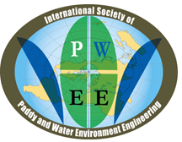
1st ANNOUNCEMENT: CALL FOR ABSTRACT

PAWEES 2017 International Conference
November 9—10, 2017
Taichung, Taiwan

AIMS AND SCOPES
The conference objective is to create an interactive platform for paddy and water environment related researchers, scientists, practitioners, policy makers and other professionals from Asia-Pacific Region and else around the world to share and present their novel advances, research findings, perspectives and experiences in response to, but not limited to, sustainable water and environmental management.

CONFERENCE THEMES
General session:
The conference pivots on the general theme “Sustainable Water and Environmental Management” accompanied with the following focal topics:
Topic 1 | Sustainable water use and ecologically sustainable development
Topic 2 | Development of rural society with water in Asia
Topic 3 | Sustainable paddy farming
Topic 4 | Integrated watershed management
Topic 5 | Droughts and flood disaster risk management
Student session:
“Sustainable Water and Environmental Management”

CALL FOR ABSTRACTS
Authors are invited to submit abstracts to the scientific committee of the conference. The notification of acceptance will be dispatched after the decision making from the scientific committee. Student sessions will be operated separately.
Submission:
The abstract submission process for PAWEES 2017 will be through an online submission portal. Submitters are requested to create an account and submit an abstract for review according to the Registration steps on this website.
Oral presentation:
Time allotment for each oral presentation will be 15 minutes, in which 10 minutes for presentation and 5 minutes for Q & A are suggested, and session rooms are equipped with standard PowerPoint presentation facilities.
Poster presentation:
Poster boards are 8' high with a surface of 4' x 6' and are placed in rows in a poster room. Presenters are asked to be at their assigned poster board during the entire length of the poster session.

LANGUAGE
The official language of the conference will be English. All abstracts and posters should be submitted in English.

IMPORTANT DATES
Abstract Submission: August 31, 2017
Notification of Acceptance: September 30, 2017
Registration: before September 30, 2017

CONFERENCE TIME & VENUE
Time: November 9—10, 2017
Venue: Taichung, Taiwan

REGISTRATION FEES
International participants
The registration fees are USD 200 (NTD 6,400) for general members, and USD 100 (NTD 3,200) for students and accompanying persons. The registered delegates and participants shall be provided during the Conference with a conference kit (programs and proceedings), official snacks, lunches and reception dinner, attendance in the opening program, and a field trip. Only payments and issuance of receipts will be done on site.
Local participants
The registration fee is NTD 2600 (NTD 600 for the participation in the Conference only). Participants are requested to remit payments through postal order (郵政劃撥帳號：00114264；戶名：社團法人台灣農業工程學會) before 30 September, 2017. Issuance of receipts will be done on site or sent via email.

ORGANIZERS
International Society of Paddy and Water Environment Engineering (PAWEES)
Taiwan Agricultural Engineers Society (TAES)
Department of Bioenvironmental Systems Engineering, National Taiwan University (NTU)
Hydrotech Research Institute, National Taiwan University
Taichung Irrigation Association
Liugong Irrigation Association
Chising Irrigation Association
Council of Agriculture, Executive Yuan, Taiwan (COA)
Water Resources Agency, Ministry of Economic Affairs, Taiwan (WRA)
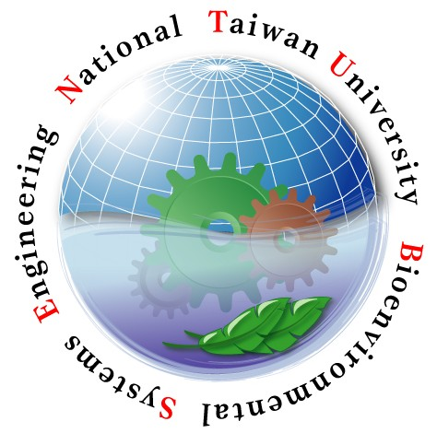



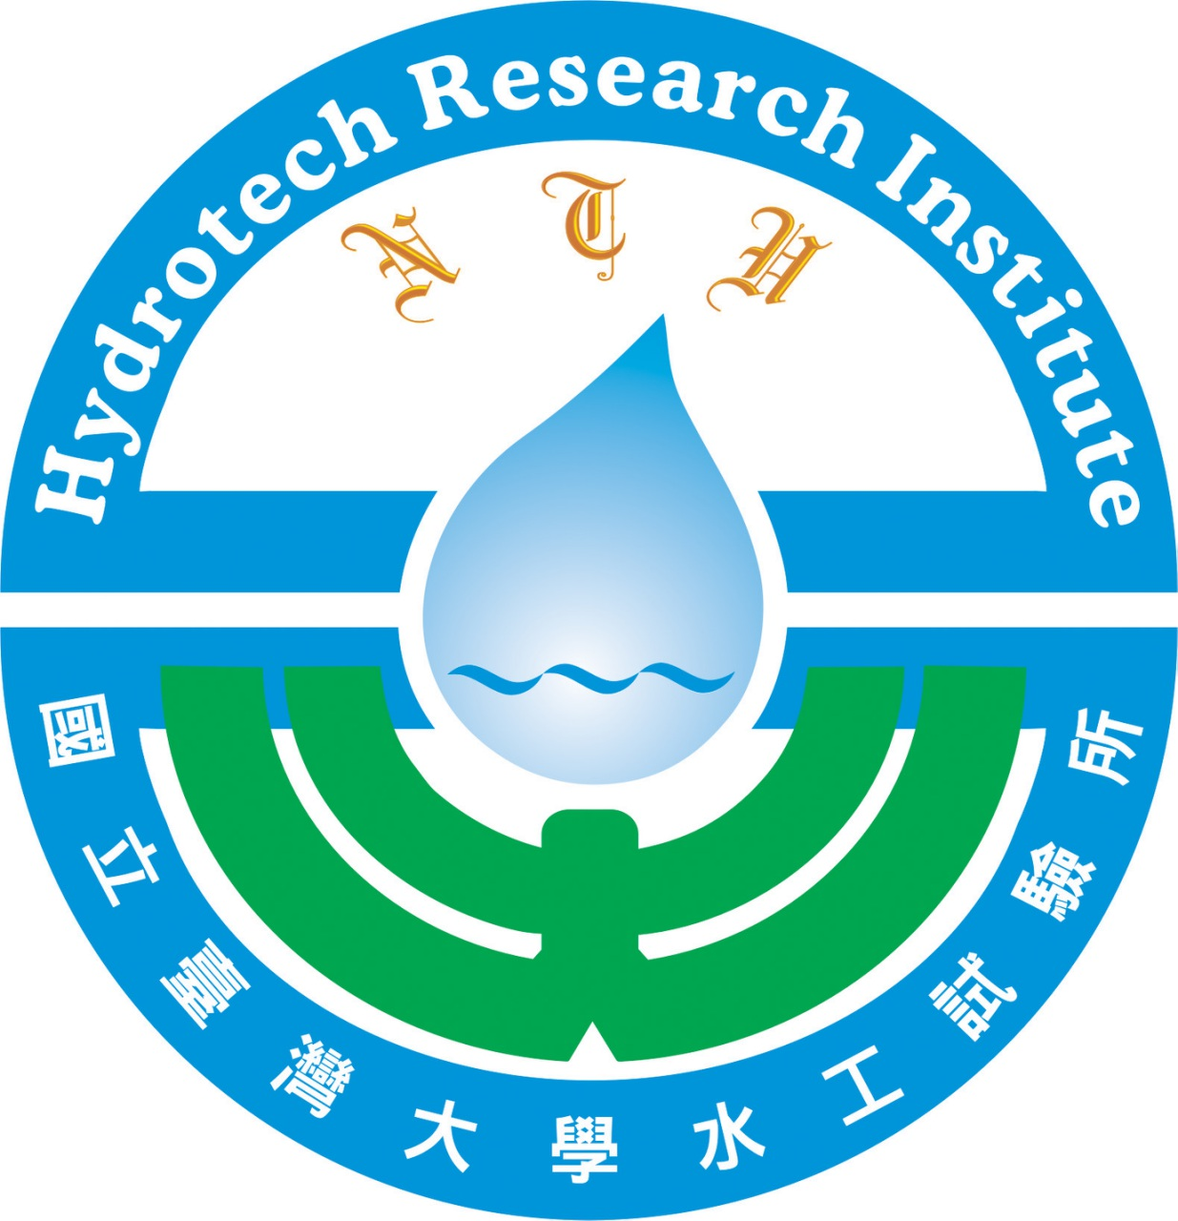
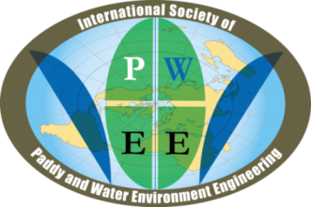
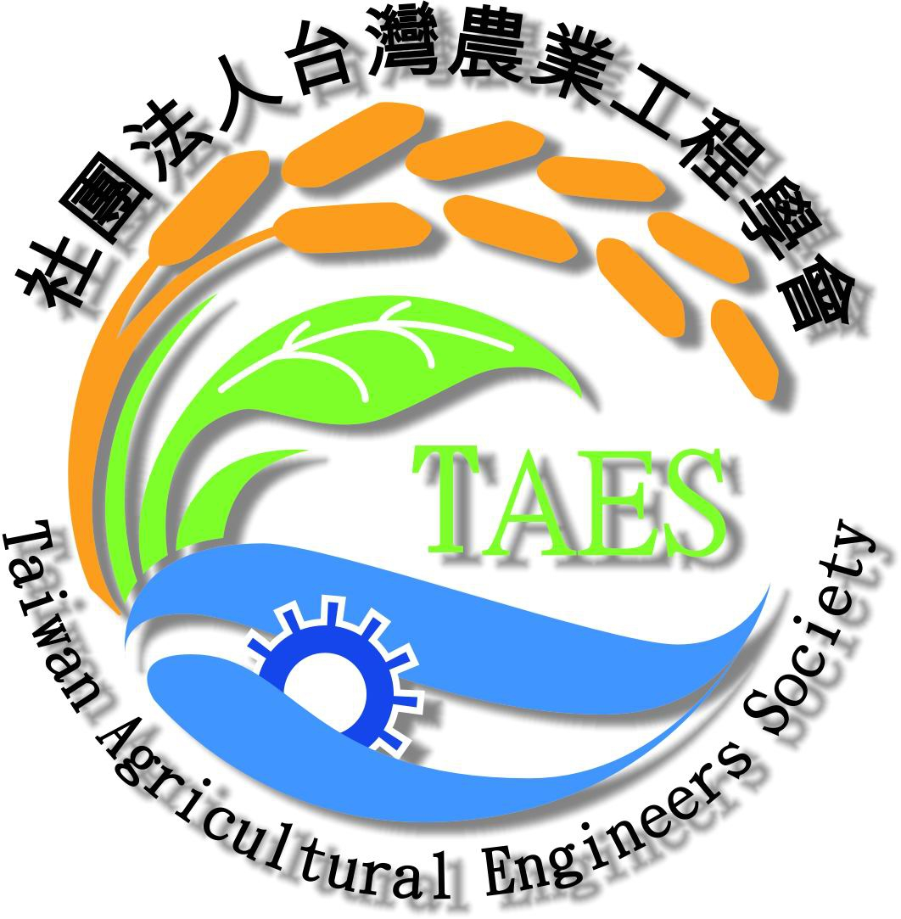


CONTACTS
Should any inquiry on submission, send it to:
Prof. Ke-Sheng Cheng,
pawees2017@gmail.com
Dept. of Bioenvironmental Systems Engineering, National Taiwan University, Taiwan

