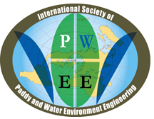
2nd ANNOUNCEMENT: CALL FOR ABSTRACT
https://pawees.info/

PAWEES 2017 International Conference
November 9—10, 2017
Taichung, Taiwan
CONFERENCE AIM AND SCOPE
The PAWEES 2017 International Conference aims to provide an interactive platform for researchers, practitioners, policy makers, and other professionals in the field of paddy and water environment from around the globe to present and share their novel advances, research findings, perspectives, and experiences to foster sustainable water and environmental management. The scope of the PAWEES 2017 Conference is on Sustainable Water and Environmental Management.
CONFERENCE THEMES
General session:
Topic 1: Sustainable development with respect to water and ecology
Topic 2: Harmonizing rural development with water resources management
Topic 3: Sustainable paddy farming
Topic 4: Integrated watershed management
Topic 5: Droughts and floods disaster risk management

Student session: “Sustainable Water and Environmental Management”

PRESENTATIONS
Oral presentation
Time allotment for each oral presentation will be 25 minutes, including 20 minutes for presentation and 5 minutes for Q & A. Session rooms are equipped with standard PowerPoint presentation facilities.
Poster presentation
All posters should be made in A1 size. Poster boards will be provided during the poster session.
LANGUAGE
The official language of the conference will be English. All abstracts and posters should be submitted in English.
IMPORTANT DATES
Abstract Submission Deadline: August 31, 2017
Notification of Acceptance: September 30, 2017
Registration Deadline: September 30, 2017
Registration Form is provided separately.
REGISTRATION FEES
International participants
The standard registration fee is 200 US dollars (or equivalently, 6,400 Taiwan dollars). For students and accompanying persons, the registration fee is 100 US dollars (or 3,200 Taiwan dollars). The registration fee covers conference kit (program book and proceedings), admission to opening ceremony, plenary sessions, scientific sessions, break refreshments, lunch, reception banquet, and field trip. Hotel accommodation and related travel costs are not included in the registration fee.
For international participants, registration fee will be paid on site. Payment can only be made by cash in either US dollars or Taiwan dollars. Please note that we do NOT accept credit card payment of the registration fee.
Local participants
The registration fee is NTD 1600 (NTD 600 for the participation in the Conference only). Participants are requested to remit payments through postal order (郵政劃撥帳號：00114264；戶名：社團法人臺灣農業工程學會) before 30 September, 2017. Issuance of receipts will be done on site or sent via email.
VENUE
Nan-Shan Education & Training Center
http://www.ns-etc.com.tw/etc/eng/traffic/traffic01.jsp
Address: No. 300, Cheng-gong W. Rd., Wuri Dist., Taichung City, Taiwan
TEL：+886-4-2334-180
台中南山人壽訓練中心（台中市烏日區成功西路300號）

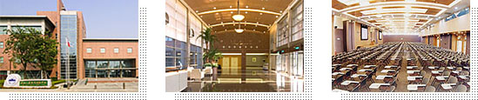

ACCOMMODATIONS
Freshfields Resort & Conference Hotel
http://www.freshfields.com.tw/en/index.asp
Address: No.2,Wen-Quan Road, Wuri Dist., Taichung City, Taiwan
Email: info@freshfields.com.tw; TEL: +886-4-23829888
清新溫泉會館（台灣台中市烏日區溫泉路2號）
Fees (valid by 30 September, 2017): Please refer to Hotel Reservation Form provided separately for details.
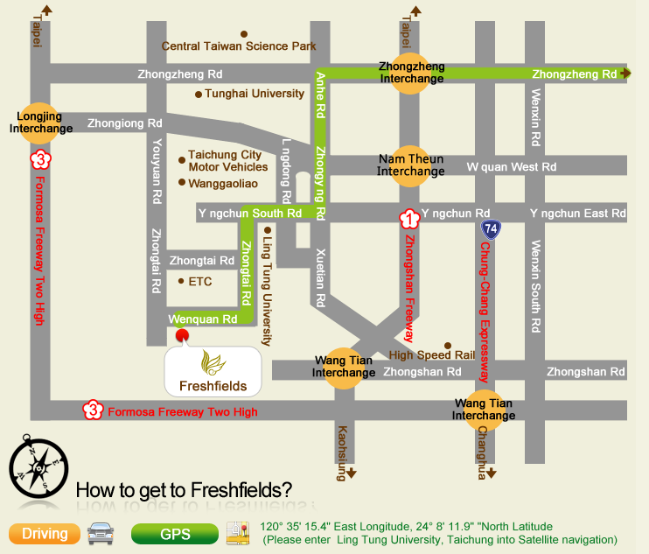

TRANSPORTATION INFORMATION
From Taiwan Taoyuan International Airport:
Take Taoyuan Airport MRT to A18 Taoyuan HSR station (Airport MRT, http://www.taoyuan-airport.com/english/taoyuan_metro)
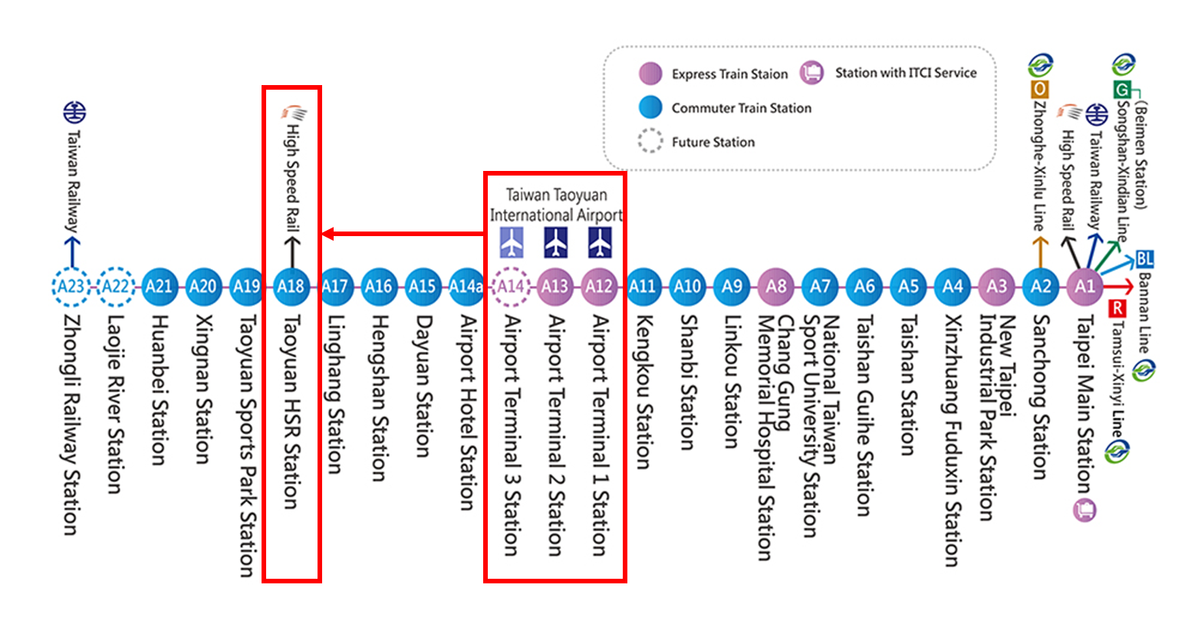
Then take high-speed rail to Taichung station (THSRC, http://www.thsrc.com.tw/en/?lc=en)
There are 3 options to get to Freshfields Resort & Conference Hotel (清新溫泉會館) and Nan-Shan Education & Training Center (台中南山人壽訓練中心) from THSR Taichung station:
- By taxi (200-250 Taiwan dollars)
- By free hotel shuttle bus (by reservation only: info@freshfields.com.tw)
- By Changhwa Bus Route 99 (彰化客運99路) (20-25 Taiwan dollars): Freshfields Resort & Conference Hotel (清新溫泉飯店) stop

PROGRAM
November 8, 2017 Arrival

November 9, 2017 PAWEES 2017 International Conference
Award Ceremony, Annual Meeting
November 10, 2017 Technical Tour: Hu-Shan Reservoir（湖山水庫）
http://www.wracb.gov.tw/ct.asp?xItem=2120&CtNode=924&mp=7

November 10, 2017 Departure
ORGANIZERS
International Society of Paddy and Water Environment Engineering (PAWEES)
Taiwan Agricultural Engineers Society (TAES)
Department of Bioenvironmental Systems Engineering, National Taiwan University
Hydrotech Research Institute, National Taiwan University
Taichung Irrigation Association
Liugong Irrigation Association
Chising Irrigation Association
Council of Agriculture, Executive Yuan, Taiwan (COA)
Water Resources Agency, Ministry of Economic Affairs, Taiwan (WRA)
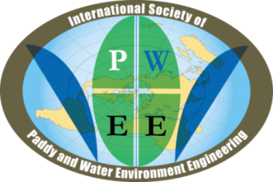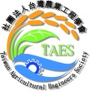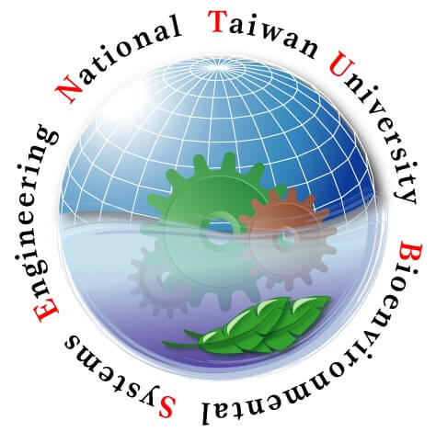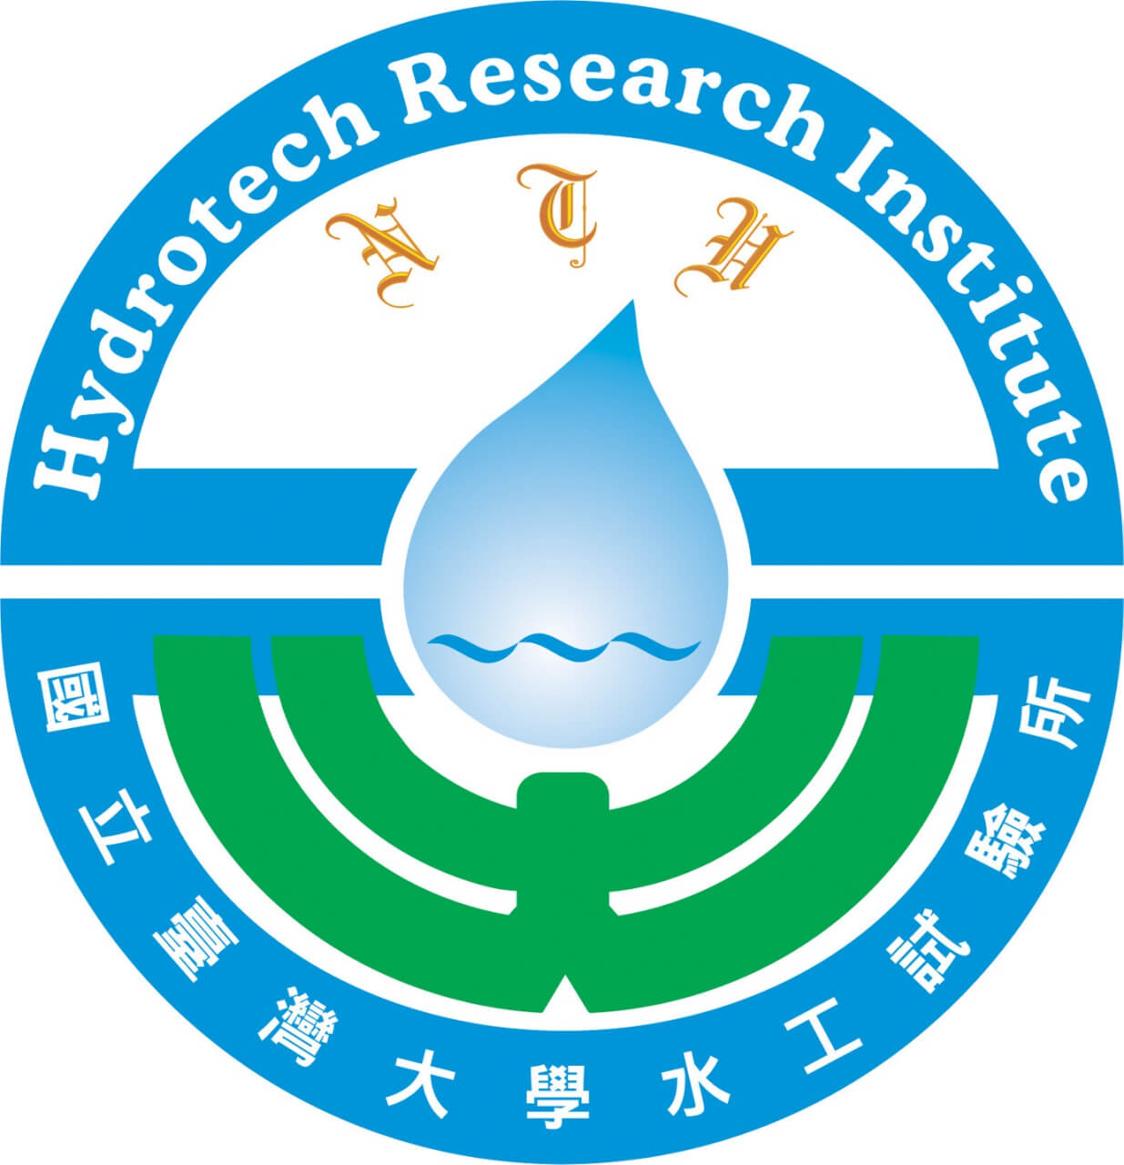

CONTACT
For inquiries of PAWEES 2017 International Conference, please contact

Prof. Ke-Sheng Cheng
pawees2017@gmail.com
Department of Bioenvironmental Systems Engineering
National Taiwan University, Taiwan

