|  |
| --- |
|  |

|  |
| --- |
| **eMart v5.0 UI Specification Document -1** |
| Case Study |
|  |
| This document covers Software Requirements and UI Specification of eMart, along with list of Technologies to be used to develop this Software System |
|  |
| **IIHT** |
| **7/1/2020** |
|  |

Table of Contents

1. Business Requirement(eMart) 2

1.1. Roles 2

1.1.1. Buyer Use Cases. 2

1.1.2. Seller Use Cases 2

1.1.3. Admin Use Cases(optional) 3

Features marked as optional are not mandatory for GenCs 3

1.1.4. Data fields 3

2. Design Inputs 5

3. UI Specification – Front End 6

4. Full Stack Technologies 9

5. Technical Spec – Solution Development Environment 10

5.1. Front End Layer 10

5.2. Middle Tier Layer 10

5.3. Database & Integration Layer 10

5.4. Ancillary Layer 10

5.5. Security 10

5.6. Deployment & Infrastructure 11

5.7. Editors 11

6. Deliverables of Front End 11

# Business Requirement(eMart)

eMart is an online eCommerce portal used to search and buy an item online. Buyer can add items to the cart, checkout and perform other operations. Admin can block/unblock Seller, Buyer, selling items. Below are eMart Features in detail.

## Roles

Below are the different roles, which need to be supported by above Software System.

#1. Buyer

#2. Seller

#3. Admin(optional)

Below are the Use Cases which need to be supported by each of above Roles

### Buyer Use Cases.

Login/Logout

Signup

Should be able to search an Item.

Once list of items are displayed, it should be possible to filter items based on Price, Manufacturer, etc...

When a specific item is selected by Buyer, complete details of item need to be displayed along with picture(one or more) and (list of)specifications which depends on Category and Sub Category of the item. Add to Cart button need to be provided.

It should be possible to open the Cart and checkout. Tax amount need to be displayed.

Items in the Cart can be deleted

It should be possible to apply discount, before checking out.

It should be possible to view History of purchases, along with Item, numbers

Integration with any Payment Gateway(optional)

### Seller Use Cases

Login/Logout

Signup with details such as Company/individual name, email id, Postal Address, GSTIN, Bank details

Add an item to be sold along with the number of items(in Stock)

Should be able to view Inventory(items sold and remaining)

Should be able to generate report like number of items sold and which items, over certain period.

Tax Calculation need to be performed.(optional)

### Admin Use Cases(optional)

Login/Logout

Block/Unblock a specific Seller

Block/Unblock a specific item sold by a Seller

Block/Unblock a specific Buyer

Add/remove Categories, Sub Category along with GST

Add/update discounts - discount code, start date, end date

View daily Turnover Category wise

**NOTE: Shipping/Delivery Tracking related Use Cases are not in the scope, it is assumed that Seller need to manage Shipping/Delivery Tracking offline.**

### Features marked as optional are not mandatory for GenCs

### Data fields

Below are data fields, for your reference, you add more fields based on your Analysis.

**Buyer:** Buyer’s login and profile details

id

username

password

emailid

mobile number

created datetime

**Seller:** Seller’s login and Selling company details

id

username

password

companyname

GSTIN

brief about company

postal_address

website

emailid

contact number

**Category:** List of Categories, for example Electronic, Fashion, etc…

category_id

category_name

brief_details

**Subcategory:** Sub Category of each Category. For example Electronic Category can have Mobile, TV, Laptop, etc… as Sub categories

subcategory_id

subcategory_name

category_id

brief_details

GST %

For example Mobiles, TV, etc... can be Sub Catgeories in Electronic Category

**Items:** Selling Item details

id

category_id

subcategory_id

price

item_name

description

stock_number

remarks

**Purchase History:**

Id

Buyer_id

Seller_id

Transaction_id

Item_id

Number_of_items

Date_time

remarks

**Transactions:** Transactions performed during Checkout, etc…

id

user_id

seller_id

transaction_type(Eg. debit or credit)

date_time

remarks

**Discounts:** Discount details

Id

Discount_code

percentage

start_date

end_date

description

# Design Inputs

Next sections in this document provides inputs on designing the solution for above requirements.

Design inputs provided are just for your reference purpose, Associates can make changes or additions to the Design, based on their analysis.

# UI Specification – Front End

In this Phase you will develop Front End of the SPA application using HTML5, Angular, Javascript and Jquery where required.

This Phase includes development of

1. Angular components with Templates
2. Angular Routing
3. Angular Services, to invoke Spring Boot REST End points.

Below can be various Angular Components

1. LogIn/Logout – Login/Logout for both Seller and Buyer
2. BuyerSignup – Buyer Sign up component
3. SellerSignup – Seller Sign up component
4. SearchItems – Lets Buyer to search for any Item/Product
5. SearchResults – List of matching Items need to be displayed, along with Filtering option.
6. DisplayItemComplete – Display single Item with full details(price, seller, specifications of Item)
7. DisplayItemSummary – Display single Item with basic details(price, seller, product name)
8. PurchaseHistory – List of items purchased in reverse chronological order
9. ShoppingCart – List of Items in Shopping Cart
10. SellerAddItem – Seller can add an Item (and its specifications) which need to be sold on portal
11. SellerUpdateStock - used to update Stock number of already existing Item

Angular Routing feature is used to display Navigation links on Web Pages. When User clicks a Navigation link, the corresponding Component is displayed.

As known, Angular Services are used to interact with the REST end points, using Observable or Promises.

Below are the Wireframes which need to be made available as part of Angular Components, responsive UI of the application using HTML5, HTML5 API, CSS3 and Bootstrap/Material.

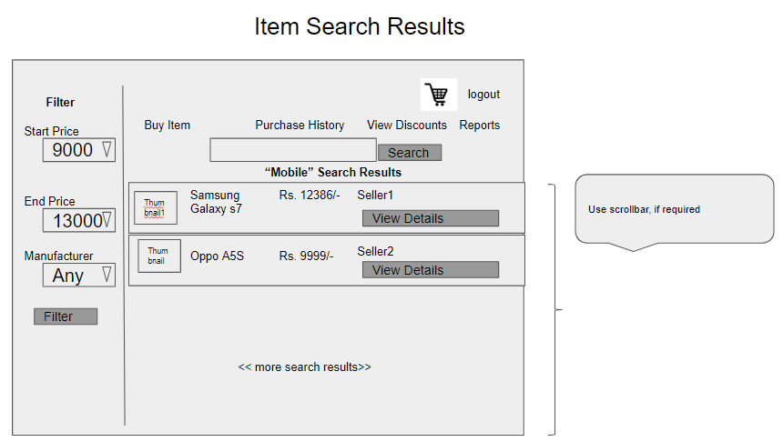

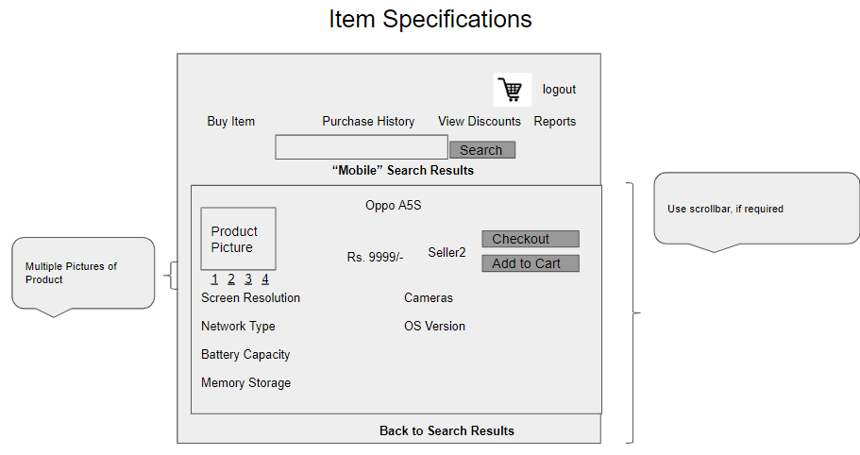

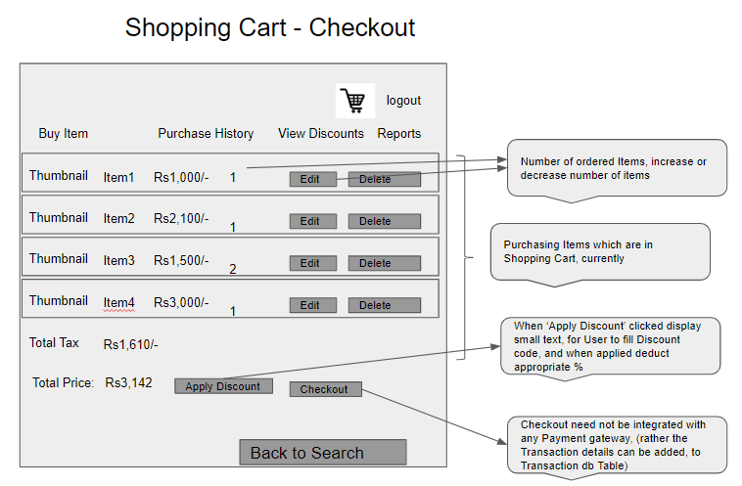

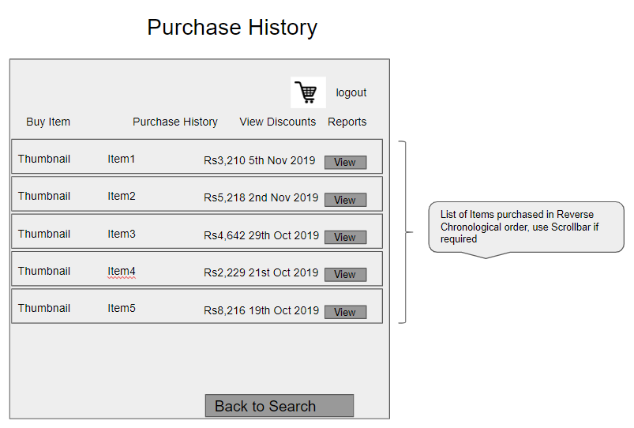

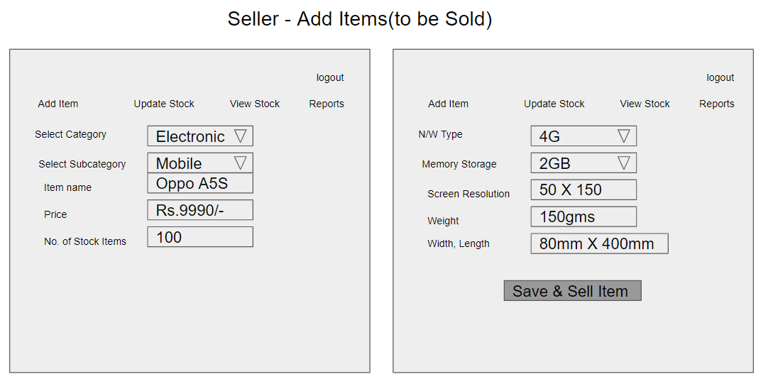

LogIn, Logout & SignUp components can be added, to above List of Wireframes.

Webpages need to include all Happy and UnHappy Paths, for example consider Login Webpage, UnHappy path would be when User enters invalid Username or Password, corresponding error message need to be displayed in the Login Page. Similarly consider Happy and UnHappy Paths for all Use Cases.

Based on the requirements, Front End need to be divided into multiple components to accommodate above Wireframes. Angular Routing can be used to create navigation Links. For Authentication, store JWT token in Local or Session Storage(on Client). REST APIs are invoked from the corresponding Angular Services,

As known JWT token is generated on the Server side and received by Client on successful authentication. Angular’s HttpInterceptor can be used to automatically send JWT Token thru Header of every HttpRequest to REST API end points.

# Full Stack Technologies

The technologies included in Full Stack are not limited to following but may consist of:

* UI Layer (HTML5, CSS3, Bootstrap 4, JavaScript, Jquery, Angular 4/6)
* Middleware Restful API (Spring Boot Restful & MicroServices, JAX-RS, Spring MVC)
* Database Persistence ( Hibernate)
* Database layer (MySQL)
* Ancillary skills (GIT, Jenkins(CI/CD), Docker, Maven) etc.

To complete this case study, you should be comfortable with basic single page web application concepts including REST and CRUD. You may use angular-cli to create your template project. All web pages need to be responsive.

Ref1: https://cli.angular.io/

Ref2: https://github.com/angular/angular-cli

# Technical Spec – Solution Development Environment

## Front End Layer

|  |  |
| --- | --- |
| **Framework(s)/SDK/Libraries** | **Version** |
| Angular with TypeScript | 4/6 |
| Bootstrap | 3.0 or above |
| CSS | 3 |
| HTML | 5 |
| JavaScript | 1.8 or above |
| JQuery | 1.3 |

## Middle Tier Layer

|  |  |  |
| --- | --- | --- |
| **Technology** | **Framework(s)/SDK/Libraries** | **Version** |
| Java Stack | Spring Boot | 1.5 or above |
| Spring MVC | 4.0 or above |
| JDK | 1.7 or above |
| Maven | 3.x or above |

## Database & Integration Layer

|  |  |  |
| --- | --- | --- |
| **Technology** | **Framework(s)/SDK/Libraries** | **Version** |
| Java Stack | Hibernate | 4.0 or above |
| JAX-RS Jersey/ Spring Restful |  |
| MySQL | 5.7.19 |

## Ancillary Layer

|  |  |  |
| --- | --- | --- |
| **Technology** | **Framework(s)/SDK/Libraries** | **Version** |
| Source Code Management Tool | GIT | 2.14.2 |
| Build Tool/JAVA Stack | Maven | 3.x |
| Testing Tool/JAVA Stack | JUnit/Mockito | 4.x |
| Testing Tool/JAVA Stack | Spring Test | 4.x |
| REST Controllers can be tested using Postman Tool | | |

## Security

|  |  |
| --- | --- |
| **Name** | **Version** |
| Spring Boot Security |  |
| JWT |  |

## Deployment & Infrastructure

|  |  |  |
| --- | --- | --- |
| **Technology** | **Framework(s)/SDK/Libraries** | **Version** |
| Docker | - |  |
| Apache Tomcat | - |  |
| Jenkins(CI/CD) | - |  |

## Editors

|  |  |
| --- | --- |
| **Name** | **Version** |
| STS(Spring Tool Suite) |  |
| Visual Studio Code |  |

# 

# Deliverables of Front End

1. Html templates along with Angular components
2. Unit Tested Angular Components using Jasmine

Refer the next two documents eMart’s **Software Specification Document-2** and **Full Stack Certification Guideline Document-3**

For any further queries you can contact fullstack@iiht.com