环境：redhat7.5

IP地址：192.168.4.5

关闭防火墙、SELinux

配置好yum

[root@zabbixserver ~]# ls

nginx-1.12.2.tar.gz php-mbstring-5.4.16-42.el7.x86_64.rpm

php-bcmath-5.4.16-42.el7.x86_64.rpm zabbix-3.4.13.tar.gz

php-fpm-5.4.16-42.el7.x86_64.rpm

[root@zabbixserver ~]# useradd -s /sbin/nologin nginx

[root@zabbixserver ~]# yum -y install gcc make zlib-devel openssl-devel pere-devel ncurese-devel

[root@zabbixserver ~]# tar -xf nginx-1.12.2.tar.gz

[root@zabbixserver ~]# cd nginx-1.12.2/

[root@zabbixserver nginx-1.12.2]# ./configure --prefix=/usr/local/nginx --user=nginx --group=nginx --with-http_ssl_module

[root@zabbixserver nginx-1.12.2]# make && make install

[root@zabbixserver nginx-1.12.2]# cd

[root@zabbixserver ~]# yum -y install php php-mysql mariadb mariadb-devel mariadb-server

[root@zabbixserver ~]# ls php-fpm-5.4.16-42.el7.x86_64.rpm

php-fpm-5.4.16-42.el7.x86_64.rpm

[root@zabbixserver ~]# rpm -ivh --nodeps php-fpm-5.4.16-42.el7.x86_64.rpm

警告：php-fpm-5.4.16-42.el7.x86_64.rpm: 头V3 RSA/SHA256 Signature, 密钥 ID f4a80eb5: NOKEY

准备中... ################################# [100%]

正在升级/安装...

1:php-fpm-5.4.16-42.el7 ################################# [100%]

[root@zabbixserver ~]#

[root@zabbixserver nginx]# cd /usr/local/nginx/

[root@zabbixserver nginx]# cat conf/nginx.conf | grep -v ^$ | grep -v '#'

worker_processes 1;

events {

worker_connections 1024;

}

http {

include mime.types;

default_type application/octet-stream;

sendfile on;

keepalive_timeout 65;

fastcgi_buffers 8 16k;

fastcgi_buffer_size 32k;

fastcgi_connect_timeout 300;

fastcgi_send_timeout 300;

fastcgi_read_timeout 300;

server {

listen 80;

server_name localhost;

location / {

root html;

index index.php index.html index.htm;

}

error_page 500 502 503 504 /50x.html;

location = /50x.html {

root html;

}

location ~ \.php$ {

root html;

fastcgi_pass 127.0.0.1:9000;

fastcgi_index index.php;

include fastcgi.conf;

}

}

}

##启服务

[root@zabbixserver nginx]# cd

[root@zabbixserver ~]# /usr/local/nginx/sbin/nginx -c /usr/local/nginx/conf/nginx.conf

[root@zabbixserver ~]# systemctl start php-fpm.service

[root@zabbixserver ~]# systemctl start mariadb

[root@zabbixserver ~]# ss -ntplu | grep nginx

tcp LISTEN 0 128 *:80 *:* users:(("nginx",pid=3971,fd=6),("nginx",pid=3970,fd=6))

[root@zabbixserver ~]# ss -ntplu | grep php

tcp LISTEN 0 128 127.0.0.1:9000 *:* users:(("php-fpm",pid=4002,fd=0),("php-fpm",pid=4001,fd=0),("php-fpm",pid=4000,fd=0),("php-fpm",pid=3999,fd=0),("php-fpm",pid=3998,fd=0),("php-fpm",pid=3996,fd=6))

[root@zabbixserver ~]# ss -ntplu | grep mysql

tcp LISTEN 0 50 *:3306 *:* users:(("mysqld",pid=4249,fd=14))

[root@zabbixserver ~]#

[root@zabbixserver ~]# mysql

Welcome to the MariaDB monitor. Commands end with ; or \g.

Your MariaDB connection id is 4

Server version: 5.5.56-MariaDB MariaDB Server

Copyright (c) 2000, 2017, Oracle, MariaDB Corporation Ab and others.

Type 'help;' or '\h' for help. Type '\c' to clear the current input statement.

MariaDB [(none)]> set password=password('123456');

Query OK, 0 rows affected (0.01 sec)

MariaDB [(none)]> exit

Bye

[root@zabbixserver ~]# cat /usr/local/nginx/html/mysql.php

<?php

$mysqli = new mysqli('127.0.0.1','root','123456','mysql');

if (mysqli_connect_errno()){

die('Unable to connect!'). mysqli_connect_error();

}

$sql = "select * from user";

$result = $mysqli->query($sql);

while($row = $result->fetch_array()){

printf("Host:%s",$row[0]);

printf("</br>");

printf("Name:%s",$row[1]);

printf("</br>");

}

?>

[root@zabbixserver ~]# curl http://127.0.0.1/mysql.php

Host:localhost</br>Name:root</br>Host:zabbixserver.tedu.cn</br>Name:root</br>Host:127.0.0.1</br>Name:root</br>Host:::1</br>Name:root</br>Host:localhost</br>Name:</br>Host:zabbixserver.tedu.cn</br>Name:</br>

[root@zabbixserver ~]#

##lnmp平台搭建完成

##安装zabbix

[root@zabbixserver ~]# yum -y install net-snmp-devel curl-devel

[root@zabbixserver ~]# yum -y localinstall libevent-devel-2.0.21-4.el7.x86_64.rpm

[root@zabbixserver ~]# tar -xf zabbix-3.4.13.tar.gz

[root@zabbixserver ~]# cd zabbix-3.4.13/

[root@zabbixserver zabbix-3.4.13]# ./configure --enable-server --enable-agent --enable-proxy --with-mysql=/usr/bin/mysql_config --with-net-snmp --with-libcurl

[root@zabbixserver zabbix-3.4.13]# make && make install

[root@zabbixserver zabbix-3.4.13]# mysql -uroot -p123456

Welcome to the MariaDB monitor. Commands end with ; or \g.

Your MariaDB connection id is 7

Server version: 5.5.56-MariaDB MariaDB Server

Copyright (c) 2000, 2017, Oracle, MariaDB Corporation Ab and others.

Type 'help;' or '\h' for help. Type '\c' to clear the current input statement.

MariaDB [(none)]> create database zabbixdb character set utf8;

Query OK, 1 row affected (0.00 sec)

MariaDB [(none)]> grant all on zabbixdb.* to zabbix@'localhost' identified by

'123456';

Query OK, 0 rows affected (0.00 sec)

MariaDB [(none)]> exit

Bye

[root@zabbixserver zabbix-3.4.13]# cd database/mysql/

[root@zabbixserver mysql]# ls

data.sql images.sql schema.sql

[root@zabbixserver mysql]# mysql -uzabbix -p123456 zabbixdb < schema.sql

[root@zabbixserver mysql]# mysql -uzabbix -p123456 zabbixdb < images.sql

[root@zabbixserver mysql]# mysql -uzabbix -p123456 zabbixdb < data.sql

[root@zabbixserver mysql]# cd ../../frontends/

[root@zabbixserver frontends]# ll

总用量 4

drwxr-xr-x 13 1001 1001 4096 8月 27 19:42 php

[root@zabbixserver frontends]# cp -r php /usr/local/nginx/html/zabbix

[root@zabbixserver frontends]# chown -R nginx:nginx /usr/local/nginx/html/zabbix/

[root@zabbixserver frontends]# cd /usr/local/

[root@zabbixserver local]# vim etc/zabbix_server.conf

[root@zabbixserver local]# cat etc/zabbix_server.conf | grep -v ^$ | grep -v ^#

LogFile=/tmp/zabbix_server.log

DBHost=localhost

DBName=zabbixdb

DBUser=zabbix

DBPassword=123456

Timeout=4

LogSlowQueries=3000

[root@zabbixserver local]# useradd -s /sbin/nologin zabbix

[root@zabbixserver local]# zabbix_server

[root@zabbixserver local]# ss -ntplu | grep zabbix

tcp LISTEN 0 128 *:10051 *:* users:(("zabbix_server",pid=14265,fd=4),("zabbix_server",pid=14264,fd=4),(zabbix_server",pid=14259,fd=4),("zabbix_server",pid=14258,fd=4),("zabbix_server",pid=14255,fd=4),("zabbix_server",pid=14253,fd=4),("zabbix_server",pid=14251,fd=4),("zabbix_server",pid=14249,fd=4),("zabbix_server",pid=14247,fd=4),("zabbix_server",pid=14244,fd=4),("zabbix_server",pid=14243,fd=4),("zabbix_server",pid=14242,fd=4),("zabbix_server",pid=14241,fd=4),("zabbix_server",pid=14240,fd=4),("zabbix_server",pid=14239,fd=4),("zabbix_server",pid=14238,fd=4),("zabbi_server",pid=14236,fd=4),("zabbix_server",pid=14235,fd=4),("zabbix_server",pid=14234,fd=4),("zabbix_server",pid=14231,fd=4),("zabbix_server",pid=14230,fd=4),("zabbix_server",pid=14225,fd=4),("zabbix_server",pid=14224,fd=4),("zabbix_server",pid=14223,fd=4),("zabbix_server",pid=14222,fd=4),("zabbix_server",pid=14219,fd=4),("zabbix_server",pid=14218,fd=4),("zabbix_server",pid=14217,fd=4),(zabbix_server",pid=14216,fd=4),("zabbix_server",pid=14215,fd=4),("zabbix_server",pid=14214,fd=4),("zabbix_server",pid=14213,fd=4),("zabbix_server",pid=14212,fd=4),("zabbix_server",pid=14207,fd=4))

[root@zabbixserver local]#

[root@room8pc205 ~]# firefox <http://192.168.4.5/zabbix/>

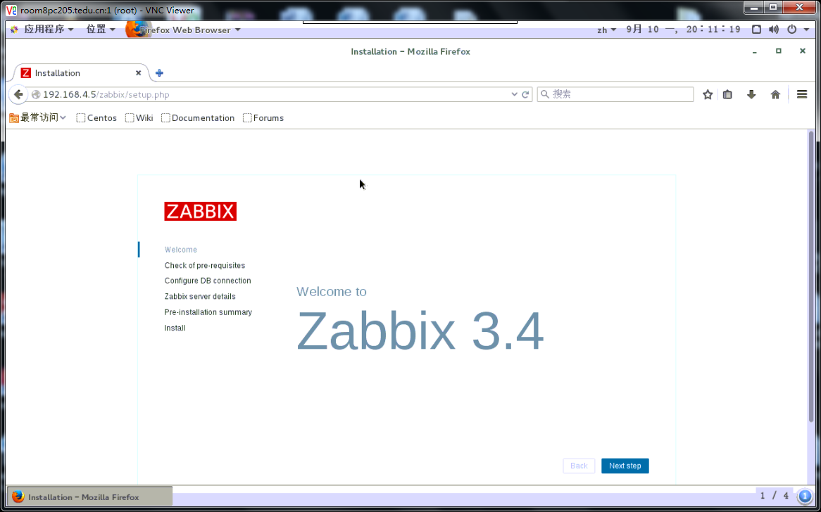

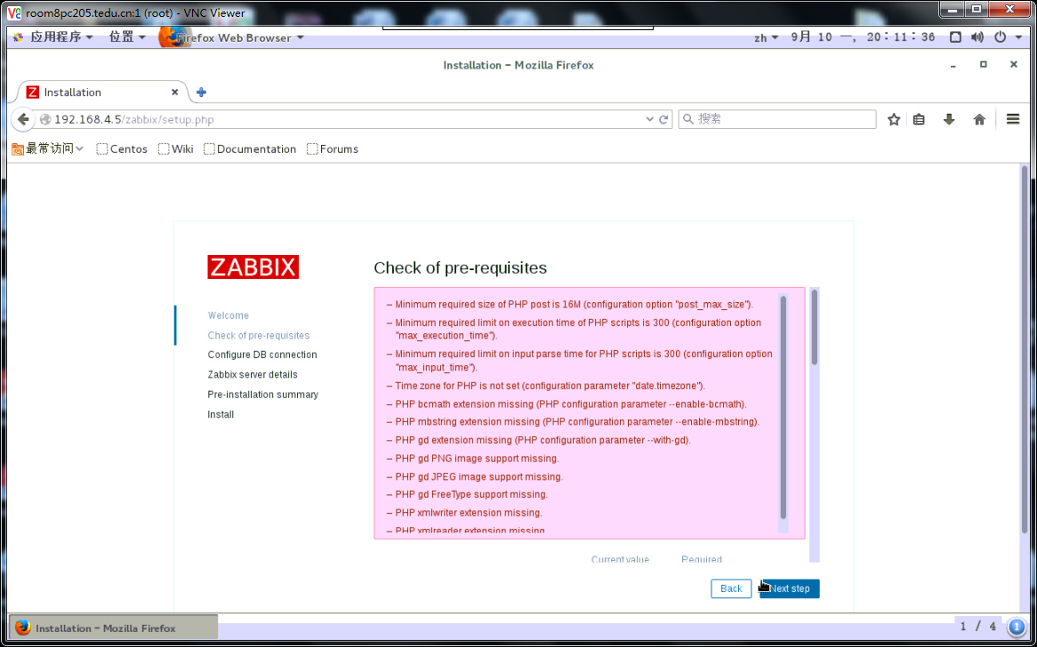

#修改php参数

[root@zabbixserver ~]# yum -y install php-gd php-xml

[root@zabbixserver ~]# ls php*

php-bcmath-5.4.16-42.el7.x86_64.rpm php-mbstring-5.4.16-42.el7.x86_64.rpm

php-fpm-5.4.16-42.el7.x86_64.rpm

[root@zabbixserver ~]# rpm -ivh --nodeps php-bcmath-5.4.16-42.el7.x86_64.rpm

警告：php-bcmath-5.4.16-42.el7.x86_64.rpm: 头V3 RSA/SHA256 Signature, 密钥 ID f4a80eb5: NOKEY

准备中... ################################# [100%]

正在升级/安装...

1:php-bcmath-5.4.16-42.el7 ################################# [100%]

[root@zabbixserver ~]# rpm -ivh --nodeps php-mbstring-5.4.16-42.el7.x86_64.rpm

警告：php-mbstring-5.4.16-42.el7.x86_64.rpm: 头V3 RSA/SHA256 Signature, 密钥 ID f4a80eb5: NOKEY

准备中... ################################# [100%]

正在升级/安装...

1:php-mbstring-5.4.16-42.el7 ################################# [100%]

[root@zabbixserver ~]#

[root@zabbixserver ~]# vim /etc/php.ini

date.timezone = Asia/Shanghai //设置时区

max_execution_time = 300 //最大执行时间，秒

post_max_size = 32M //POST数据最大容量

max_input_time = 300 //服务器接收数据的时间限制

memory_limit = 128M //内存容量限制

[root@zabbixserver ~]# systemctl restart php-fpm

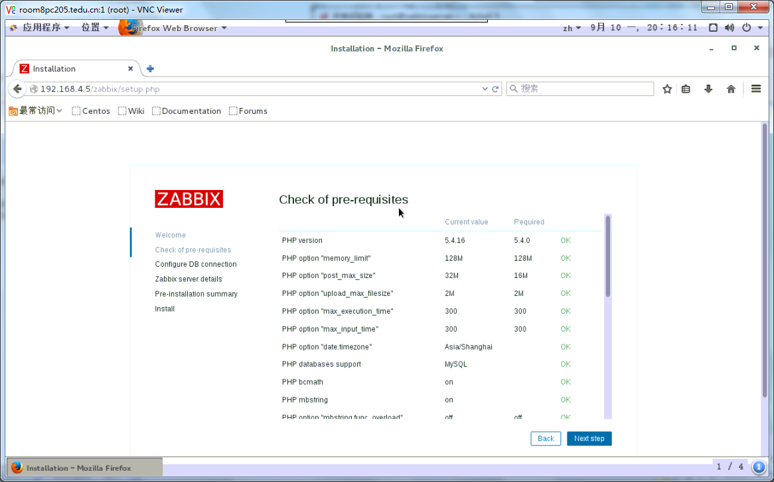

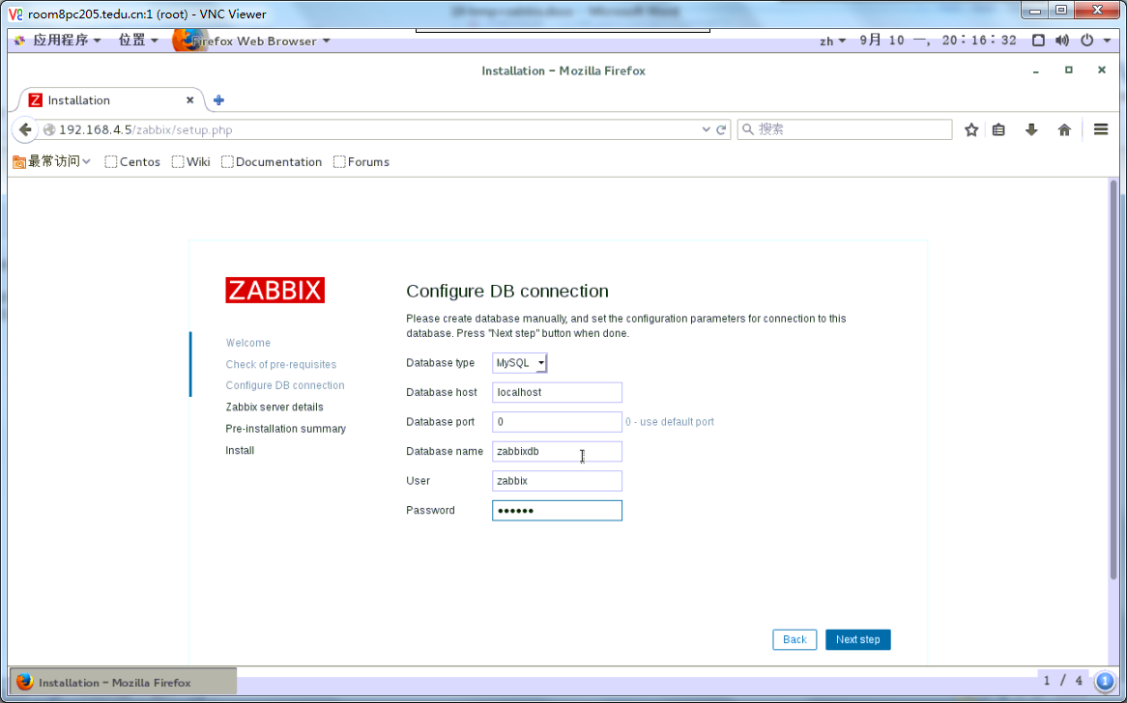

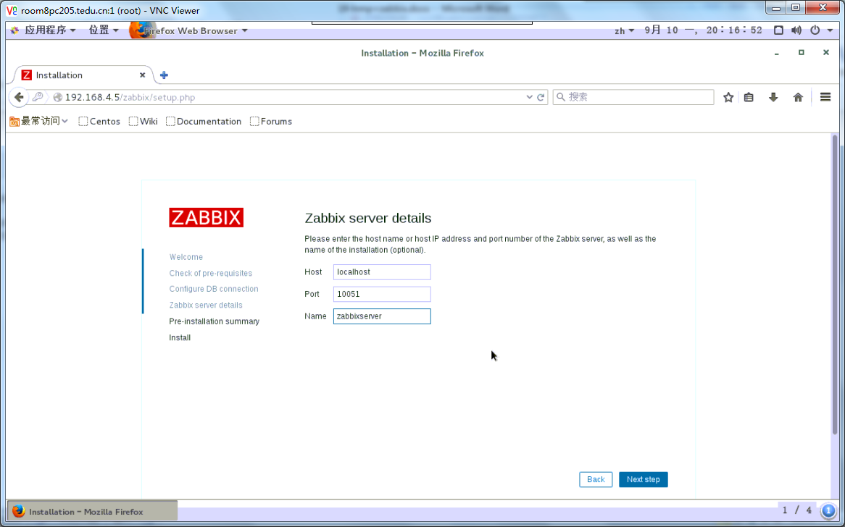

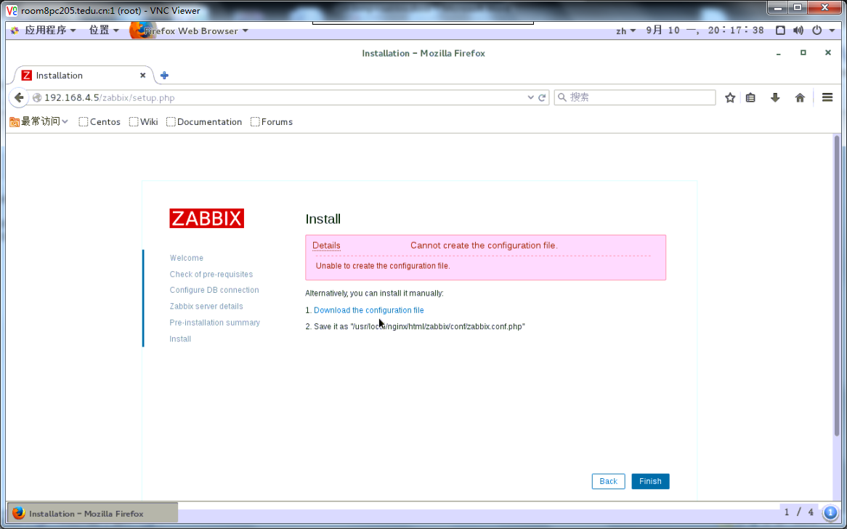

#执行页面上提示的操作

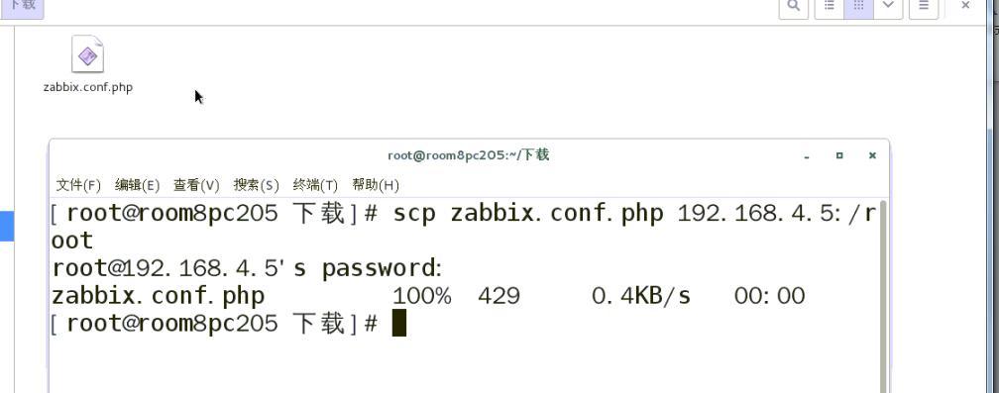

[root@zabbixserver ~]# ll zabbix.conf.php

-rw-r--r-- 1 root root 429 9月 10 20:20 zabbix.conf.php

[root@zabbixserver ~]# mv zabbix.conf.php /usr/local/nginx/html/zabbix/conf

[root@zabbixserver ~]# chown nginx:nginx /usr/local/nginx/html/zabbix/conf/zabbix.conf.php

#刷新页面

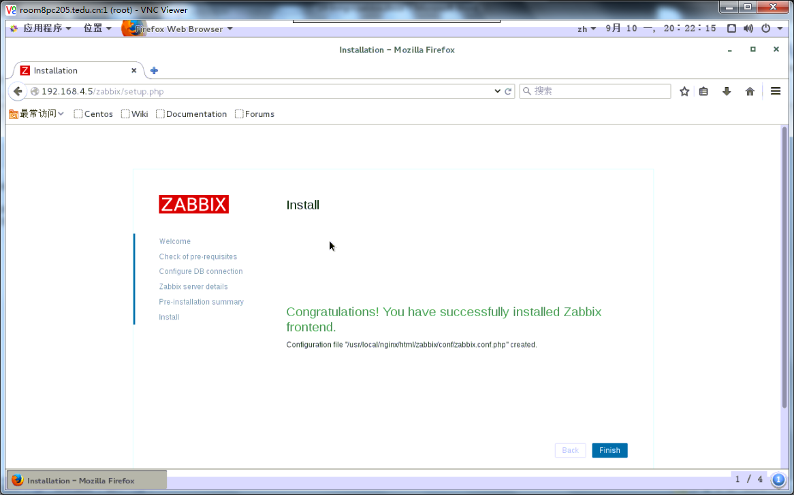

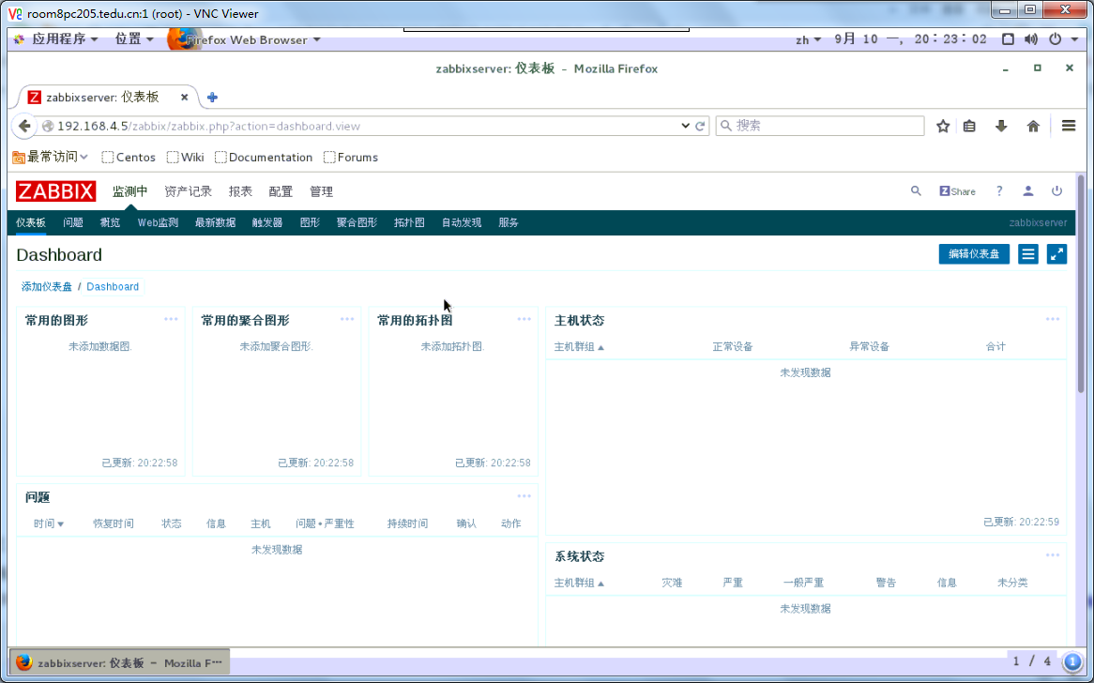

##部署完成

#配置被监控端

[root@zabbixserver ~]# cat /usr/local/etc/zabbix_agentd.conf | grep -v ^$ | grep -v ^#

LogFile=/tmp/zabbix_agentd.log

Server=127.0.0.1,192.168.4.5

ServerActive=127.0.0.1, 192.168.4.5

Hostname=zabbixserver

UnsafeUserParameters=1

[root@zabbixserver ~]# zabbix_agentd

[root@zabbixserver ~]# ss -ntplu | grep 10050

tcp LISTEN 0 128 *:10050 *:* users:(("zabbix_agentd",pid=15290,fd=4),("zabbix_agentd",pid=15289,fd=4),("zabbix_agentd",pid=15288,fd=4),("zabbix_agentd",pid=15287,fd=4),("zabbix_agentd",pid=15286,fd=4),("zabbix_agentd",pid=15285,fd=4),("zabbix_agentd",pid=15284,fd=4))

[root@zabbixserver ~]#

第二版：指定zabbix安装目录

前边部署lnmp平台的过程一致，不在赘述

[root@zabbix_server ~]# yum -y install net-snmp-devel curl-devel

[root@zabbix_server ~]# yum -y localinstall libevent-devel-2.0.21-4.el7.x86_64.rpm

[root@zabbix_server ~]# useradd -s /sbin/nologin zabbix

[root@zabbix_server ~]# tar -xf zabbix-3.4.13.tar.gz

[root@zabbix_server ~]# cd zabbix-3.4.13/

[root@zabbix_server zabbix-3.4.13]# ./configure --prefix=/usr/local/zabbix --enable-server --enable-agent --enable-proxy --with-mysql=/usr/bin/mysql_config --with-net-snmp --with-libcurl

[root@zabbix_server zabbix-3.4.13]# make install

[root@zabbix_server ~]# mysql -uroot -p123456

Welcome to the MariaDB monitor. Commands end with ; or \g.

Your MariaDB connection id is 4

Server version: 5.5.56-MariaDB MariaDB Server

Copyright (c) 2000, 2017, Oracle, MariaDB Corporation Ab and others.

Type 'help;' or '\h' for help. Type '\c' to clear the current input statement.

MariaDB [(none)]> create database zabbixdb character set utf8;

Query OK, 1 row affected (0.00 sec)

MariaDB [(none)]> grant all on zabbixdb.* to zabbix@'localhost' identified by '123456';

Query OK, 0 rows affected (0.00 sec)

MariaDB [(none)]> exit

Bye

[root@zabbix_server ~]#

root@zabbix_server ~]# cd zabbix-3.4.13/database/mysql/

[root@zabbix_server mysql]# ls

data.sql images.sql schema.sql

[root@zabbix_server mysql]# mysql -uzabbix -p123456 zabbixdb < schema.sql

[root@zabbix_server mysql]# mysql -uzabbix -p123456 zabbixdb < images.sql

[root@zabbix_server mysql]# mysql -uzabbix -p123456 zabbixdb < data.sql

[root@zabbix_server mysql]# cd ../../frontends/

[root@zabbix_server frontends]# cp -r php /usr/local/nginx/html/zabbix

[root@zabbix_server frontends]#

[root@zabbix_server frontends]# chown -R nginx:nginx /usr/local/nginx/html/zabbix/

[root@zabbix_server ~]# cd /usr/local/zabbix/etc/

[root@zabbix_server etc]# cat zabbix_server.conf | grep -v ^# | grep -v ^$

LogFile=/tmp/zabbix_server.log

DBHost=localhost

DBName=zabbixdb

DBUser=zabbix

DBPassword=123456

Timeout=4

LogSlowQueries=3000

[root@zabbix_server etc]# cd /root/zabbix-3.4.13/misc/init.d/fedora/core5/

[root@zabbix_server core5]# ls

zabbix_agentd zabbix_server

[root@zabbix_server core5]# cp -p * /etc/init.d/

[root@zabbix_server core5]# cd

[root@zabbix_server ~]# vim /etc/init.d/zabbix_server

[root@zabbix_server ~]# sed -n '21p' /etc/init.d/zabbix_server

ZABBIX_BIN="/usr/local/zabbix/sbin/zabbix_server"

[root@zabbix_server ~]# /etc/init.d/zabbix_server start

Reloading systemd: [ 确定 ]

Starting zabbix_server (via systemctl): [ 确定 ]

[root@zabbix_server ~]# ss -ntplu |grep zabbix

tcp LISTEN 0 128 *:10051 *:* users:(("zabbix_server",pid=14038,fd=4),("zabbix_server",pid=14035,fd=4),(zabbix_server",pid=14034,fd=4),("zabbix_server",pid=14031,fd=4),("zabbix_server",pid=14030,fd=4),("zabbix_server",pid=14029,fd=4),("zabbix_server",pid=14027,fd=4),("zabbix_server",pid=14025,fd=4),("zabbix_server",pid=14022,fd=4),("zabbix_server",pid=14020,fd=4),("zabbix_server",pid=14018,fd=4),("zabbix_server",pid=14017,fd=4),("zabbix_server",pid=14016,fd=4),("zabbix_server",pid=14015,fd=4),("zabbix_server",pid=14014,fd=4),("zabbix_server",pid=14013,fd=4),("zabbi_server",pid=14012,fd=4),("zabbix_server",pid=14010,fd=4),("zabbix_server",pid=14008,fd=4),("zabbix_server",pid=14006,fd=4),("zabbix_server",pid=14004,fd=4),("zabbix_server",pid=14002,fd=4),("zabbix_server",pid=14001,fd=4),("zabbix_server",pid=13996,fd=4),("zabbix_server",pid=13995,fd=4),("zabbix_server",pid=13994,fd=4),("zabbix_server",pid=13993,fd=4),("zabbix_server",pid=13992,fd=4),(zabbix_server",pid=13991,fd=4),("zabbix_server",pid=13990,fd=4),("zabbix_server",pid=13989,fd=4),("zabbix_server",pid=13988,fd=4),("zabbix_server",pid=13987,fd=4),("zabbix_server",pid=13982,fd=4))

[root@zabbix_server ~]# sed -n '21p' /etc/init.d/zabbix_agentd

ZABBIX_BIN="/usr/local/zabbix/sbin/zabbix_agentd"

[root@zabbix_server ~]# /etc/init.d/zabbix_agentd start

Starting zabbix_agentd (via systemctl): [ 确定 ]

[root@zabbix_server ~]# ss -ntplu | grep 10050

tcp LISTEN 0 128 *:10050 *:* users:(("zabbix_agentd",pid=14313,fd=4),("zabbix_agentd",pid=14312,fd=4),("zabbix_agentd",pid=14311,fd=4),("zabbix_agentd",pid=14310,fd=4),("zabbix_agentd",pid=14309,fd=4),("zabbix_agentd",pid=14308,fd=4),("zabbix_agentd",pid=14307,fd=4))

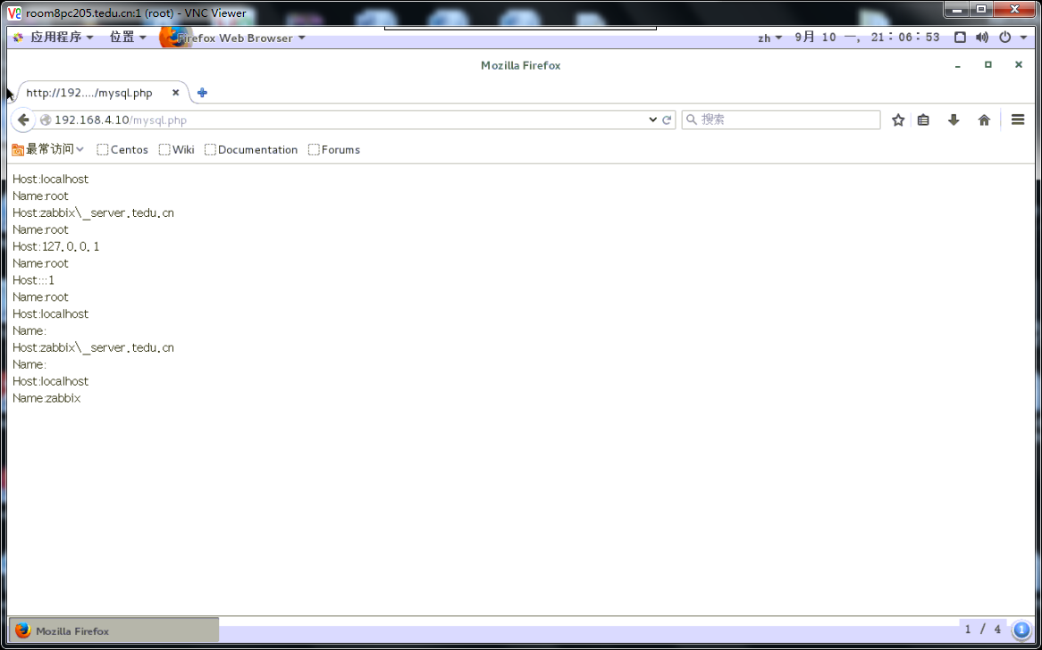

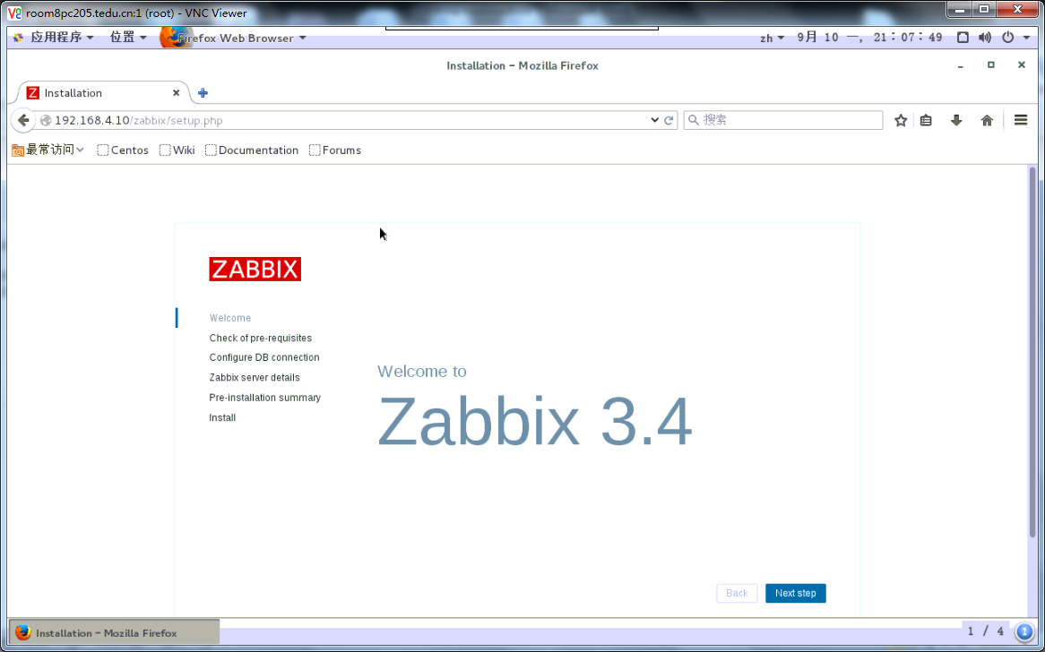

[root@zabbix_server ~]# yum -y install php-gd php-xml

[root@zabbix_server ~]# rpm -ivh --nodeps php-mbstring-5.4.16-42.el7.x86_64.rpm

警告：php-mbstring-5.4.16-42.el7.x86_64.rpm: 头V3 RSA/SHA256 Signature, 密钥 ID f4a80eb5: NOKEY

准备中... ################################# [100%]

正在升级/安装...

1:php-mbstring-5.4.16-42.el7 ################################# [100%]

[root@zabbix_server ~]# rpm -ivh --nodeps php-bcmath-5.4.16-42.el7.x86_64.rpm 警告：php-bcmath-5.4.16-42.el7.x86_64.rpm: 头V3 RSA/SHA256 Signature, 密钥 ID f4a80eb5: NOKEY

准备中... ################################# [100%]

正在升级/安装...

1:php-bcmath-5.4.16-42.el7 ################################# [100%]

[root@zabbix_server ~]#

[root@zabbixserver ~]# vim /etc/php.ini

date.timezone = Asia/Shanghai //设置时区

max_execution_time = 300 //最大执行时间，秒

post_max_size = 32M //POST数据最大容量

max_input_time = 300 //服务器接收数据的时间限制

memory_limit = 128M //内存容量限制

[root@zabbixserver ~]# systemctl restart php-fpm