zabbix安装

环境zabbixserver 192.168.4.155

zabbixclient 192.168.4.156

关闭防火墙，SELinux

#zabbixserver

[root@zabbixserver ~]# yum -y install gcc gcc-c++ httpd php php-mysql mariadb-server php-gd php-xml php-ladp php-pear php-xmlrpc

[root@zabbixserver ~]# systemctl start httpd; systemctl start mariadb

[root@zabbixserver ~]# mysql

MariaDB [(none)]> create database zabbixdb;

Query OK, 1 row affected (0.00 sec)

MariaDB [(none)]> grant all on zabbixdb.* to zabbixuser@'localhost' identified by '123456';

Query OK, 0 rows affected (0.00 sec)

[root@zabbixserver zabbix-3.2.3]# yum -y install mariadb-devel

[root@zabbixserver zabbix-3.2.3]# useradd zabbix

[root@zabbixserver zabbix-3.2.3]# tar -xf zabbix-3.2.3.tar.gz

[root@zabbixserver zabbix-3.2.3]# cd zabbix-3.2.3/

[root@zabbixserver zabbix-3.2.3]# ./configure --prefix=/usr/local/zabbix --enable-server --enable-agent --with-mysql

[root@zabbixserver zabbix-3.2.3]# make install

[root@zabbixserver zabbix-3.2.3]# ls /usr/local/zabbix/

bin etc lib sbin share

[root@zabbixserver zabbix-3.2.3]# cd database/mysql/

[root@zabbixserver mysql]# ls

data.sql images.sql schema.sql

[root@zabbixserver mysql]# mysql -uzabbixuser -p123456 zabbixdb < schema.sql

[root@zabbixserver mysql]# mysql -uzabbixuser -p123456 zabbixdb < images.sql

[root@zabbixserver mysql]# mysql -uzabbixuser -p123456 zabbixdb < data.sql

MariaDB [(none)]> use zabbixdb

Reading table information for completion of table and column names

You can turn off this feature to get a quicker startup with -A

Database changed

MariaDB [zabbixdb]> show tables;

+----------------------------+

| Tables_in_zabbixdb |

+----------------------------+

| acknowledges |

| actions |

| alerts |

| application_discovery |

| application_prototype |

| application_template |

| applications |

| auditlog |

| auditlog_details |

| autoreg_host |

| conditions |

| config |

| corr_condition |

| corr_condition_group |

| corr_condition_tag |

| corr_condition_tagpair |

| corr_condition_tagvalue |

| corr_operation |

| correlation |

| dbversion |

| dchecks |

| dhosts |

| drules |

| dservices |

| escalations |

| event_recovery |

| event_tag |

| events |

| expressions |

| functions |

| globalmacro |

| globalvars |

| graph_discovery |

| graph_theme |

| graphs |

| graphs_items |

| group_discovery |

| group_prototype |

| groups |

| history |

| history_log |

| history_str |

| history_text |

| history_uint |

| host_discovery |

| host_inventory |

| hostmacro |

| hosts |

| hosts_groups |

| hosts_templates |

| housekeeper |

| httpstep |

| httpstepitem |

| httptest |

| httptestitem |

| icon_map |

| icon_mapping |

| ids |

| images |

| interface |

| interface_discovery |

| item_application_prototype |

| item_condition |

| item_discovery |

| items |

| items_applications |

| maintenances |

| maintenances_groups |

| maintenances_hosts |

| maintenances_windows |

| mappings |

| media |

| media_type |

| opcommand |

| opcommand_grp |

| opcommand_hst |

| opconditions |

| operations |

| opgroup |

| opinventory |

| opmessage |

| opmessage_grp |

| opmessage_usr |

| optemplate |

| problem |

| problem_tag |

| profiles |

| proxy_autoreg_host |

| proxy_dhistory |

| proxy_history |

| regexps |

| rights |

| screen_user |

| screen_usrgrp |

| screens |

| screens_items |

| scripts |

| service_alarms |

| services |

| services_links |

| services_times |

| sessions |

| slides |

| slideshow_user |

| slideshow_usrgrp |

| slideshows |

| sysmap_element_url |

| sysmap_url |

| sysmap_user |

| sysmap_usrgrp |

| sysmaps |

| sysmaps_elements |

| sysmaps_link_triggers |

| sysmaps_links |

| task |

| task_close_problem |

| timeperiods |

| trends |

| trends_uint |

| trigger_depends |

| trigger_discovery |

| trigger_tag |

| triggers |

| users |

| users_groups |

| usrgrp |

| valuemaps |

+----------------------------+

127 rows in set (0.00 sec)

[root@zabbixserver zabbix-3.2.3]# cd frontends/

[root@zabbixserver frontends]# cp -r php/ /var/www/html/zabbix

[root@zabbixserver frontends]# vim /etc/php.ini

672 post_max_size = 16M

878 date.timezone = Asia/Shanghai

394 max_input_time = 300

[root@zabbixserver frontends]# systemctl restart httpd

[root@zabbixserver ~]# ls

anaconda-ks.cfg zabbix-3.2.3

php-bcmath-5.4.45-13.el7.remi.x86_64.rpm zabbix-3.2.3.tar.gz

php-mbstring-5.4.45-13.el7.remi.x86_64.rpm

[root@zabbixserver ~]# rpm -ivh --nodeps php-*.rpm

[root@zabbixserver ~]# systemctl restart httpd

[root@zabbixserver ~]# chmod o+w /var/www/html/zabbix/conf

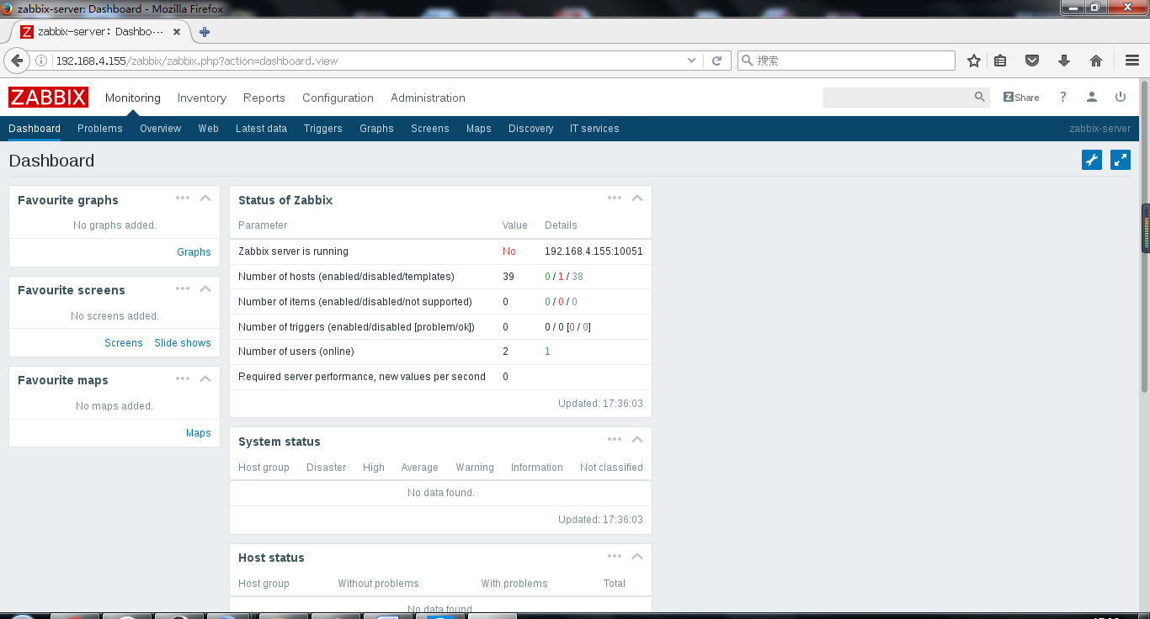

#用户名admin密码zabbix初始化登录web页面

[root@zabbixserver ~]# cat /var/www/html/zabbix/conf/zabbix.conf.php

<?php

// Zabbix GUI configuration file.

global $DB;

$DB['TYPE'] = 'MYSQL';

$DB['SERVER'] = 'localhost';

$DB['PORT'] = '0';

$DB['DATABASE'] = 'zabbixdb';

$DB['USER'] = 'zabbixuser';

$DB['PASSWORD'] = '123456';

// Schema name. Used for IBM DB2 and PostgreSQL.

$DB['SCHEMA'] = '';

$ZBX_SERVER = '192.168.4.155';

$ZBX_SERVER_PORT = '10051';

$ZBX_SERVER_NAME = 'zabbix-server';

$IMAGE_FORMAT_DEFAULT = IMAGE_FORMAT_PNG;

#zabbix初始化配置保存文件内容

[root@zabbixserver ~]# grep -v ^# /usr/local/zabbix/etc/zabbix_server.conf | grep -v ^$

LogFile=/tmp/zabbix_server.log

DBName=zabbixdb

DBUser=zabbixuser

DBPassword=123456

Timeout=4

LogSlowQueries=3000

#修改服务端配置文件

[root@zabbixserver ~]# cp zabbix-3.2.3/misc/init.d/fedora/core/zabbix_server /etc/init.d/

[root@zabbixserver ~]# chmod +x /etc/init.d/zabbix_server

#拷贝启动脚本

[root@zabbixserver ~]# grep -v ^# /etc/init.d/zabbix_server

. /etc/init.d/functions

# Zabbix-Directory

BASEDIR=/usr/local/zabbix

# Binary File

BINARY_NAME=zabbix_server

# Full Binary File Call

FULLPATH=$BASEDIR/sbin/$BINARY_NAME

# PID file

PIDFILE=/tmp/$BINARY_NAME.pid

# Establish args

ERROR=0

STOPPING=0

if [ -f $PIDFILE ] && [ -s $PIDFILE ]

then

PID=`cat $PIDFILE`

if [ "x$PID" != "x" ] && kill -0 $PID 2>/dev/null && [ $BINARY_NAME == `ps -e | grep $PID | awk '{print $4}'` ]

then

STATUS="$BINARY_NAME (pid `pidof $APP`) running.."

RUNNING=1

else

rm -f $PIDFILE

STATUS="$BINARY_NAME (pid file existed ($PID) and now removed) not running.."

RUNNING=0

fi

else

if [ `ps -e | grep $BINARY_NAME | head -1 | awk '{ print $1 }'` ]

then

STATUS="$BINARY_NAME (pid `pidof $APP`, but no pid file) running.."

else

STATUS="$BINARY_NAME (no pid file) not running"

fi

RUNNING=0

fi

start() {

if [ $RUNNING -eq 1 ]

then

echo "$0 $ARG: $BINARY_NAME (pid $PID) already running"

else

action $"Starting $BINARY_NAME: " $FULLPATH

touch /var/lock/subsys/$BINARY_NAME

fi

}

stop() {

echo -n $"Shutting down $BINARY_NAME: "

killproc $BINARY_NAME

RETVAL=$?

echo

[ $RETVAL -eq 0 ] && rm -f /var/lock/subsys/$BINARY_NAME

RUNNING=0

}

case "$1" in

start)

start

;;

stop)

stop

;;

status)

status $BINARY_NAME

;;

restart)

stop

sleep 10

start

;;

help|*)

echo $"Usage: $0 {start|stop|status|restart|help}"

cat <<EOF

start - start $BINARY_NAME

stop - stop $BINARY_NAME

status - show current status of $BINARY_NAME

restart - restart $BINARY_NAME if running by sending a SIGHUP or start if not running

help - this screen

EOF

exit 1

;;

esac

exit 0

#修改启动脚本

[root@zabbixserver ~]# /etc/init.d/zabbix_server start

Reloading systemd: [ 确定 ]

Starting zabbix_server (via systemctl): [ 确定 ]

[root@zabbixserver ~]# netstat -anptu | grep :10051

tcp 0 0 0.0.0.0:10051 0.0.0.0:* LISTEN 17139/zabbix_server

tcp 0 0 192.168.4.155:35356 192.168.4.155:10051 TIME_WAIT -

[root@zabbixserver ~]#

#启动服务

##配置被监控主机

[root@zabbixclient ~]# useradd zabbix

[root@zabbixclient ~]# tar -xf zabbix-3.2.3.tar.gz

[root@zabbixclient ~]# cd zabbix-3.2.3/

[root@zabbixclient zabbix-3.2.3]# yum -y install gcc gcc-c++

[root@zabbixclient zabbix-3.2.3]# ./configure --prefix=/usr/local/zabbix --enable-agent

[root@zabbixclient zabbix-3.2.3]# make install

[root@zabbixclient zabbix-3.2.3]# ls /usr/local/zabbix/

bin etc lib sbin share

#确认安装

[root@zabbixclient ~]# cp zabbix-3.2.3/misc/init.d/fedora/core/zabbix_agentd /etc/init.d/

[root@zabbixclient ~]# chmod +x /etc/init.d/zabbix_agentd

[root@zabbixclient ~]# sed -i '22s;/usr/local;/usr/local/zabbix;' /etc/init.d/zabbix_agentd

[root@zabbixclient ~]# sed -n '22p' /etc/init.d/zabbix_agentd

BASEDIR=/usr/local/zabbix

#修改启动脚本

[root@zabbixclient ~]# grep -v ^# /usr/local/zabbix/etc/zabbix_agentd.conf | grep -v ^$

LogFile=/tmp/zabbix_agentd.log

Server=127.0.0.1, 192.168.4.155

ServerActive=192.168.4.155:10051

Hostname=Zabbix client

#修改客户端配置文件

[root@zabbixclient ~]# /etc/init.d/zabbix_agentd start

Reloading systemd: [ 确定 ]

Starting zabbix_agentd (via systemctl): [ 确定 ]

[root@zabbixclient ~]# netstat -anptu | grep :10050

tcp 0 0 0.0.0.0:10050 0.0.0.0:* LISTEN 1184/zabbix_agentd

#启动服务

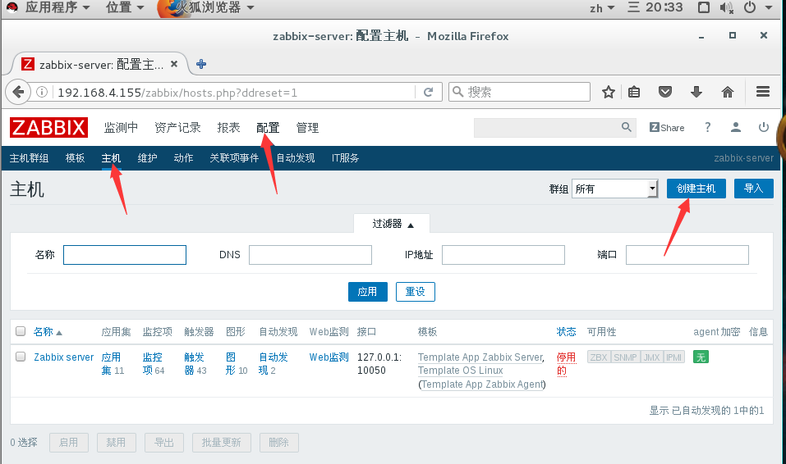

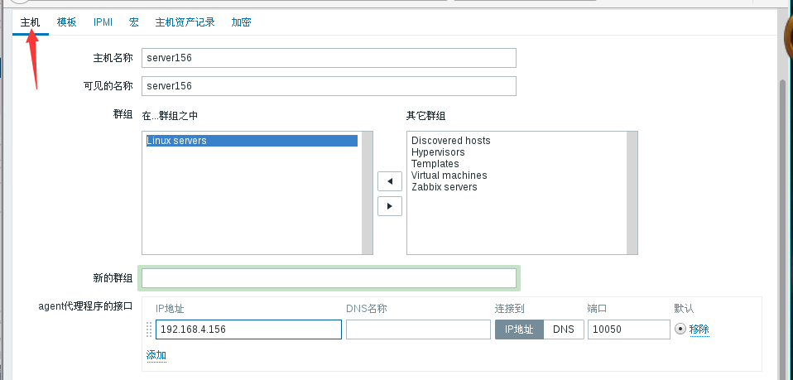

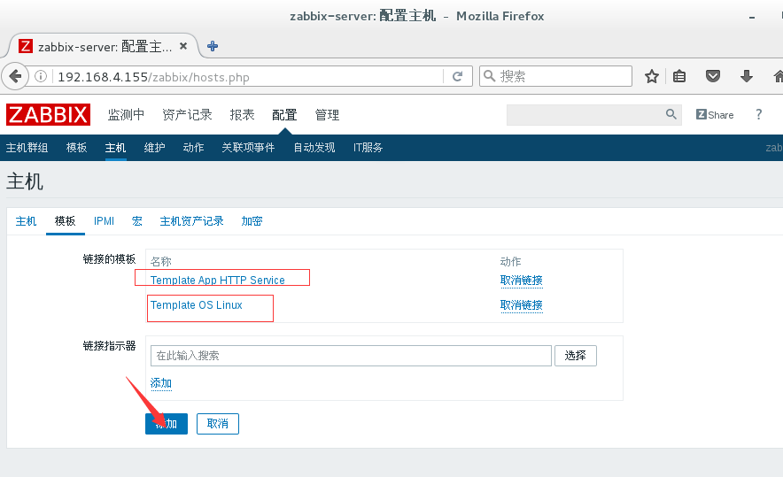

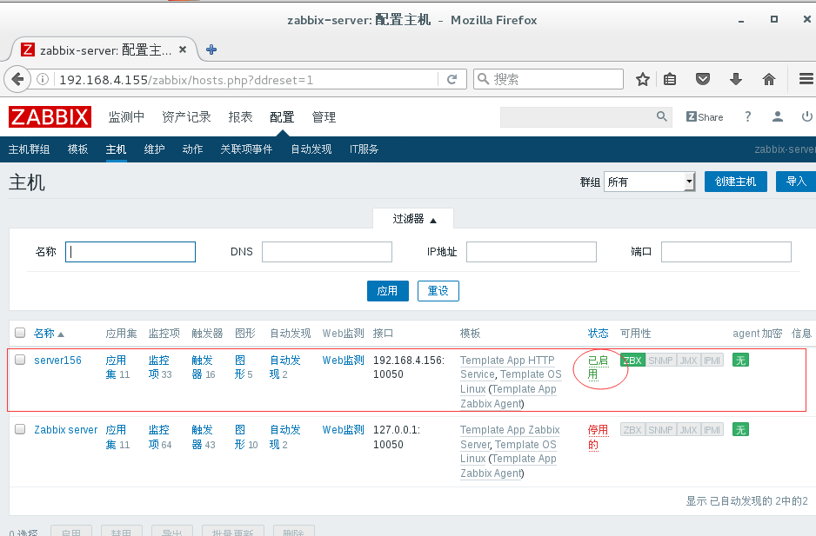

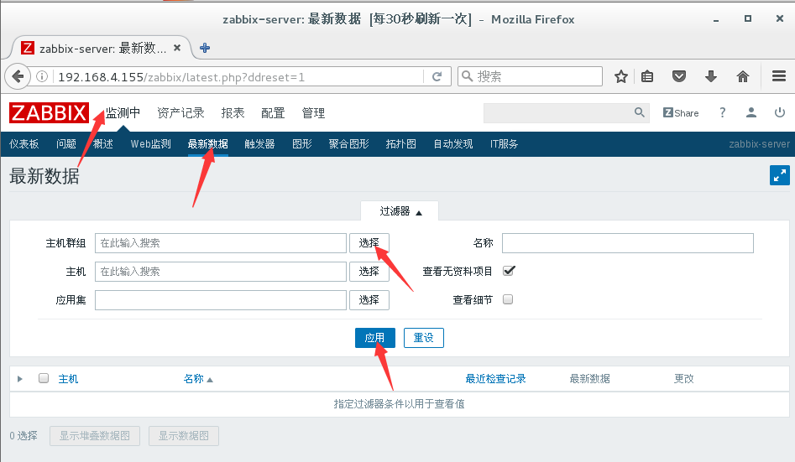

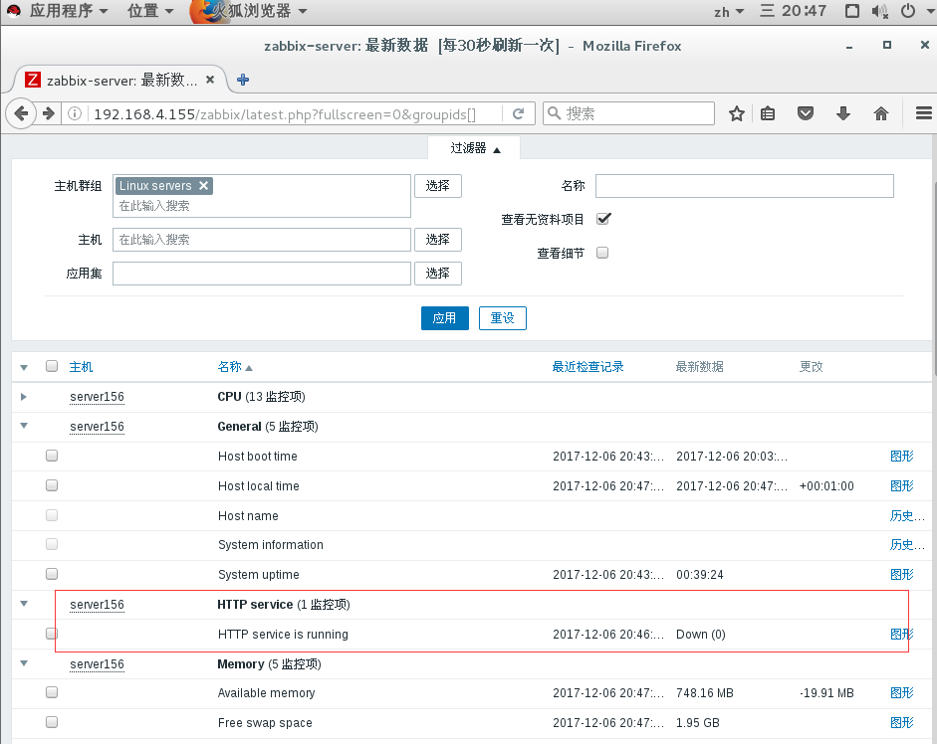

#监控本机

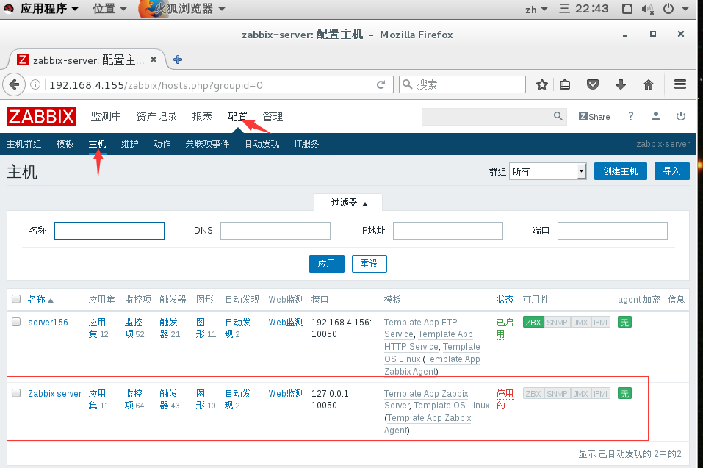

[root@zabbixserver ~]# netstat -anptu | grep :10050

tcp 0 0 192.168.4.155:44362 192.168.4.156:10050 TIME_WAIT -

[root@zabbixserver ~]# grep -v ^# /usr/local/zabbix/etc/zabbix_agentd.conf | grep -v ^$

LogFile=/tmp/zabbix_agentd.log

Server=127.0.0.1

ServerActive=127.0.0.1:10051

Hostname=Zabbix server

[root@zabbixserver ~]# cp zabbix-3.2.3/misc/init.d/fedora/core/zabbix_agentd /etc/init.d/

[root@zabbixserver ~]# chmod +x /etc/init.d/zabbix_agentd

[root@zabbixserver ~]# sed -n '22p' /etc/init.d/zabbix_agentd

BASEDIR=/usr/local/Zabbix

[root@zabbixserver ~]# netstat -anptu | grep :10050

tcp 0 0 0.0.0.0:10050 0.0.0.0:* LISTEN 3143/zabbix_agentd

tcp 0 0 192.168.4.155:44810 192.168.4.156:10050 TIME_WAIT -

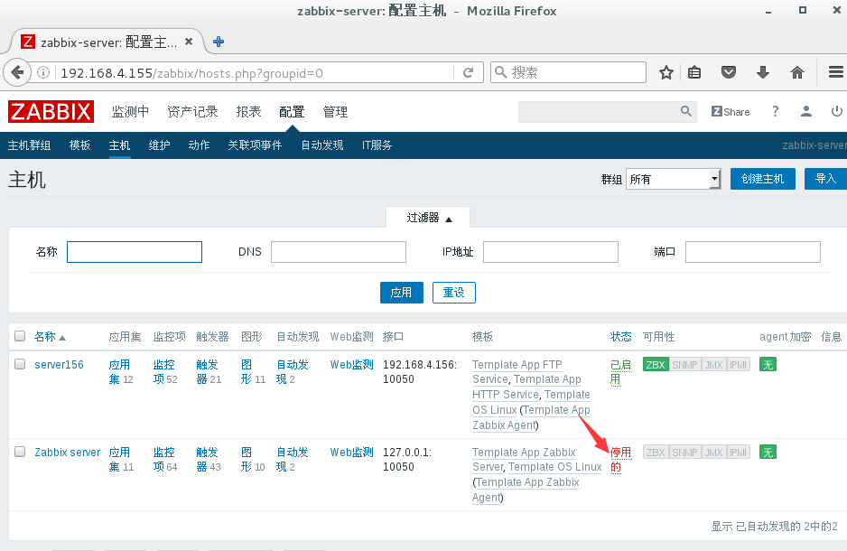

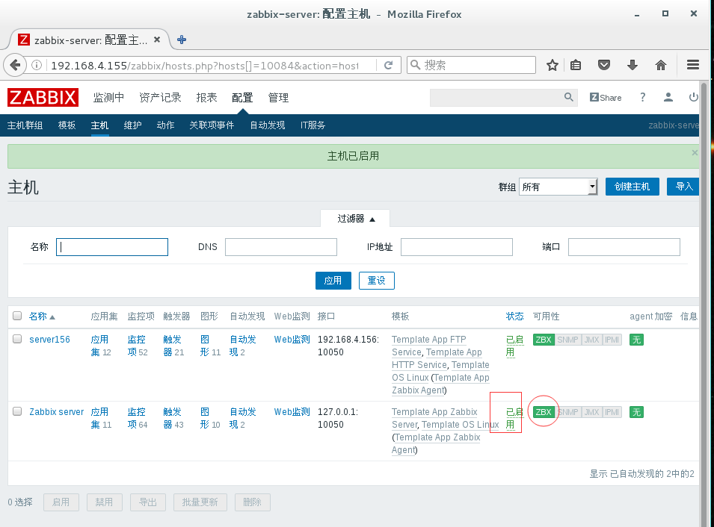

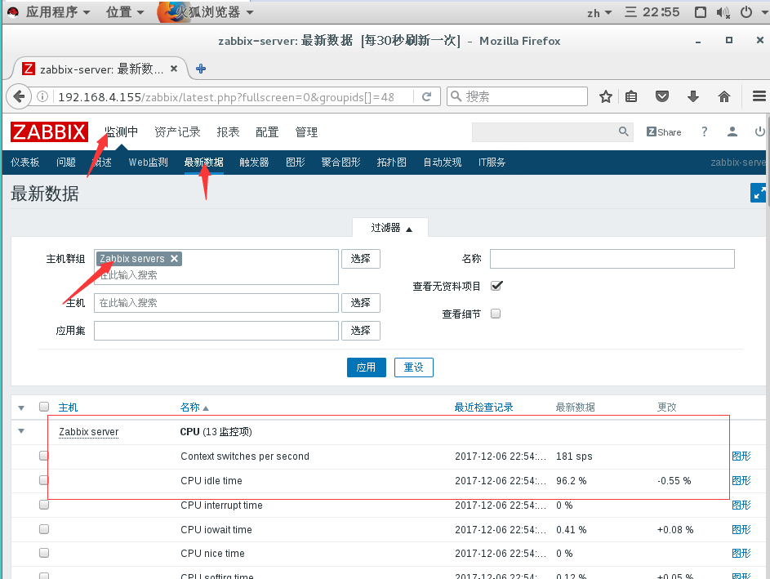

#自定义监控项

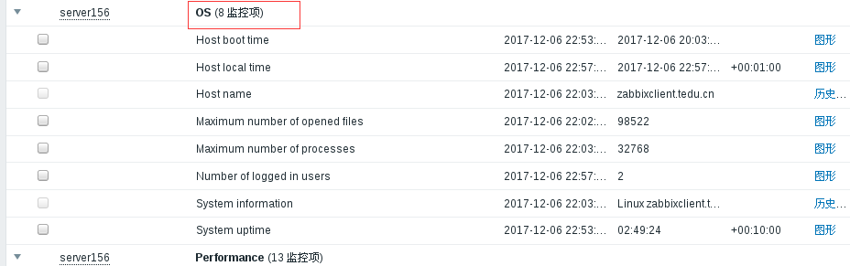

[root@zabbixclient ~]# sed -n '262p' /usr/local/zabbix/etc/zabbix_agentd.conf

Include=/usr/local/zabbix/etc/zabbix_agentd.conf.d/

[root@zabbixclient ~]# sed -n '278p' /usr/local/zabbix/etc/zabbix_agentd.conf

UnsafeUserParameters=1

[root@zabbixclient ~]# cat /usr/local/zabbix/etc/zabbix_agentd.conf.d/user.conf

UserParameter=get_sum_users,wc -l /etc/passwd | awk '{print $1}'

[root@zabbixclient ~]# /etc/init.d/zabbix_agentd stop

Stopping zabbix_agentd (via systemctl): [ 确定 ]

[root@zabbixclient ~]# /etc/init.d/zabbix_agentd start

Starting zabbix_agentd (via systemctl): [ 确定 ]

[root@zabbixclient ~]# /usr/local/zabbix/bin/zabbix_get -s 127.0.0.1 -p 10050 -k get_sum_users

28

[root@zabbixserver ~]# /usr/local/zabbix/bin/zabbix_get -s 192.168.4.156 -p 10050 -k get_sum_users

28

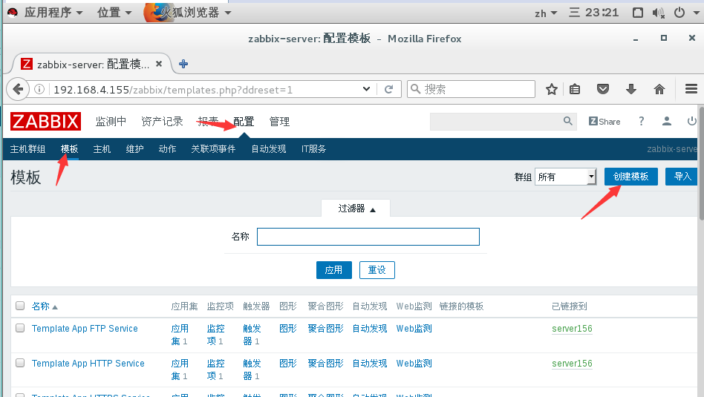

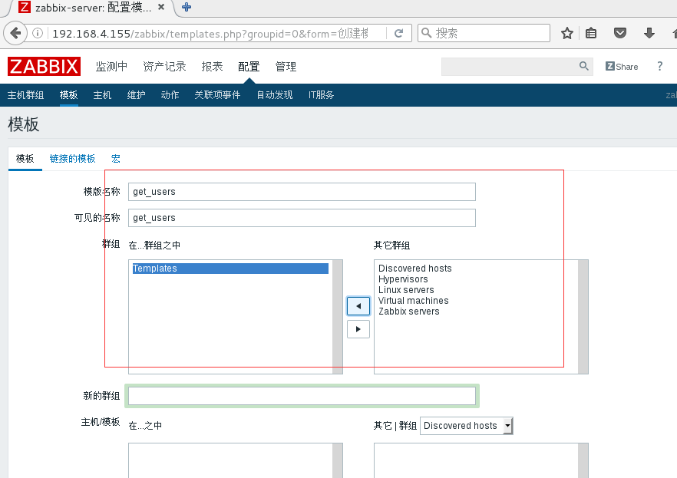

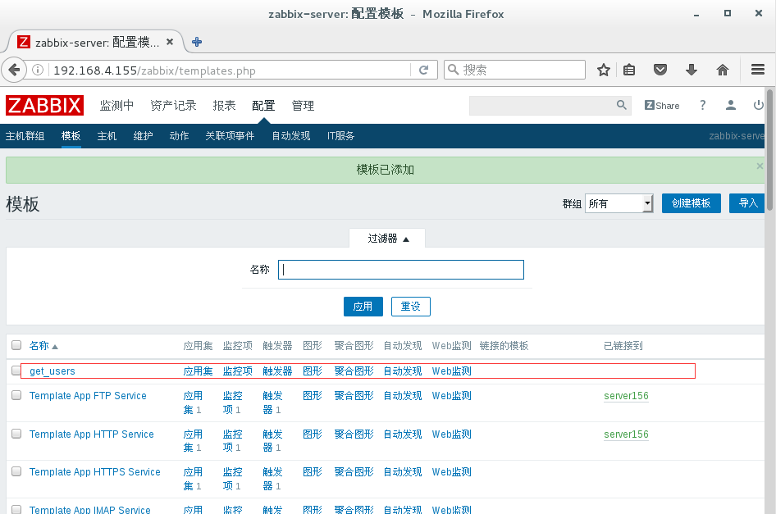

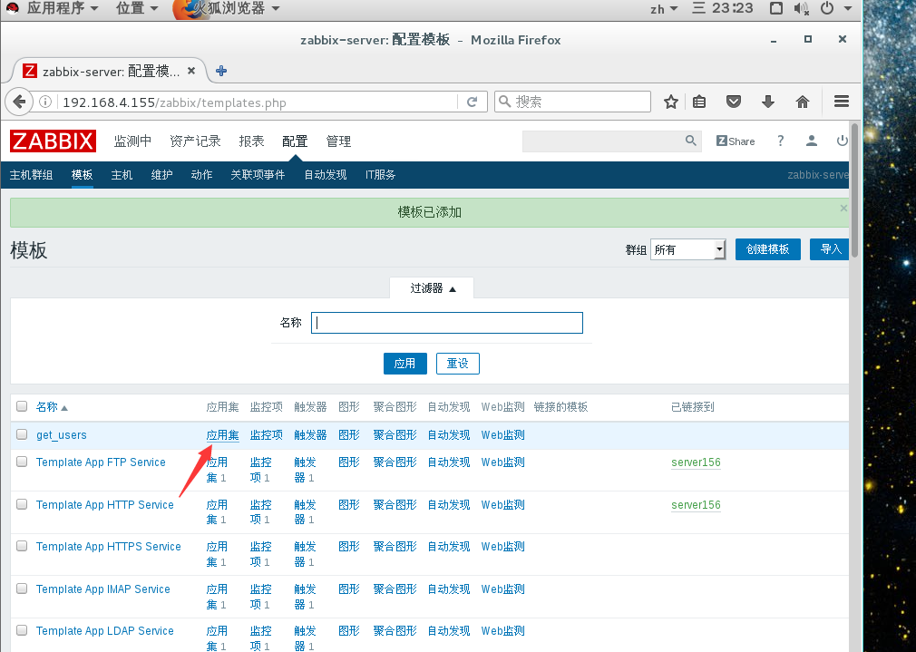

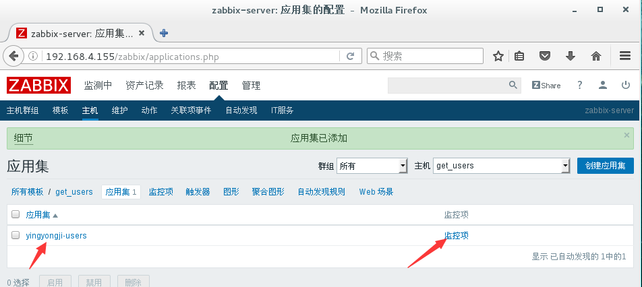

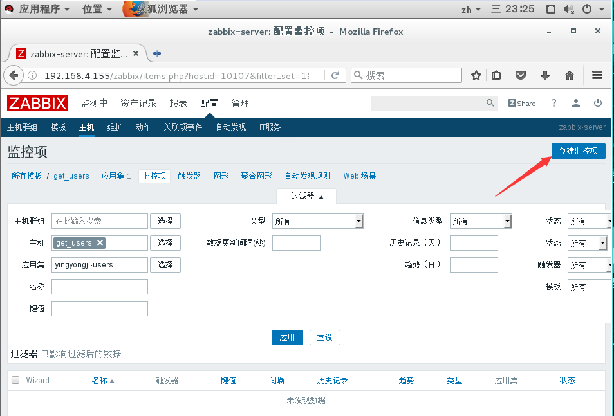

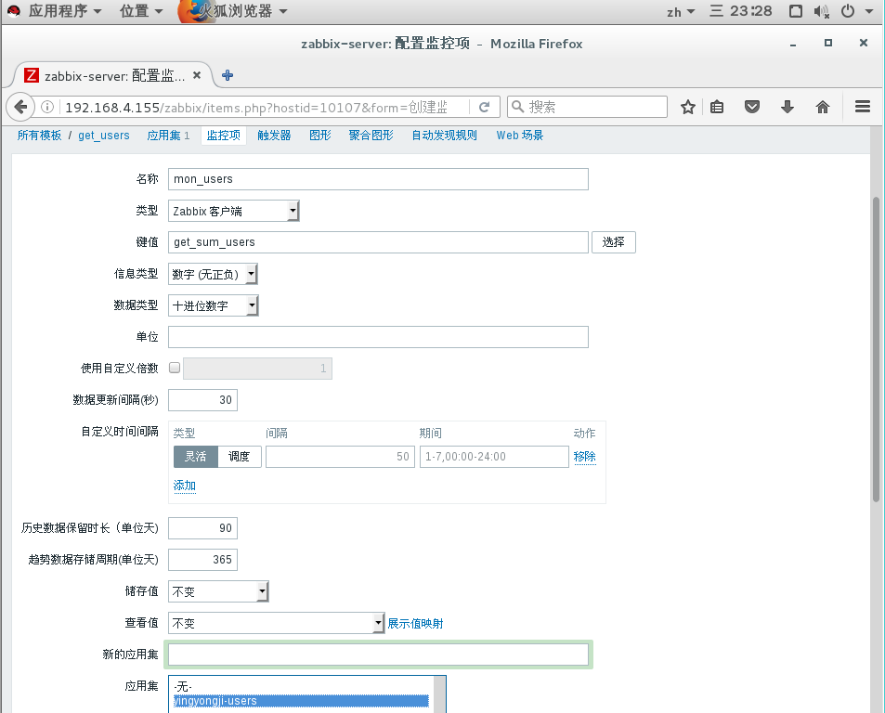

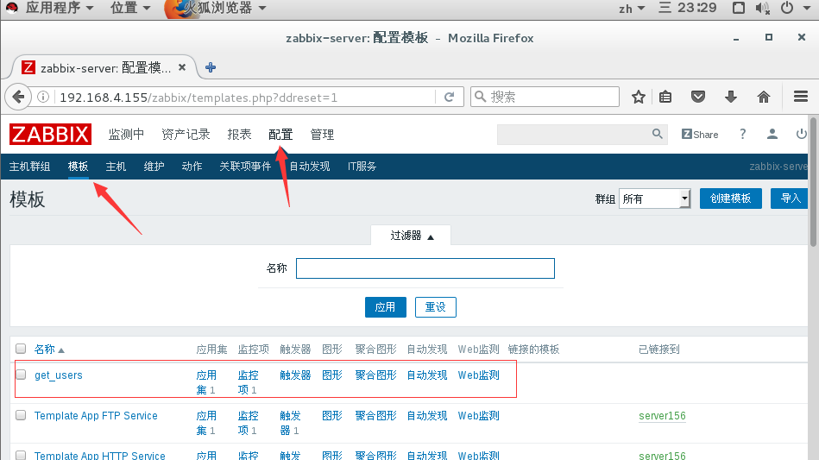

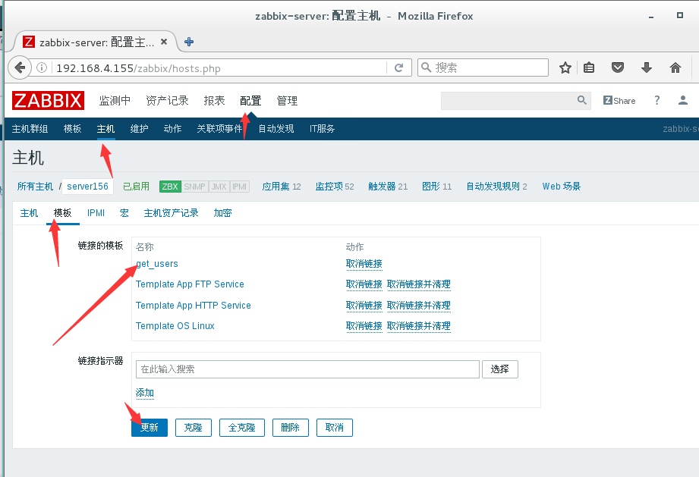

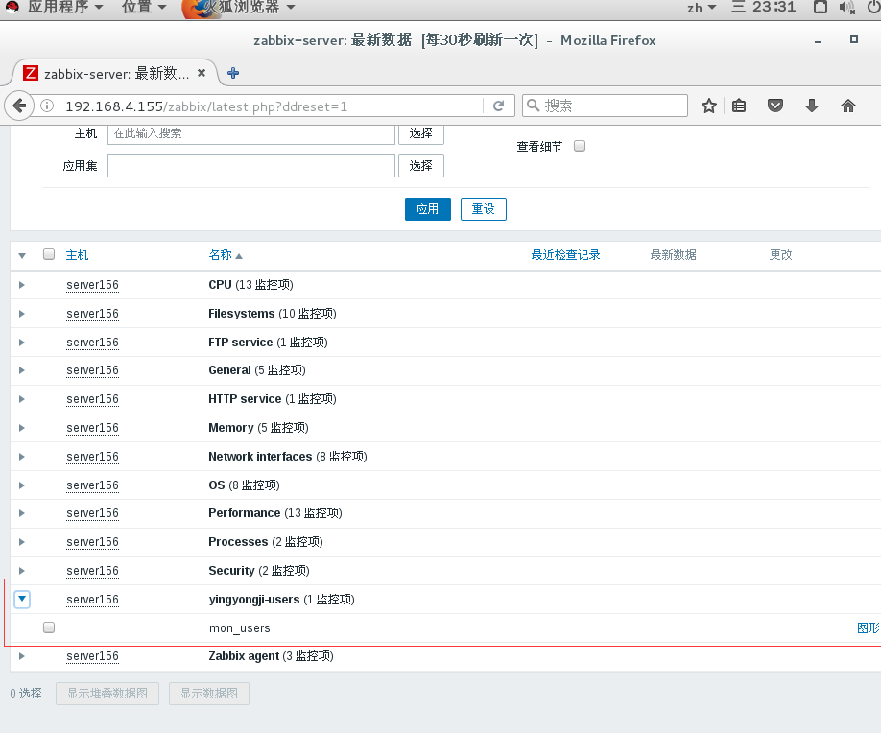

[root@zabbixserver ~]# systemctl status postfix.service

● postfix.service - Postfix Mail Transport Agent

Loaded: loaded (/usr/lib/systemd/system/postfix.service; enabled; vendor preset: disabled)

Active: active (running) since 三 2017-12-06 20:01:33 CST; 3h 32min ago

Main PID: 839 (master)

[root@zabbixserver ~]# mail -s 'test' zabbix < /etc/hosts

[root@zabbixserver ~]# mail -u zabbix

Heirloom Mail version 12.5 7/5/10. Type ? for help.

"/var/mail/zabbix": 1 message 1 new

>N 1 root Wed Dec 6 23:34 19/753 "test"

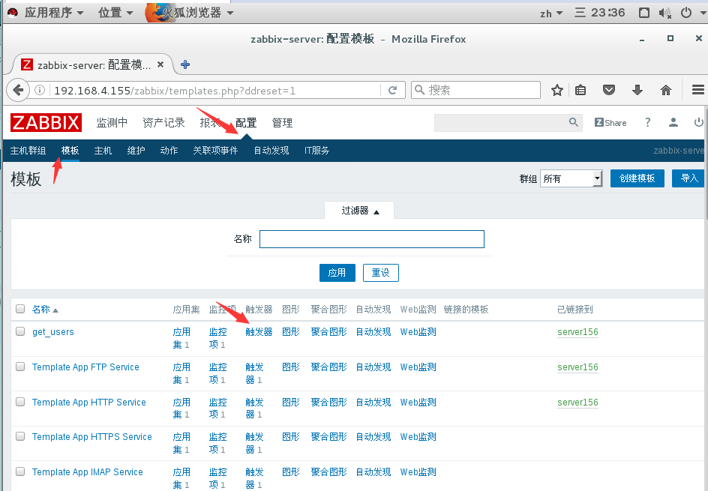

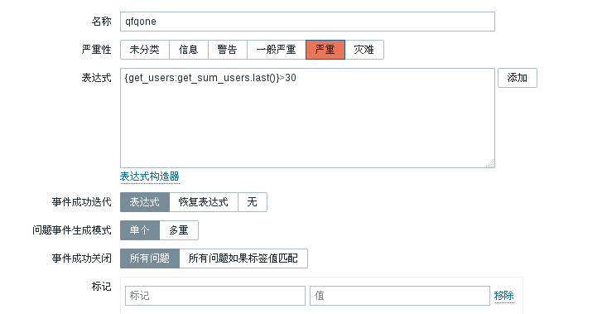

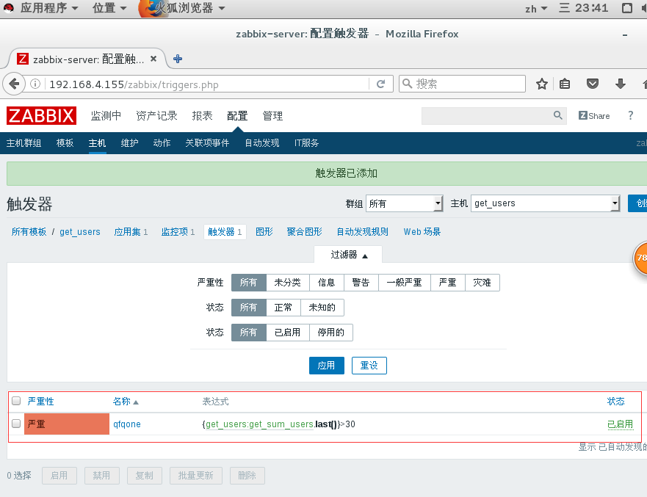

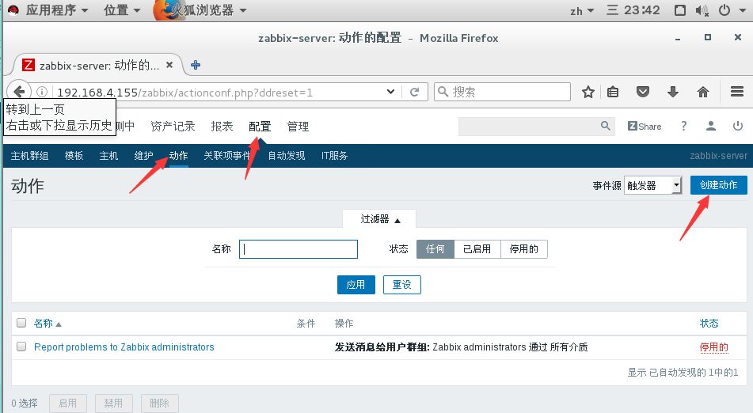

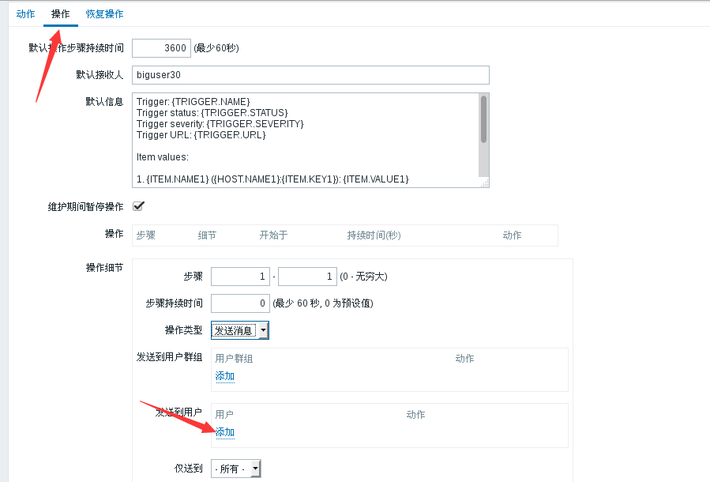

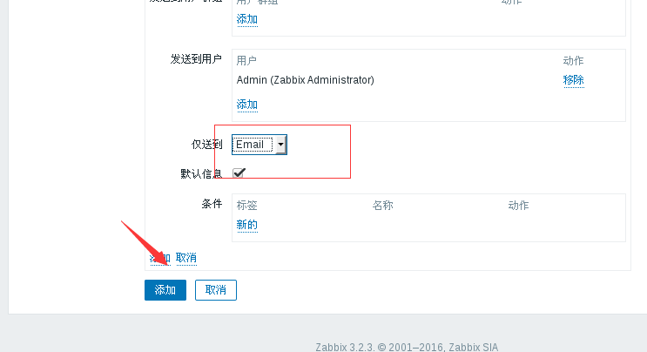

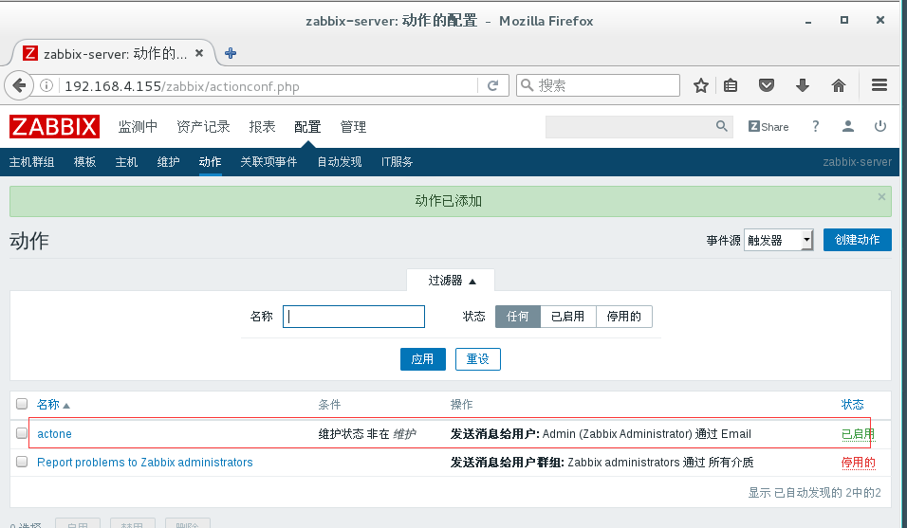

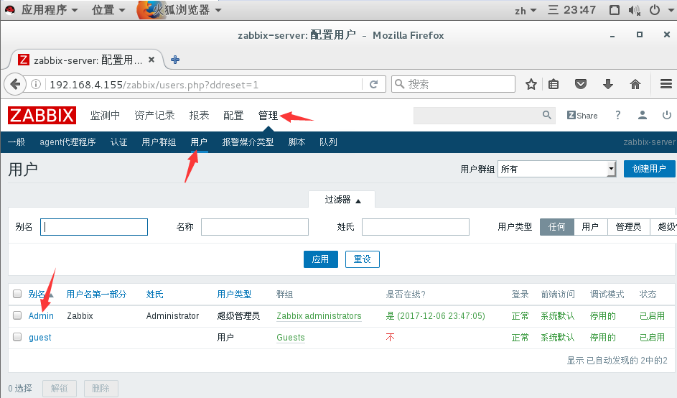

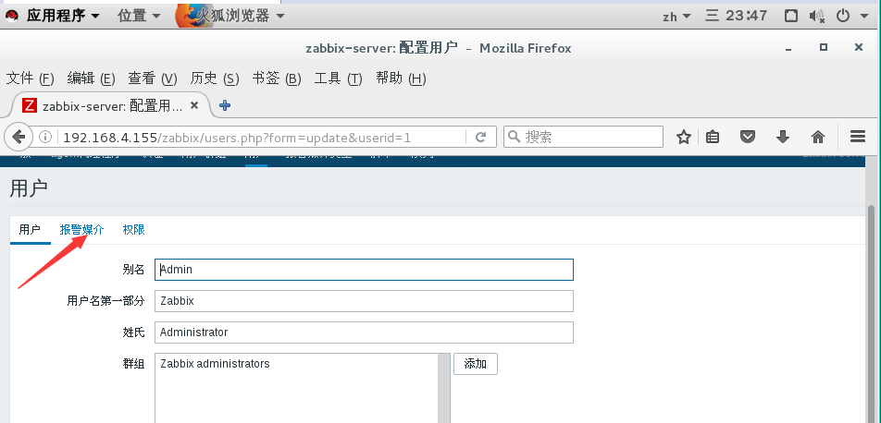

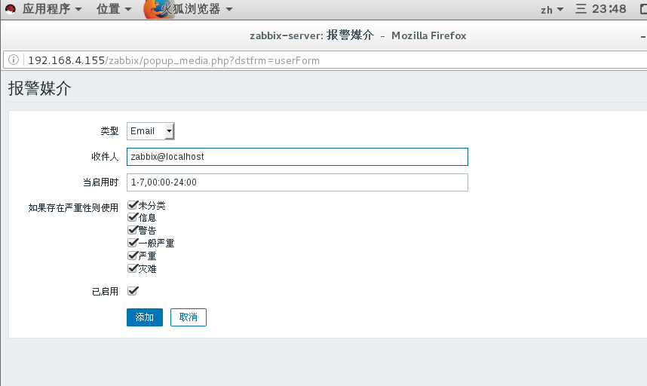

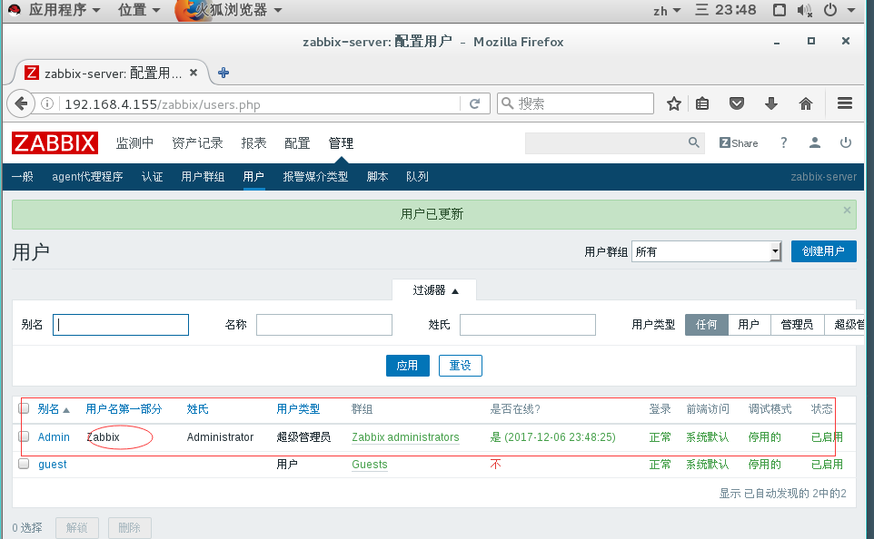

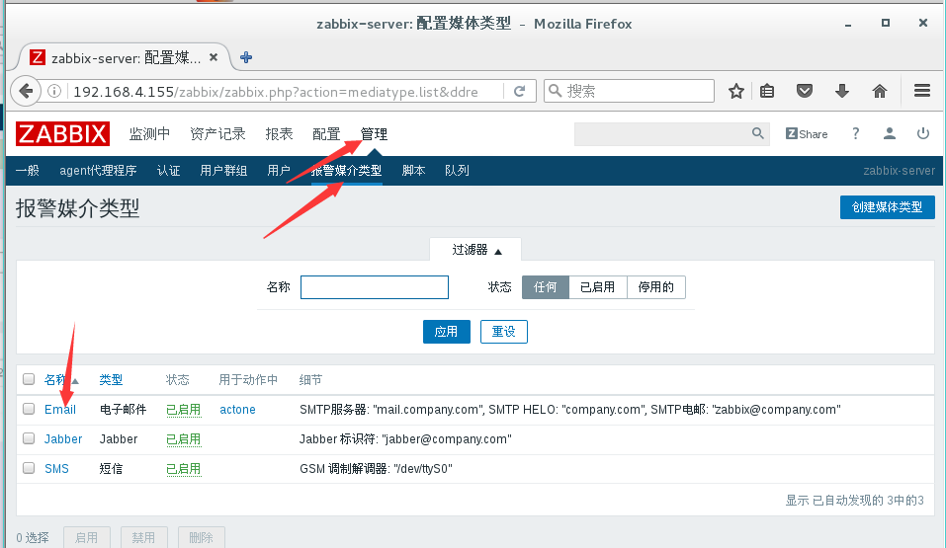

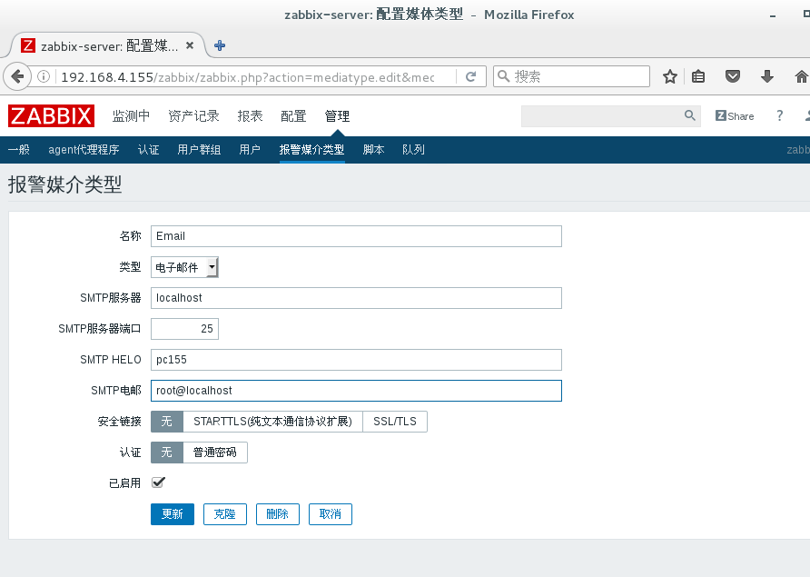

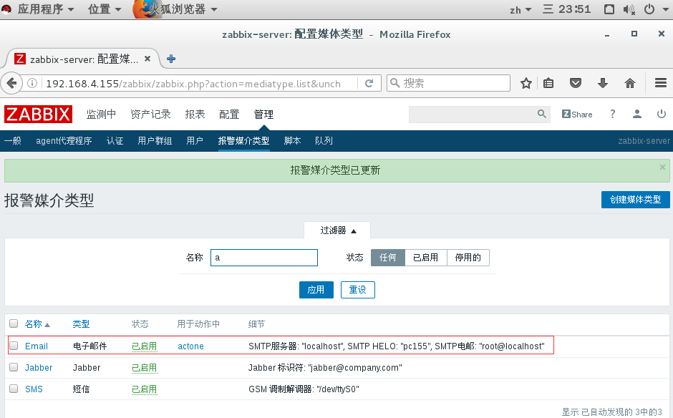



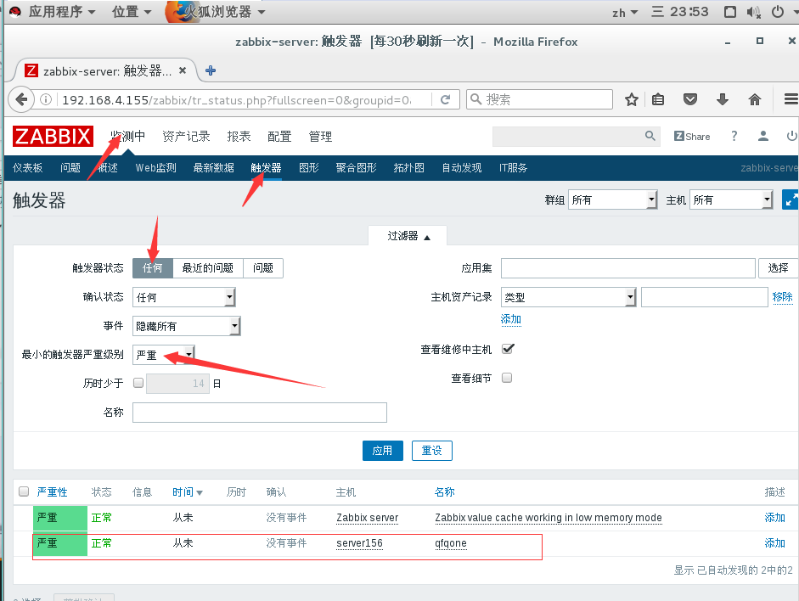

[root@zabbixclient ~]# useradd zhangsan

[root@zabbixclient ~]# useradd zhangsi

[root@zabbixclient ~]# useradd zhangwu

