搭建基于LNMP的WordPress和uwsgi+Django运行环境

#环境、材料准备：rhel7.5虚拟机一台

[root@server15 ~]# ls

install_py3.sh myansi.tar.gz nginx-1.12.2.tar.gz php-fpm-5.4.16-42.el7.x86_64.rpm Python-3.6.8.tgz wordpress-4.9-zh_CN.zip

#部署Python3运行环境

[root@server15 ~]# bash install_py3.sh

#部署LNMP平台

[root@server15 ~]# yum -y install gcc make openssl-devel php php-mysql mariadb mariadb-server

[root@server15 ~]# useradd -s /sbin/nologin nginx

[root@server15 ~]# tar -xf nginx-1.12.2.tar.gz

[root@server15 ~]# cd nginx-1.12.2/

[root@server15 nginx-1.12.2]# ./configure --prefix=/usr/local/nginx --user=nginx --group=nginx --with-http_ssl_module

[root@server15 nginx-1.12.2]# make && make install

[root@server15 nginx-1.12.2]# cd /usr/local/nginx/

[root@server15 nginx]# ./sbin/nginx

[root@server15 nginx]# ss -ntplu | grep nginx

tcp LISTEN 0 128 *:80 *:* users:(("nginx",pid=17589,fd=6),("nginx",pid=17588,fd=6))

[root@server15 ~]# systemctl start php-fpm.service

[root@server15 ~]# ss -ntplu | grep php

tcp LISTEN 0 128 127.0.0.1:9000 *:* users:(("php-fpm",pid=17649,fd=0),("php-fpm",pid=17648,fd=0),("php-fpm",pid=17647,fd=0),("php-fpm",pid=17646,fd=0),("php-fpm",pid=17645,fd=0),("php-fpm",pid=17643,fd=6))

#测试php

[root@server15 ~]# cd /usr/local/nginx/

[root@server15 nginx]# vim conf/nginx.conf

[root@server15 nginx]# sed -i "/^$/d" conf/nginx.conf

[root@server15 nginx]# sed -i "/#/d" conf/nginx.conf

[root@server15 nginx]# cat conf/nginx.conf

user nginx;

worker_processes 1;

events {

worker_connections 1024;

}

http {

include mime.types;

default_type application/octet-stream;

log_format main '$remote_addr - $remote_user [$time_local] "$request" '

'$status $body_bytes_sent "$http_referer" '

'"$http_user_agent" "$http_x_forwarded_for"';

access_log logs/access.log main;

sendfile on;

keepalive_timeout 65;

gzip on;

server {

listen 80;

server_name localhost;

charset utf-8;

access_log logs/host.access.log main;

location / {

root html;

index index.html index.htm;

}

error_page 500 502 503 504 /50x.html;

location = /50x.html {

root html;

}

location ~ \.php$ {

root html;

fastcgi_pass 127.0.0.1:9000;

fastcgi_index index.php;

include fastcgi.conf;

}

}

}

[root@server15 nginx]# ./sbin/nginx -t

nginx: the configuration file /usr/local/nginx/conf/nginx.conf syntax is ok

nginx: configuration file /usr/local/nginx/conf/nginx.conf test is successful

[root@server15 nginx]# ./sbin/nginx -s reload

[root@server15 nginx]# vim html/info.php

[root@server15 nginx]# cat html/info.php

<?php

phpinfo();

?>

[root@server15 nginx]# curl http://127.0.0.1/info.php

<!DOCTYPE html PUBLIC "-//W3C//DTD XHTML 1.0 Transitional//EN" "DTD/xhtml1-transitional.dtd">

<html xmlns="http://www.w3.org/1999/xhtml"><head>

<style type="text/css">

body {background-color: #ffffff; color: #000000;}

body, td, th, h1, h2 {font-family: sans-serif;}

pre {margin: 0px; font-family: monospace;}

a:link {color: #000099; text-decoration: none; background-color: #ffffff;}

a:hover {text-decoration: underline;}

table {border-collapse: collapse;}

.center {text-align: center;}

.center table { margin-left: auto; margin-right: auto; text-align: left;}

.center th { text-align: center !important; }

td, th { border: 1px solid #000000; font-size: 75%; vertical-align: baseline;}

h1 {font-size: 150%;}

h2 {font-size: 125%;}

.p {text-align: left;}

.e {background-color: #ccccff; font-weight: bold; color: #000000;}

.h {background-color: #9999cc; font-weight: bold; color: #000000;}

.v {background-color: #cccccc; color: #000000;}

.vr {background-color: #cccccc; text-align: right; color: #000000;}

img {float: right; border: 0px;}

hr {width: 600px; background-color: #cccccc; border: 0px; height: 1px; color: #000000;}

</style>

<title>phpinfo()</title><meta name="ROBOTS" content="NOINDEX,NOFOLLOW,NOARCHIVE" /></head>

<body><div class="center">

<table border="0" cellpadding="3" width="600">

<tr class="h"><td>

<a href="http://www.php.net/"><img border="0" src="/info.php?=PHPE9568F34-D428-11d2-A769-00AA001ACF42" alt="PHP Logo" /></a><h1 class="p">PHP Version 5.4.16</h1>

</td></tr>

#测试MySQL

[root@server15 ~]# vim /etc/my.cnf

[root@server15 ~]# sed -i "/^$/d" /etc/my.cnf

[root@server15 ~]# sed -i "/^#/d" /etc/my.cnf

[root@server15 ~]# cat /etc/my.cnf

[mysqld]

character_set_server="utf8"

innodb_file_per_table=1

datadir=/var/lib/mysql

socket=/var/lib/mysql/mysql.sock

symbolic-links=0

[mysqld_safe]

log-error=/var/log/mariadb/mariadb.log

pid-file=/var/run/mariadb/mariadb.pid

!includedir /etc/my.cnf.d

[root@server15 ~]# systemctl restart mariadb

[root@server15 ~]# vim /usr/local/nginx/html/mysql.php

[root@server15 ~]# cat /usr/local/nginx/html/mysql.php

<?php

$mysqli = new mysqli('localhost', 'root', '', 'mysql');

if (mysqli_connect_error()){

die('Uable to connect'). mysqli_connect_error();

}

$sql = "select * from user";

$result = $mysqli->query($sql);

while($row=$result->fetch_array()){

printf("Host:%s", $row[0]);

printf("</br>");

printf("Name:%s", $row[1]);

printf("</br>");

}

?>

[root@server15 ~]# curl http://127.0.0.1/mysql.php

Host:localhost</br>Name:root</br>Host:server15.tedu.cn</br>Name:root</br>Host:127.0.0.1</br>Name:root</br>Host:::1</br>Name:root</br>Host:localhost</br>Name:</br>Host:server15.tedu.cn</br>Name:</br>

[root@server15 ~]#

#LNMP平台构建完成

#部署WordPress

[root@server15 ~]# ls wordpress-4.9-zh_CN.zip

wordpress-4.9-zh_CN.zip

[root@server15 ~]# yum -y install unzip

[root@server15 ~]# unzip wordpress-4.9-zh_CN.zip

[root@server15 ~]# ls wordpress

index.php wp-activate.php wp-comments-post.php wp-cron.php wp-load.php wp-settings.php xmlrpc.php

license.txt wp-admin wp-config-sample.php wp-includes wp-login.php wp-signup.php

readme.html wp-blog-header.php wp-content wp-links-opml.php wp-mail.php wp-trackback.php

[root@server15 ~]# cp -r wordpress/* /usr/local/nginx/html/

[root@server15 ~]# chmod -R 777 /usr/local/nginx/html/

[root@server15 ~]# mysql

MariaDB [(none)]> create database wordpress default character set utf8;

Query OK, 0 rows affected (0.01 sec)

MariaDB [(none)]> grant all on wordpress.* to worduser@'%' identified by '123456';

Query OK, 0 rows affected (0.01 sec)

MariaDB [(none)]> grant all on wordpress.* to worduser@'localhost' identified by '123456';

Query OK, 0 rows affected (0.01 sec)

MariaDB [(none)]> flush privileges;

Query OK, 0 rows affected (0.00 sec)

MariaDB [(none)]> exit

Bye

[root@server15 ~]# cd /usr/local/nginx/

[root@server15 nginx]# vim conf/nginx.conf

[root@server15 nginx]# sed -n "18p" conf/nginx.conf

server_name wordpress.tedu.cn;

[root@server15 nginx]# sed -n "23p" conf/nginx.conf

index index.php index.html index.htm;

[root@server15 nginx]# ./sbin/nginx -t

nginx: the configuration file /usr/local/nginx/conf/nginx.conf syntax is ok

nginx: configuration file /usr/local/nginx/conf/nginx.conf test is successful

[root@server15 nginx]# ./sbin/nginx -s reload

[root@room8pc205 ~]# tail -1 /etc/hosts

192.168.4.15 wordpress.tedu.cn django.tedu.cn

[root@room8pc205 ~]# firefox http://wordpress.tedu.cn/index.php

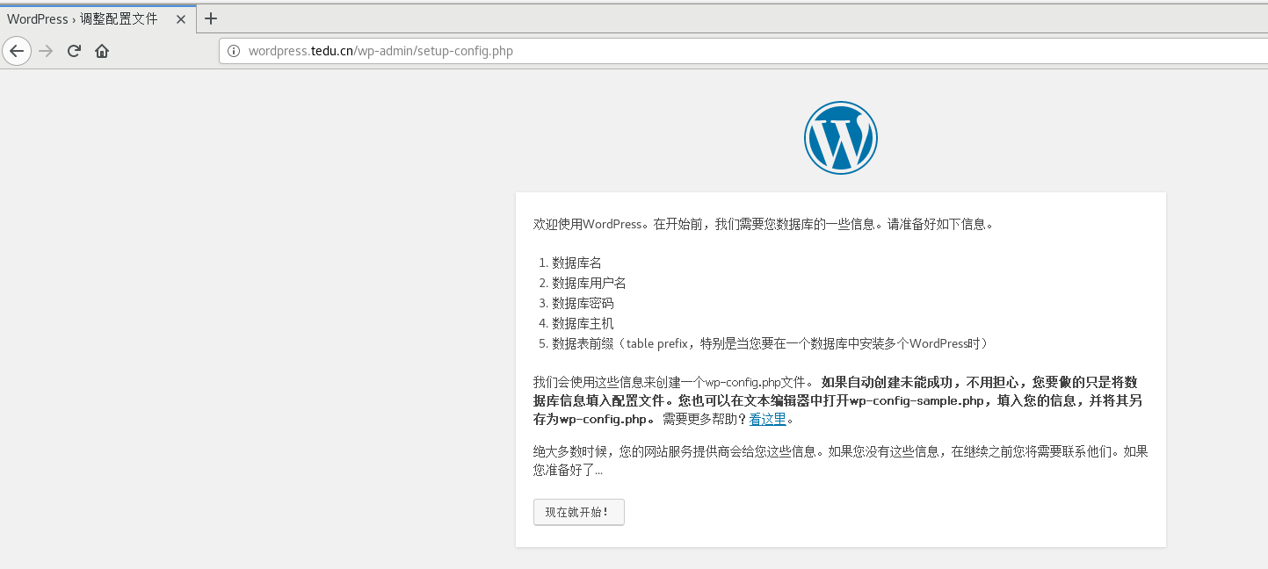

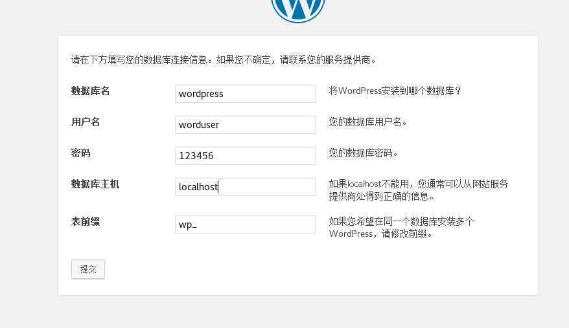



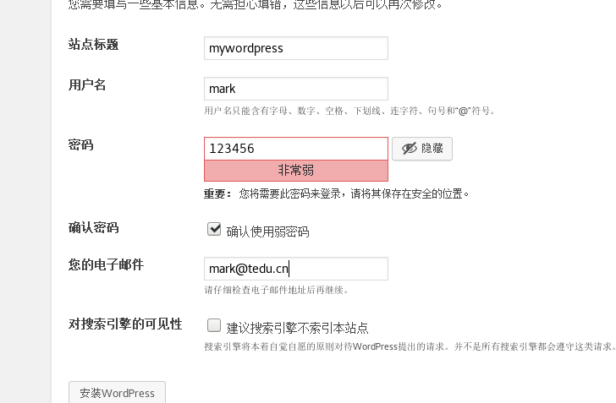



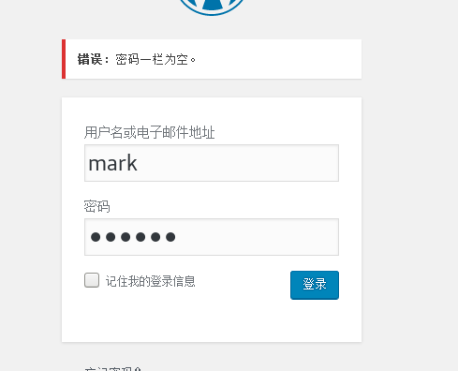

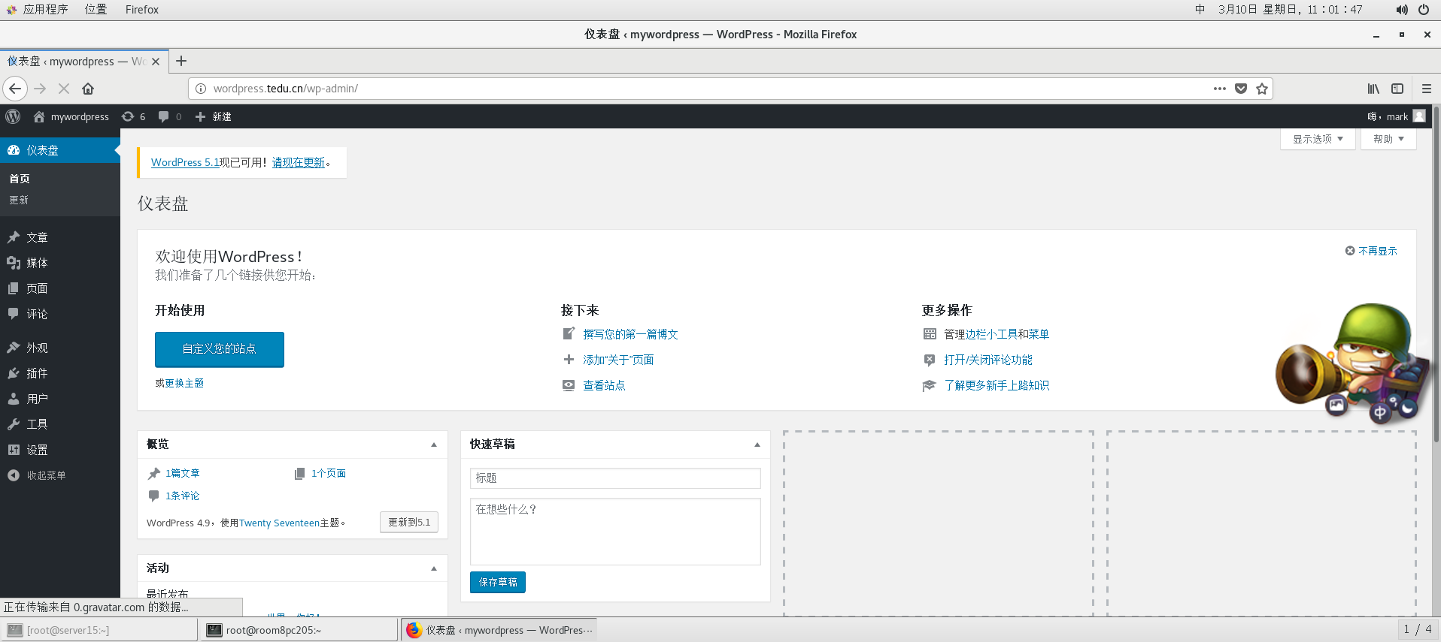

#WordPress安装完成

#部署nginx+uwsgi+Django

[root@server15 nginx]# cd

[root@server15 ~]# ls myansi.tar.gz

myansi.tar.gz

[root@server15 ~]# mkdir /frame

[root@server15 ~]# tar -xf myansi.tar.gz -C /frame/

[root@server15 ~]# ls /frame/

djenv project02

#djenv是Django的虚拟环境

#project02是项目源代码

#修改虚拟环境变量参数

[root@server15 ~]# cd /frame/djenv/bin/

[root@server15 bin]# vim activate

[root@server15 bin]# sed -n "40p" activate

VIRTUAL_ENV="/frame/djenv"

[root@server15 bin]# vim pip

[root@server15 bin]# sed -n '1p' pip

#!/frame/djenv/bin/python3

[root@server15 bin]# vim pip3

[root@server15 bin]# sed -n '1p' pip3

#!/frame/djenv/bin/python3

[root@server15 bin]# vim pip3.6

[root@server15 bin]# sed -n '1p' pip3.6

#!/frame/djenv/bin/python3

#启动虚拟环境

[root@server15 bin]# source activate

(djenv) [root@server15 bin]# pip list | grep django

(djenv) [root@server15 bin]# pip list | grep -i django

Django 1.11.6

#虚拟环境启动成功

#安装uwsgi

(djenv) [root@server15 bin]# pip install uwsgi

Successfully installed uwsgi-2.0.18

#初始化项目数据库

(djenv) [root@server15 bin]# mysql

MariaDB [(none)]> set password=password('123456');

Query OK, 0 rows affected (0.00 sec)

MariaDB [(none)]> create database myansi default character set utf8;

Query OK, 1 row affected (0.00 sec)

MariaDB [(none)]> exit

Bye

(djenv) [root@server15 bin]# cd /frame/project02/myansible/

(djenv) [root@server15 myansible]# ls

ansicfg manage.py myansible webansi

(djenv) [root@server15 myansible]# python manage.py makemigrations

No changes detected

(djenv) [root@server15 myansible]# python manage.py migrate

Operations to perform:

Apply all migrations: admin, auth, contenttypes, sessions, webansi

Running migrations:

Applying contenttypes.0001_initial... OK

Applying auth.0001_initial... OK

Applying admin.0001_initial... OK

Applying admin.0002_logentry_remove_auto_add... OK

Applying contenttypes.0002_remove_content_type_name... OK

Applying auth.0002_alter_permission_name_max_length... OK

Applying auth.0003_alter_user_email_max_length... OK

Applying auth.0004_alter_user_username_opts... OK

Applying auth.0005_alter_user_last_login_null... OK

Applying auth.0006_require_contenttypes_0002... OK

Applying auth.0007_alter_validators_add_error_messages... OK

Applying auth.0008_alter_user_username_max_length... OK

Applying sessions.0001_initial... OK

Applying webansi.0001_initial... OK

#测试uwsgi环境

(djenv) [root@server15 myansible]# uwsgi --http :8001 --wsgi-file test.py

#会报warning，以root身份运行uwsgi，不用管，因为这个项目涉及到ansible，如果降级启动无法向/root/.ansible/tmp写入文件

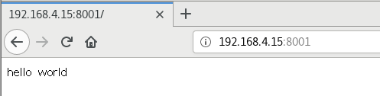

#测试访问192.168.4.15的8001端口，页面上见到helloworld表示环境配置成功

#测试Django项目

(djenv) [root@server15 myansible]# uwsgi --http :8000 --chdir=/frame/project02/myansible --wsgi-file=/frame/project02/myansible/myansible/wsgi.py --master --processes 4 --threads 2

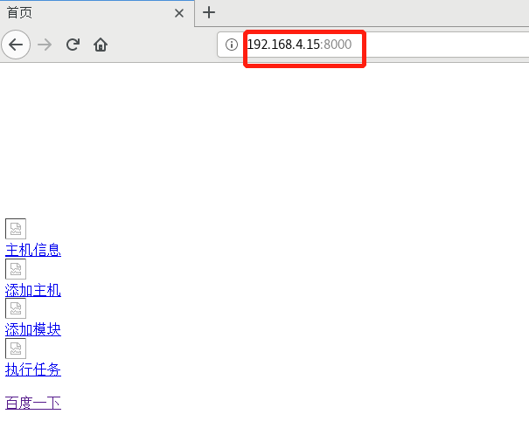

#页面访问如此即为正常，因为静态资源不能正常加载

#编写nginx_uwsgi的链接文件

(djenv) [root@server15 myansible]# vim n_py.xml

(djenv) [root@server15 myansible]# cat n_py.xml

<uwsgi>

<socket>127.0.0.1:8000</socket>

<listen>80</listen>

<pidfile>uwsgi.pid</pidfile>

<master>true</master>

<chdir>/frame/project02/myansible</chdir>

<module>myansible.wsgi</module>

<processes>4</processes>

<threads>2</threads>

<daemonize>/var/log/uwsgi.log</daemonize>

</uwsgi>

#启动uwsgi程序

(djenv) [root@server15 myansible]# uwsgi -x n_py.xml

[uWSGI] parsing config file n_py.xml

(djenv) [root@server15 myansible]# ss -ntplu | grep :8000

tcp LISTEN 0 80 127.0.0.1:8000 *:* users:(("uwsgi",pid=19821,fd=3),("uwsgi",pid=19818,fd=3),("uwsgi",pid=19817,fd=3),("uwsgi",pid=19816,fd=3),("uwsgi",pid=19814,fd=3))

#出现红色提示语句表示uwsgi程序启动成功

#配置nginx

(djenv) [root@server15 myansible]# cd /usr/local/nginx/

(djenv) [root@server15 nginx]# vim conf/nginx.conf

(djenv) [root@server15 nginx]# tail conf/nginx.conf

server {

listen 80;

server_name django.tedu.cn;

charset utf-8;

location / {

include uwsgi_params;

uwsgi_pass 127.0.0.1:8000;

}

}

}

(djenv) [root@server15 nginx]# ./sbin/nginx -t

nginx: the configuration file /usr/local/nginx/conf/nginx.conf syntax is ok

nginx: configuration file /usr/local/nginx/conf/nginx.conf test is successful

(djenv) [root@server15 nginx]# ./sbin/nginx -s reload

#测试访问

[root@root8pc205 ~]# firefox http://django.tedu.cn

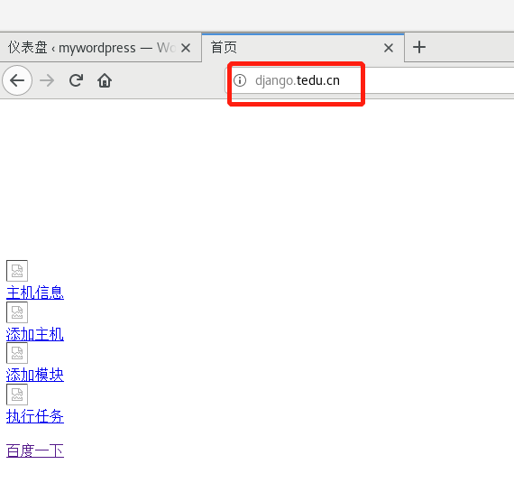

#见到此页面表示nginx链接uwsgi程序成功，还需要配置静态资源

#修改nginx配置文件

(djenv) [root@server15 nginx]# vim conf/nginx.conf

(djenv) [root@server15 nginx]# tail -15 conf/nginx.conf

}

server {

listen 80;

server_name django.tedu.cn;

charset utf-8;

location / {

include uwsgi_params;

uwsgi_pass 127.0.0.1:8000;

}

location /static/ {

alias /frame/project02/myansible/webansi/static/;

index index.html;

}

}

}

(djenv) [root@server15 nginx]# ./sbin/nginx -t

nginx: the configuration file /usr/local/nginx/conf/nginx.conf syntax is ok

nginx: configuration file /usr/local/nginx/conf/nginx.conf test is successful

(djenv) [root@server15 nginx]# ./sbin/nginx -s reload

#重载nginx以后刷新页面

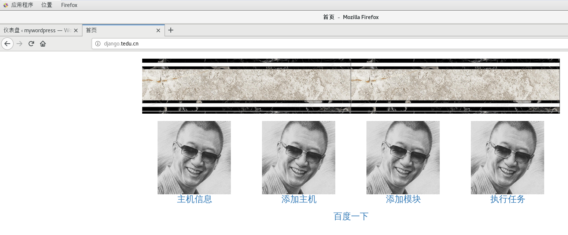

#带有bootstrap的页面加载成功，nginx+uswgi+Django部署成功