安装PHPMyAdmin图形管理工具

实验环境：

rhel7.5系统虚拟机

IP地址：192.168.4.50

关闭防火墙、SELinux

配置好yum

安装好MySQL5.7的rpm包

基于lamp平台：

[root@mysql_server ~]# systemctl status mysqld

● mysqld.service - MySQL Server

Loaded: loaded (/usr/lib/systemd/system/mysqld.service; enabled; vendor preset: disabled)

Active: active (running) since 三 2018-10-31 11:17:19 CST; 3h 26min ago

Docs: man:mysqld(8)

[root@mysql_server ~]# yum -y install httpd php php-mysql

[root@mysql_server ~]# systemctl start httpd

[root@mysql_server ~]# vim /var/www/html/mysql.php

[root@mysql_server ~]# cat /var/www/html/mysql.php

<?php

$link=mysql_connect("localhost","root","123456");

if(!$link) echo "Failed";

else echo "Succeeful";

?>

[root@mysql_server ~]# curl http://127.0.0.1/mysql.php

Succeeful

[root@mysql_server ~]#

[root@mysql_server ~]# tar -xf phpMyAdmin-2.11.11-all-languages.tar.gz

[root@mysql_server ~]# mv phpMyAdmin-2.11.11-all-languages /var/www/html/pma

[root@mysql_server ~]# chown -R apache:apache /var/www/html/pma/

[root@mysql_server ~]# cd /var/www/html/pma/

[root@mysql_server pma]# cp config.sample.inc.php config.inc.php

[root@mysql_server pma]# vim config.inc.php

[root@mysql_server pma]# sed -n "17p;31p" config.inc.php

$cfg['blowfish_secret'] = 'tarena'; /* YOU MUST FILL IN THIS FOR COOKIE AUTH! */

$cfg['Servers'][$i]['host'] = 'localhost';

[root@room8pc205 ~]# firefox <http://192.168.4.50/pma>

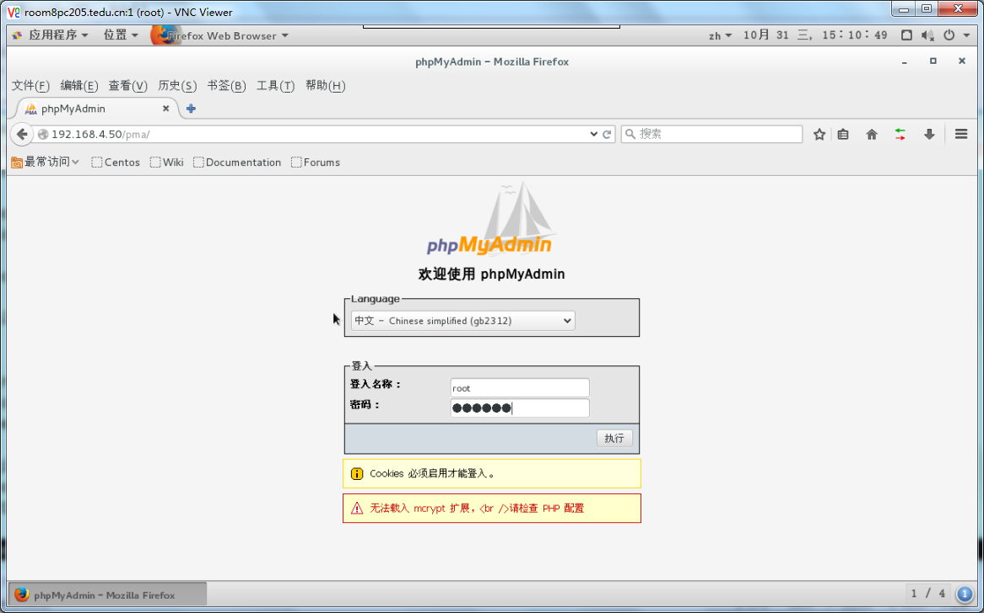

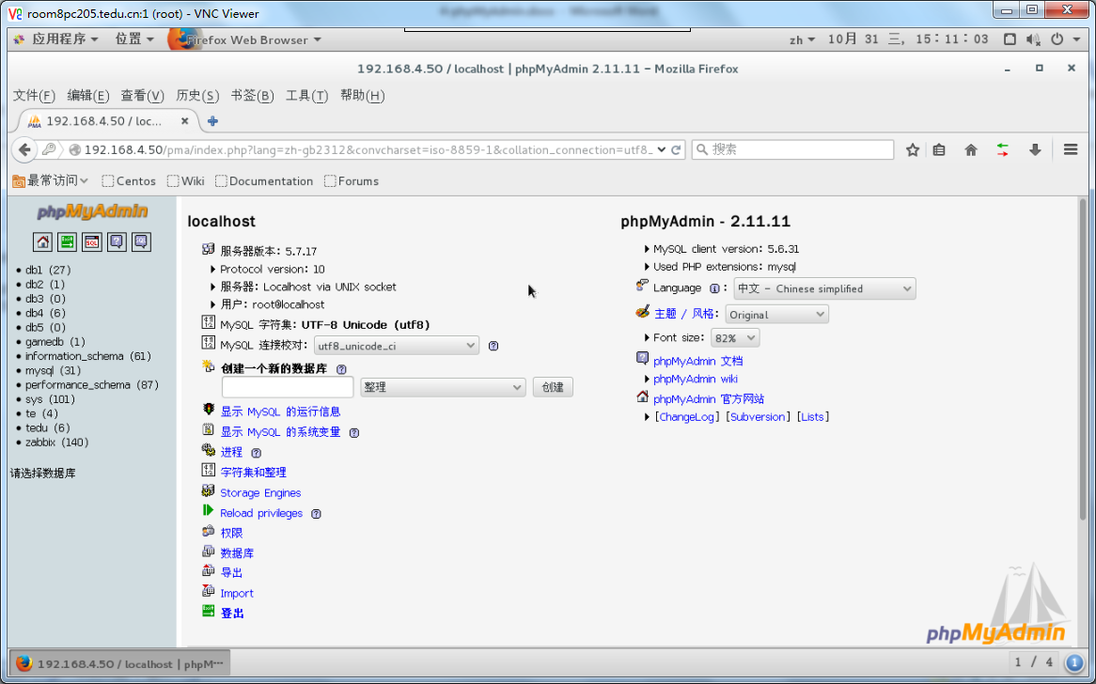

基于lnmp平台：

[root@mysql_server ~]# systemctl status mysqld

● mysqld.service - MySQL Server

Loaded: loaded (/usr/lib/systemd/system/mysqld.service; enabled; vendor preset: disabled)

Active: active (running) since 三 2018-10-31 11:17:19 CST; 3h 26min ago

Docs: man:mysqld(8)

[root@mysql_server ~]# systemctl stop httpd

[root@mysql_server ~]# useradd -s /sbin/nologin nginx

[root@mysql_server ~]# tar -xf nginx-1.12.2.tar.gz

[root@mysql_server ~]# cd nginx-1.12.2/

[root@mysql_server nginx-1.12.2]# yum -y install gcc pcre-devel

[root@mysql_server nginx-1.12.2]# ./configure --prefix=/usr/local/nginx --user=nginx --group=nginx

[root@mysql_server nginx-1.12.2]# make && make install

[root@mysql_server nginx-1.12.2]# cd

[root@mysql_server ~]# rpm -ivh --nodeps php-fpm-5.4.16-42.el7.x86_64.rpm

[root@mysql_server ~]# vim /usr/local/nginx/conf/nginx.conf

[root@mysql_server ~]# cat /usr/local/nginx/conf/nginx.conf | grep -v ^$ | grep -v "#"

worker_processes 1;

events {

worker_connections 1024;

}

http {

include mime.types;

default_type application/octet-stream;

sendfile on;

keepalive_timeout 65;

server {

listen 80;

server_name localhost;

location / {

root html;

index index.html index.htm;

}

error_page 500 502 503 504 /50x.html;

location = /50x.html {

root html;

}

location ~ \.php$ {

root html;

fastcgi_pass 127.0.0.1:9000;

fastcgi_index index.php;

include fastcgi.conf;

}

}

}

[root@mysql_server ~]# ln -s /usr/local/nginx/sbin/nginx /sbin/

[root@mysql_server ~]# nginx

[root@mysql_server ~]# netstat -antpu | grep nginx

tcp 0 0 0.0.0.0:80 0.0.0.0:* LISTEN 11814/nginx: master

[root@mysql_server ~]# systemctl start php-fpm.service

[root@mysql_server ~]# netstat -antpu | grep php

tcp 0 0 127.0.0.1:9000 0.0.0.0:* LISTEN 11842/php-fpm: mast

[root@mysql_server ~]# cp /var/www/html/mysql.php /usr/local/nginx/html/

[root@mysql_server ~]# curl http://127.0.0.1/mysql.php

Succeeful[root@mysql_server ~]# cat /usr/local/nginx/html/mysql.php

<?php

$link=mysql_connect("localhost","root","123456");

if(!$link) echo "Failed";

else echo "Succeeful";

?>

[root@mysql_server ~]# tar -xf phpMyAdmin-2.11.11-all-languages.tar.gz

[root@mysql_server ~]# mv phpMyAdmin-2.11.11-all-languages /usr/local/nginx/html/pma

[root@mysql_server ~]# chown -R nginx:nginx /usr/local/nginx/html/pma/

[root@mysql_server ~]# cd /usr/local/nginx/html/pma/

[root@mysql_server pma]# cp config.sample.inc.php config.inc.php

[root@mysql_server pma]# vim config.inc.php

[root@mysql_server pma]# sed -n '17p;31p' config.inc.php

$cfg['blowfish_secret'] = 'tedu'; /* YOU MUST FILL IN THIS FOR COOKIE AUTH! */

$cfg['Servers'][$i]['host'] = 'localhost';

[root@room8pc205 ~]# firefox http://192.168.4.50/pma

