Tomcat-session共享

环境：centos7.4虚拟机4台，搭建好yum，关闭防火墙，SELinux，清空iptables规则

IP地址： nginx 192.168.1.1 nginx 反向代理

Tomcat1 192.168.1.2 Tomcat web服务器

Tomcat2 192.168.1.3 Tomcat web服务器

Cache 192.168.1.4 memcached、redis 缓存服务器

[root@tomcat1 ~]# tar -xf apache-tomcat-8.0.30.tar.gz

[root@tomcat1 ~]# mv apache-tomcat-8.0.30 /usr/local/tocmat

[root@tomcat1 ~]# cd /usr/local/tocmat/

[root@tomcat1 tocmat]# echo tomcat1 >> webapps/ROOT/test.html

[root@tomcat1 tocmat]# rm -rf /dev/random

[root@tomcat1 tocmat]# ln -s /dev/urandom /dev/random

[root@tomcat1 tocmat]# ./bin/startup.sh

[root@tomcat1 tocmat]# netstat -antpu | grep java

tcp6 0 0 :::8080 :::* LISTEN 1522/java

tcp6 0 0 127.0.0.1:8005 :::* LISTEN 1522/java

tcp6 0 0 :::8009 :::* LISTEN 1522/java

[root@tomcat1 tocmat]# curl localhost:8080/test.html

tomcat1

[root@tomcat1 tomcat]#

[root@tomcat2 ~]# tar -xf apache-tomcat-8.0.30.tar.gz

[root@tomcat2 ~]# mv apache-tomcat-8.0.30 /usr/local/tomcat

[root@tomcat2 ~]# cd /usr/local/tomcat/

[root@tomcat2 tomcat]# echo tomcat2 >> webapps/ROOT/test.html

[root@tomcat2 tomcat]# rm -rf /dev/random

[root@tomcat2 tomcat]# ln -s /dev/urandom /dev/random

[root@tomcat2 tomcat]# ./bin/startup.sh

[root@tomcat2 tomcat]# netstat -antpu | grep java

tcp6 0 0 :::8080 :::* LISTEN 1314/java

tcp6 0 0 127.0.0.1:8005 :::* LISTEN 1314/java

tcp6 0 0 :::8009 :::* LISTEN 1314/java

[root@tomcat2 tomcat]# curl localhost:8080/test.html

tomcat2

[root@tomcat2 tomcat]#

[root@proxy ~]# cd /usr/local/nginx/

[root@proxy nginx]# vim conf/nginx.conf

[root@proxy nginx]# sed -rn "35,38p;48,50p" conf/nginx.conf

upstream toms {

server 192.168.1.2:8080;

server 192.168.1.3:8080;

}

location / {

proxy_pass http://toms/;

}

[root@proxy nginx]# ./sbin/nginx -t

nginx: the configuration file /usr/local/nginx/conf/nginx.conf syntax is ok

nginx: configuration file /usr/local/nginx/conf/nginx.conf test is successful

[root@proxy nginx]# ./sbin/nginx

[root@proxy nginx]# curl localhost/test.html

tomcat1

[root@proxy nginx]# curl localhost/test.html

tomcat2

[root@proxy nginx]#

#测试memcached服务

[root@cache ~]# yum -y install memcached

[root@cache ~]# systemctl start memcached.service

[root@cache ~]# netstat -antpu | grep 11211

tcp 0 0 0.0.0.0:11211 0.0.0.0:* LISTEN 1249/memcached

tcp6 0 0 :::11211 :::* LISTEN 1249/memcached

udp 0 0 0.0.0.0:11211 0.0.0.0:* 1249/memcached

udp6 0 0 :::11211 :::* 1249/memcached

[root@cache ~]#

[root@cache ~]# yum -y install httpd php php-devel php-pecl-memcache

[root@cache ~]# systemctl start httpd

[root@cache ~]# cd /var/www/html/

[root@cache html]# vim test.php

[root@cache html]# cat test.php

<?php

$i="33";

echo "$i\n"

?>

[root@cache html]# curl localhost/test.php

33

[root@cache html]# vim mem.php

[root@cache html]# cat mem.php

<?php

$memcache = new Memcache;

$memcache->connect('127.0.0.1', 11211) or die ('could not connect!');

$memcache->set('key', 'testmem');

$get_values=$memcache->get('key');

echo "$get_values";

echo "\n";

?>

[root@cache html]# curl localhost/mem.php

testmem

[root@cache html]#

#测试本地session

[root@tomcat1 ~]# cd /usr/local/tocmat/

[root@tomcat1 tocmat]# vim webapps/ROOT/getsess.jsp

[root@tomcat1 tocmat]# cat webapps/ROOT/getsess.jsp

<html>

<body bgcolor="red">

<center>

<%String s = session.getId();%>

<%=s%>

<h1>

Tomcat1

</h1>

</center>

</body>

</html>

[root@tomcat1 tomcat]#

[root@tomcat2 ~]# cd /usr/local/tomcat/

[root@tomcat2 tomcat]# vim webapps/ROOT/getsess.jsp

[root@tomcat2 tomcat]# cat webapps/ROOT/getsess.jsp

<html>

<body bgcolor="green">

<center>

<%String s = session.getId();%>

<%=s%>

<h1>

Tomcat2

</h1>

</center>

</body>

</html>

[root@tomcat2 tomcat]#

#测试本地session

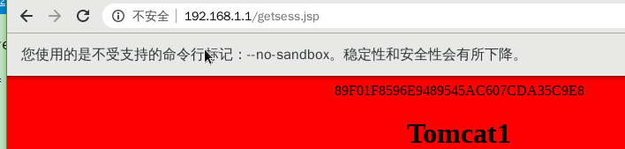

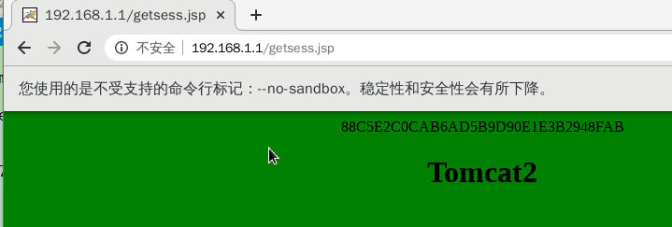

#memcached实现Tomcat的session共享

[root@tomcat1 ~]# ls tomcat_session/*.jar

tomcat_session/asm-5.1.jar tomcat_session/minlog-1.3.0.jar

tomcat_session/kryo-3.0.3.jar tomcat_session/msm-kryo-serializer-1.9.2.jar

tomcat_session/kryo-serializers-0.34.jar tomcat_session/reflectasm-1.11.1.jar

tomcat_session/memcached-session-manager-1.9.2.jar tomcat_session/spymemcached-2.11.1.jar

tomcat_session/memcached-session-manager-tc8-1.9.2.jar

[root@tomcat1 ~]# cp tomcat_session/*.jar /usr/local/tocmat/lib/

[root@tomcat1 ~]# cd /usr/local/tocmat/

[root@tomcat1 tocmat]# vim conf/context.xml

[root@tomcat2 tomcat]# sed -rn "36,39p" conf/context.xml

<Manager className="de.javakaffee.web.msm.MemcachedBackupSessionManager"

memcachedNodes="cache:192.168.1.4:11211"

requestUriIgnorePattern=".*\.(ico|png|gif|jpg|css|js)$"

transcoderFactoryClass="de.javakaffee.web.msm.JavaSerializationTranscoderFactory"/>

[root@tomcat1 tocmat]# ./bin/shutdown.sh

[root@tomcat1 tocmat]# ./bin/startup.sh

[root@tomcat1 tocmat]# cd

[root@tomcat1 ~]# netstat -antpu | grep java

tcp6 0 0 :::8080 :::* LISTEN 1807/java

tcp6 0 0 127.0.0.1:8005 :::* LISTEN 1807/java

tcp6 0 0 :::8009 :::* LISTEN 1807/java

tcp6 0 0 192.168.1.2:48154 192.168.1.4:11211 ESTABLISHED 1807/java

tcp6 0 0 192.168.1.2:48152 192.168.1.4:11211 ESTABLISHED 1807/java

tcp6 0 0 192.168.1.2:48150 192.168.1.4:11211 ESTABLISHED 1807/java

tcp6 0 0 192.168.1.2:48156 192.168.1.4:11211 ESTABLISHED 1807/java

tcp6 0 0 192.168.1.2:48148 192.168.1.4:11211 ESTABLISHED 1807/java

[root@tomcat1 ~]#

[root@tomcat2 ~]# ls tomcat_session/*.jar

tomcat_session/asm-5.1.jar tomcat_session/minlog-1.3.0.jar

tomcat_session/kryo-3.0.3.jar tomcat_session/msm-kryo-serializer-1.9.2.jar

tomcat_session/kryo-serializers-0.34.jar tomcat_session/reflectasm-1.11.1.jar

tomcat_session/memcached-session-manager-1.9.2.jar tomcat_session/spymemcached-2.11.1.jar

tomcat_session/memcached-session-manager-tc8-1.9.2.jar

[root@tomcat2 ~]# cp tomcat_session/*.jar /usr/local/tomcat/lib/

[root@tomcat2 ~]# cd /usr/local/tomcat/

[root@tomcat2 tomcat]# vim conf/context.xml

[root@tomcat2 tomcat]# sed -rn "36,39p" conf/context.xml

<Manager className="de.javakaffee.web.msm.MemcachedBackupSessionManager"

memcachedNodes="cache:192.168.1.4:11211"

requestUriIgnorePattern=".*\.(ico|png|gif|jpg|css|js)$"

transcoderFactoryClass="de.javakaffee.web.msm.JavaSerializationTranscoderFactory"/>

[root@tomcat2 tomcat]# ./bin/shutdown.sh

[root@tomcat2 tomcat]# ./bin/startup.sh

[root@tomcat2 tomcat]# cd

[root@tomcat2 ~]# netstat -antpu | grep java

tcp6 0 0 :::8080 :::* LISTEN 1620/java

tcp6 0 0 127.0.0.1:8005 :::* LISTEN 1620/java

tcp6 0 0 :::8009 :::* LISTEN 1620/java

tcp6 0 0 192.168.1.3:57768 192.168.1.4:11211 ESTABLISHED 1620/java

tcp6 0 0 192.168.1.3:57772 192.168.1.4:11211 ESTABLISHED 1620/java

tcp6 0 0 192.168.1.3:57770 192.168.1.4:11211 ESTABLISHED 1620/java

tcp6 0 0 192.168.1.3:57776 192.168.1.4:11211 ESTABLISHED 1620/java

tcp6 0 0 192.168.1.3:57774 192.168.1.4:11211 ESTABLISHED 1620/java

[root@tomcat2 ~]#

#测试session共享

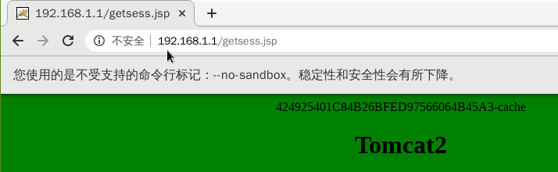

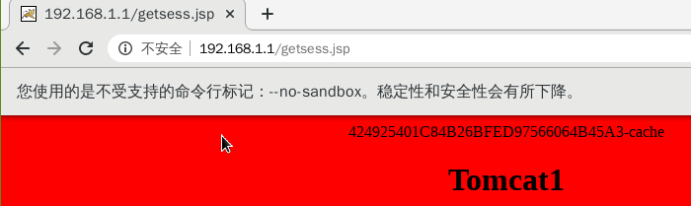

#共享成功

#用redis实现Tomcat的session共享

[root@cache ~]# yum -y install gcc

[root@cache ~]# tar -xf redis-5.0.7.tar.gz

[root@cache ~]# cd redis-5.0.7/

[root@cache redis-5.0.7]# make

[root@cache redis-5.0.7]# make install PREFIX=/usr/local/redis

[root@cache redis-5.0.7]# cp redis.conf /usr/local/redis/bin/

[root@cache redis-5.0.7]# cd /usr/local/redis/bin/

[root@cache bin]# vim redis.conf

[root@cache bin]# cat redis.conf | grep -v "^#" | grep -v "^$"

bind 0.0.0.0

protected-mode yes

port 6379

tcp-backlog 511

timeout 0

tcp-keepalive 300

daemonize yes

supervised no

pidfile /var/run/redis_6379.pid

loglevel notice

logfile "/usr/local/redis/bin/redis.log"

databases 16

always-show-logo yes

save 900 1

save 300 10

save 60 10000

stop-writes-on-bgsave-error yes

rdbcompression yes

rdbchecksum yes

dbfilename dump.rdb

dir /usr/local/redis/bin/

replica-serve-stale-data yes

replica-read-only yes

repl-diskless-sync no

repl-diskless-sync-delay 5

repl-disable-tcp-nodelay no

replica-priority 100

lazyfree-lazy-eviction no

lazyfree-lazy-expire no

lazyfree-lazy-server-del no

replica-lazy-flush no

appendonly no

appendfilename "appendonly.aof"

appendfsync everysec

no-appendfsync-on-rewrite no

auto-aof-rewrite-percentage 100

auto-aof-rewrite-min-size 64mb

aof-load-truncated yes

aof-use-rdb-preamble yes

lua-time-limit 5000

slowlog-log-slower-than 10000

slowlog-max-len 128

latency-monitor-threshold 0

notify-keyspace-events ""

hash-max-ziplist-entries 512

hash-max-ziplist-value 64

list-max-ziplist-size -2

list-compress-depth 0

set-max-intset-entries 512

zset-max-ziplist-entries 128

zset-max-ziplist-value 64

hll-sparse-max-bytes 3000

stream-node-max-bytes 4096

stream-node-max-entries 100

activerehashing yes

client-output-buffer-limit normal 0 0 0

client-output-buffer-limit replica 256mb 64mb 60

client-output-buffer-limit pubsub 32mb 8mb 60

hz 10

dynamic-hz yes

aof-rewrite-incremental-fsync yes

rdb-save-incremental-fsync yes

[root@cache bin]# ./redis-server redis.conf

[root@cache bin]# netstat -antpu | grep redis

tcp 0 0 0.0.0.0:6379 0.0.0.0:* LISTEN 6053/./redis-server

[root@cache bin]# ./redis-cli info server

# Server

redis_version:5.0.7

redis_git_sha1:00000000

redis_git_dirty:0

redis_build_id:8360bfe2c2fc32ca

redis_mode:standalone

os:Linux 3.10.0-693.el7.x86_64 x86_64

arch_bits:64

multiplexing_api:epoll

atomicvar_api:atomic-builtin

gcc_version:4.8.5

process_id:6053

run_id:94744beaa9cf7dcd1a8723d45623175c408e30e6

tcp_port:6379

uptime_in_seconds:30

uptime_in_days:0

hz:10

configured_hz:10

lru_clock:15851084

executable:/usr/local/redis/bin/./redis-server

config_file:/usr/local/redis/bin/redis.conf

[root@cache bin]# cd

[root@cache ~]# tar -xf phpredis-2.2.4.tar.gz

[root@cache ~]# cd phpredis-2.2.4/

[root@cache phpredis-2.2.4]# phpize

Configuring for:

PHP Api Version: 20100412

Zend Module Api No: 20100525

Zend Extension Api No: 220100525

[root@cache phpredis-2.2.4]# ./configure --with-php-config=/usr/bin/php-config

[root@cache phpredis-2.2.4]# make && make install

[root@cache phpredis-2.2.4]# ls /usr/lib64/php/modules/redis.so

/usr/lib64/php/modules/redis.so

[root@cache phpredis-2.2.4]# vim /etc/php.d/redis.ini

[root@cache phpredis-2.2.4]# cat /etc/php.d/redis.ini

extension="redis.so"

[root@cache phpredis-2.2.4]# systemctl restart httpd

[root@cache phpredis-2.2.4]# php -m | grep -i redis

redis

[root@cache phpredis-2.2.4]# cd /var/www/html/

[root@cache html]# vim redis.php

[root@cache html]# cat redis.php

<?php

$redis = new Redis();

$redis->connect('127.0.0.1', 6379); //连接Redis

$redis->select(2);//选择数据库2

$redis->set( "testKey" , "Hello Redis"); //设置测试key

echo $redis->get("testKey");//输出value

echo "\n";

?>

[root@cache html]# curl localhost/redis.php

Hello Redis

[root@cache html]#

#部署redis共享

[root@tomcat1 ~]# cd tomredis/

[root@tomcat1 tomredis]# ls

commons-pool2-2.2.jar jedis-2.8.2.jar tomcat-redis-session-manager.jar

[root@tomcat1 tomredis]# cp * /usr/local/tocmat/lib/

[root@tomcat1 tomredis]# cd /usr/local/tocmat/

[root@tomcat1 tocmat]# vim conf/context.xml

[root@tomcat1 tocmat]# sed -rn "43,45p" conf/context.xml

<Valve className="com.orangefunction.tomcat.redissessions.RedisSessionHandlerValve" />

<Manager className="com.orangefunction.tomcat.redissessions.RedisSessionManager"

host="192.168.1.4" port="6379" database="0" maxInactiveInterval="60" />

[root@tomcat1 tocmat]# ./bin/shutdown.sh

Using CATALINA_BASE: /usr/local/tocmat

Using CATALINA_HOME: /usr/local/tocmat

Using CATALINA_TMPDIR: /usr/local/tocmat/temp

Using JRE_HOME: /usr

Using CLASSPATH: /usr/local/tocmat/bin/bootstrap.jar:/usr/local/tocmat/bin/tomcat-juli.jar

[root@tomcat1 tocmat]# ./bin/startup.sh

[root@tomcat2 ~]# cd tomredis/

[root@tomcat2 tomredis]# ls

commons-pool2-2.2.jar jedis-2.8.2.jar tomcat-redis-session-manager.jar

[root@tomcat2 tomredis]# cp * /usr/local/tomcat/lib/

[root@tomcat2 tomredis]# cd /usr/local/tomcat/

[root@tomcat2 tomcat]# vim conf/context.xml

[root@tomcat2 tomcat]# sed -rn "44,46p" conf/context.xml

<Valve className="com.orangefunction.tomcat.redissessions.RedisSessionHandlerValve" />

<Manager className="com.orangefunction.tomcat.redissessions.RedisSessionManager"

host="192.168.1.4" port="6379" database="0" maxInactiveInterval="60" />

[root@tomcat2 tomcat]# ./bin/shutdown.sh &> /dev/null

[root@tomcat2 tomcat]# ./bin/startup.sh

#测试redis实现Tomcat的session共享

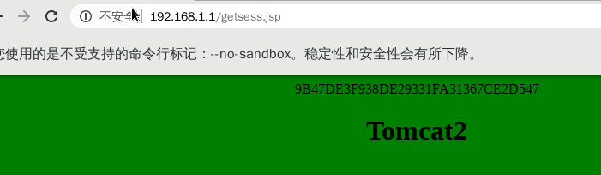

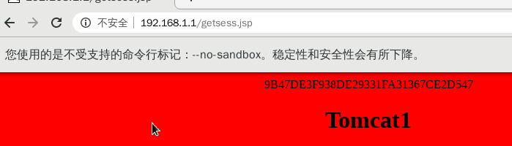

#成功通过redis实现session共享