**MS Azure Machine Learning Tutorial**

Regression: Linear Regression

1. If you have not already done so, open a browser and browse to https://studio.azureml.net. Then sign in using the Microsoft account associated with your Azure ML account.

2. Create a new blank experiment, and give it the title **2017CitibikeRegression**. Add your downloaded **Citibike.csv** to saved datasets, and add it to the experiment canvas.

3. Find the **Select Columns in Dataset** module, and drag it to the experiment canvas under Citibike.csv. Exclude StartStationName, EndStationName, StartTime, EndTime, StartStationLatitude, StartStationLongtitude, EndStationLatitude, EndStationLongtitude.

4. Find the **Clean Missing Data** module, and drag it to the experiment canvas under the Select Columns in Dataset module. Select all columns. Set the minimum missing value ratio to 0 and set maximum missing value ratio to 1. Select custom substitution value for the cleaning mode and set replacement value to 0.

5. Find the **Normalize Data** module, and drag it to the experiment canvas under the clean missing data module. Connect to the cleaned dataset from the clean missing data module. Select Zscore for transformation method and check use 0 for constant column. Launch column selector and select all numeric columns. Your experiment canvas should look like this for now.

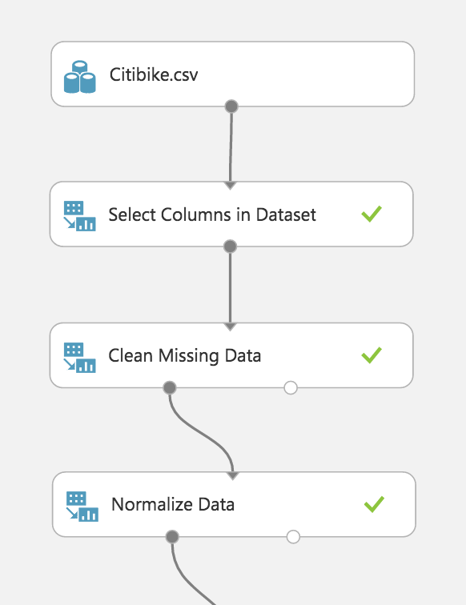

6. Find the **Split Data** module, and drag it to the experiment canvas under the Normalize data module. Connect to the transformed dataset from the Normalized Data module.

Select the following:

Splitting mode: Split Rows

Fraction of rows: 0.7

Randomized split: checked

Random seed: 123456

Stratified split: False

7. Find the **Linear Regression model**, and drag it to the experiment canvas.

8. Find the **Train Model**, and drag it to the experiment canvas, connect the Two-Class Logistic Regression module to the untrained model(left) of the train model, and connect the results dataset1 of split data to the dataset of Train Model. Select StartDate column in the label column.

9. Find the **Score Model**, and drag it to the experiment canvas under the train model. Connect the top left dot to the train model and connect the dataset to the result dataset2 of split data.

10. Find the **Permutation Feature Importance** module, and drag it to the experiment canvas. Connect left dot to the train model and right dot to the results dataset2 of split data.

11. Find the **Evaluate model** and drag it to the experiment canvas under the score model.

12. Your experiment canvas should look like the following screenshot. Save and run the experiment.

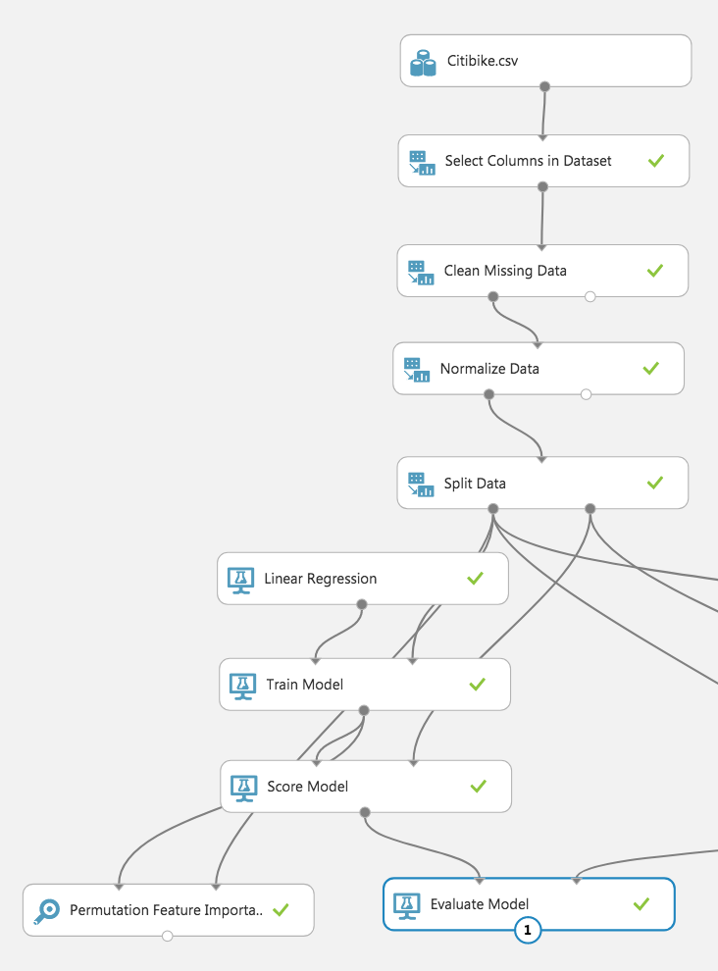

Regression: Boosted Decision Tree Regression

1. Find the **Boosted Decision Tree Regression Model**, and drag it to the experiment canvas.

2. Copy the **Train Model**, **Score Model**, **Permutation Feature Importance, Evaluate model** and paste on the right side of the experiment canvas, under the Two-Class Boosted Decision Tree Model.

3. Now, your experiment canvas should look like the following screenshot. Save and run the experiment.

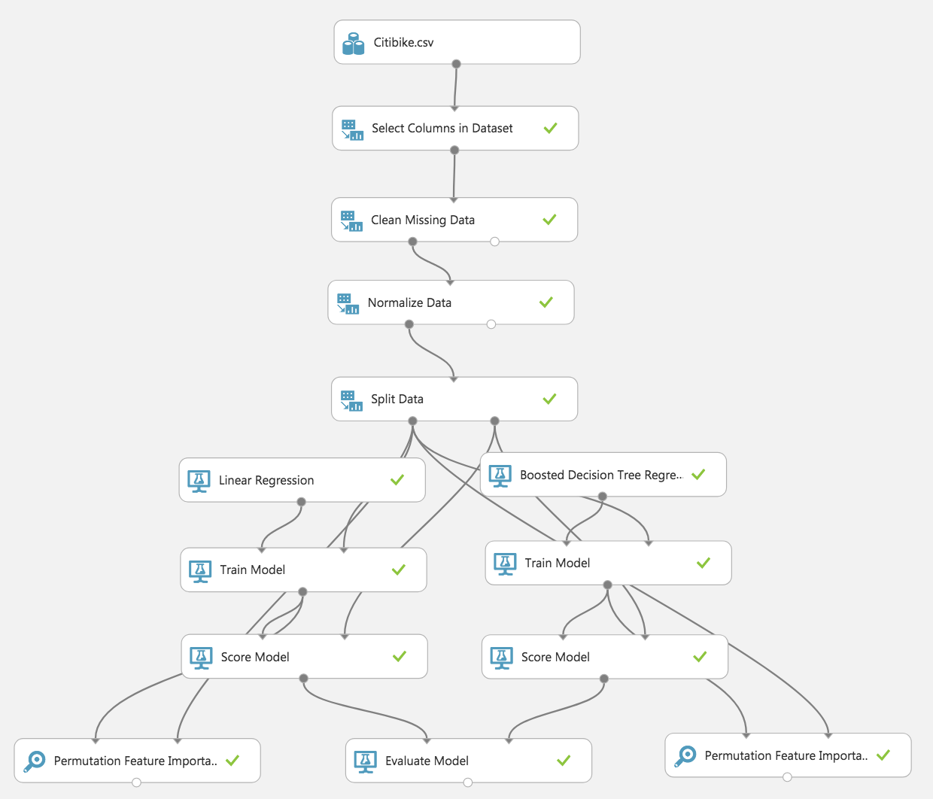

4. Right click on the new evaluate model, click visualize under the Evaluation results, the results should look like this.

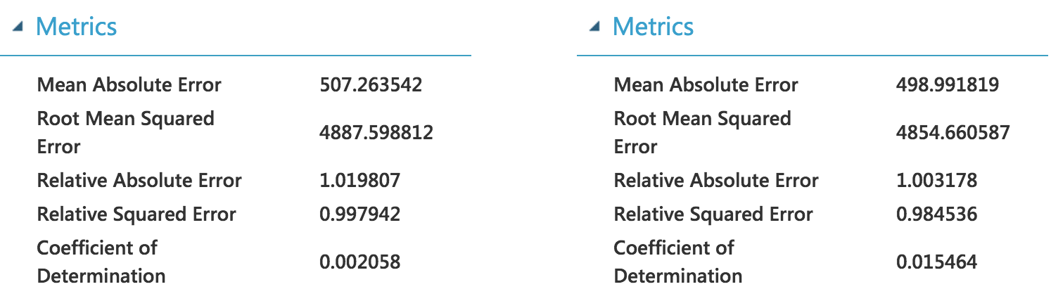

*[Azure ML tutorial end]*