Homework-3

**Out Date:** 09/13/2019 (Friday)

**Due Date:** 09/22/2019 (Sunday) 11:59PM

Team#: ___

Team Member-1:____________________________Member’s Contribution (in %) __

Team Member-2:____________________________Member’s Contribution (in %) __

**Submission**

1. Work on the Problme-1 and Problem-2.
2. Prepare your Python file for Problem-1 (e.g., HW3_P1_Team#.py).
3. Prepare your Python file for Problem-2 (e.g., HW3_P2_Team#.py).
4. Upload the files to blackboard.

**Problem-1 [40 points]**

Develop a set of functions to analyze tweeter data. Specifically, write a program to prompt the user to enter a tweeter string. The program should develop a set of functions for the following string operations:

1. **Word counter:** count the number of words in the string and display it. For instance, for an input of “I will complete MSDS in one year.”, the program should display 7 words. **[5 points]**
2. **Average number of letters:** calculate average number of letters in each word. For instance, this above string has 27 characters (excluding white spaces) and 7 words. The average is 27/7 = 3.86. **[5 points]**
3. **Upper case letters:** count upper case letters. They are 5 upper case letters in the above string. **[5 points]**
4. **Lower case letters:** count lower case letters. They are 21 lower case letters in the above string. **[5 points]**
5. **Reverse the string:** write a function named reverse() which should take a string and return the reversed string. **[5 points]**
6. **String Stats:** The program should count and display the number of alphabets (a to z, and A to Z) **[5 points]**, number of digits (0 to 9) **[5 points]** and number of special characters (such as #, $, @) **[5 points]**. For this, write a function.

Use the following two tweet as test cases:

**Tweet-1**

'lets you choose #CleanPower for NO additional cost! IT IS A NO-BRAINER!!!'

**Tweet-2**

'Tesla software V10 is lookin real good! Releasing to early access list soon …'

**Problem-2 [40 points]**

A Personal Fitness Tracker is a wearable device that tracks your physical activity, calories burned, heart rate, sleeping patterns, and so on. One common physical activity that most of these devices track is the number of steps you take each day. You will find a file named **steps.txt** in this folder. The **steps.txt** file contains the number of steps a person has taken each day for a year. There are 365 lines in the file, and each line contains the number of steps taken during a day. (The first line is the number of steps taken on January 1st, the second line is the number of steps taken on January 2nd, and so forth.) Write a program that reads the file **[10 points],** then displays the average, minimum, and maximum number of steps taken for each month **[10 + 5 + 5 points]**. The data is from a year that was not a leap year, so February has 28 days. Display the output in a tabular format such as the following **[10 points]**:

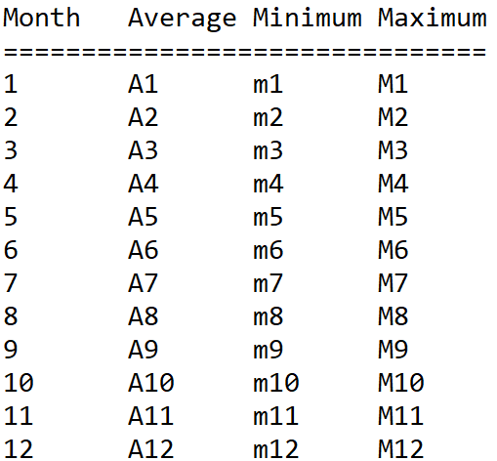

Please make sure your code follows the Python programing style guide available here: <https://www.python.org/dev/peps/pep-0008/> **[10 points]**.

Please make sure the code is well-commented **[10 points]**