1. install the [Node.js](https://nodejs.org/) JavaScript runtime and [npm](https://www.npmjs.com/" \t "_blank) (the Node.js package manager) and you can get them from <https://nodejs.org/en/download/>

**Tip**: To test that you have Node.js and npm correctly installed on your machine, you can type node --version and npm --version.

1. install the Angular CLI, in a terminal or command prompt type:

npm install -g @angular/cli

1. create a new Angular application by typing:

ng new my-app

1. run the Angular application by navigating to the new folder and typing ng serve to start the web server and open the application in a browser, "Welcome to app!!" will be on http://localhost:4200 page

cd my-app

ng serve

1. open your Angular application in VS Code, open another terminal (or command prompt) and navigate to the my-app folder and type code .:

cd my-app

code .

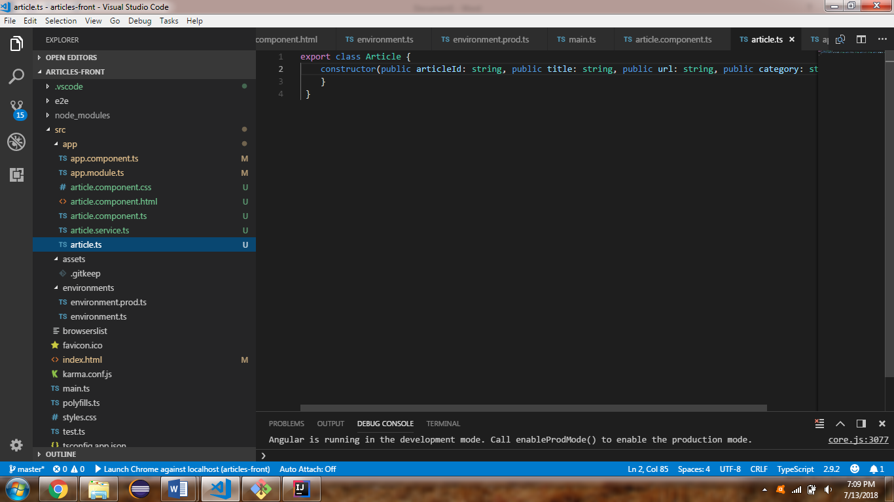

1. work on

app.components.ts

article.component.css

article.component.html

article.component.ts

article.module.ts

article.service.ts

article.ts

1. Run REST Web Service using Spring Boot
2. Our Angular application is ready on the following URL.

http://localhost:4200

