**INFSCI 2750: Cloud Computing**

**Mini Project 3**

# Yannan Yuan yay75@pitt.edu

# Xuezhi Xu xux15@pitt.edu

# Ying Zhang yiz165@pitt.edu

# Part 1: Setting up Cassandra

* Start the Cassandra process on all the nodes manually to monitor the service status and logs:

Master machine:

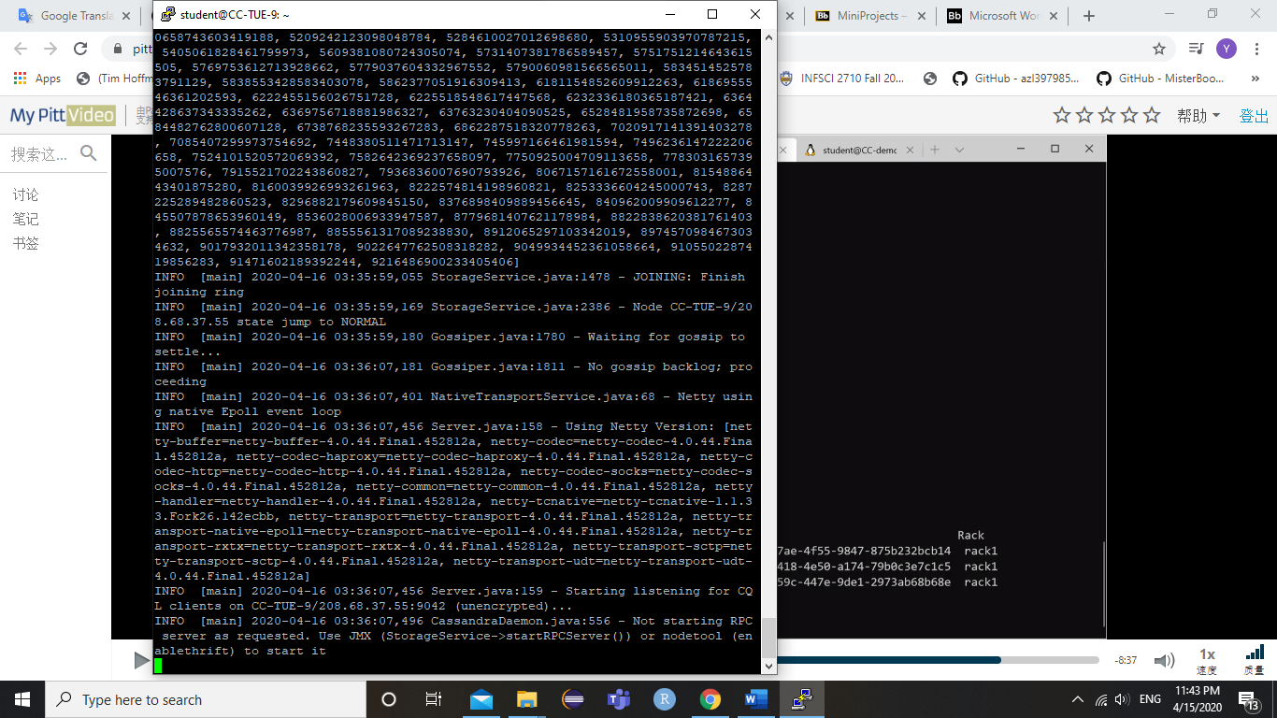

Slave Machine:

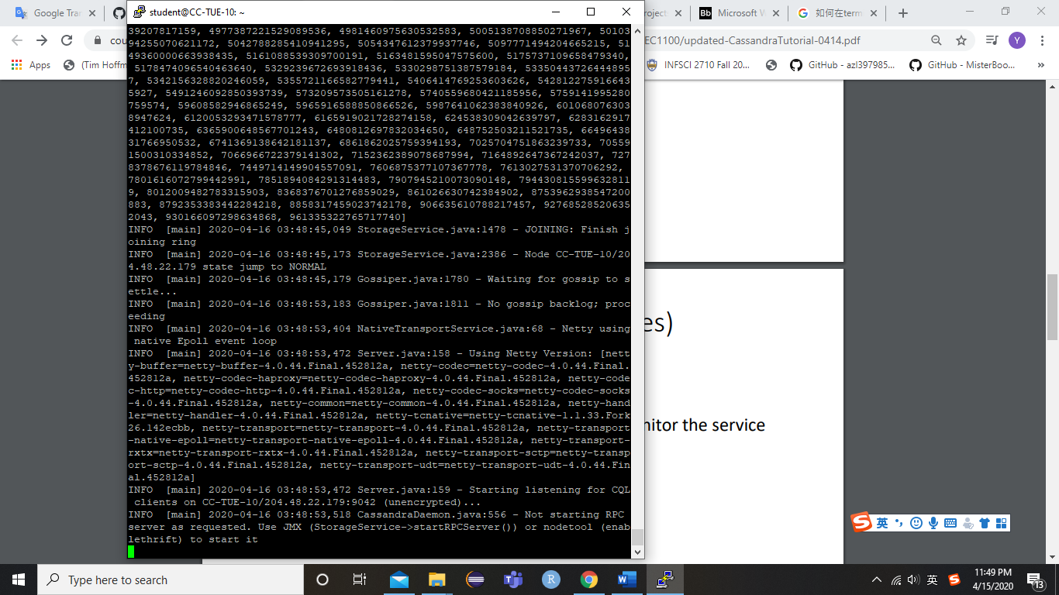

Slave Machine:

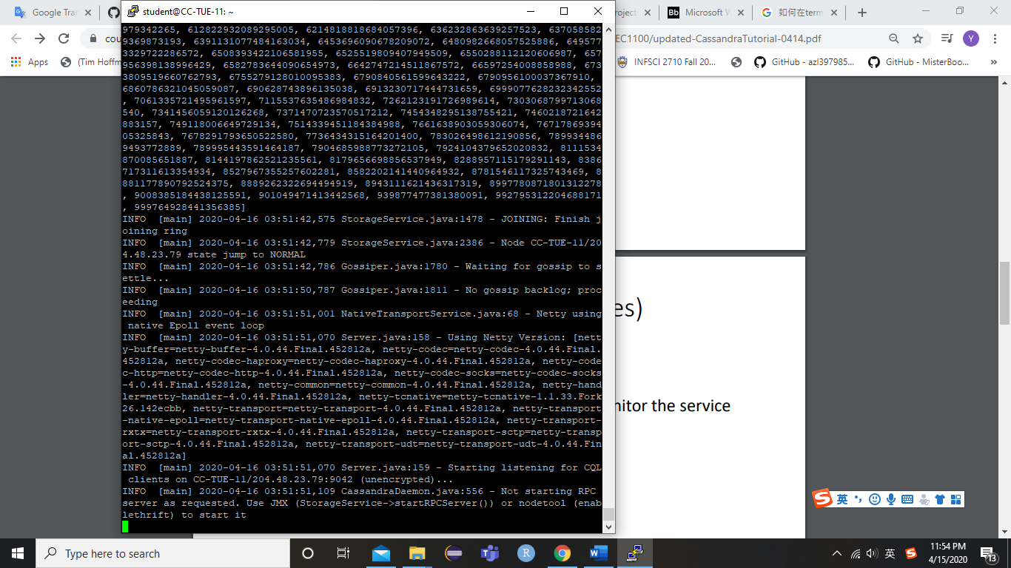

* Start CQL client:

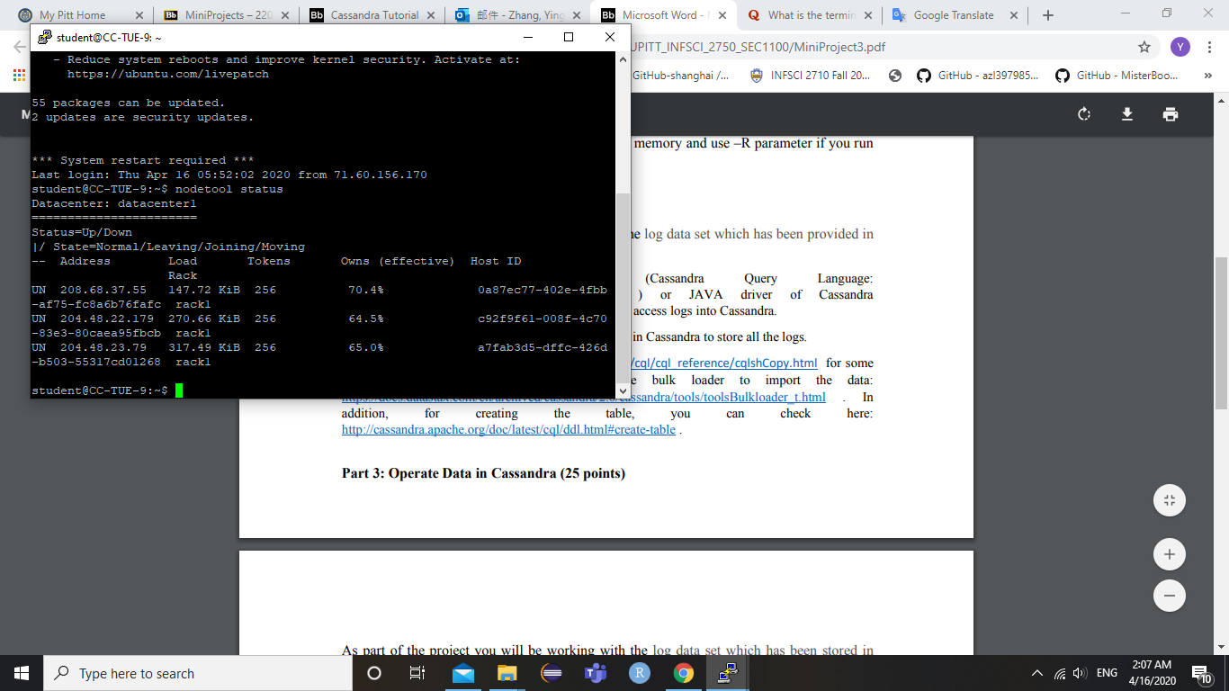

* CQL test:

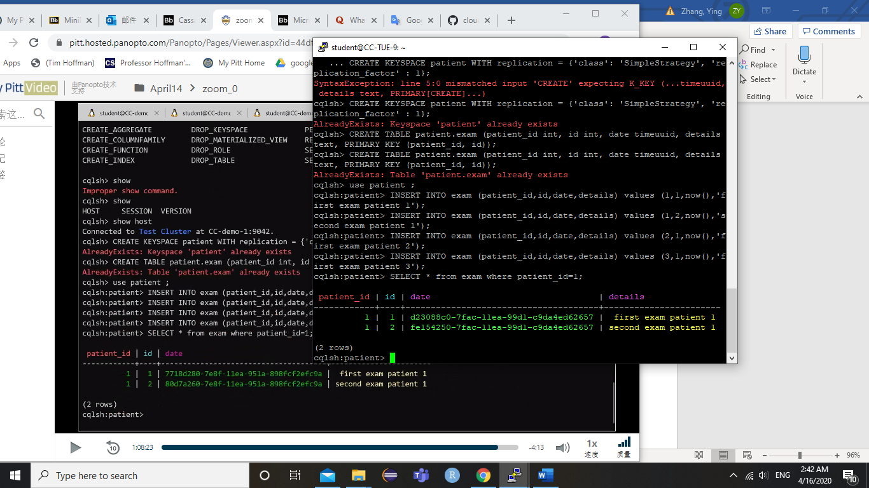

# Part 2: Import Data into Cassandra

* Create a new table:

CREATE KEYSPACE project3 WITH replication = {'class':'SimpleStrategy', 'replication_factor' : 1};

USE project3;

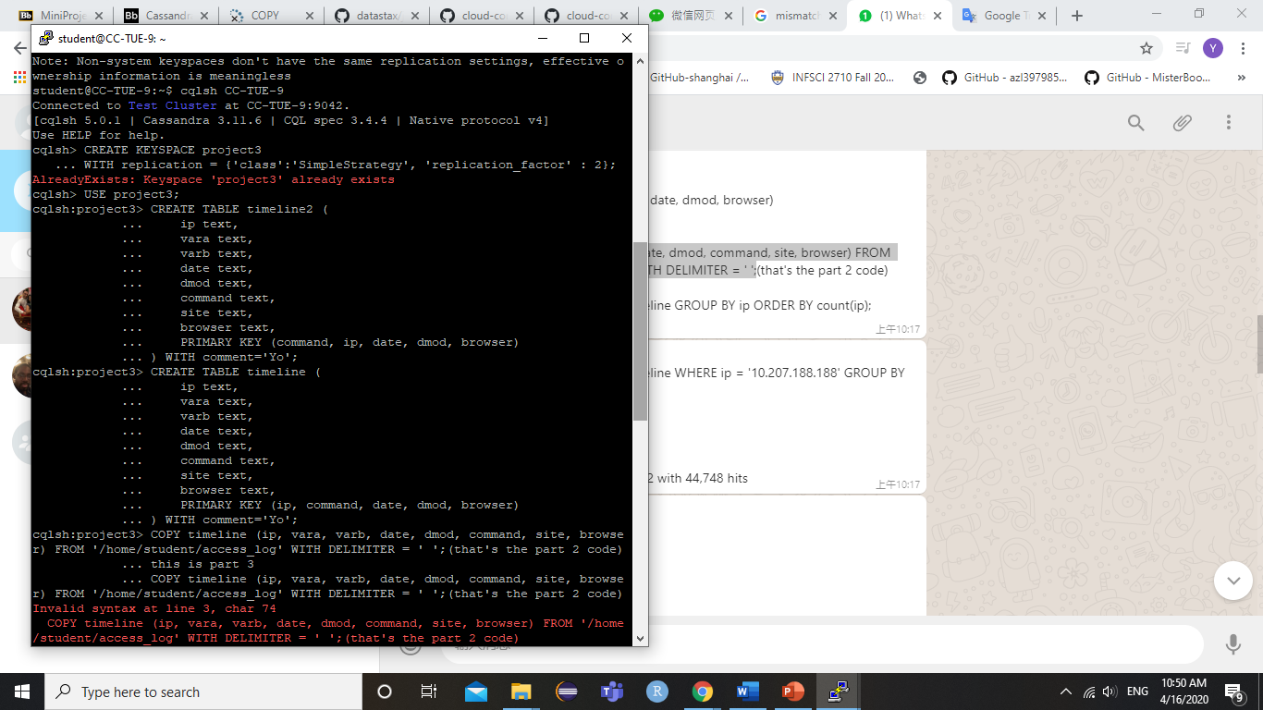

* Import data from access_log:

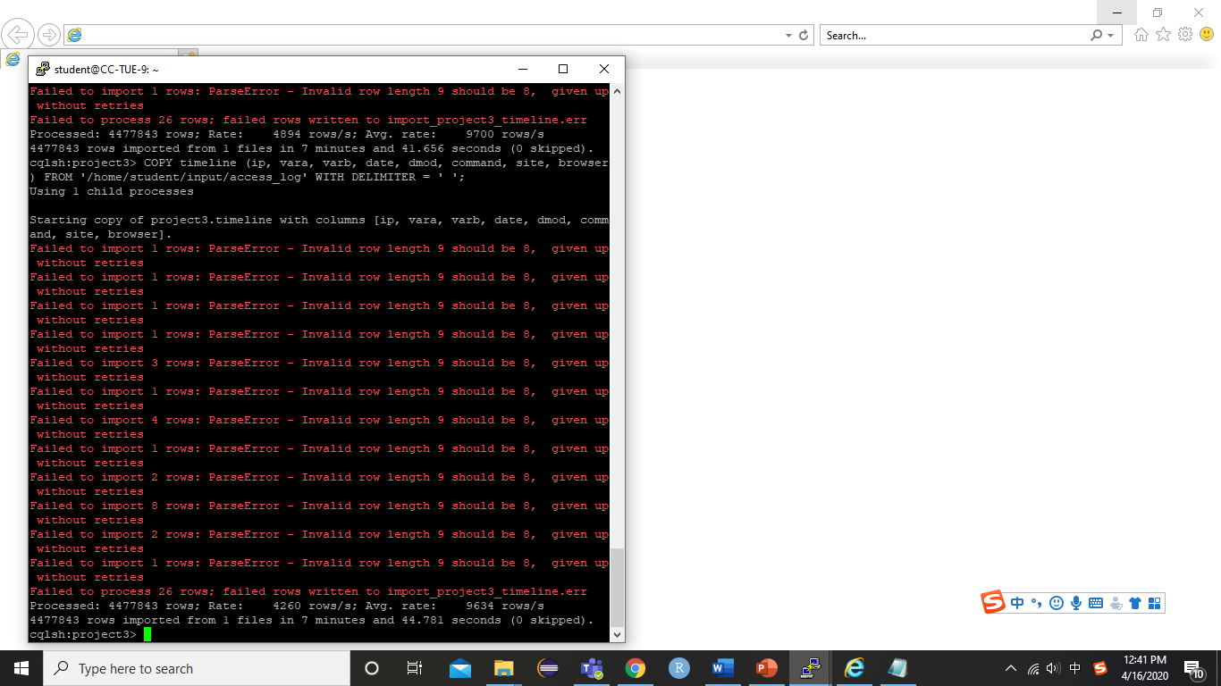

# Part 3: Operate Data in Cassandra

1. How many hits were made to the website item “/assets/img/release-schedule-logo.png”?

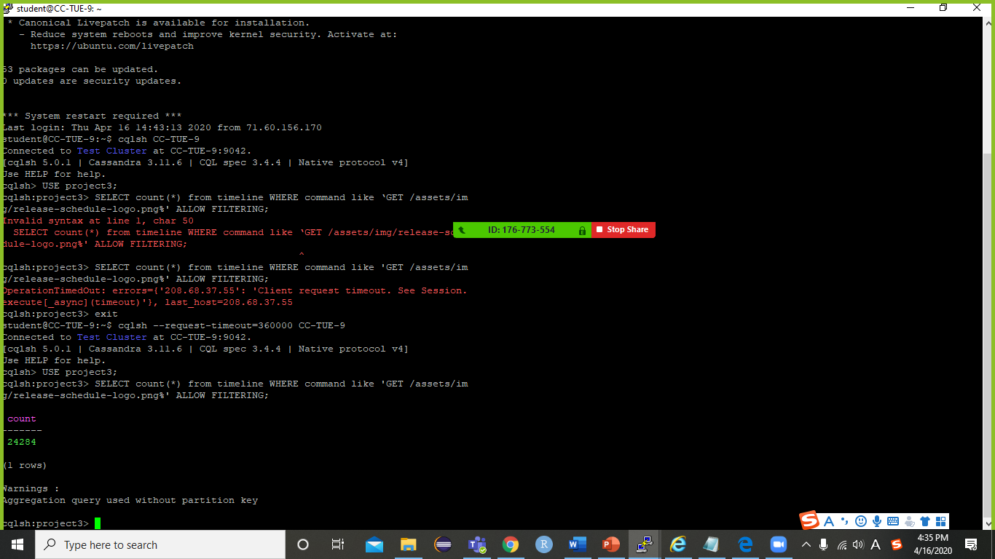

24284

1. How many hits were made from the IP: 10.207.188.188?

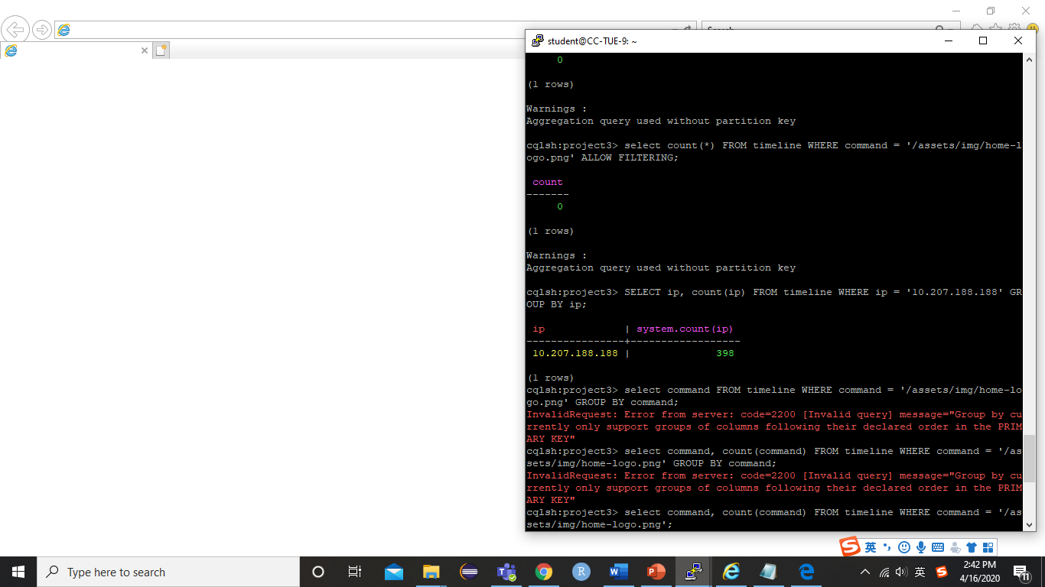

398

1. Which path in the website has been hit most? How many hits were made to the path?

/assets/css/combined.css

105006

4. Which IP accesses the website most? How many accesses were made by it?

10.216.113.172

158316

