|  |
| --- |
|  |
| Computer Architecture |
| Project One |
|  |
| Sipeng Wang  Jiafang Liu  Christopher Marc Licata |
| **2016/11/5** |
|  |

|  |
| --- |
|  |

**1. Introduction**

**1.1. Purpose**

The purpose of this document is to include design notes and architecture for all phases of the computer simulator. The purpose of this project is to design and implement a computer simulator in order to gain broader understanding of the computer architecture including ISA, memory structure, operations and I/O capabilities.

**1.2. Component**

The class project is structured into four segments of increasing difficulty that build towards a detailed understanding of the internal design of computer systems and a fairly complex simulation of a computer system. Each segment is due to the grader at about 3 week intervals (see Syllabus).

The four components are:

|  |  |
| --- | --- |
| **Component** | **Description** |
| I: Basic Machine | Design and implement the basic machine architecture.  Implement a simple memory  Execute Load and Store instructions  Build initial user interface to simulator |
| II: Memory and Cache  Design | Design and implement the modules for enhanced  memory and cache operations  Implement all instructions except for MSR, CHK, and  Floating Point/Vector operations  Extend the user interface.  Demonstrate 1st program running on your simulator. |
| III: Execute All Instructions | Make sure all instructions (as specified below) execute on your simulator  Demonstrate 2nd program running on your simulator |
| IV:  A. Floating Point and Vector Operations | A. Floating Point and Vector Operations  Design and implement the modules for floating point and vector operations and simple pipelining; extend the user interface |

**2. System Overview**

*[General system Overview]*

**3. Architectural Design and Design Notes**

**3.1. Program Control and Flow**

mGUI

Control Unit

.SingleCircle()

Operater Unit

(instructions)

The program control flow is primarily controlled by the GUI and the computer’s clock cycle (in control Unit) in Phase 1. The Control Unit loads the special instruction from operator unit.

**Memory and Cache Design:**

In Phase2, we implement a simple cache, which sits between memory and the rest of the processor. The cache only fetches and cleans on demand from the operator unit. A least recently used replacement policy is used to determine which cache blocks should remain in memory. Main memory is updated via a write back mechanism by tracking the dirty status of each cache block. The cache is fully implemented and functional.

**3.2 Instruction Decomposition:**

* **LDR r, x, address[,I]**
* *MAR <- PC*
* *MBR <- C(MAR)*
* *IR <- MBR*
* *Decode IR*
* *IR0-5 <- OPCODE*
* *IR6-7 <- R(0-3)*
* *IR8-9 <- IX(1-3)*
* *IR10 <- Indirect Addressing Bit*
* *IR11-15 <- Address*
* *Compute EA*
* *R<-C( EA) r <- c(c(EA)), if I bit set*
* *PC <- PC + 1*
* **STR r, x, address[,I]**
* *MAR <- PC*
* *MBR <- C(MAR)*
* *IR <- MBR*
* *Decode IR*
* *IR0-5 <- OPCODE*
* *IR6-7 <- R(0-3)*
* *IR8-9 <- IX(1-3)*
* *IR10 <- Indirect Addressing Bit*
* *IR11-15 <- Address*
* *Compute EA*
* *C(EA)<-R c(c(EA)) <- c(r) if I-bit set //Load the contents of the Register into the memory*
* *PC <- PC + 1 // Increment PC*
* **LDA r, x, address[,I]**
* *MAR <- PC*
* *MBR <- C(MAR)*
* *IR <- MBR*
* *Decode IR*
* *IR0-5 <- OPCODE*
* *IR6-7 <- R(0-3)*
* *IR8-9 <- IX(1-3)*
* *IR10 <- Indirect Addressing Bit*
* *IR11-15 <- Address*
* *Compute EA*
* *R <- EA r  c(EA), if I bit set*
* *PC <- PC + 1*
* **LDX x, address[,I]**
* *MAR <- PC*
* *MBR <- C(MAR)*
* *IR <- MBR*
* *Decode IR*
* *IR0-5 <- OPCODE*
* *IR6-7 <- R(0-3)*
* *IR8-9 <- IX(1-3)*
* *IR10 <- Indirect Addressing Bit*
* *IR11-15 <- Address*
* *Compute EA*
* *IX <- C(EA)*
* *PC <- PC + 1*
* **STX x, address[,I]**
* *MAR <- PC*
* *MBR <- C(MAR)*
* *IR <- MBR*
* *Decode IR*
* *IR0-5 <- OPCODE*
* *IR6-7 <- R(0-3)*
* *IR8-9 <- IX(1-3)*
* *IR10 <- Indirect Addressing Bit*
* *IR11-15 <- Address*
* *Compute EA*
* *EA <- c(X0) C(EA) <- c(Xx), if I-bit set*
* *PC <- PC + 1 //Increment PC*
* **AMR r, x, address[,I]**
* *MAR <- PC*
* *MBR <- C(MAR)*
* *IR <- MBR*
* *Decode IR*
* *IR0-5 <- OPCODE*
* *IR6-7 <- R(0-3)*
* *IR8-9 <- IX(1-3)*
* *IR10 <- Indirect Addressing Bit*
* *IR11-15 <- Address*
* *Compute EA*
* *R <- C(R) + C(EA)*
* *PC <- PC + 1 ;Increment PC*
* **SMR r, x, address[,I]**
* *MAR <- PC*
* *MBR <- M(MAR)*
* *IR <- MBR*
* *Decode IR*
* *IR0-5 <- OPCODE*
* *IR6-7 <- R(0-3)*
* *IR8-9 <- IX(1-3)*
* *IR10 <- Indirect Addressing Bit*
* *IR11-15 <- Address*
* *Compute EA*
* *R <- C(R)-C(EA)*
* *PC <- PC + 1 ;Increment PC*
* **AIR r, immed**
* *MAR <- PC*
* *MBR <- M(MAR)*
* *IR <- MBR*
* *Decode IR*
* *IR0-5 <- OPCODE*
* *IR6-7 <- R(0-3)*
* *IR8-9 <- IX(1-3)*
* *IR10 <- Indirect Addressing Bit*
* *IR11-15 <- Immed*
* *R <-C(R)+Immed*
* *PC <- PC + 1*
* **SIR r, immed**
* *MAR <- PC*
* *MBR <- M(MAR)*
* *IR <- MBR*
* *Decode IR*
* *IR0-5 <- OPCODE*
* *IR6-7 <- R(0-3)*
* *IR8-9 <- IX(1-3)*
* *IR10 <- Indirect Addressing Bit*
* *IR11-15 <- Immed*
* *R <- C(R) - Immed*
* *PC <- PC + 1*

**Effective Address (EA) Computation:**

EA =

if I = 0:

if IX = 00, Address

if IX = 1..3, c(Xj) + Address, where j = c(IX)

if I = 1:

if IX = 00, c(Address) // indirect addressing

if IX = 1..3, c(c(Xj) + Address), where j = c(IX)

**3.2 Phase 2 - Memory and Cache Design**

* **JZ r, x address[, I]**
* MAR <- PC
* MBR <- M(MAR)
* IR <- MBR
* Decode IR
* IR0-5 <- OPCODE
* IR6-7 <- R(0-3)
* IR8-9 <- IX(1-3)
* IR10 <- Indirect Addressing Bit
* IR11-15 <- Address
* IF C(r)==0 PC<- C(EA) else PC<PC+1
* **JNE r, x address[, I]**
* MAR <- PC
* MBR <- M(MAR)
* IR <- MBR
* Decode IR
* IR0-5 <- OPCODE
* IR6-7 <- R(0-3)
* IR8-9 <- IX(1-3)
* IR10 <- Indirect Addressing Bit
* IR11-15 <- Address
* IF(CR!=0) PC<- C(EA) else PC<PC+1
* **JCC cc, x address[, I]**
* MAR <- PC
* MBR <- M(MAR)
* IR <- MBR
* Decode IR
* IR0-5 <- OPCODE
* IR6-7 <- CC(0-3)
* IR8-9 <- IX(1-3)
* IR10 <- Indirect Addressing Bit
* IR11-15 <- Address
* IF CC(0-3)==1 PC<- C(EA) else PC<PC+1
* **JMA x, address[, I]**
* MAR <- PC
* MBR <- M(MAR)
* IR <- MBR
* Decode IR
* IR0-5 <- OPCODE
* IR6-7 <- R(0-3) (Ignored)
* IR8-9 <- IX(1-3)
* IR10 <- Indirect Addressing Bit
* IR11-15 <- Address
* PC<- C(EA)
* **JSP r, x address[, I]**
* MAR <- PC
* MBR <- M(MAR)
* IR <- MBR
* Decode IR
* IR0-5 <- OPCODE
* IR6-7 <- R(0-3)
* IR8-9 <- IX(1-3)
* IR10 <- Indirect Addressing Bit
* IR11-15 <- Address
* R3<-PC+1
* IF I bit set PC<- C(EA) else PC<-EA
* **RFS immed**
* MAR <- PC
* MBR <- M(MAR)
* IR <- MBR
* Decode IR
* IR0-5 <- OPCODE
* IR6-7 <- R(0-3)
* IR8-9 <- IX(1-3)
* IR10 <- Indirect Addressing Bit
* IR11-15 <- Immed
* R0 <- Immed
* PC <- C(R3) IX, I fields are ignored
* **SOB r, x address[, I]**
* MAR <- PC
* MBR <- M(MAR)
* IR <- MBR
* Decode IR
* IR0-5 <- OPCODE
* IR6-7 <- R(0-3)
* IR8-9 <- IX(1-3)
* IR10 <- Indirect Addressing Bit
* IR11-15 <- Address
* R <- C(R)-1
* If C(R)>0 PC <- EA else PC<-PC+1
* **JGE r, x address[, I]**
* MAR <- PC
* MBR <- M(MAR)
* IR <- MBR
* Decode IR
* IR0-5 <- OPCODE
* IR6-7 <- R(0-3)
* IR8-9 <- IX(1-3)
* IR10 <- Indirect Addressing Bit
* IR11-15 <- Address
* If C(R)>=0 Then PC <- EA or C(EA), If I bit set;

Else PC <-PC + 1

* **MLT rx, ry**
* MAR <- PC
* MBR <- M(MAR)
* IR <- MBR
* Decode IR
* IR0-5 <- OPCODE
* IR6-7 <- RX
* IR8-9 <- RY
* RX <- C(RX)*C(RY) RX must be 0 or 2
* RX+1 <- C(RX)*C(RY)
* **DVD rx, ry**
* MAR <- PC
* MBR <- M(MAR)
* IR <- MBR
* Decode IR
* IR0-5 <- OPCODE
* IR6-7 <- RX
* IR8-9 <- RY
* RX <- C(RX)/C(RY)
* RX+1 <- C(RX)/C(RY)
* **TRR rx, ry**
* MAR <- PC
* MBR <- M(MAR)
* IR <- MBR
* Decode IR
* IR0-5 <- OPCODE
* IR6-7 <- RX
* IR8-9 <- RY
* If C(RX)==C(RY) CC(4) <- 1 else CC(4) <-0
* **AND rx, ry**
* MAR <- PC
* MBR <- M(MAR)
* IR <- MBR
* Decode IR
* IR0-5 <- OPCODE
* IR6-7 <- RX
* IR8-9 <- RY
* C(RX) <- C(RY) AND C(RY)
* **ORR rx, ry**
* MAR <- PC
* MBR <- M(MAR)
* IR <- MBR
* Decode IR
* IR0-5 <- OPCODE
* IR6-7 <- RX
* IR8-9 <- RY
* C(RX) <- C(RY) OR C(RY)
* **ORR rx, ry**
* MAR <- PC
* MBR <- M(MAR)
* IR <- MBR
* Decode IR
* IR0-5 <- OPCODE
* IR6-7 <- RX
* IR8-9 <- RY
* C(RX) <- NOT C(RY)
* **SRC r, count, L/R, A/L**
* MAR <- PC
* MBR <- M(MAR)
* IR <- MBR
* Decode IR
* IR0-5 <- OPCODE
* IR6-7 <- R(0-3)
* IR8 <- AL
* IR9 <- LR
* IR10 -15<- Count
* R < - Shift Register
* **RRC r, count, L/R, A/L**
* MAR <- PC
* MBR <- M(MAR)
* IR <- MBR
* Decode IR
* IR0-5 <- OPCODE
* IR6-7 <- R(0-3)
* IR8 <- AL
* IR9 <- LR
* IR10 -15<- Count
* R < - Rotator Register
* **IN r, devid**
* MAR <- PC
* MBR <- M(MAR)
* IR <- MBR
* Decode IR
* IR0-5 <- OPCODE
* IR6-7 <- R(0-3)
* IR8-9 <- NULL
* IR10 -15<- devid
* R < - input number
* **out r, devid**
* MAR <- PC
* MBR <- M(MAR)
* IR <- MBR
* Decode IR
* IR0-5 <- OPCODE
* IR6-7 <- R(0-3)
* IR8-9 <- NULL
* IR10 -15<- devid
* R < - out put number
* **CHK r, devid**
* MAR <- PC
* MBR <- M(MAR)
* IR <- MBR
* Decode IR
* IR0-5 <- OPCODE
* IR6-7 <- R(0-3)
* IR8-9 <- NULL
* IR10 -15<- devid
* R < - device status

**3. 3 Phase 3 - Execute All Instructions**

**Load/Store Instructions:**

LDR:

Instruction: 0000010000000101

Opcode:000001 R:0 IX:0 I:0 ADDR：101

Excepted：R0 = 1 (0000000000000001)

Result: Passed

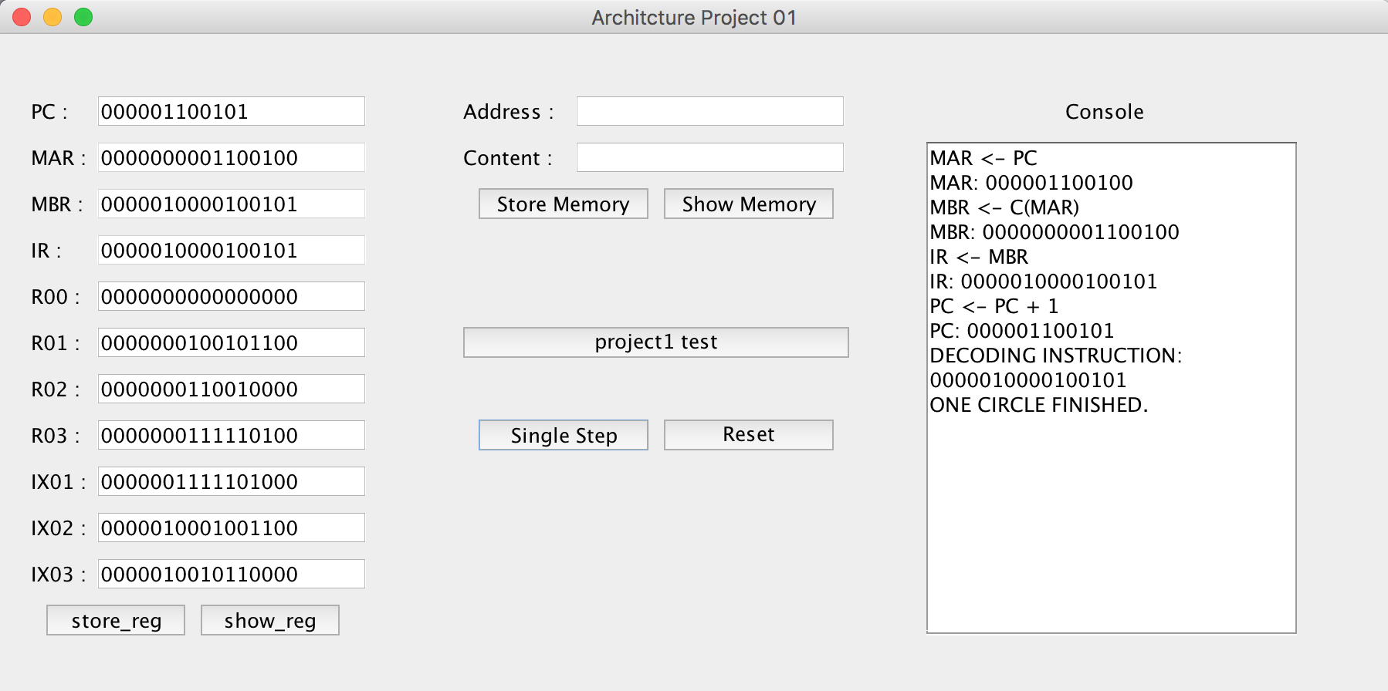

STR:

Instruction: 0000100100000110

Opcode:000010 R:01 IX:0 I:0 ADDR：110

Excepted：address(0000000000000110) = 0000000100101100

Result: Passed

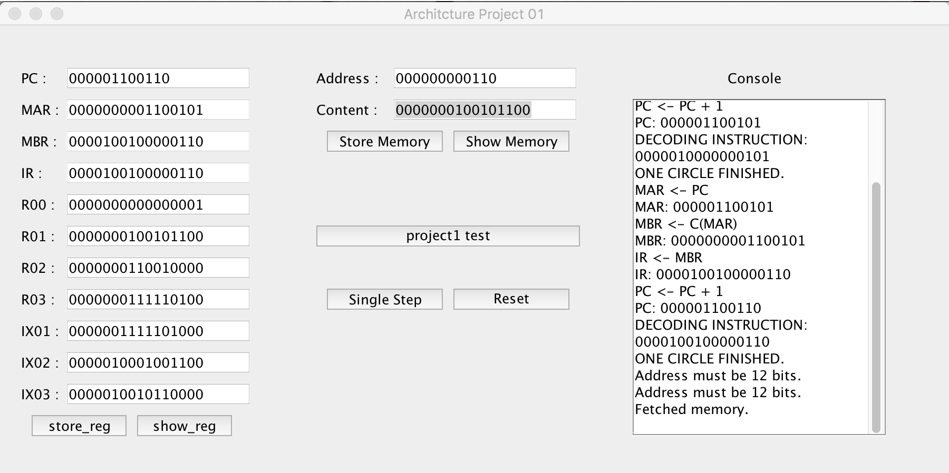

LDA:

Instruction: 0000111000000111

Opcode:000011 R:10 IX:0 I:0 ADDR：111

Excepted: R00 = 0000000000000111

Result: Passed

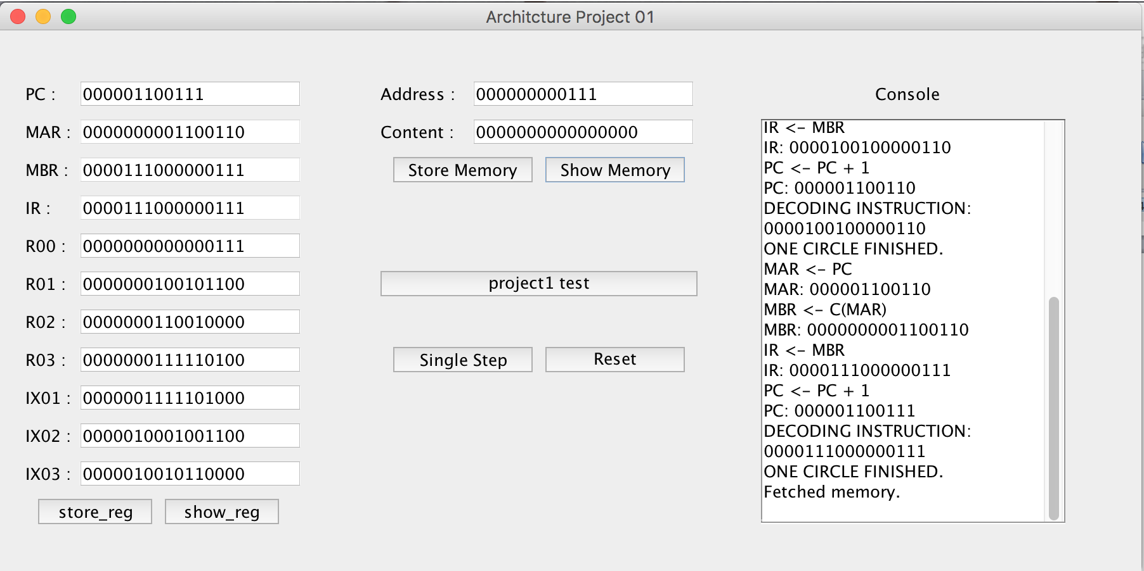

LDX:

Instruction: 1010010001100001

Opcode: 101001R:00 IX:01 I:1 ADDR：1

Excepted: IX01 = 0000000000000001

Result: Passed

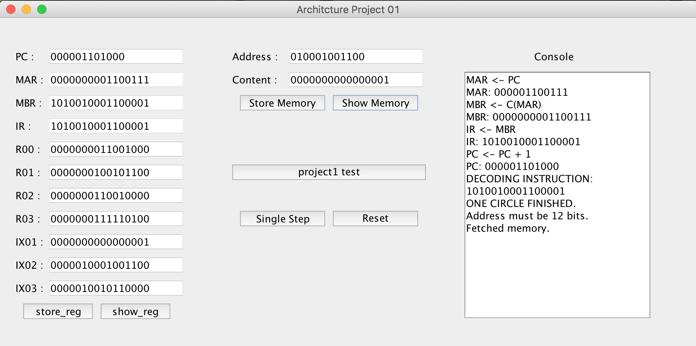

STX:

Instruction: 1010100001001111

Opcode: 101010 R:00 IX:01 I:1 ADDR：1111

Excepted: address(0000000000001111) = 0000000000000001

Result: Passed

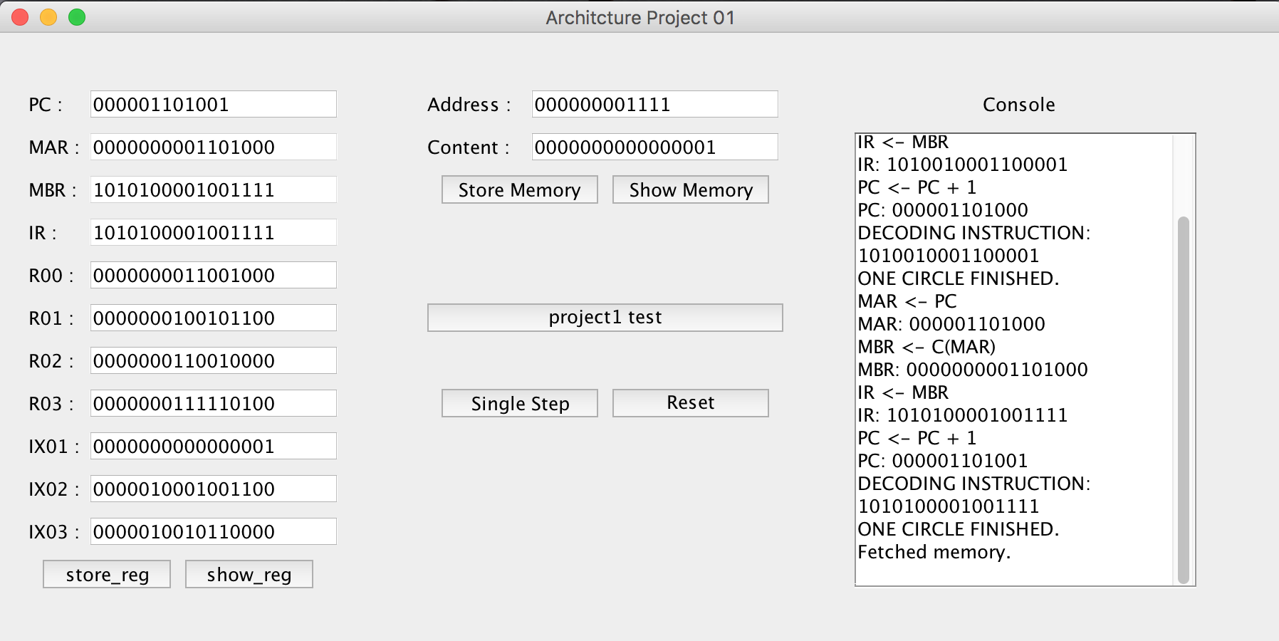

AMR:

Instruction: 0000101000011111

Opcode: 000010 R:10 IX:00 I:0 ADDR：11111

Excepted: R2 = 0000000110010001

Result: Passed

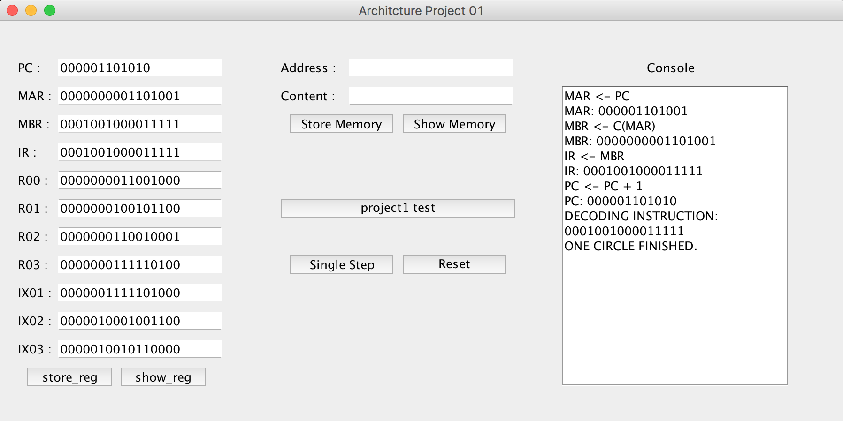

SMR:

Instruction: 0000111000011111

Opcode: 000011 R:10 IX:00 I:0 ADDR：11111

Excepted: R2 = 0000000000011111

Result: Passed

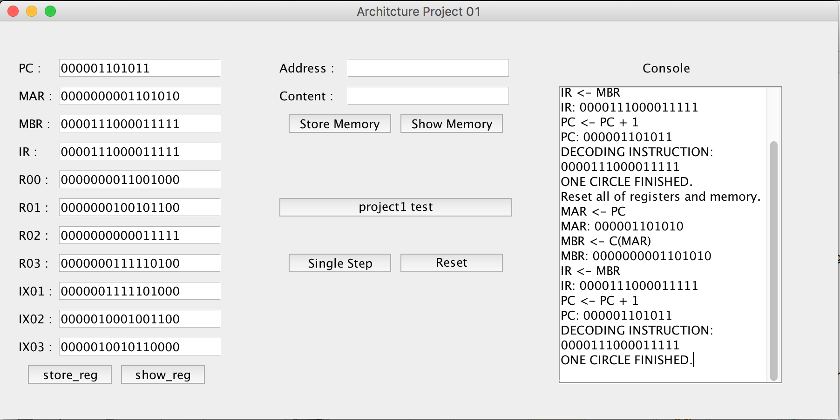

AIR:

Instruction: 0001001000011111

Opcode: 000100 R:10 IX:00 I:0 immed：11111

Excepted: R2 =0000000000100000

Result: Passed

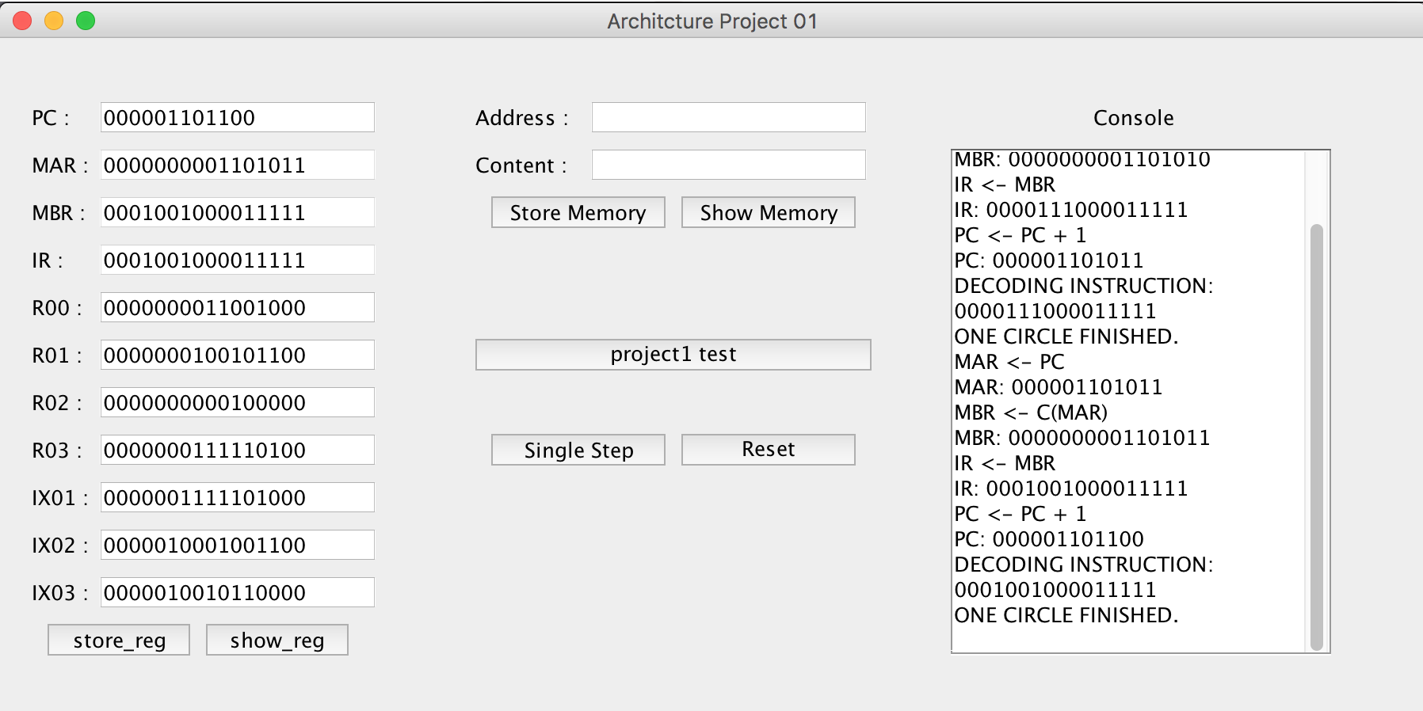

SIR:

Instruction: 1001011001011111

Opcode: 000101R:10 IX:00 I:0 immed：1111

Excepted: R2 = 0000000000011111

Result: Passed

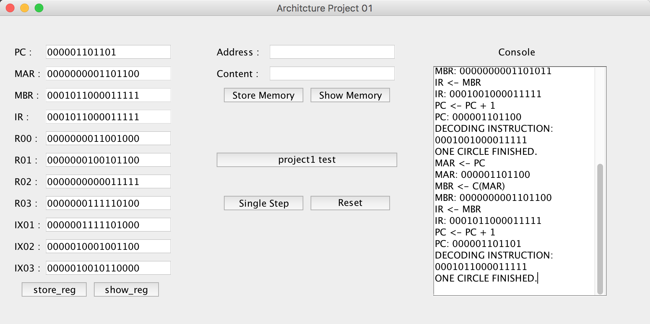

**Transfer Instructions:**

JZ:

Instruction: 001010 00 01 000000

Opcode: 001010 R:00 IX: 01 I: 0 address：0000

Excepted: R0 = 0000000011001000

Result: Passed

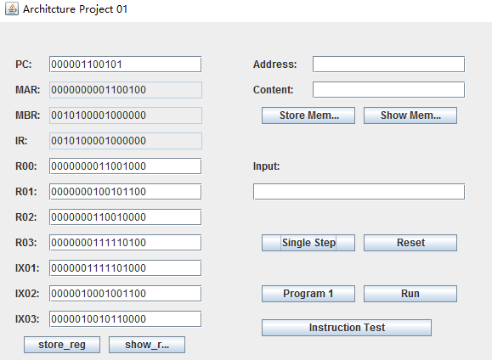

JNE:

Instruction: 001011 00 01 000000

Opcode: 001011 R:00 IX: 01 I: 0 address：0000

Excepted: R0 = 0000000011001000

Result: Passed

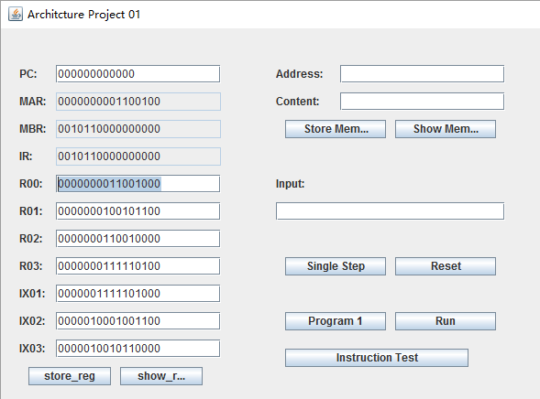

JCC:

Instruction: 001100 00 01 000001

Opcode: 001011 R:00 IX: 01 I: 0 address：0000

Excepted: R0 = 0000000011001000

Result: Passed

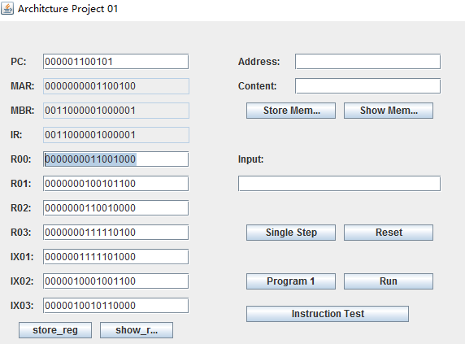

JMA:

Instruction: 001101 00 01 000001

Opcode: 001011 R:00 IX: 01 I: 0 address：0000

Excepted: R0 = 0000000011001000

Result: Passed

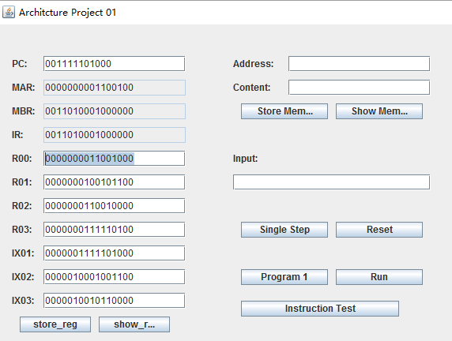

JSR:

Instruction: 001110 00 01 000001

Opcode: 001011 R:00 IX: 01 I: 0 address：0000

Excepted: R0 = 0000000011001000

Result: Passed

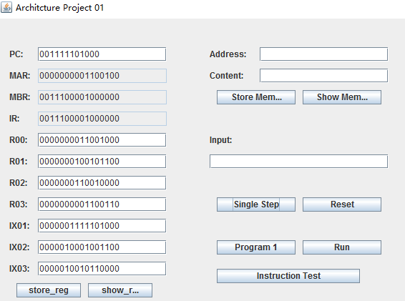

RFS:

Instruction: 001111 00 01 000001

Opcode: 001011 R:00 IX: 01 I: 0 address：0000

Excepted: R0 = 0000000000000000

PC= 000111110100

Result: Passed

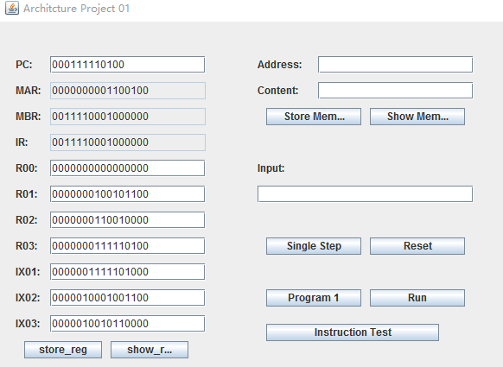

RFS:

Instruction: 010000 00 01 000001

Opcode: 001011 R:00 IX: 01 I: 0 address：0000

Excepted: R0 = 001111101000

Result: Passed

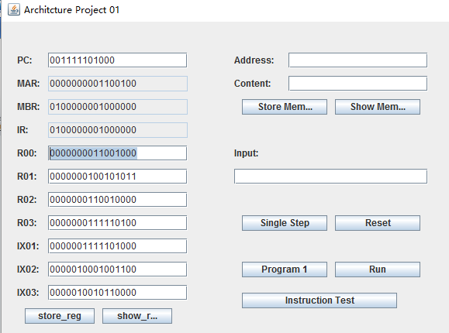

RFS:

Instruction: 010001 00 01 000001

Opcode: 001011 R:00 IX: 01 I: 0 address：0000

Excepted: PC = 001111101000

Result: Passed

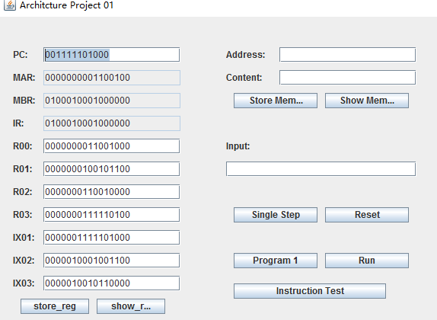

MLT:

Instruction: 010100 00 01 000001

Opcode: 001011 RX:00 RY: 01 I: 0 address：0000

Excepted: RX-R0: 0000010101100111

RY-R1: 1001110001000000

Result: Passed

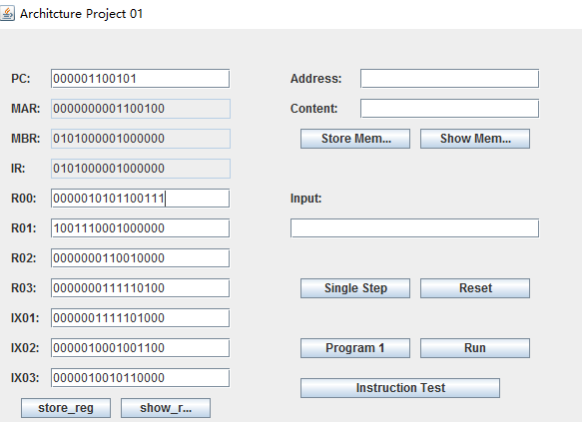

DVD:

Instruction: 111101 00 01 000000

Opcode: 001011 RX:00 RY: 01 I: 0 address：0000

Excepted: RX-R0: 0000000000000001

RY-R1: 0000000000000000

Result: Passed

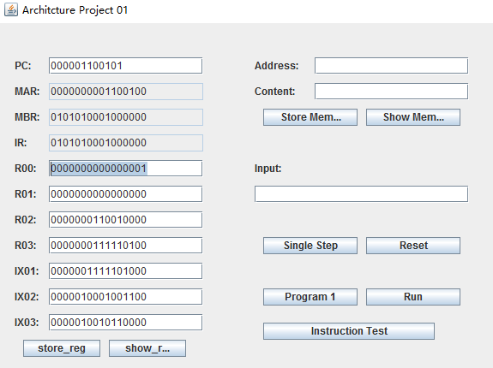

RRC:

Instruction: 100000 0 0 01 00 0000

Opcode: 100000 R:00 AL:0 BL:1 count: 0000

Excepted: R0: 0001110010101000

Result: Passed

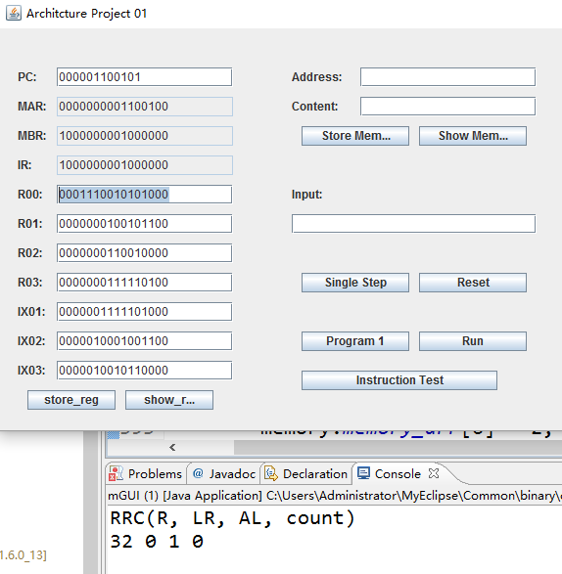

SRC:

Instruction: 011111 0 0 01 00 0000

Opcode: 011111 R:00 AL:0 BL:1 count: 0000

Excepted: R0: 0000000011001000

Result: Passed

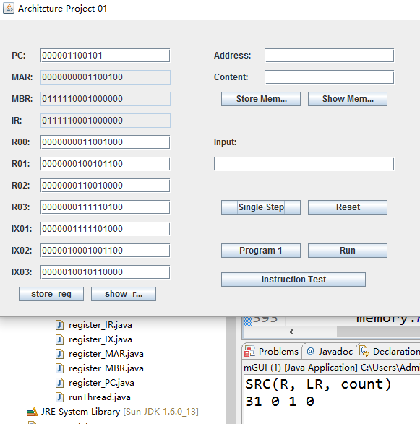

IN:

Instruction: 111101 00 01 000000

Opcode: 111101 R:00 DevID：000000

Result: Passed

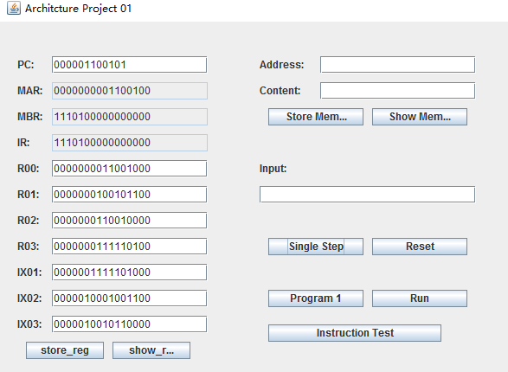

OUT:

Instruction: 111110 00 01 000000

Opcode: 111110 R:00 DevID：000000

Result: Passed

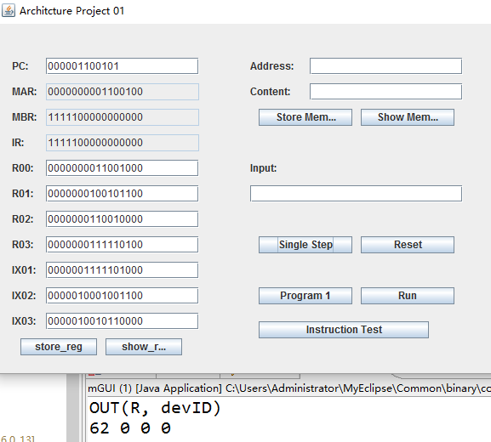

CHK:

Instruction: 111111 00 01 000000

Opcode: 111111 R:00 Devid：000000

Excepted: R0: 0000000011001000

Result: Passed

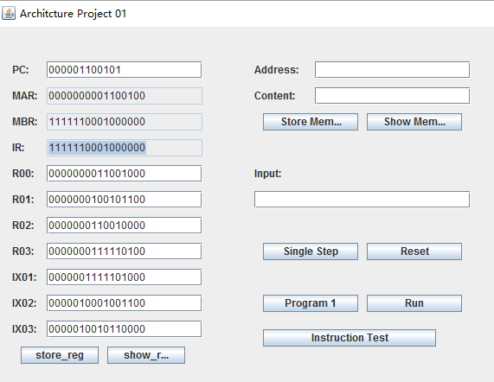

**3.4 Program1 :**

**Program1 Logical explanation:**

1. Input 20 numbers one by one in temp[20]

2. Put in memory 500—519 and input the good number in find put in memory 520

3. C version Pseudocode of program1 in my simulator all the instructions are store from memory[100]

4. All the data are start from 500 memory before 100 are used to store temporary data

5. Address from 11 to 31 are especially important int differ = find - temp[0]

int m, n, a, b;

int s

if (differ < 0)

m = -differ;

else

m = differ;

n = temp[0];

int i = 0

for( i = 1; i < 20; i++)

{

s = find - temp[i];

if(s < 0)

a = -s;

else

a = s;

if(a - m < 0)

{

m = a;

n = temp[i];

}

}

printf("%d",n);

**Program 1 Test:**

**Beginning Blannk**

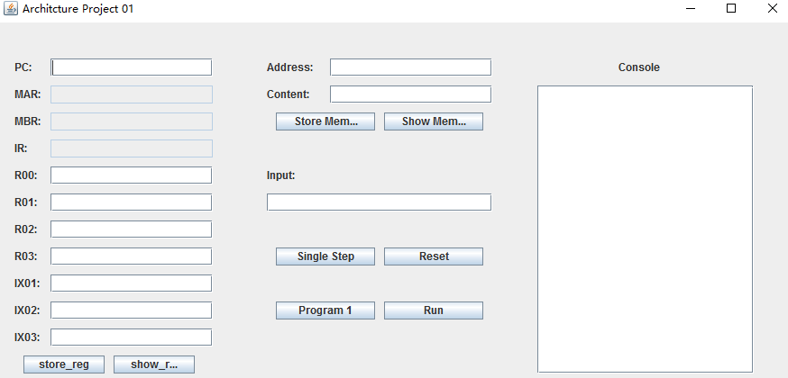

**First step: Click Program1 to load program1**

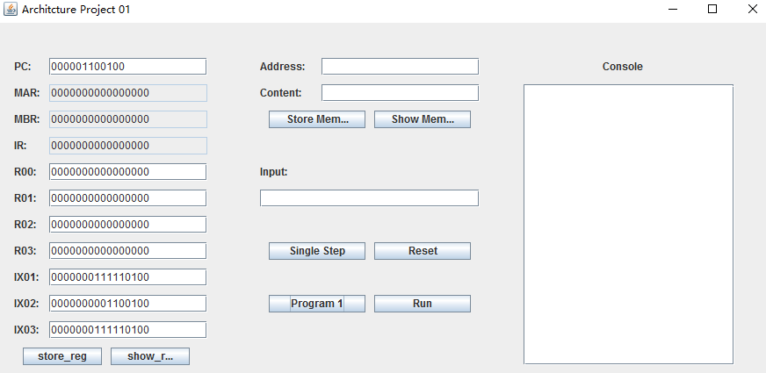

**Second Step: Click Run Button to run program1**

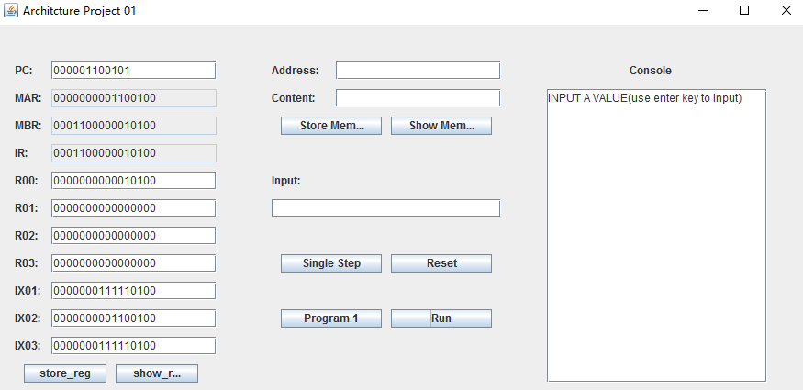

**Third Step : Input 20 number in the input textbox. Use enter key after putting a number in the input textbox every time.**

The testing results:

The red words is the 20 numbers that could be inputted by users.

The yellow background is the final result of program 1.

INPUT A VALUE(use enter key to input)

OUTPUT:

10100 (20)

OUTPUT:

1111111111111110 (65534)

INPUT A VALUE(use enter key to input)

OUTPUT:

10011 (19)

OUTPUT:

1000101011100 (4444)

INPUT A VALUE(use enter key to input)

OUTPUT:

10010 (18)

OUTPUT:

1101100100000011 (55555)

INPUT A VALUE(use enter key to input)

OUTPUT:

10001 (17)

OUTPUT:

101001101 (333)

INPUT A VALUE(use enter key to input)

OUTPUT:

10000 (16)

OUTPUT:

11011110 (222)

INPUT A VALUE(use enter key to input)

OUTPUT:

1111 (15)

OUTPUT:

1101111 (111)

INPUT A VALUE(use enter key to input)

OUTPUT:

1110 (14)

OUTPUT:

0 (0)

INPUT A VALUE(use enter key to input)

OUTPUT:

1101 (13)

OUTPUT:

1101000001010 (6666)

INPUT A VALUE(use enter key to input)

OUTPUT:

1100 (12)

OUTPUT:

101001101 (333)

INPUT A VALUE(use enter key to input)

OUTPUT:

1011 (11)

OUTPUT:

100010101110 (2222)

INPUT A VALUE(use enter key to input)

OUTPUT:

1010 (10)

OUTPUT:

10011100001111 (9999)

INPUT A VALUE(use enter key to input)

OUTPUT:

1001 (9)

OUTPUT:

1111111111111010 (65530)

INPUT A VALUE(use enter key to input)

OUTPUT:

1000 (8)

OUTPUT:

101001101 (333)

INPUT A VALUE(use enter key to input)

OUTPUT:

111 (7)

OUTPUT:

101001101 (333)

INPUT A VALUE(use enter key to input)

OUTPUT:

110 (6)

OUTPUT:

1000101101000 (4456)

INPUT A VALUE(use enter key to input)

OUTPUT:

101 (5)

OUTPUT:

10001010111 (1111)

INPUT A VALUE(use enter key to input)

OUTPUT:

100 (4)

OUTPUT:

11011110 (222)

INPUT A VALUE(use enter key to input)

OUTPUT:

11 (3)

OUTPUT:

1111100111 (999)

INPUT A VALUE(use enter key to input)

OUTPUT:

10 (2)

OUTPUT:

10001010111000 (8888)

INPUT A VALUE(use enter key to input)

OUTPUT:

1 (1)

OUTPUT:

1100001001 (777)

INPUT A VALUE(use enter key to input)

OUTPUT:

0 (0)

OUTPUT:

1010011010 (666)( this is the number, which enter by user to find the most closest number )

OUTPUT:

1100001001 (777)( this the result that is the most closest number to 666)

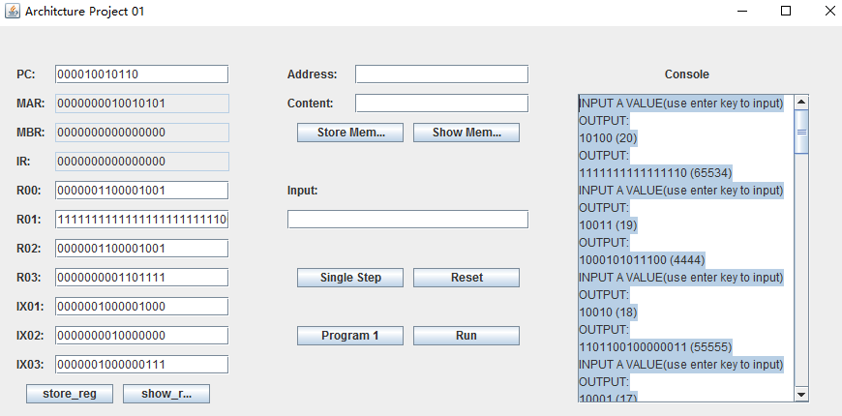

**The result:**

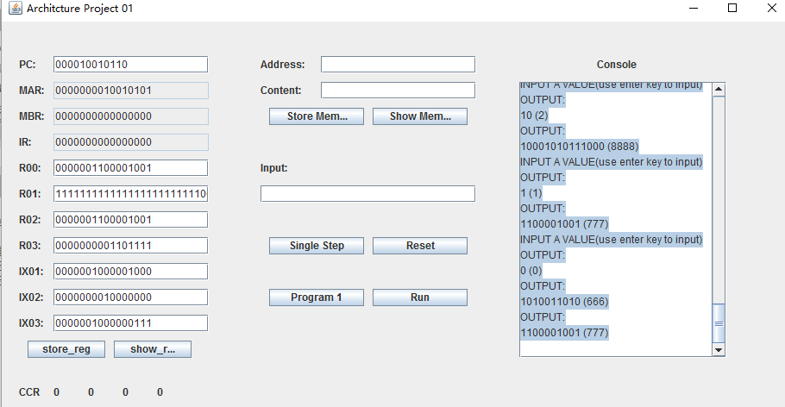

**Program 2 Test:**

**Program2 Logical Explanation:**

1. Load the contents from paragraph.txt that contains six sentences.

2. Running the program.

3. Store the words (include space and ‘\n’) to the memory started from 500

4. Store the words to look up started at 400

5. Store the length of the words to look up at memory 28 (0)

6. Scan the words from memory at 500

7. Put the location of the first character of each word at location started from 1000 (1)

8. Put the location of the last character of each word at location started from 1100 (2)

9. Put the location of the row number of each word at location started from 1200

10. Put the location of the column character of each word at location started from 1300

11. Get the length of each word from (1) and (2) (3)

12 Compare (0) and (3) if equal then it means the length is the same. If the length is not same, we jump to next word

13. In the comparison of the two words, if any character is different in matched word, we set the flag bit 1 located at memory 1

14. After scanning each word, we check the flag bit and determine whether to output

15 At last we output the row and column and the words we find.

**Pseudocode**

String wordToScan;

String words[100];

int length;

int templength;

int number;

int row[100];

int column[100];

int flag = 0;

read words from paragraph.txt

store the words to words[ ]

the row to row[ ] and the column to column[ ], and

know the number of words

input word to look up

length = wordToScan.length();

for(int i = 0;i < number; i++ ){

if(length == words[i].length())

{

for(int j = 0; j < length; j++){

if(words[i][j] != wordToScan[j])//may need to change in real java maybe tostring

flag = 1;

}

if(flag == 0)

{

output row column and word

}

flag = 0;

}

}

**Program 1 Test:**

**Step 1: Beginning Blannk**

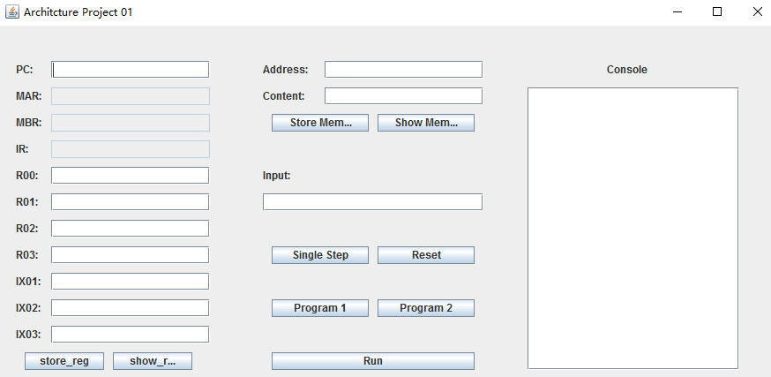

**Step2: click program 2**

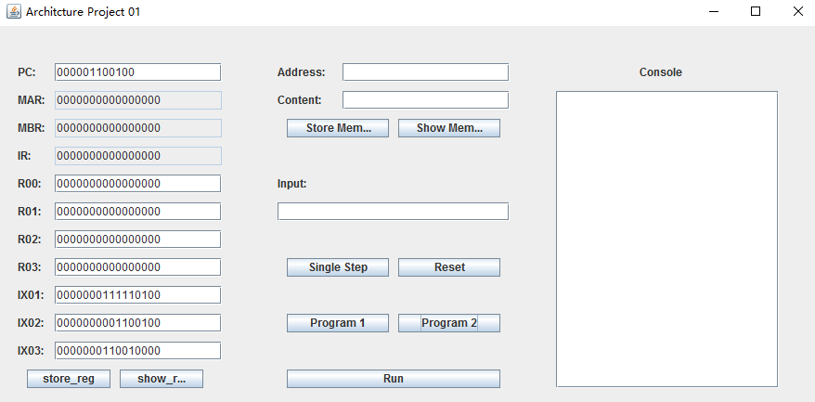

**Step3: click run button**

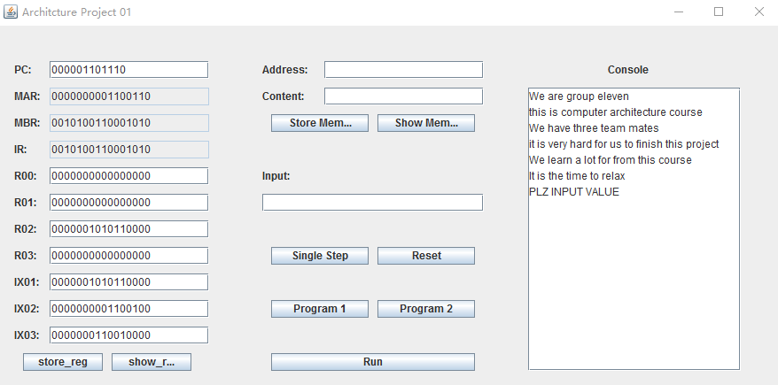

**Step 4: Input a word in Input box and Click Enter key**

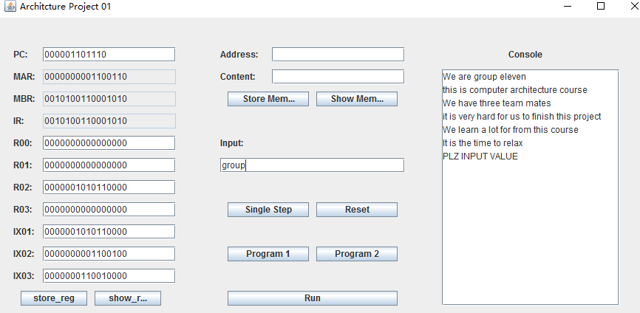

**Click Enter key to get Result:**

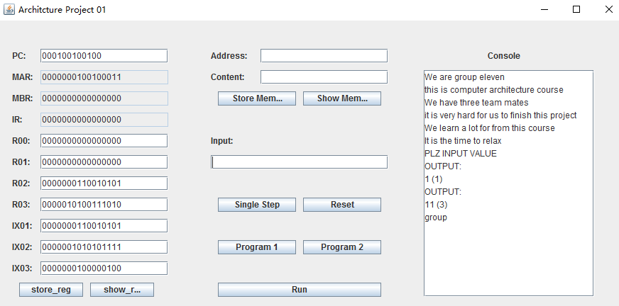

**The test result:**

**1. Input:** group

**Result: Right( output the group, row number and column number)**

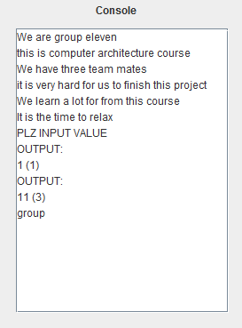

**2. Input: aaaaa**

**Result: Right(only output aaaaa )**

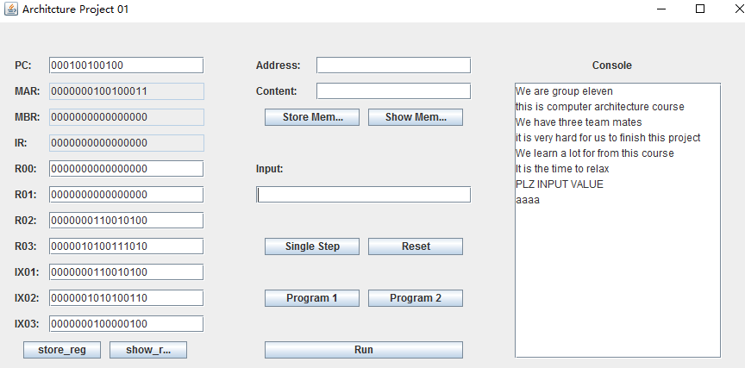

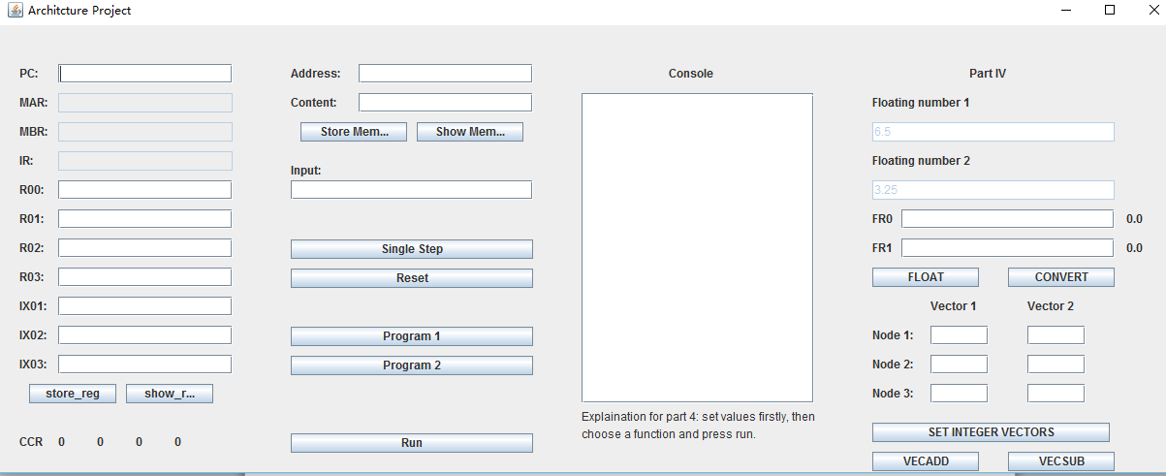**Phase4 test:**

* + - 1. **begin blank:**
      2. **click float button then click Run button**

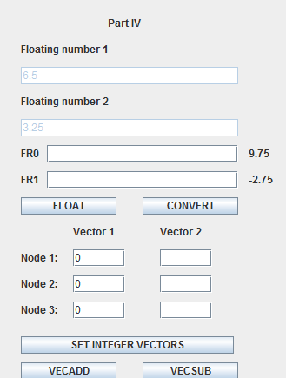

* + - 1. **click button using following sequences:**

**reset button, convert button then Run button.**

**Results:**

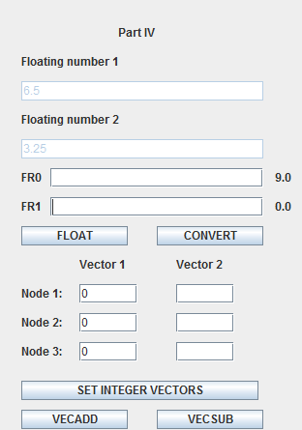

* + - 1. **Test vector:**

**Begin blank:**

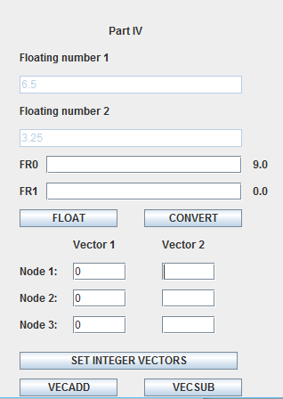

**Input integer value into vector:**

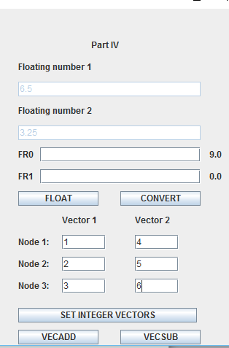

**Click SET INTEGER VECTORS:**

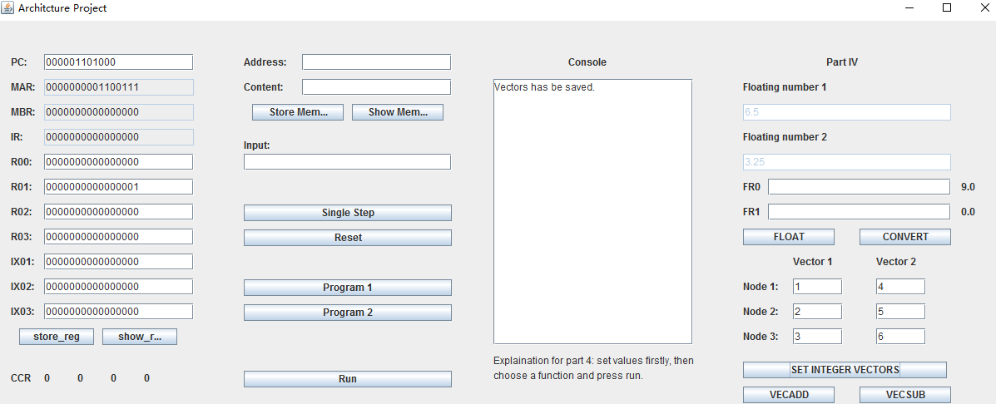

**Then click VECADD button , Run button：**

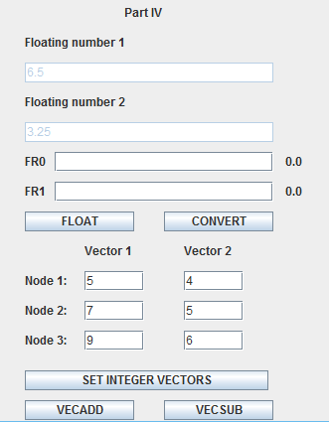

**Click SETINTEGER VECTORS , VECSUB, the Run button:**

**Results:**

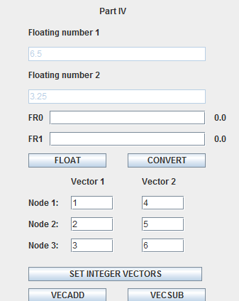

**3. Components**

**3.1 Interface Design**

**Phase1:**

In our project, we separate the whole project into two parts, UI design and implement background stage. The initial stage is that we try our best to create a UI that could put all the Components. In the left, we use JLabel to tag the name of the components and JTextBox to input contents and show results. We have Seven JButtons which have the name that tell users the functions on it. The STORE_REGISTER button and SHOW_REGISTER button, user could use it the Store the register information in any one Register and show the information about the all register. On the top of the screen is The SHOWMEMORY JButton, user could input the memory address and contents, then clicking STORE MEMORY store what users input. Users also could click the SHOW MEMORY to see what contents in address. In the middle of the screen we design Two JButtons that required to design in Phase one： Project1 test, Single step. The reset button use to the reset all the information in the whole program. In the right of the screen, we have a JTextfield to display the all the information and state about this program.

Phase2: We add Input textbox using to input 20 numbers. Program1 button and Run button are necessary to implement Program1 test. User needs to click program1 then click Run button before inputting numbers. The right console is used to display information program 1 test Results.

Phase3: in the Phase 3, the UI has little difference with the Phase 2. We just change the run button position and put the program2 button into the phase2 run button position. If users want to test the program2, the first step is to click the program2 button loading the program, then to click the run button. Next users can input a words to see if the words in the paragraph. Finally, the console will display the results.

Phase4：In the phase4, we implemented the phase in the right of the GUI. The float number1 textbox and the float number 2 textbox are the two test numbers. The FLOAT button is used to test the results of float1+float2 and float2-float1. The CONVET button is used to convert float point to fixed point number. In the lower right corner, we implement vector function: vector add and vector sub.

**The final UI:**



References