MSSV-MRTK hybird project
- Download MSSV and MSSV-MRTK on disk
If you follow the github’s repository readme,you will download the two project,and like this:
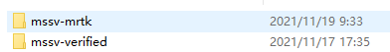

- Configurate MSSV first
ensure configurate MSSV project first,and work properly,see https://github.com/yinhun2012/MSSV and do it,if you complete this,you will see like this:
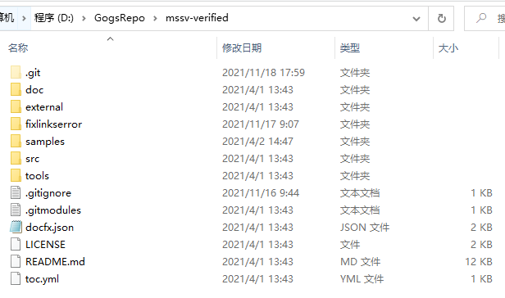
in case this isn’t work well,suggest try package it and run.

- Configurate MSSV-MRTK
open mssv-mrtk.assets,and mklink the mssv example.assets.folders to current folder,like this:
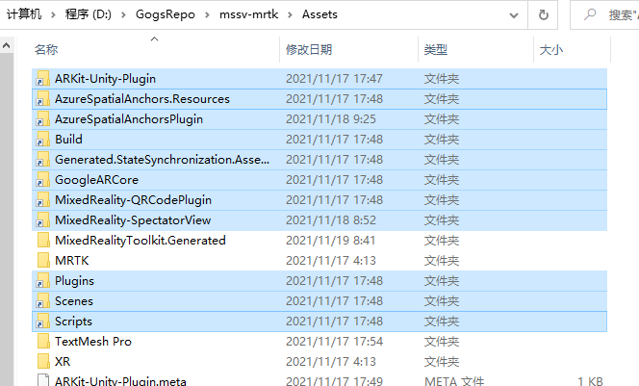
the cmd.mklink tutorial is in MSSV repository.
the origin sv.example folder like this:
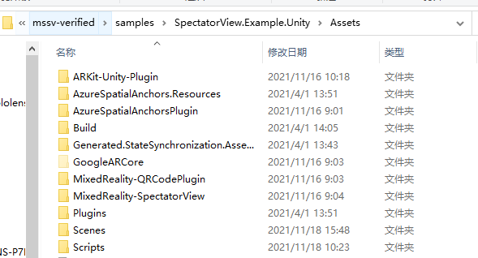

- Package Hololens2 and Android
configurate new scenes,such as MRTK-HandInteraction Demo:
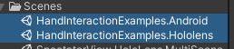
The hololens scene:
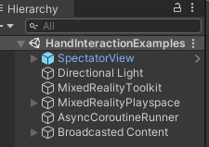
The android scene:
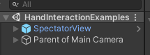
then package out:
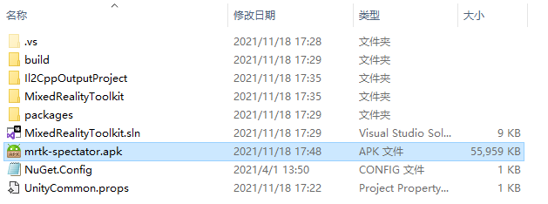
It will work properly

