- add the following five folders link to example.assets
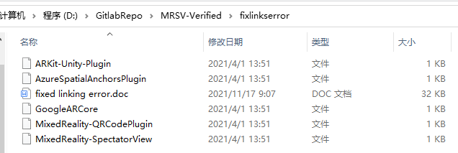
the operation is in <fixed linking error.doc>,if you solve the problem,you will see the example.assets had five more folders like this:
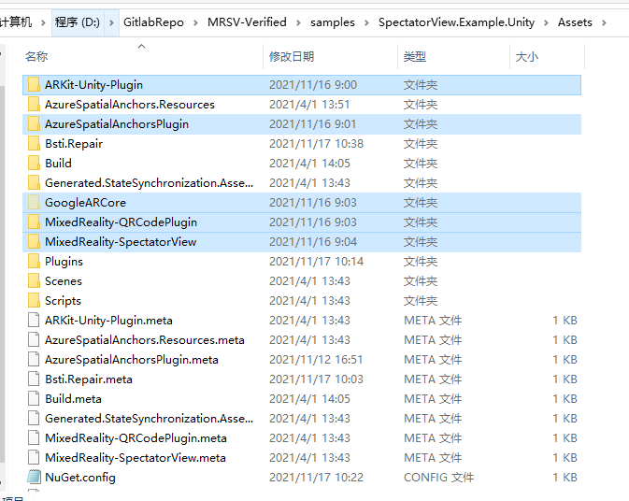
- open project with unity,and follow the settings(Hololens2)
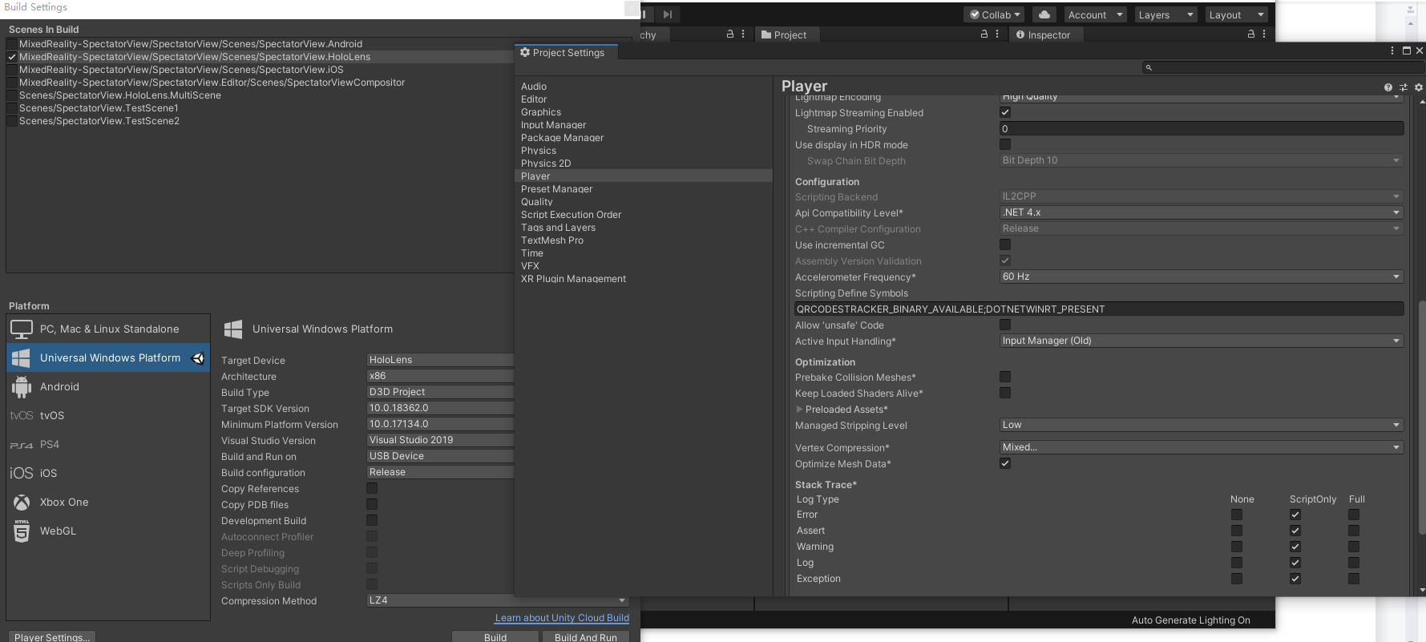
- switch the platform,and see the setting(android)
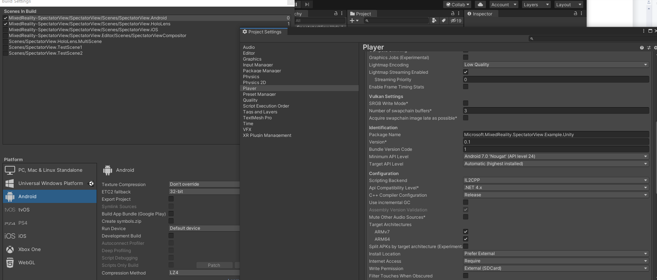
- if you want work with imac,and package ios,you need attention the arkit-unity-plugin folder,the a-u-p inside example.assets was i chose to download, not guaranteed to match your xcode project,so you can download and cover it by yourself.
