Report

File

OpenDataCriteriaChecklist

Candidate to be made public

Owned by the province

Restriction-free

Free of charge

High value : what score did the dataset receive

Useable format

Managed data: assign data management responsibility

Quality

Opendata-SNSDatasetTracking

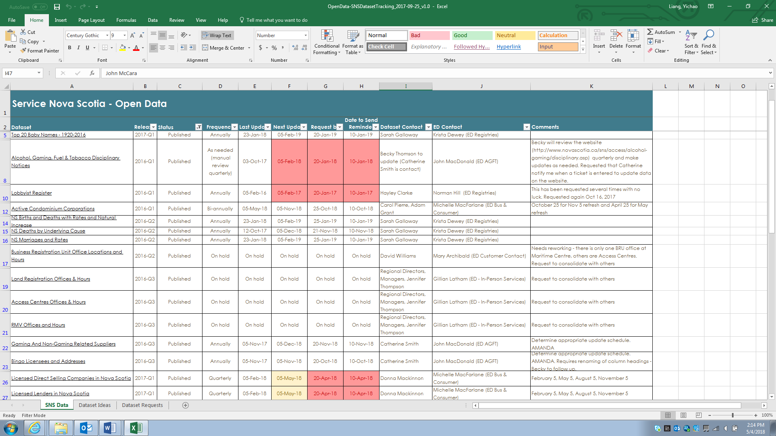

OpenDataValueFramework

Criteria: how often is the data requested

Is there general demand or interest in the data

Does publishing the datasets support province of nova scotia or department mandates or priority initiatives

Is the information/ data release legislated

Does the data fall into one of the categories of high value datasets as described in the G8 open data charter

Is the data complete

Can the data easily published

Is the data timely

Is the data updated on a regular basis

Are the datasets resulting information products

OpenDataInfographic

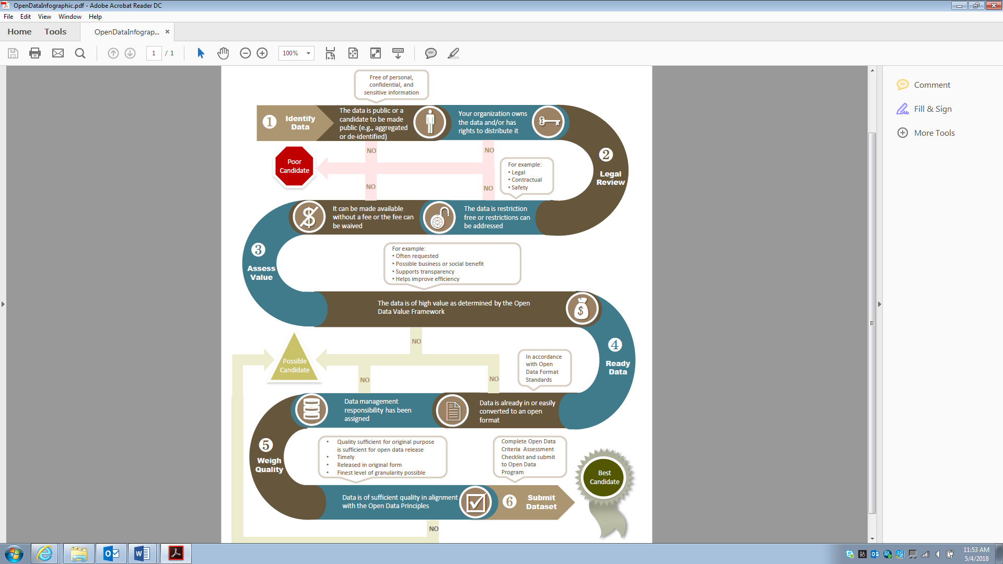

High level functional analysis

Records management project

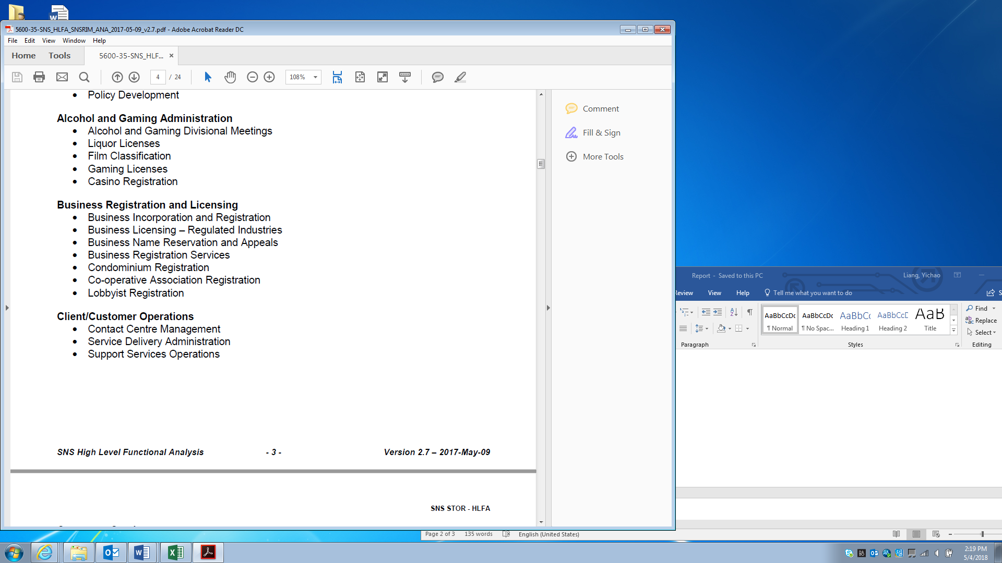

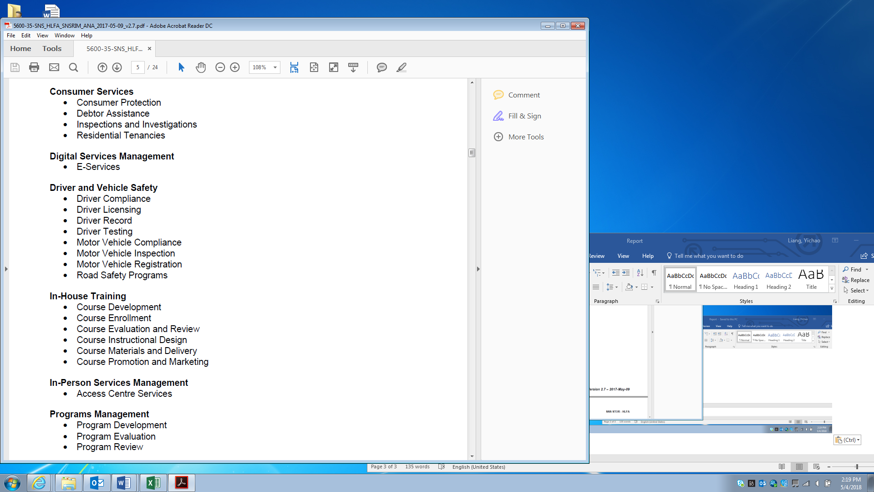

Combine dataset

Update datasets

Digitization research