Dataset NS Births and Deaths with Rates and Natural Increase

Column chart: Birth rate, deaths rates, and natural increase comparison by county

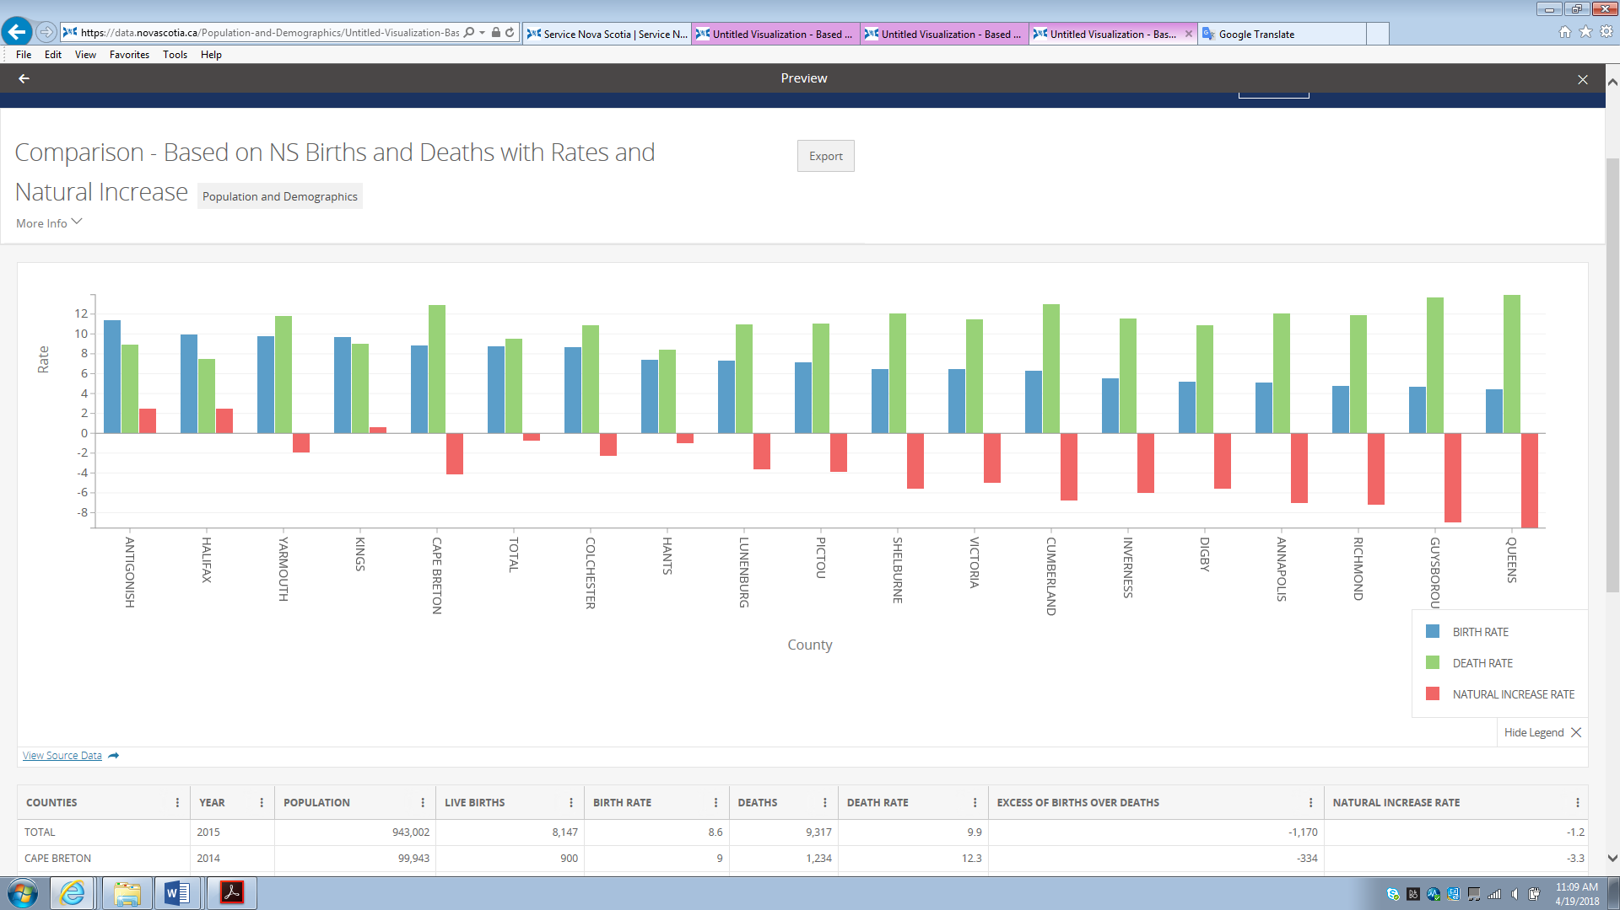

(built in tool)

Bar chart: Birth rate, death rate, and natural increase comparison by year

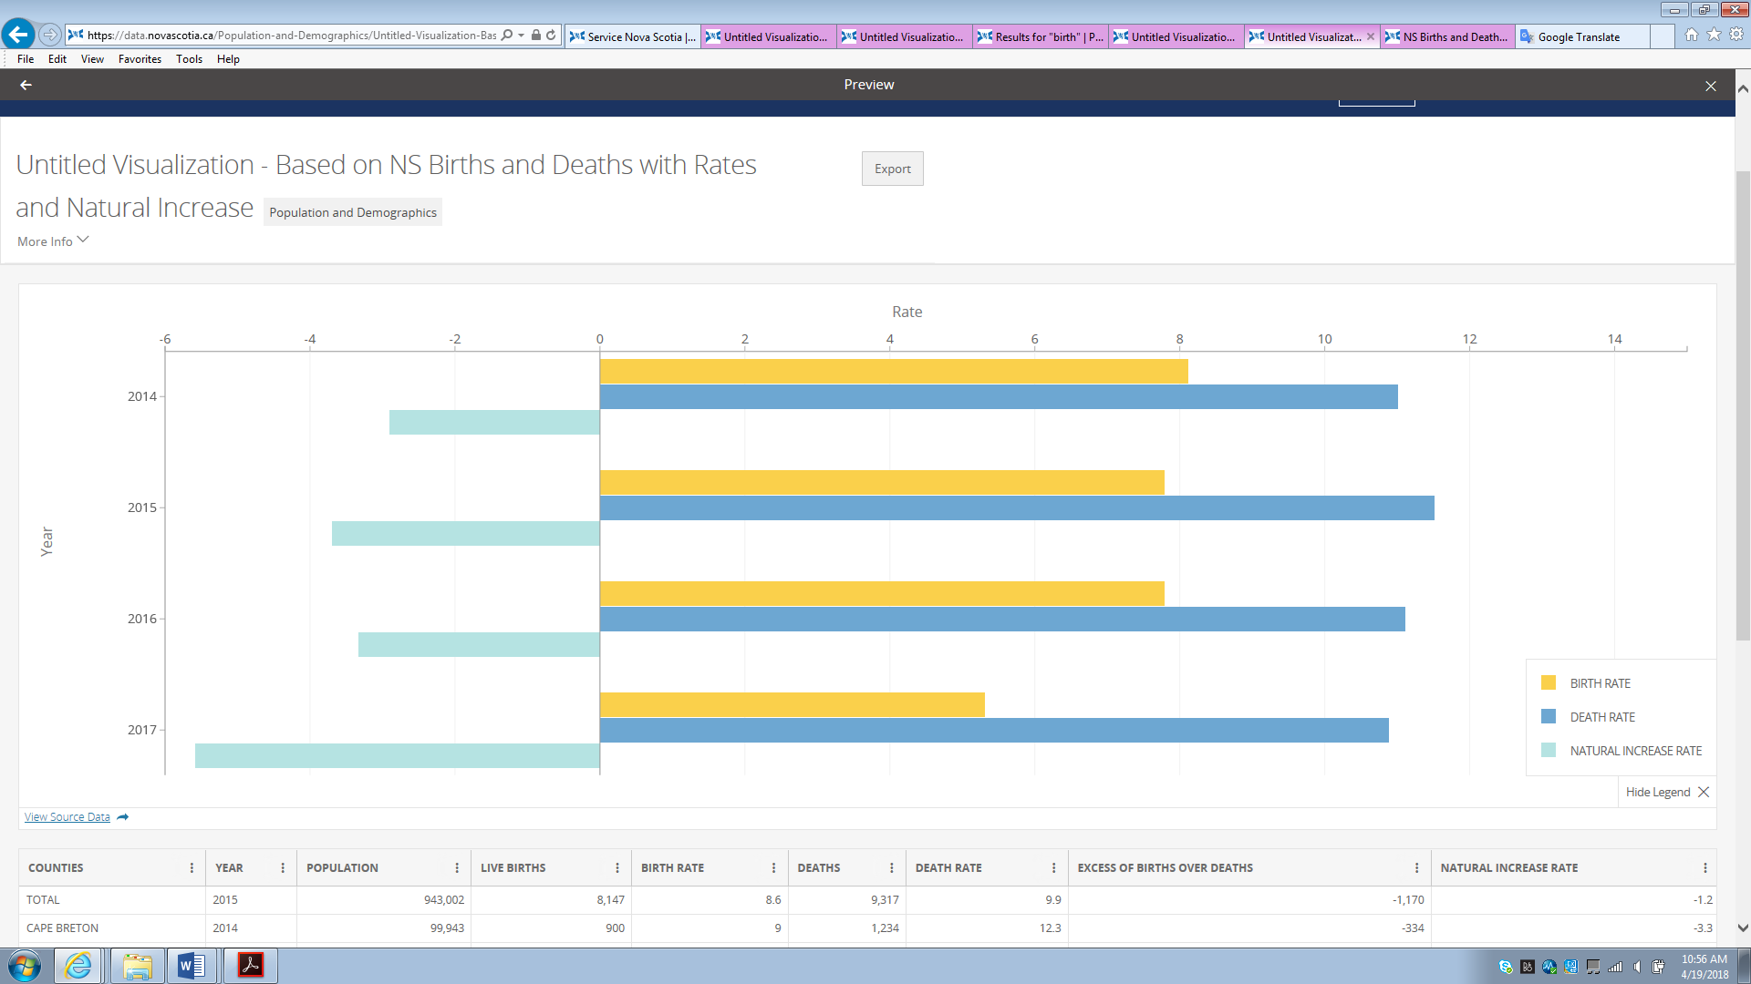

(built in tool)

Live birth, birth rate over years

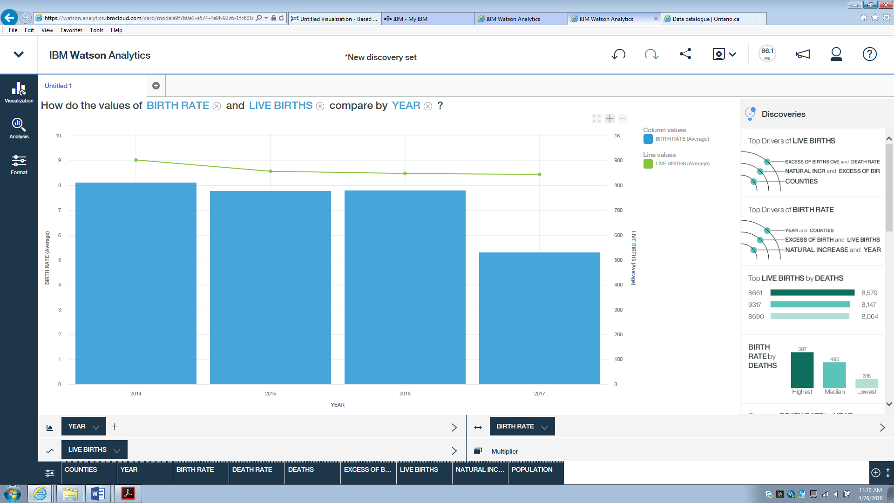

(By IBM Watson)

Dataset:NS births by Age of Partents

Area chart: Distribution about age of mother and age of father

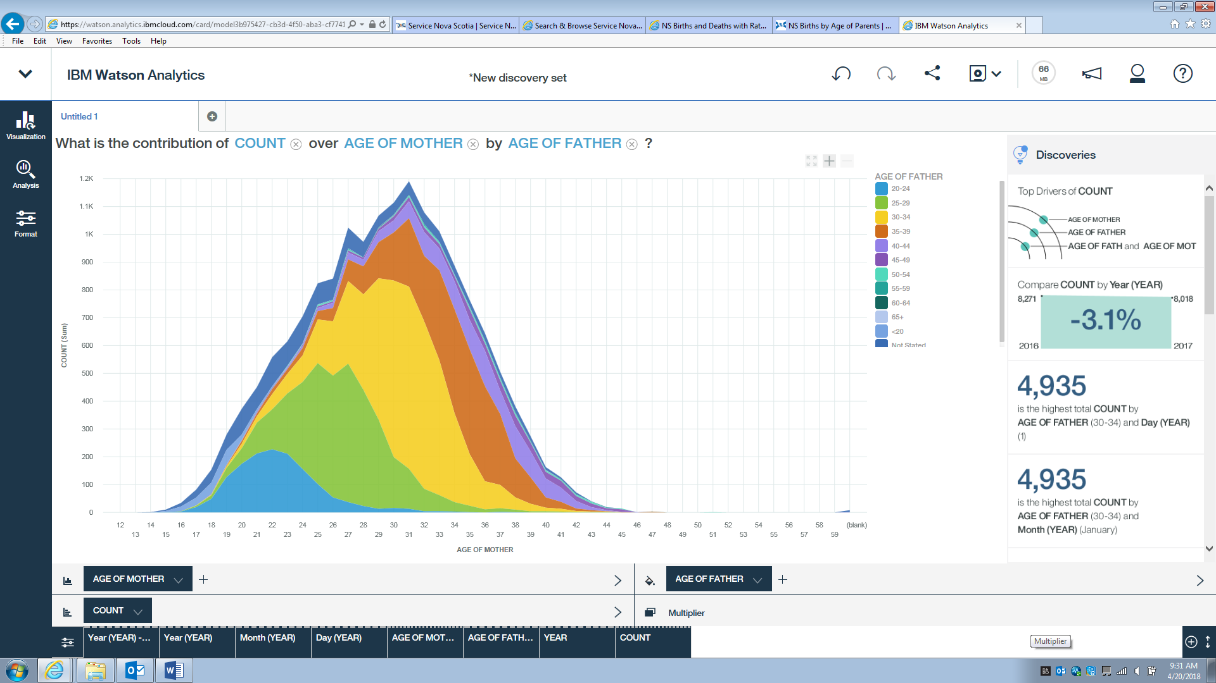

(By IBM Watson)

Dataset: Consumer Protection Complaints Types and Frequency

Bar chart: Number of complaints by complain category and year

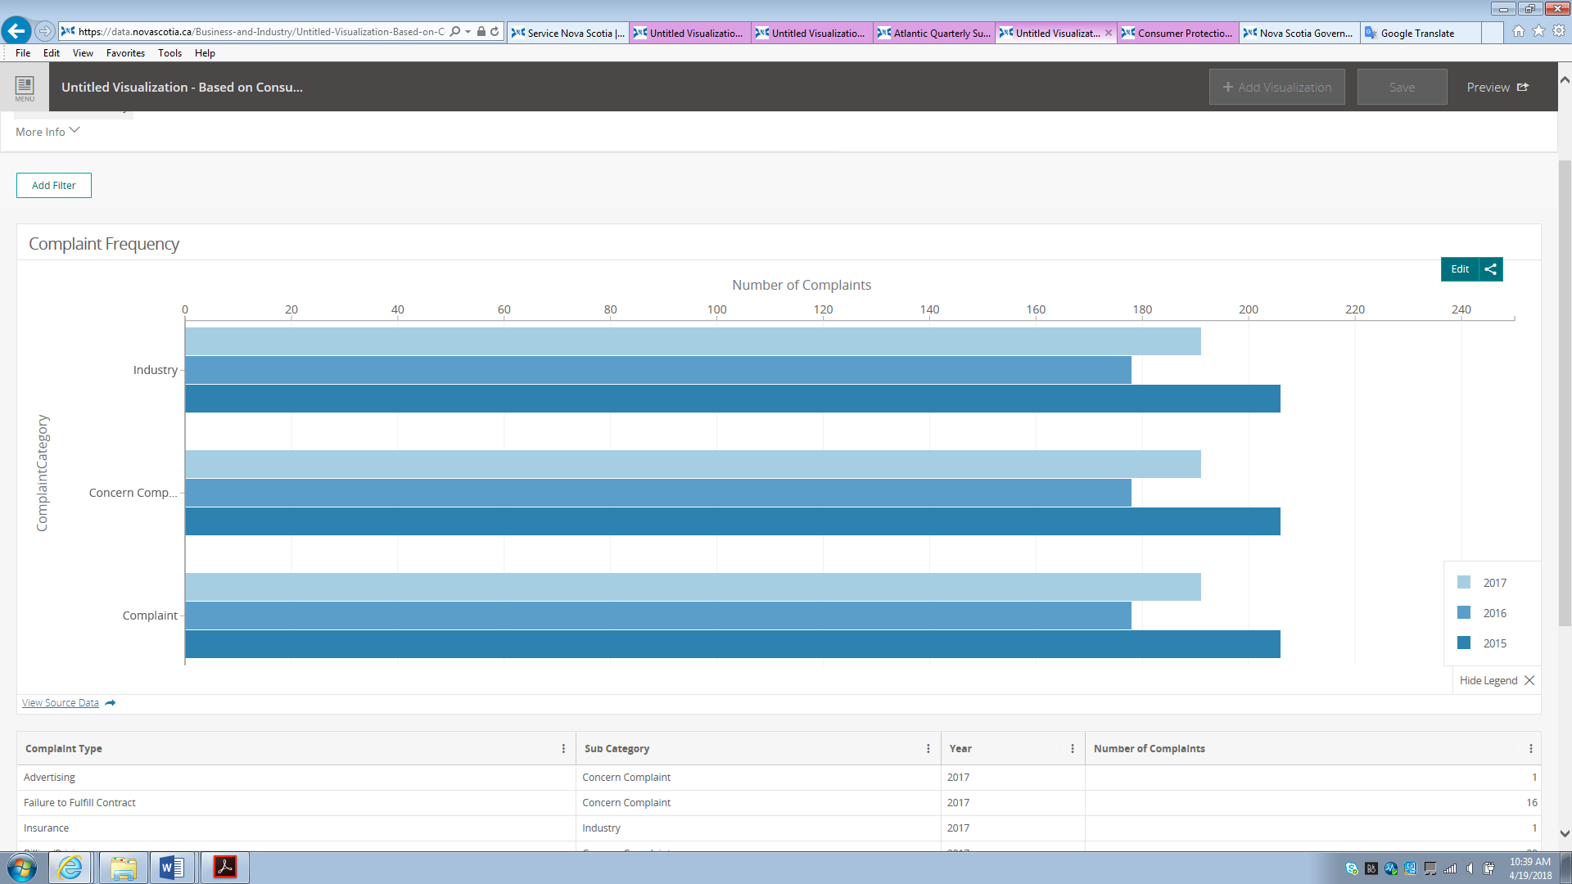

(built in tool)

Bar chart: Number of complaints by complaint type and sub category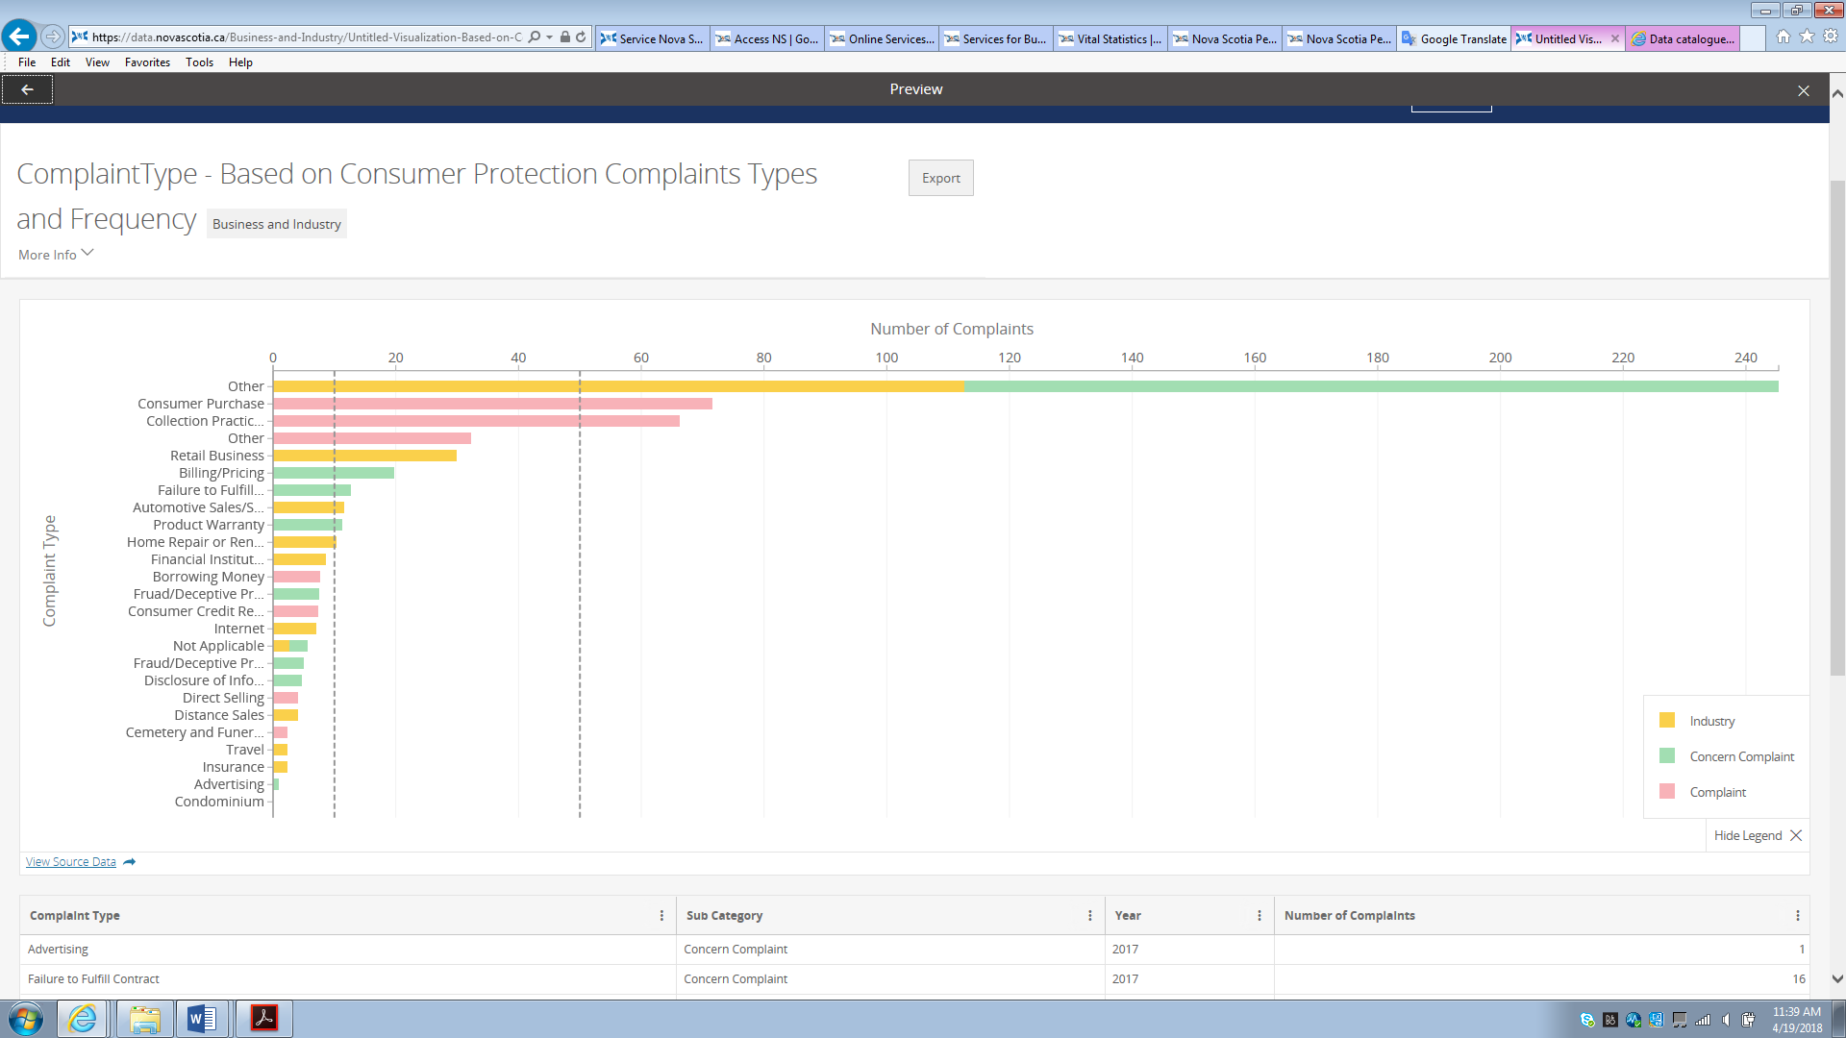

(built in tool)

Dataset: Licensed Hearing Aid Dealer in Nova Scotia

Hearing Aid Dealer map

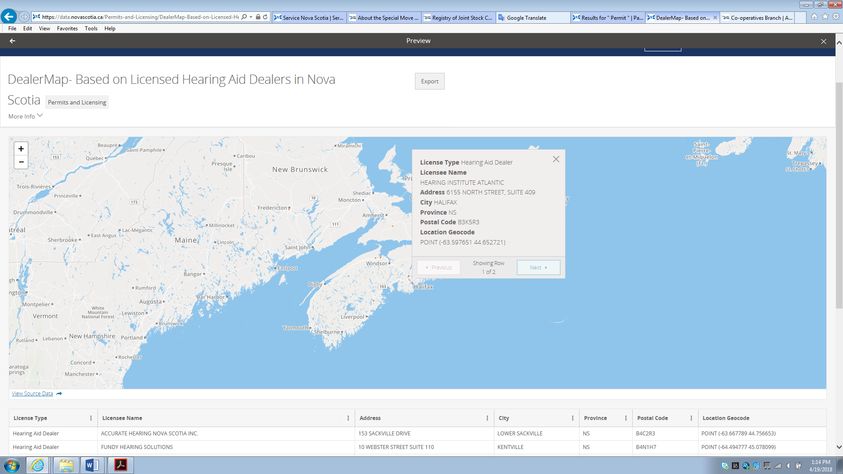

(built in tool)

Datasets: NS Provincial Gaming Activity

Bar chart: 2014-2017 Total Wager by gaming activities

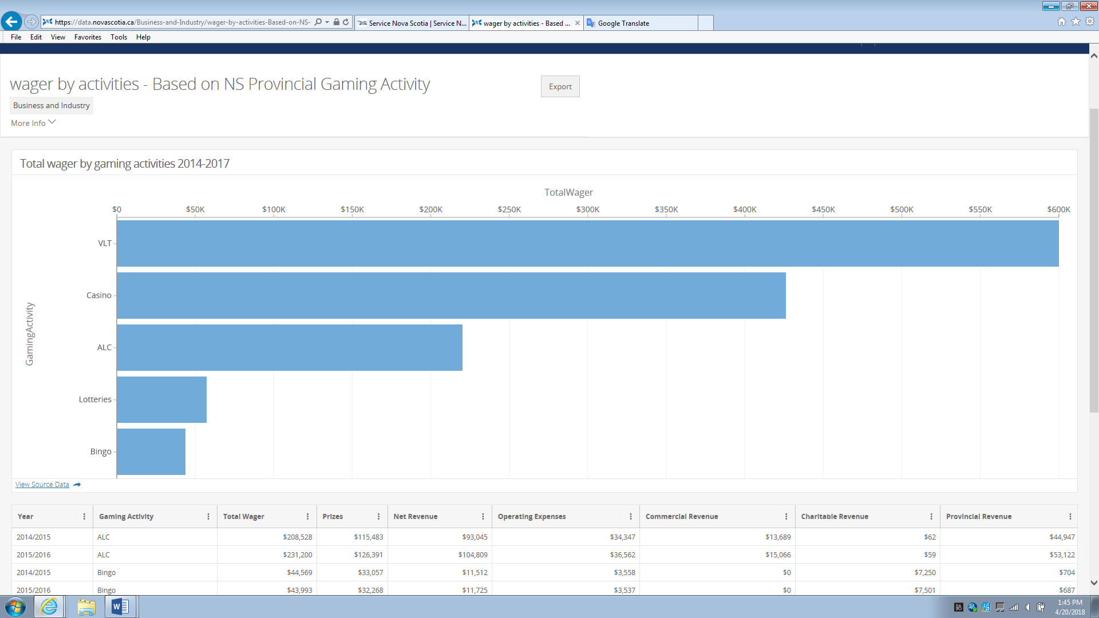

(built in tool)

Dataset: Atlantic quarterly summer 2017 tobacco and e-cigarette use

Bar chart: Response by group (filtered by table)

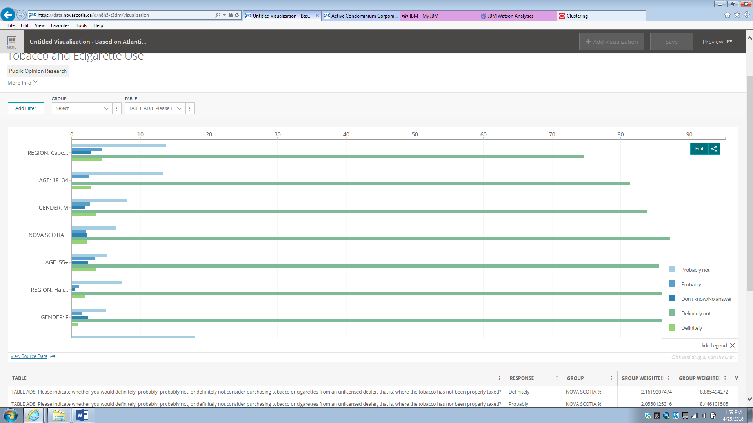

(built in visualization)

Treemap response by table filtered by group

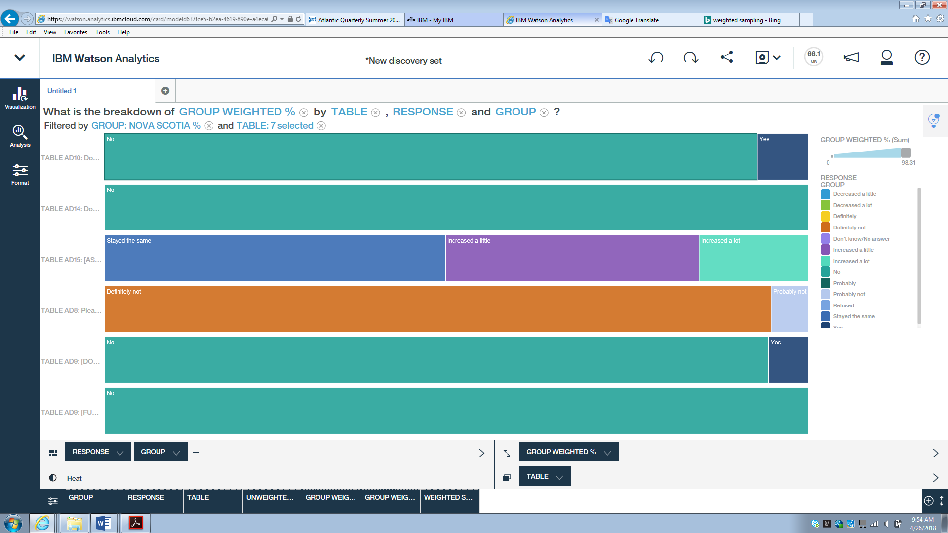

(IBM Watson Analytics)

Decisions rule: Use response to predict table

For data recovery use

If some data is missing or messed up, using decision rule can identify response match which table.

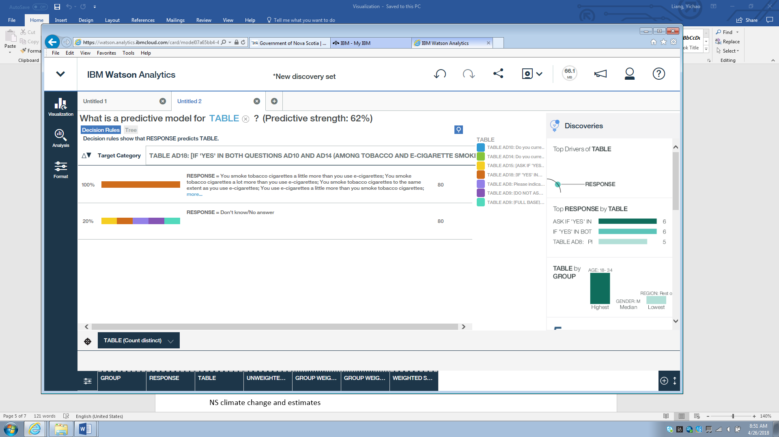

(IBM Watson Analytcis)

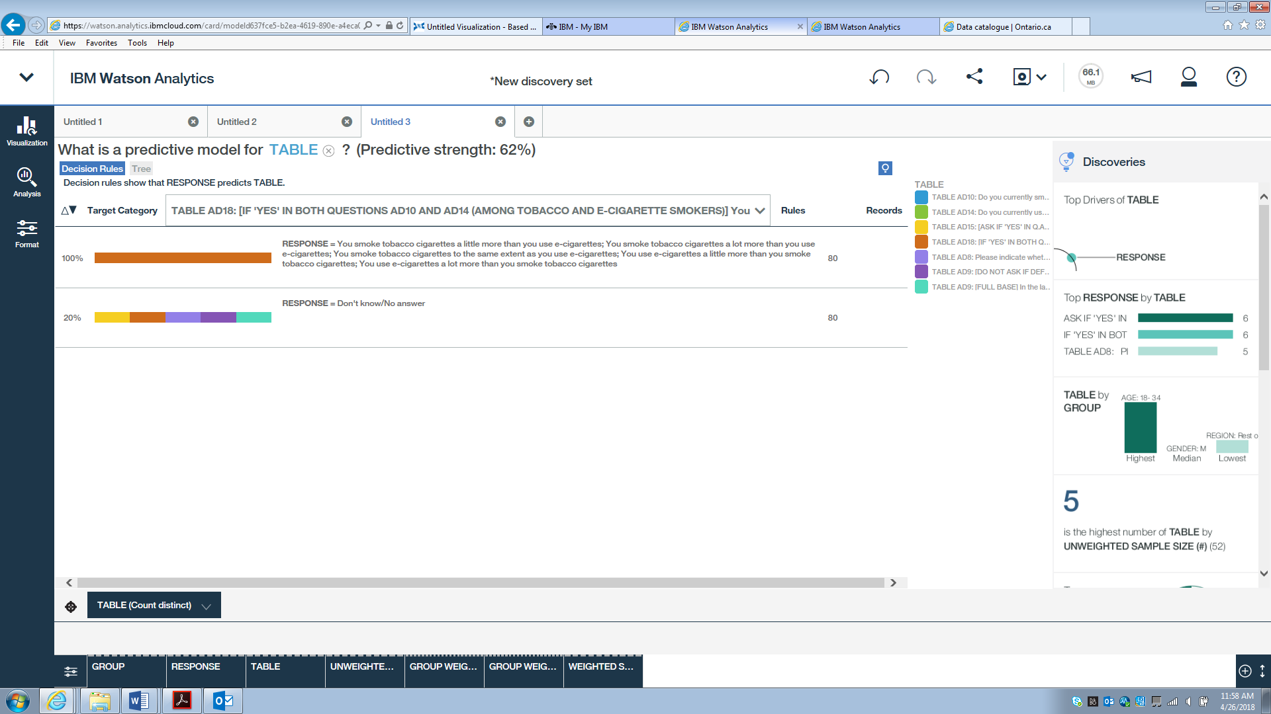

(IBM Watson Analytics)

Datasets: Surgical Wait Time

Consult Wait Time/ Surgery Wait Time

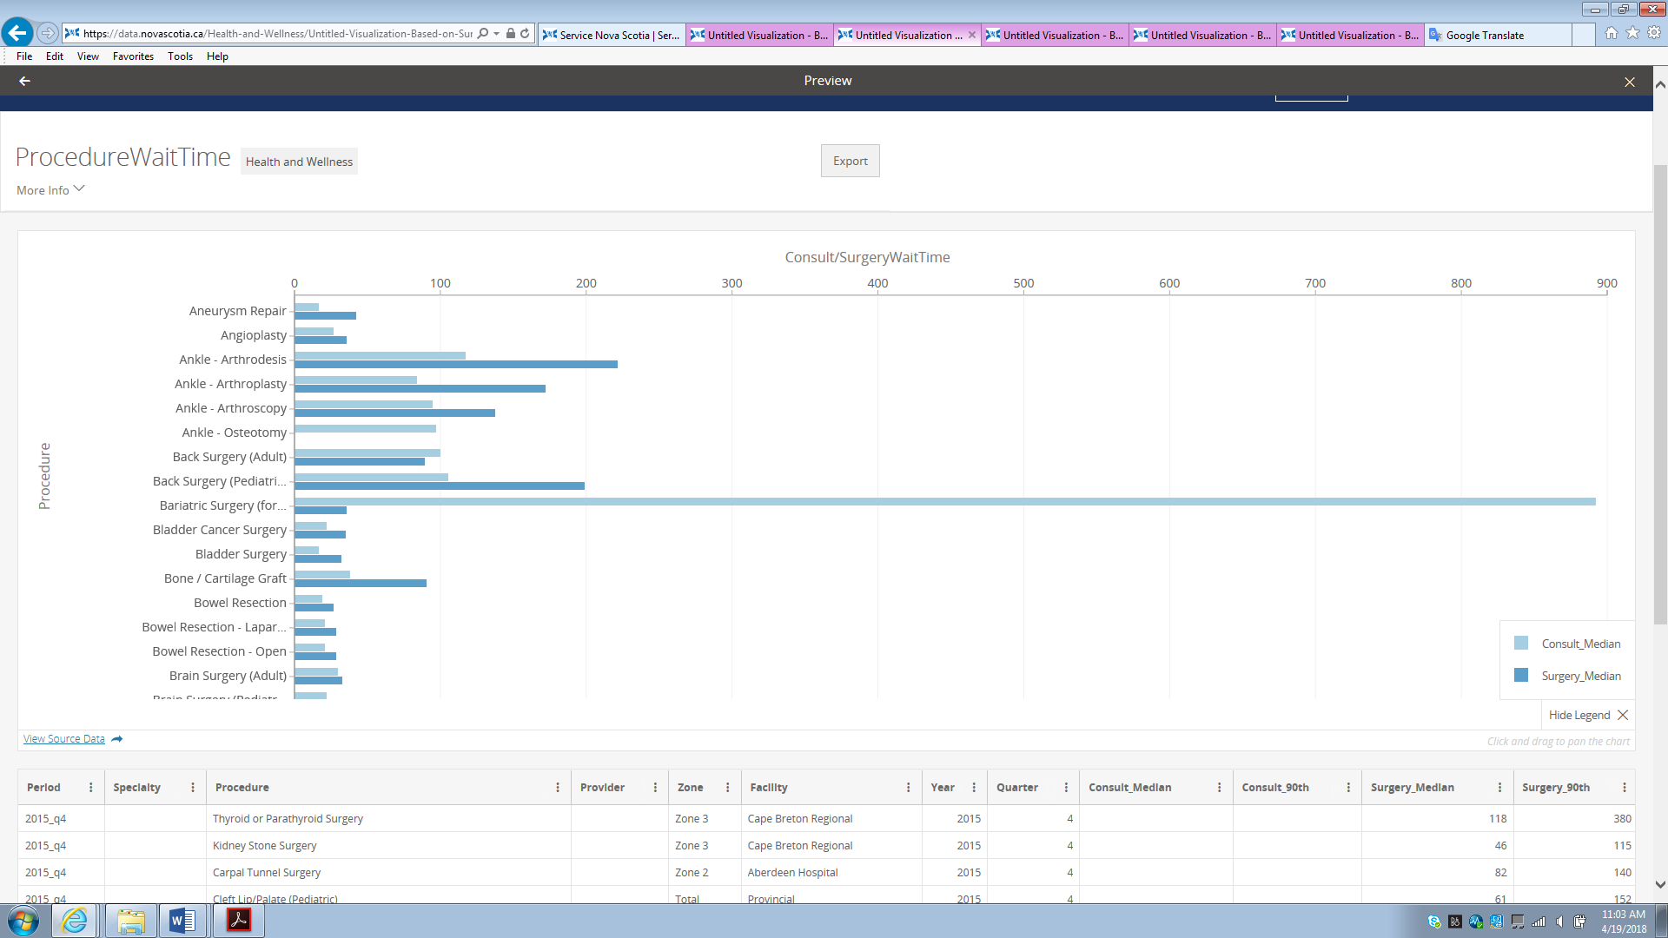

Consult/Surgery Wait Time by Procedure

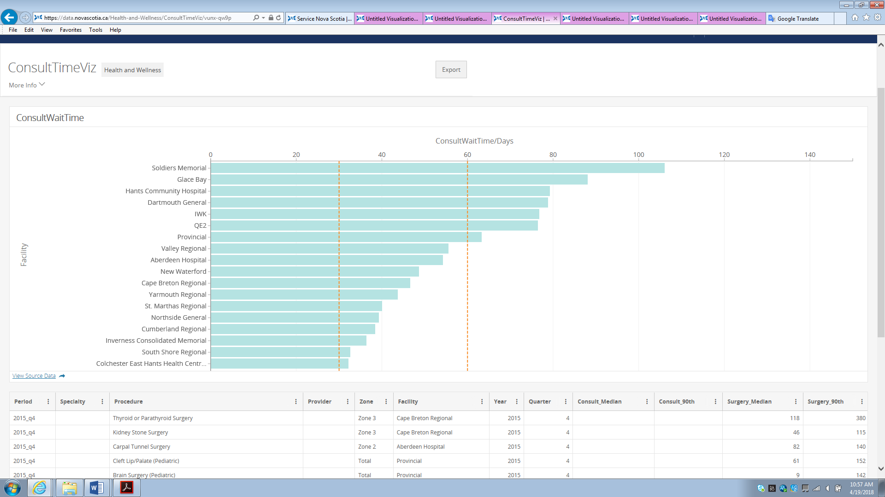

Consult Wait Time by Facility

Dataset: NS Climate Change Data

NS climate change and estimates

