linux的访问日志不记录静态文件、切割、静态元素过期时间配置

[原创](javascript:;)[Gary_加油涛](http://blog.51cto.com/taoxie)[2017-12-21 21:59:19](javascript:;)[评论(0)](http://blog.51cto.com/taoxie/2053107#comment)[445人阅读](javascript:;)

**访问日志不记录静态文件**

一个网站会有很多元素，尤其是图片、js、css等静态的文件非常多，用户每请求一个页面就会访问诸多的图片、js等静态元素，这些元素的请求都会被记录在日志中。如果一个站点访问量很大，那么访问日志文件增长会非常快，一天就可以达到几GB。这不仅对于服务器的磁盘空间造成影响，更重要的是会影响磁盘的读写速度。还好这些巨量的静态元素请求记录到日志里的意义并不大，所以可以限制这些静态元素去记录日志，并且需要把日志按天归档，一天一个日志，这样也可以防止单个日志文件过大。

1. 修改虚拟主机配置文件：

[root@gary-tao local]*# vim /usr/local/apache2.4/conf/extra/httpd-vhosts.conf*

参考配置修改如下：

<VirtualHost *:80>

DocumentRoot "/data/wwwroot/111.com"

ServerName 111.com

ServerAlias 111.com

SetEnvIf Request_URI ".*\.gif$" img

SetEnvIf Request_URI ".*\.jpg$" img

SetEnvIf Request_URI ".*\.png$" img

SetEnvIf Request_URI ".*\.bmp$" img

SetEnvIf Request_URI ".*\.swf$" img

SetEnvIf Request_URI ".*\.js$" img

SetEnvIf Request_URI ".*\.css$" img

CustomLog "logs/123.com-access_log" combined env=!img

</VirtualHost>

更改配置文件后需要重新加载配置文件：

[root@gary-tao local]*# /usr/local/apache2.4/bin/apachectl -t*

Syntax OK

[root@gary-tao local]*# /usr/local/apache2.4/bin/apachectl graceful*

**修改完后，示例如下：**

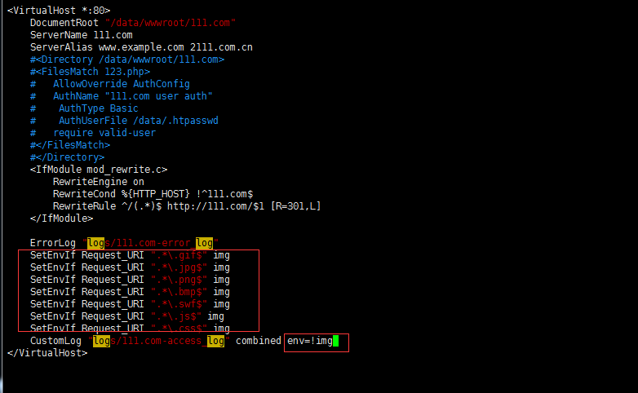

**解释说明：**

先定义一个img环境变量，把gif、jpg、png、bmp、swf、js、css等格式的文件全部归类到img里，后面的env=!imge有用到一个“！”,这相当于取反了，意思是把img以外的类型文件记录到日志里。

验证如下：

[root@gary-tao **local**]*# curl -x127.0.0.1:80 111.com/alskdda.jpg -I*

HTTP/1.1 404 Not Found

Date: Thu, 21 Dec 2017 06:39:14 GMT

Server: Apache/2.4.29 (Unix) PHP/7.1.6

Content-Type: text/html; charset=iso-8859-1

[root@gary-tao **local**]*# !tail //未更新配置前日志是有jpg文件。*

tail /usr/**local**/apache2.4/logs/111.com-access_log

127.0.0.1 - - [20/Dec/2017:20:36:35 +0800] "HEAD http://111.com/123.php HTTP/1.1" 200 -

127.0.0.1 - - [20/Dec/2017:20:39:23 +0800] "HEAD http://111.com/123.php HTTP/1.1" 403 -

127.0.0.1 - - [20/Dec/2017:20:40:16 +0800] "HEAD http://111.com/123.php HTTP/1.1" 200 -

127.0.0.1 - - [20/Dec/2017:21:10:16 +0800] "HEAD http://111.com/123.php HTTP/1.1" 200 - "-" "curl/7.29.0"

127.0.0.1 - - [20/Dec/2017:21:10:31 +0800] "HEAD http://111.com/123.php HTTP/1.1" 200 - "-" "curl/7.29.0"

172.16.111.1 - xie [20/Dec/2017:21:10:38 +0800] "GET / HTTP/1.1" 200 12 "-" "Mozilla/5.0 (Windows NT 6.1; WOW64) AppleWebKit/537.36 (KHTML, like Gecko) Chrome/49.0.2623.221 Safari/537.36 SE 2.X MetaSr 1.0"

172.16.111.1 - xie [20/Dec/2017:21:10:38 +0800] "GET / HTTP/1.1" 200 12 "-" "Mozilla/5.0 (Windows NT 6.1; WOW64) AppleWebKit/537.36 (KHTML, like Gecko) Chrome/49.0.2623.221 Safari/537.36 SE 2.X MetaSr 1.0"

172.16.111.1 - xie [20/Dec/2017:21:10:39 +0800] "GET / HTTP/1.1" 200 12 "-" "Mozilla/5.0 (Windows NT 6.1; WOW64) AppleWebKit/537.36 (KHTML, like Gecko) Chrome/49.0.2623.221 Safari/537.36 SE 2.X MetaSr 1.0"

172.16.111.1 - xie [21/Dec/2017:14:04:49 +0800] "GET / HTTP/1.1" 200 12 "-" "Mozilla/5.0 (Windows NT 6.1; WOW64) AppleWebKit/537.36 (KHTML, like Gecko) Chrome/49.0.2623.221 Safari/537.36 SE 2.X MetaSr 1.0"

127.0.0.1 - - [21/Dec/2017:14:39:14 +0800] "HEAD HTTP://111.com/alskdda.jpg HTTP/1.1" 404 - "-" "curl/7.29.0"

[root@gary-tao **local**]*# /usr/local/apache2.4/bin/apachectl -t*

Syntax OK

[root@gary-tao **local**]*# /usr/local/apache2.4/bin/apachectl graceful*

[root@gary-tao **local**]*# curl -x127.0.0.1:80 111.com/alskdda.png -I*

HTTP/1.1 404 Not Found

Date: Thu, 21 Dec 2017 06:49:10 GMT

Server: Apache/2.4.29 (Unix) PHP/7.1.6

Content-Type: text/html; charset=iso-8859-1

[root@gary-tao **local**]*# tail /usr/local/apache2.4/logs/111.com-access_log //更新配置日志后没有png文件。*

127.0.0.1 - - [20/Dec/2017:20:40:16 +0800] "HEAD http://111.com/123.php HTTP/1.1" 200 -

127.0.0.1 - - [20/Dec/2017:21:10:16 +0800] "HEAD http://111.com/123.php HTTP/1.1" 200 - "-" "curl/7.29.0"

127.0.0.1 - - [20/Dec/2017:21:10:31 +0800] "HEAD http://111.com/123.php HTTP/1.1" 200 - "-" "curl/7.29.0"

172.16.111.1 - xie [20/Dec/2017:21:10:38 +0800] "GET / HTTP/1.1" 200 12 "-" "Mozilla/5.0 (Windows NT 6.1; WOW64) AppleWebKit/537.36 (KHTML, like Gecko) Chrome/49.0.2623.221 Safari/537.36 SE 2.X MetaSr 1.0"

172.16.111.1 - xie [20/Dec/2017:21:10:38 +0800] "GET / HTTP/1.1" 200 12 "-" "Mozilla/5.0 (Windows NT 6.1; WOW64) AppleWebKit/537.36 (KHTML, like Gecko) Chrome/49.0.2623.221 Safari/537.36 SE 2.X MetaSr 1.0"

172.16.111.1 - xie [20/Dec/2017:21:10:39 +0800] "GET / HTTP/1.1" 200 12 "-" "Mozilla/5.0 (Windows NT 6.1; WOW64) AppleWebKit/537.36 (KHTML, like Gecko) Chrome/49.0.2623.221 Safari/537.36 SE 2.X MetaSr 1.0"

172.16.111.1 - xie [21/Dec/2017:14:04:49 +0800] "GET / HTTP/1.1" 200 12 "-" "Mozilla/5.0 (Windows NT 6.1; WOW64) AppleWebKit/537.36 (KHTML, like Gecko) Chrome/49.0.2623.221 Safari/537.36 SE 2.X MetaSr 1.0"

127.0.0.1 - - [21/Dec/2017:14:39:14 +0800] "HEAD HTTP://111.com/alskdda.jpg HTTP/1.1" 404 - "-" "curl/7.29.0"

172.16.111.1 - xie [21/Dec/2017:14:43:17 +0800] "GET / HTTP/1.1" 200 12 "-" "Mozilla/5.0 (Windows NT 6.1; WOW64) AppleWebKit/537.36 (KHTML, like Gecko) Chrome/49.0.2623.221 Safari/537.36 SE 2.X MetaSr 1.0"

172.16.111.1 - xie [21/Dec/2017:14:43:18 +0800] "GET / HTTP/1.1" 200 12 "-" "Mozilla/5.0 (Windows NT 6.1; WOW64) AppleWebKit/537.36 (KHTML, like Gecko) Chrome/49.0.2623.221 Safari/537.36 SE 2.X MetaSr 1.0"

**模拟一张图片实际测试：**

[root@gary-tao ~]*# cd /data/wwwroot/111.com/ //cd到目录下面*

[root@gary-tao 111.com]*# ls*

123.php index.php

[root@gary-tao 111.com]*# rz //上传一张图片，如果不能使用rz请安装yum install -y lrzsz*

[root@gary-tao 111.com]*# ls //已上传文件*

123.php index.php QQ截图20171221141829.png

[root@gary-tao 111.com]*# curl -x127.0.0.1:80 111.com/QQ截图20171221141829.png -I //运行下程序*

HTTP/1.1 200 OK

**Date: Thu, 21 Dec 2017 07:08:49 GMT**

**Server: Apache/2.4.29 (Unix) PHP/7.1.6**

**Last-Modified: Thu, 21 Dec 2017 06:18:31 GMT**

**ETag: "91ab-560d3ab3fbbc0"**

**Accept-Ranges: bytes**

**Content-Length: 37291**

**Content-Type: image/png**

[root@gary-tao 111.com]*# tail /usr/local/apache2.4/logs/111.com-access_log //发现日志并没有图片png的记录*

127.0.0.1 - - [20/Dec/2017:21:10:16 +0800] "HEAD http://111.com/123.php HTTP/1.1" 200 - "-" "curl/7.29.0"

127.0.0.1 - - [20/Dec/2017:21:10:31 +0800] "HEAD http://111.com/123.php HTTP/1.1" 200 - "-" "curl/7.29.0"

172.16.111.1 - xie [20/Dec/2017:21:10:38 +0800] "GET / HTTP/1.1" 200 12 "-" "Mozilla/5.0 (Windows NT 6.1; WOW64) AppleWebKit/537.36 (KHTML, like Gecko) Chrome/49.0.2623.221 Safari/537.36 SE 2.X MetaSr 1.0"

172.16.111.1 - xie [20/Dec/2017:21:10:38 +0800] "GET / HTTP/1.1" 200 12 "-" "Mozilla/5.0 (Windows NT 6.1; WOW64) AppleWebKit/537.36 (KHTML, like Gecko) Chrome/49.0.2623.221 Safari/537.36 SE 2.X MetaSr 1.0"

172.16.111.1 - xie [20/Dec/2017:21:10:39 +0800] "GET / HTTP/1.1" 200 12 "-" "Mozilla/5.0 (Windows NT 6.1; WOW64) AppleWebKit/537.36 (KHTML, like Gecko) Chrome/49.0.2623.221 Safari/537.36 SE 2.X MetaSr 1.0"

172.16.111.1 - xie [21/Dec/2017:14:04:49 +0800] "GET / HTTP/1.1" 200 12 "-" "Mozilla/5.0 (Windows NT 6.1; WOW64) AppleWebKit/537.36 (KHTML, like Gecko) Chrome/49.0.2623.221 Safari/537.36 SE 2.X MetaSr 1.0"

127.0.0.1 - - [21/Dec/2017:14:39:14 +0800] "HEAD HTTP://111.com/alskdda.jpg HTTP/1.1" 404 - "-" "curl/7.29.0"

172.16.111.1 - xie [21/Dec/2017:14:43:17 +0800] "GET / HTTP/1.1" 200 12 "-" "Mozilla/5.0 (Windows NT 6.1; WOW64) AppleWebKit/537.36 (KHTML, like Gecko) Chrome/49.0.2623.221 Safari/537.36 SE 2.X MetaSr 1.0"

172.16.111.1 - xie [21/Dec/2017:14:43:18 +0800] "GET / HTTP/1.1" 200 12 "-" "Mozilla/5.0 (Windows NT 6.1; WOW64) AppleWebKit/537.36 (KHTML, like Gecko) Chrome/49.0.2623.221 Safari/537.36 SE 2.X MetaSr 1.0"

172.16.111.1 - - [21/Dec/2017:15:09:15 +0800] "GET /QQ HTTP/1.1" 404 200 "-" "Mozilla/5.0 (Windows NT 6.1; WOW64) AppleWebKit/537.36 (KHTML, like Gecko) Chrome/49.0.2623.221 Safari/537.36 SE 2.X MetaSr 1.0"

[root@gary-tao 111.com]*# vim /usr/local/apache2.4/conf/extra/httpd-vhosts.conf //为了实验需要，先把env=!img去掉*

[root@gary-tao 111.com]*# /usr/local/apache2.4/bin/apachectl -t*

Syntax OK

[root@gary-tao 111.com]*# /usr/local/apache2.4/bin/apachectl graceful //重新加载*

[root@gary-tao 111.com]*# curl -x127.0.0.1:80 111.com/QQ截图20171221141829.png -I //运行图片*

HTTP/1.1 200 OK

**Date: Thu, 21 Dec 2017 07:25:46 GMT**

**Server: Apache/2.4.29 (Unix) PHP/7.1.6**

**Last-Modified: Thu, 21 Dec 2017 06:18:31 GMT**

**ETag: "91ab-560d3ab3fbbc0"**

**Accept-Ranges: bytes**

**Content-Length: 37291**

**Content-Type: image/png**

[root@gary-tao 111.com]*# tail /usr/local/apache2.4/logs/111.com-access_log //查看下例就有png图片的日志出来*

127.0.0.1 - - [20/Dec/2017:21:10:31 +0800] "HEAD http://111.com/123.php HTTP/1.1" 200 - "-" "curl/7.29.0"

172.16.111.1 - xie [20/Dec/2017:21:10:38 +0800] "GET / HTTP/1.1" 200 12 "-" "Mozilla/5.0 (Windows NT 6.1; WOW64) AppleWebKit/537.36 (KHTML, like Gecko) Chrome/49.0.2623.221 Safari/537.36 SE 2.X MetaSr 1.0"

172.16.111.1 - xie [20/Dec/2017:21:10:38 +0800] "GET / HTTP/1.1" 200 12 "-" "Mozilla/5.0 (Windows NT 6.1; WOW64) AppleWebKit/537.36 (KHTML, like Gecko) Chrome/49.0.2623.221 Safari/537.36 SE 2.X MetaSr 1.0"

172.16.111.1 - xie [20/Dec/2017:21:10:39 +0800] "GET / HTTP/1.1" 200 12 "-" "Mozilla/5.0 (Windows NT 6.1; WOW64) AppleWebKit/537.36 (KHTML, like Gecko) Chrome/49.0.2623.221 Safari/537.36 SE 2.X MetaSr 1.0"

172.16.111.1 - xie [21/Dec/2017:14:04:49 +0800] "GET / HTTP/1.1" 200 12 "-" "Mozilla/5.0 (Windows NT 6.1; WOW64) AppleWebKit/537.36 (KHTML, like Gecko) Chrome/49.0.2623.221 Safari/537.36 SE 2.X MetaSr 1.0"

127.0.0.1 - - [21/Dec/2017:14:39:14 +0800] "HEAD HTTP://111.com/alskdda.jpg HTTP/1.1" 404 - "-" "curl/7.29.0"

172.16.111.1 - xie [21/Dec/2017:14:43:17 +0800] "GET / HTTP/1.1" 200 12 "-" "Mozilla/5.0 (Windows NT 6.1; WOW64) AppleWebKit/537.36 (KHTML, like Gecko) Chrome/49.0.2623.221 Safari/537.36 SE 2.X MetaSr 1.0"

172.16.111.1 - xie [21/Dec/2017:14:43:18 +0800] "GET / HTTP/1.1" 200 12 "-" "Mozilla/5.0 (Windows NT 6.1; WOW64) AppleWebKit/537.36 (KHTML, like Gecko) Chrome/49.0.2623.221 Safari/537.36 SE 2.X MetaSr 1.0"

172.16.111.1 - - [21/Dec/2017:15:09:15 +0800] "GET /QQ HTTP/1.1" 404 200 "-" "Mozilla/5.0 (Windows NT 6.1; WOW64) AppleWebKit/537.36 (KHTML, like Gecko) Chrome/49.0.2623.221 Safari/537.36 SE 2.X MetaSr 1.0"

127.0.0.1 - - [21/Dec/2017:15:25:46 +0800] "HEAD HTTP://111.com/QQ\xe6\x88\xaa\xe5\x9b\xbe20171221141829.png HTTP/1.1" 200 - "-" "curl/7.29.0"

测试完成后把刚才去掉的env=!img添加到配置文件里去。

**添加上图片后可以上浏览器上打开，示例如下：**

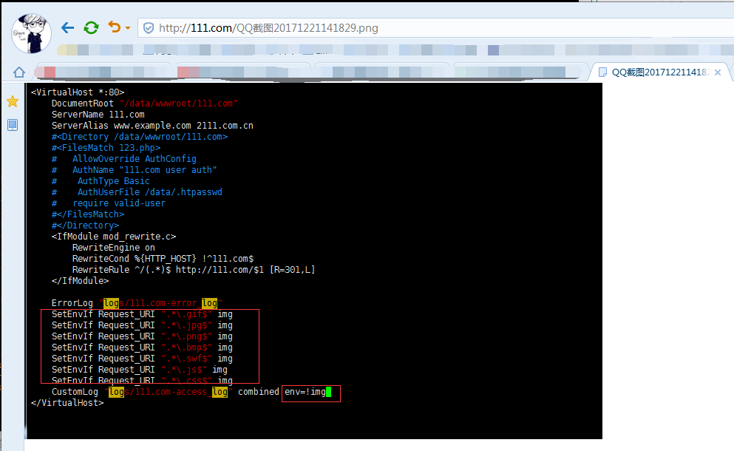

**访问日志切割**

日志一直记录总有一天会把整个磁盘占满，所以有必要让它自动切割，并删除老的日志文件，防止磁盘写满，用日期记录日志方便管理及查找。还要写一个任务计划，定期清理超过时间的日志。

1. 修改虚拟主机配置文件，给日志做一个切割。

[root@gary-tao local]*# vim /usr/local/apache2.4/conf/extra/httpd-vhosts.conf*

参考配置修改如下：

<VirtualHost *:80>

DocumentRoot "/data/wwwroot/111.com"

ServerName 111.com

ServerAlias 111.com

SetEnvIf Request_URI ".*\.gif$" img

SetEnvIf Request_URI ".*\.jpg$" img

SetEnvIf Request_URI ".*\.png$" img

SetEnvIf Request_URI ".*\.bmp$" img

SetEnvIf Request_URI ".*\.swf$" img

SetEnvIf Request_URI ".*\.js$" img

SetEnvIf Request_URI ".*\.css$" img

CustomLog "|/usr/local/apache2.4/bin/rotatelogs -l logs/111.com-access_%Y%m%d.log 86400" combined env=!img

</VirtualHost>

更改配置文件后需要重新加载配置文件：

[root@gary-tao local]*# /usr/local/apache2.4/bin/apachectl -t*

Syntax OK

[root@gary-tao local]*# /usr/local/apache2.4/bin/apachectl graceful*

[root@gary-tao 111.com]*# /usr/local/apache2.4/bin/apachectl graceful*

[root@gary-tao 111.com]*# ls /usr/local/apache2.4/logs/*

111.com-access_log 111.com-error_log abc.com-access_log abc.com-error_log access_log error_log httpd.pid

[root@gary-tao ~]*# curl -x127.0.0.1:80 111.com/123.php*

123.php[root@gary-tao ~]*#*

[root@gary-tao ~]*# ls /usr/local/apache2.4/logs/*

111.com-access_log 111.com-access_20171221.log abc.com-error_log error_log

111.com-error_log abc.com-access_log access_log httpd.pid

[root@gary-tao ~]*# ls /usr/local/apache2.4/logs/111.com-access_20171221.log*

/usr/local/apache2.4/logs/123.com-access_20171221.log

[root@gary-tao ~]*# cat !$*

cat /usr/local/apache2.4/logs/123.com-access_20171221.log

127.0.0.1 - - [21/Dec/2017:16:47:53 +0800] "GET HTTP://111.com/123.php HTTP/1.1" 200 7 "-" "curl/7.29.0"

127.0.0.1 - - [21/Dec/2017:16:53:56 +0800] "GET HTTP://111.com/123.php HTTP/1.1" 200 7 "-" "curl/7.29.0"

127.0.0.1 - - [21/Dec/2017:16:54:06 +0800] "GET HTTP://111.com/123.php HTTP/1.1" 200 7 "-" "curl/7.29.0"

[root@gary-tao ~]# curl -x127.0.0.1:80 111.com/123.php.png -I //访问图片的

HTTP/1.1 404 Not Found

Date: Thu, 21 Dec 2017 08:57:55 GMT

Server: Apache/2.4.29 (Unix) PHP/7.1.6

Content-Type: text/html; charset=iso-8859-1

[root@gary-tao ~]# cat /usr/local/apache2.4/logs/111.com-access_20171221.log //查看日志并没有记录

127.0.0.1 - - [21/Dec/2017:16:47:53 +0800] "GET HTTP://111.com/123.php HTTP/1.1" 200 7 "-" "curl/7.29.0"

127.0.0.1 - - [21/Dec/2017:16:53:56 +0800] "GET HTTP://111.com/123.php HTTP/1.1" 200 7 "-" "curl/7.29.0"

127.0.0.1 - - [21/Dec/2017:16:54:06 +0800] "GET HTTP://111.com/123.php HTTP/1.1" 200 7 "-" "curl/7.29.0"

**配置文件修改完后，示例如下：**

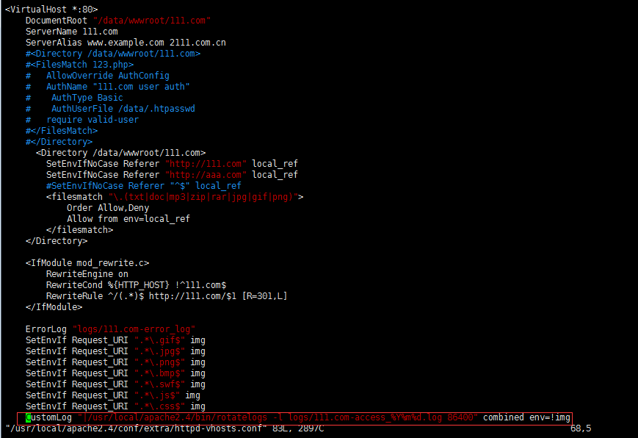

**解释说明：**

这里的123.com-access_20171221.log就是新生成的日志，而且以后会每天生成一个按日期命名的日志。

**静态元素过期时间**

在日志里会发现有一个状态码304，这个状态码表示该文件已经缓存到用户的电脑里了（浏览器访问网站的图片时会把静态的文件缓存在本地电脑里），这样下次再访问时就不用去远程下载了，而是直接访问用户电脑里面的缓存。这样做的目的是降低服务器的资源消耗，还可以提升用户访问网站的速度。那到低可以缓存多久呢？如果服务器上的某个图片更改了，那么应该访问新的图片才对，这就涉及一个静态文件缓存时长的问题，也叫作“缓存过期时间”。

1.编辑虚拟主机配置文件

**在虚拟机主配置文件添加如下配置：**

在111.com模块添加如下：

<IfModule mod_expires.c>

ExpiresActive **on** *//打开该功能的开关*

ExpiresByType image/gif "access plus 1 days"

ExpiresByType image/jpeg "access plus 24 hours"

ExpiresByType image/png "access plus 24 hours"

ExpiresByType text/css "now plus 2 hour"

ExpiresByType application/x-javascript "now plus 2 hours"

ExpiresByType application/javascript "now plus 2 hours"

ExpiresByType application/x-shockwave-flash "now plus 2 hours"

ExpiresDefault "now plus 0 min"

</IfModule>

**解释说明：**

这部分配置用到了mod_expires模块，相关配置内容并不难理解，通过字面也可以大致猜到其含义。这里gif、jpeg、png格式的文件过期时长为1天，css、js、flash格式的文件过期时长为2小时，其他文件过期时长为0，也就是不缓存。

**示例图**

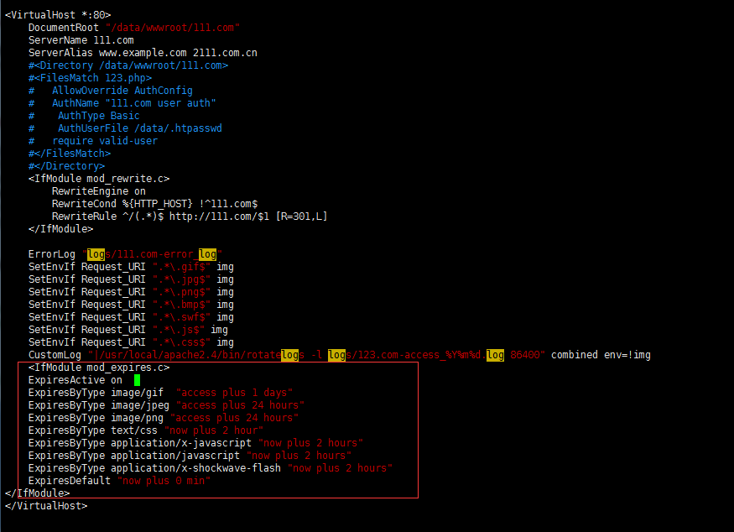

[root@gary-tao 111.com]*# vim /usr/local/apache2.4/conf/extra/httpd-vhosts.conf*

[root@gary-tao 111.com]*# /usr/local/apache2.4/bin/apachectl -t*

Syntax OK //添加完成后测试语法是否有没错误

[root@gary-tao 111.com]*# /usr/local/apache2.4/bin/apachectl -M |grep expires //没有任何输出，说明当前httpd不支持expires模块，所以需要悠配置文件，打开该模块*

[root@gary-tao 111.com]*# vim /usr/local/apache2.4/conf/httpd.conf //搜索expires关键讯，找到下面这行*

*#LoadModule expires_module modules/mod_expires.so //把本行的最前面 的#删除，保存退出*

[root@gary-tao 111.com]*# /usr/local/apache2.4/bin/apachectl graceful //重新加载配置*

[root@gary-tao 111.com]*# /usr/local/apache2.4/bin/apachectl -M |grep expires //下面有expires输出，说明正确加载expires模块。*

expires_module (shared)

2.使用curl来测试效果：

[root@gary-tao 111.com]*# curl -x127.0.0.1:80 111.com/qq.png -I*

HTTP/1.1 200 OK

**Date: Thu, 21 Dec 2017 11:54:14 GMT**

**Server: Apache/2.4.29 (Unix) PHP/7.1.6**

**Last-Modified: Thu, 21 Dec 2017 06:18:31 GMT**

**ETag: "91ab-560d3ab3fbbc0"**

**Accept-Ranges: bytes**

**Content-Length: 37291**

**Cache-Control: max-age=86400**

**Expires: Fri, 22 Dec 2017 11:54:14 GMT**

**Content-Type: image/png**

**说明：**

可以看到max-age=86400,这说明jpg的图片将缓存86400秒，也就是一天。