Supplement Materials

# Visualization of movement flux of Twitter users across Great Britain

In this study our method relies on Twitter user movements to build the connectivity network

To investigate whether the collected geo-located Twitter can

Each yellow line represents one displacement/movement from a particular Twitter user.

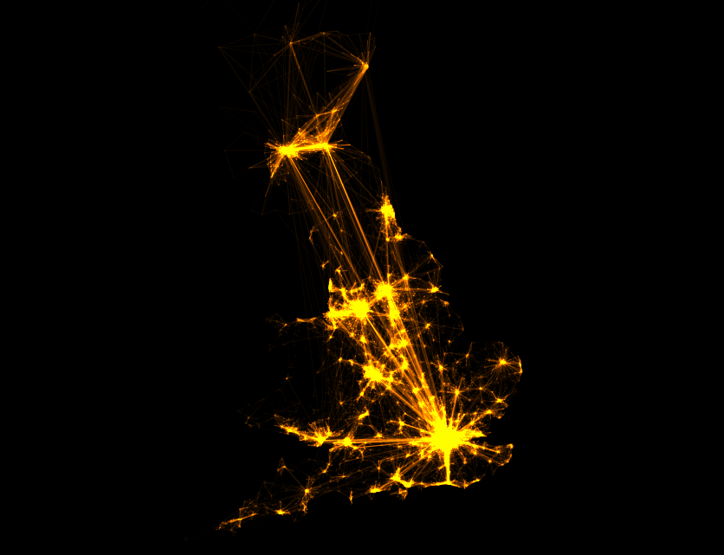

Figure 1: Visualization of the Twitter user movement flows across Great Britain

# Radius of gyration of Twitter users in Great Britain

In particular, the measurement of radius of gyration of Twitter users in Great Britain is important for choosing the cell-size of the virtual fishnet.

s in

The collected geo-located Twitter data is from June 1st to December 31st, 2014. To make sure that the

To make sure that the derived radius of gyration

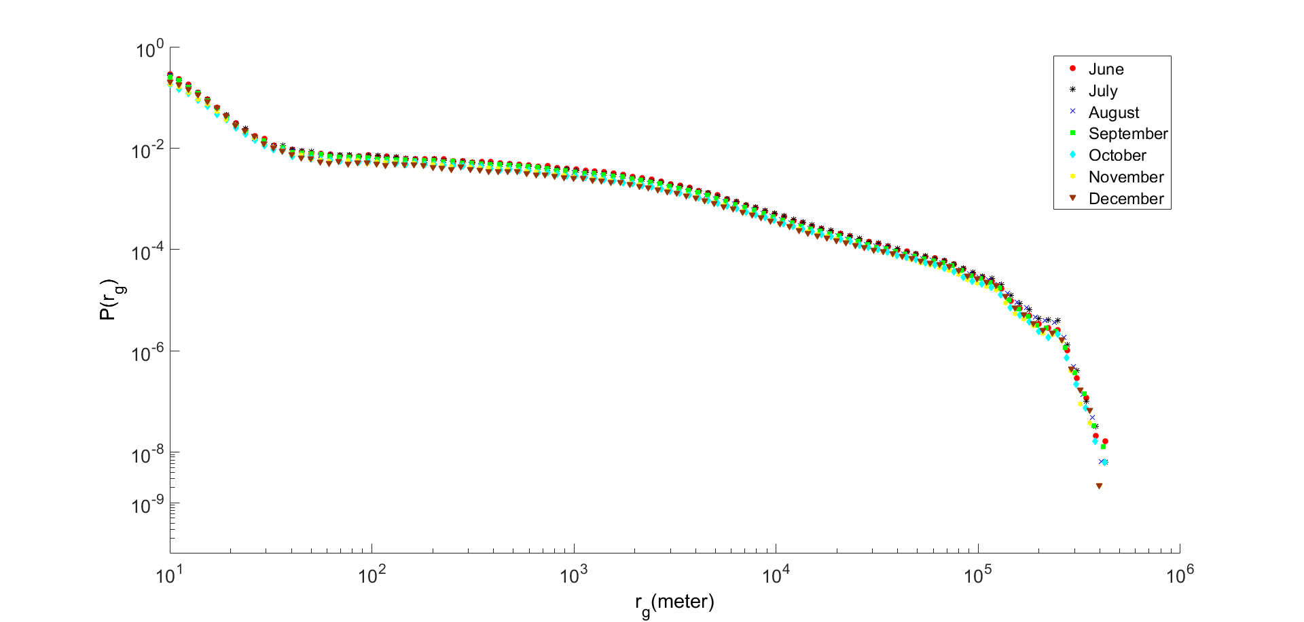

Figure 2: The probability distribution of Twitter user radius of gyration in different time span

# Mobility network based on ward divisions in Great Britain

xx

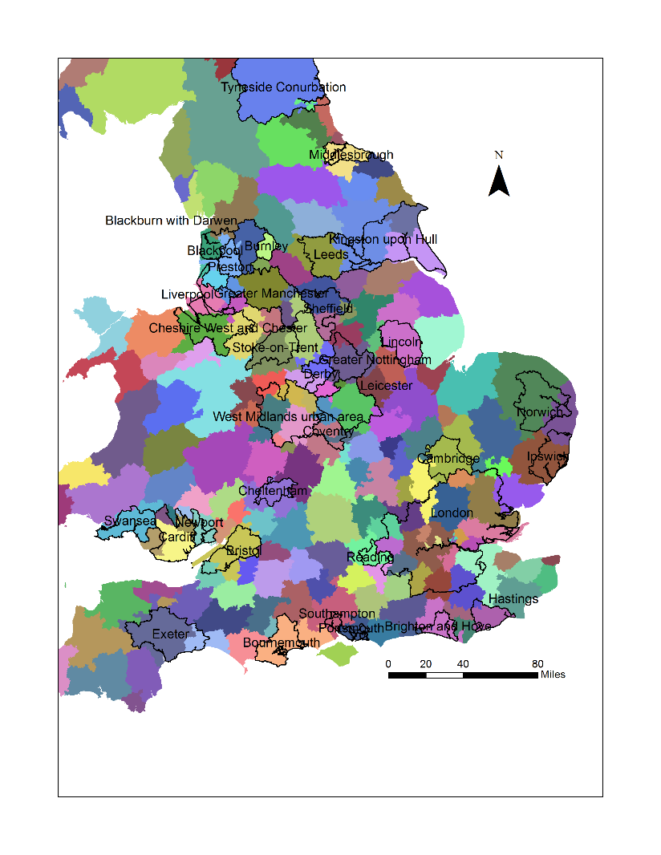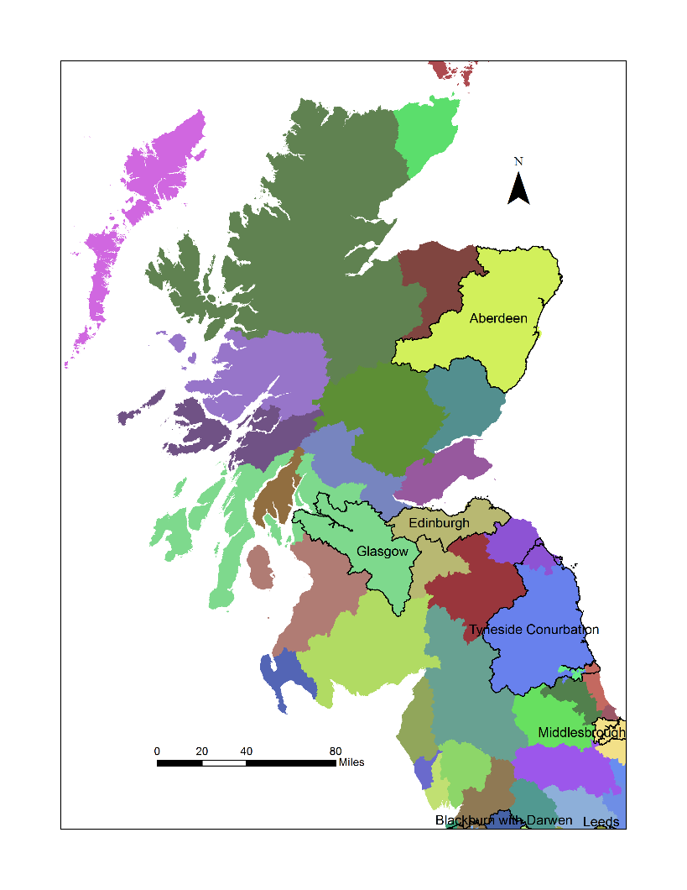

1. (b)

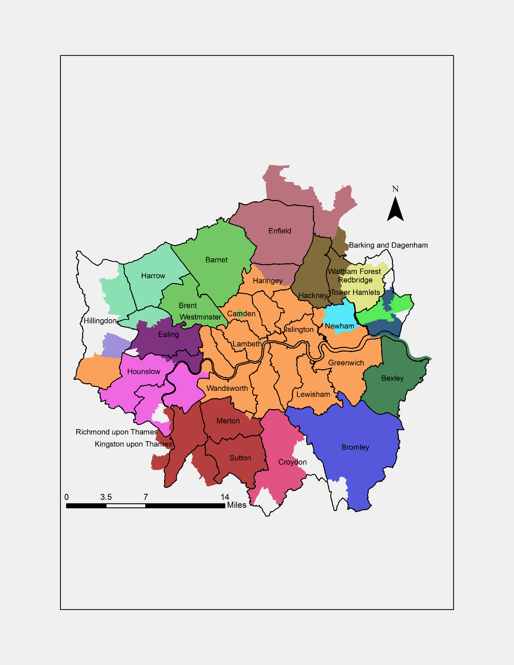

(c)

Figure 3: The community structure from collective Twitter user displacements based on the ward division in Great Britain. (a) The delineation for England and Wales (b) The delineation for Scotland (c) The delineation for the greater London region

# Mobility network with different settings

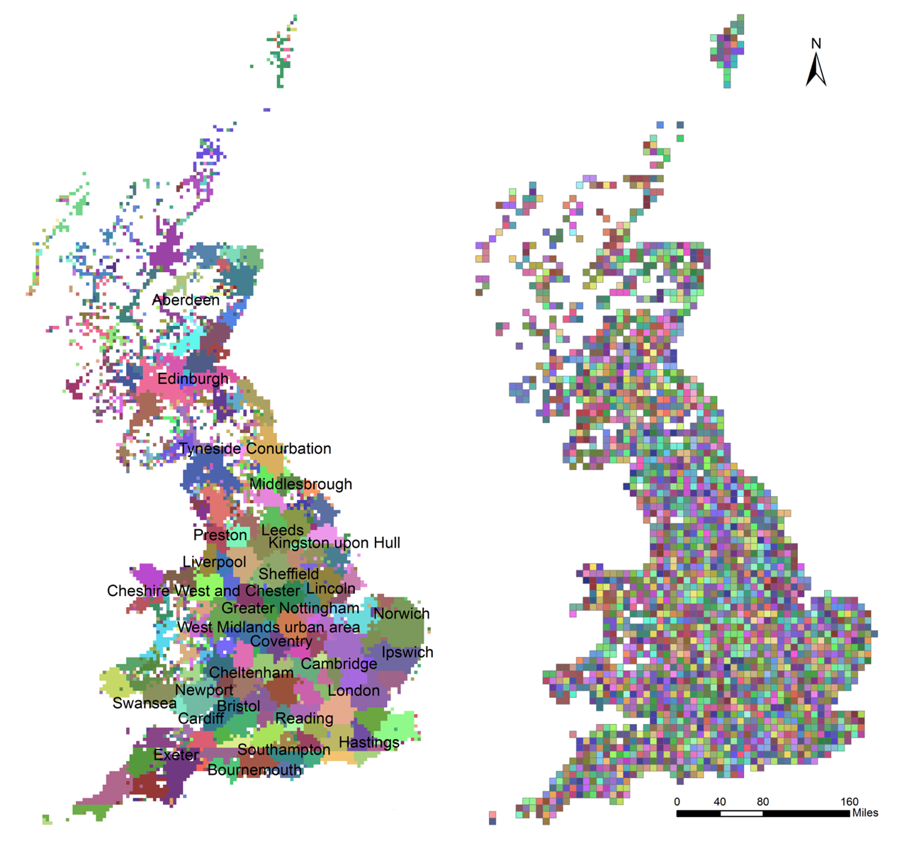

Figure 4: The community structure from collective Twitter user displacements with fishnet cell-size set to 5 km (left); and the community structure when the mobility network configured as undirected graph with fishnet cell-size of 10 km (right).

Reference:

Rae, A., 2009. From spatial interaction data to spatial interaction information? Geovisualisation and spatial structures of migration from the 2001 UK census. *Computers, Environment and Urban Systems*, 33(3), pp.161-178.