Supplement Materials

# Visualization of movement flux of Twitter users across Great Britain

In this study, our method relied on extracting Twitter user displacements/movements to build the mobility network of Twitter user spatial interactions across the Great Britain. To investigate the spatial coverage of the extracted Twitter user movements, we employed the visual-analytics method developed in (Rae 2009), where we plotted a flow map of the Twitter user displacements at the national level in Figure 1. In this figure, each yellow line represented one displacement/movement from a particular Twitter user. To achieve better visualization effects, this figure did not simply plot all the movements at once but highlighted those urban areas based on the density of movement flux. This visualization showed that the extracted Twitter user movements connected most urban areas in Great Britain and clearly exhibited long and short distance movements for connecting urban regions at different spatial scale, which was essential for building the mobility network.

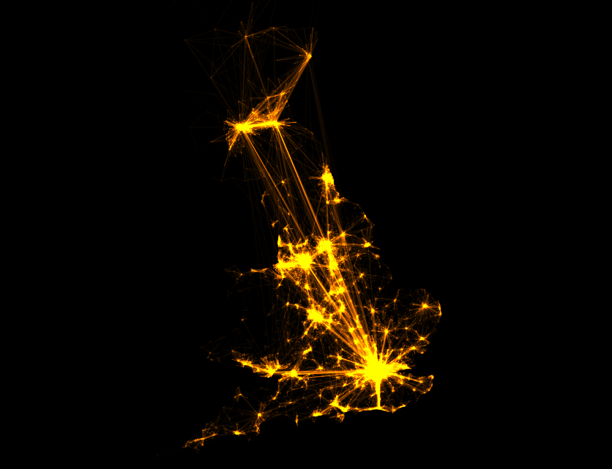

**Figure 1**: Visualization of the Twitter user movement flows across the Great Britain

# Radius of gyration of Twitter users in Great Britain

The measurement of collective radius of gyration for individual Twitter users in the Great Britain was important for choosing the cell-size of the virtual fishnet. As the collected geo-located Twitter data in this study was from June 1st to December 31st, 2014, to investigate whether there were temporal fluctuations that would affect the consistency of such a measurement, we summarized the probability distribution of the radius of gyration for Twitter users in the Great Britain with a monthly interval. Figure 2 showed that the probability distributions of the radius of gyration for Twitter users were consistent throughout the 7-month time span, which indicated the stability of using such measurements in this study. Note that in these calculations, we did not apply the criteria to filter out “tourists” as we had suggested in this study.

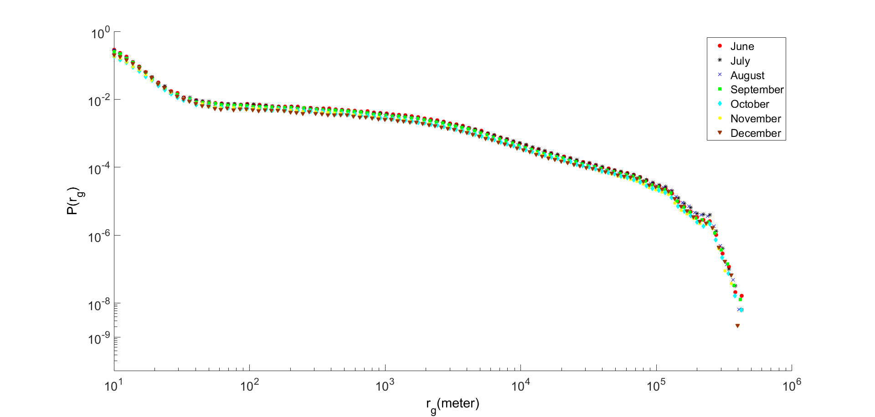

**Figure 2**: The probability distribution of the radius of gyration for Twitter users in each month

# Mobility network based on ward divisions of the Great Britain

We imposed a virtual fishnet to partitioning the geographical space in the Great Britain. Such partition does not consider the underlying population information in each fishnet cell, therefore, it is worth to compare an alternative approach that does consider population information when partitioning the geographical space. In this study, we also carried out an experiment to partition the geographical space using a ward division of the Great Britain, which is the finest/smallest administrative boundary at the national level. This choice of using finest administrative boundary was also considered to minimize the conflict that administrative boundaries may not reflect natural human spatial interactions across space.

The strongly connected communities also yielded geographically cohesive, non-overlapping urban areas shown in Figure 3. The delineated urban boundaries were visually similar to the ones derived from using a fishnet approach. In particular, in the greater London region, the separate geographic areas that include Heathrow Airport exhibited more connectivity to central London than its surrounding areas (light orange region in Figure 3 (c)). However, as ward division is geographically continuous, it is problematic in aggregating regions that do not have Twitter coverage into certain clusters. Aggregating Twitter user movements at the ward level imposed more apparent concerns of the mismatch of the overall population, as long as there was one Twitter user movement fell into the polygonal unit, the entire unit would be considered in the mobility network. In this case, less populated areas were overly represented and connected into large areas, in particular, the delineation in Scotland (green region in Figure 3 (b)).

# Mobility network with different settings

We chose a fishnet with 10 km cell-size to partition the geographical space of the Great Britain based on the statistical analysis of the probability distribution of the radius of gyration of Twitter users. Nevertheless, we also carried out an additional experiment by arbitrarily setting the fishnet cell-size to 5 km. The fishnet with smaller cell-size (i.e., 5 km) produced more and smaller strongly-connected communities within the network space as shown in Figure 4 (left). It suggested that the spatial resolution of the fishnet cells does affect the outcome from the community detection method employed in this study, where fishnet with smaller cell-size leads to more discrete and locally connected (i.e., smaller) clusters

of urban areas. Such an effect can be explained by the probability distributions of the radius of gyrations of individual Twitter users. The probability of distance that deviates from a user's center location decays with a stretched-exponential function from [50m, 10km], which means the movements from Twitter users with smaller spatial coverage dominate the strength in connecting neighboring urban regions. Finally, we also illustrated that constructing the mobility network as an undirected graph did not lead to any meaningful delineation of the urban boundaries that reflect Twitter user spatial interactions, which is shown in Figure 4 (right).

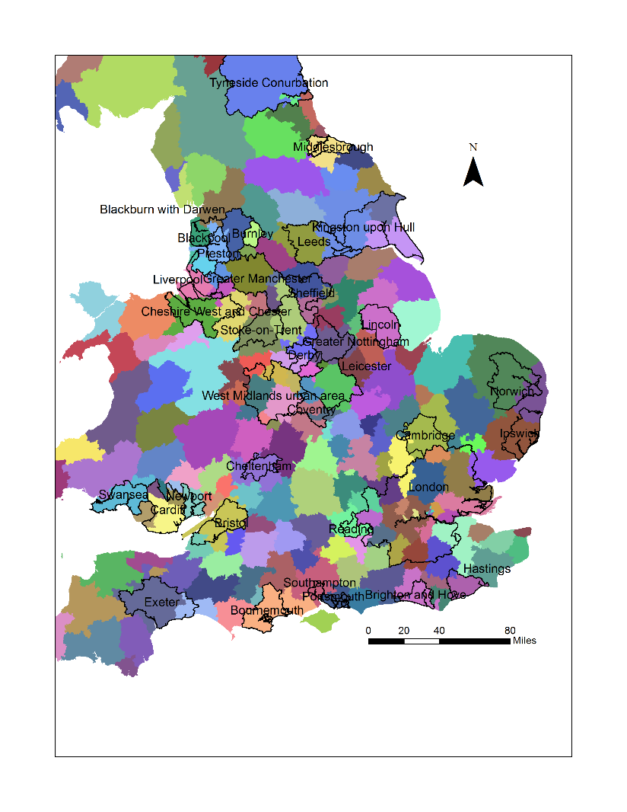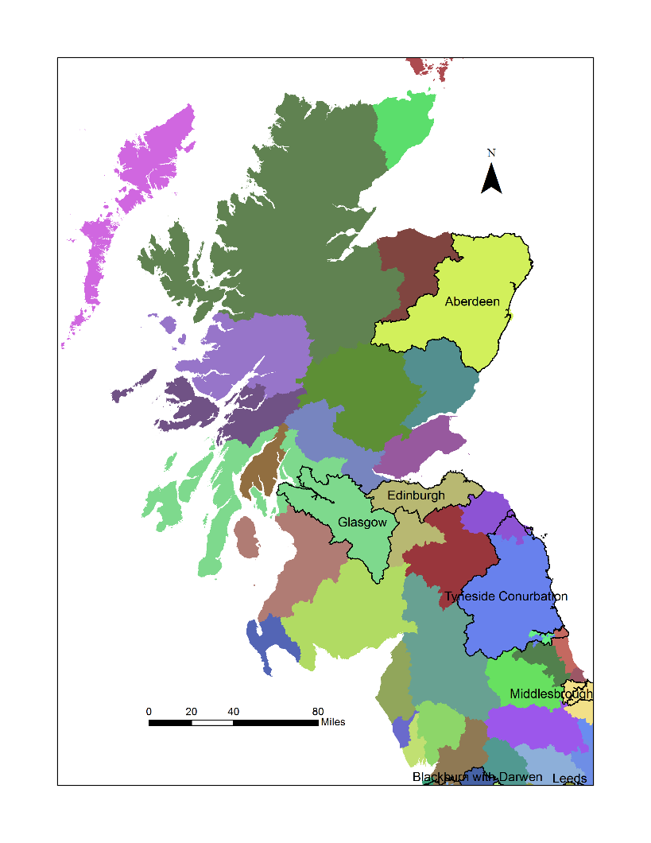

1. (b)

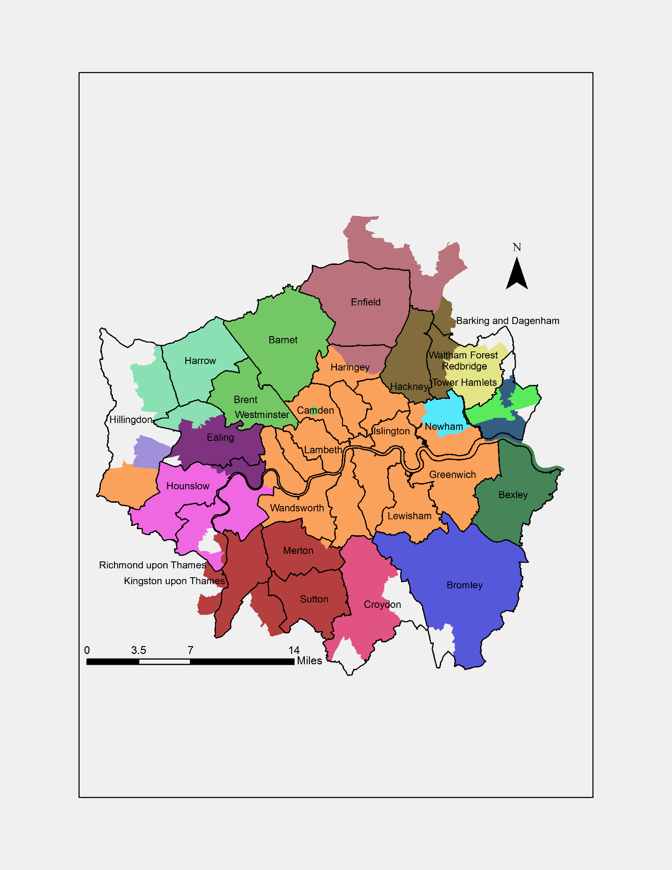

(c)

**Figure 3**: The community structure from collective Twitter user displacements based on the ward division in the Great Britain. (a) The delineation for England and Wales (b) The delineation for Scotland (c) The delineation for the greater London region

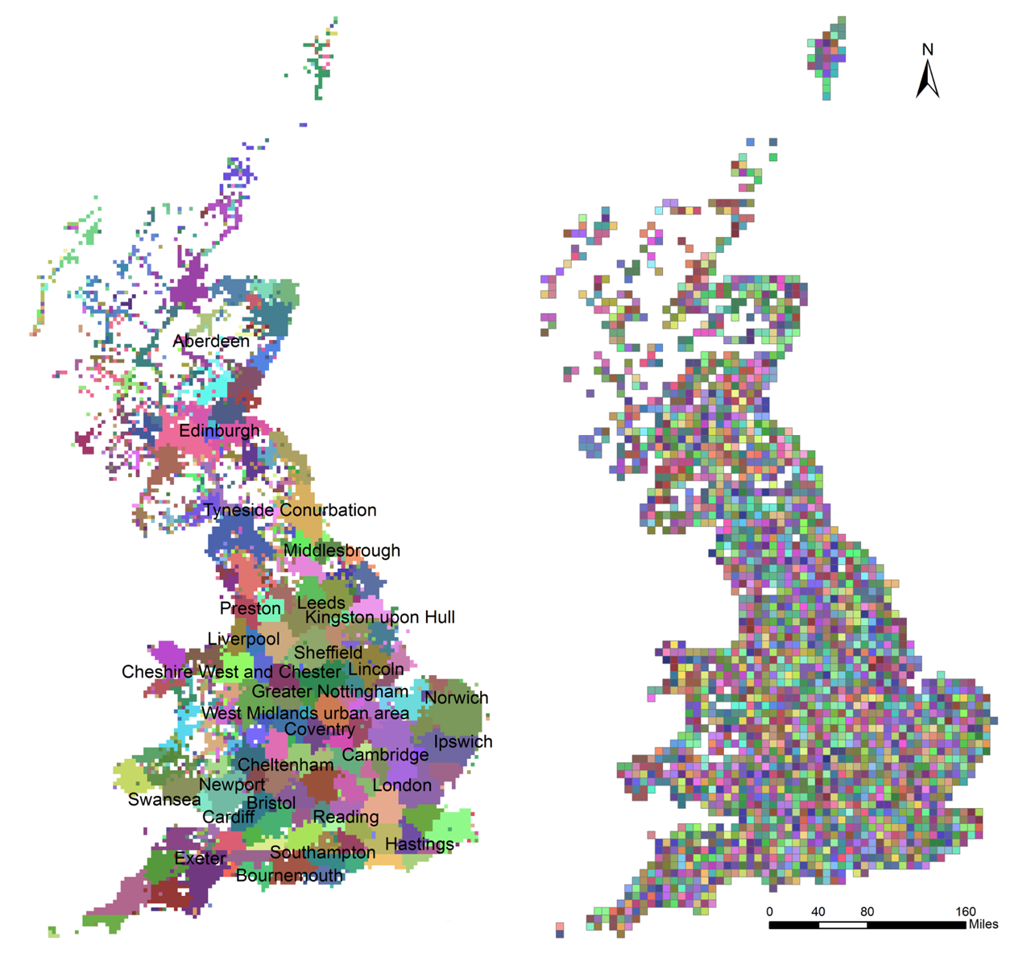

**Figure 4**: The community structure from collective Twitter user displacements with fishnet cell-size set to 5 km (left); and the community structure when the mobility network configured as undirected graph with fishnet cell-size of 10 km (right).

Reference:

Rae, A., 2009. From spatial interaction data to spatial interaction information? Geovisualisation and spatial structures of migration from the 2001 UK census. *Computers, Environment and Urban Systems*, 33(3), pp.161-178.