BBB在CCS5调试记录
调试方式
1.永远的LED
2.UART
3.TIMER
4.ADC
5.SPI
6.IIC
7.USB
8.网络
Build输出：

**** Build of configuration Debug for project hwi_test ****

"D:\\\\ccsv5\\utils\\bin\\gmake" -k all
'Building file: ../hwi_test.cfg'
'Invoking: XDCtools'
"D:/xdctools_3_25_06_96/xs" --xdcpath="D:/bios_6_35_04_50/packages;D:/uia_1_03_01_08/packages;D:/xdais_7_21_01_07/packages;D:/xdais_7_21_01_07/examples;D://ccsv5/ccs_base;" xdc.tools.configuro -o configPkg -t ti.targets.arm.elf.A8Fnv -p ti.platforms.beaglebone -r debug -c "D:/ccsv5/tools/compiler/arm_5.1.1" "../hwi_test.cfg"
configuring hwi_test.xea8fnv from package/cfg/hwi_test_pea8fnv.cfg ...
clea8fnv package/cfg/hwi_test_pea8fnv.c ...
'Finished building: ../hwi_test.cfg'
' '
'Building target: hwi_test.out'
'Invoking: ARM Linker'
"D:/ccsv5/tools/compiler/arm_5.1.1/bin/armcl" -mv7A8 --code_state=32 --abi=eabi -me -g --define=am3359 --diag_warning=225 --display_error_number --diag_wrap=off -z -m"hwi_test.map" --heap_size=0x800 --stack_size=0x800 -i"D:/ccsv5/tools/compiler/arm_5.1.1/lib" -i"D:/ccsv5/tools/compiler/arm_5.1.1/include" --reread_libs --warn_sections --display_error_number --diag_wrap=off --xml_link_info="hwi_test_linkInfo.xml" --rom_model -o "hwi_test.out" -l"./configPkg/linker.cmd" "./main.obj" "../AM3359.cmd" -l"libc.a"
<Linking>
'Finished building target: hwi_test.out'
' '

**** Build Finished ****

Debug输出：
CortxA8: Output: **** AM335x Beaglebone Initialization is in progress ..........
CortxA8: Output: **** AM335x ALL PLL Config for OPP == OPP100 is in progress .........
CortxA8: Output: Input Clock Read from SYSBOOT[15:14]: 24MHz
CortxA8: Output: **** Going to Bypass...
CortxA8: Output: **** Bypassed, changing values...
CortxA8: Output: **** Locking ARM PLL
CortxA8: Output: **** Core Bypassed
CortxA8: Output: **** Now locking Core...
CortxA8: Output: **** Core locked
CortxA8: Output: **** DDR DPLL Bypassed
CortxA8: Output: **** DDR DPLL Locked
CortxA8: Output: **** PER DPLL Bypassed
CortxA8: Output: **** PER DPLL Locked
CortxA8: Output: **** DISP PLL Config is in progress ..........
CortxA8: Output: **** DISP PLL Config is DONE ..........
CortxA8: Output: **** AM335x ALL ADPLL Config for OPP == OPP100 is Done .........
CortxA8: Output: **** AM335x DDR2 EMIF and PHY configuration is in progress...
CortxA8: Output: EMIF PRCM is in progress .......
CortxA8: Output: EMIF PRCM Done
CortxA8: Output: DDR PHY Configuration in progress
CortxA8: Output: Waiting for VTP Ready .......
CortxA8: Output: VTP is Ready!
CortxA8: Output: DDR PHY CMD0 Register configuration is in progress .......
CortxA8: Output: DDR PHY CMD1 Register configuration is in progress .......
CortxA8: Output: DDR PHY CMD2 Register configuration is in progress .......
CortxA8: Output: DDR PHY DATA0 Register configuration is in progress .......
CortxA8: Output: DDR PHY DATA1 Register configuration is in progress .......
CortxA8: Output: Setting IO control registers.......
CortxA8: Output: EMIF Timing register configuration is in progress .......
CortxA8: Output: EMIF Timing register configuration is done .......
CortxA8: Output: PHY is READY!!
CortxA8: Output: DDR PHY Configuration done
CortxA8: Output: **** AM335x Beaglebone Initialization is Done ******************
CortxA8: Output: **** AM335x Beaglebone Initialization is in progress ..........
CortxA8: Output: **** AM335x ALL PLL Config for OPP == OPP100 is in progress .........
CortxA8: Output: Input Clock Read from SYSBOOT[15:14]: 24MHz
CortxA8: Output: **** Going to Bypass...
CortxA8: Output: **** Bypassed, changing values...
CortxA8: Output: **** Locking ARM PLL
CortxA8: Output: **** Core Bypassed
CortxA8: Output: **** Now locking Core...
CortxA8: Output: **** Core locked
CortxA8: Output: **** DDR DPLL Bypassed
CortxA8: Output: **** DDR DPLL Locked
CortxA8: Output: **** PER DPLL Bypassed
CortxA8: Output: **** PER DPLL Locked
CortxA8: Output: **** DISP PLL Config is in progress ..........
CortxA8: Output: **** DISP PLL Config is DONE ..........
CortxA8: Output: **** AM335x ALL ADPLL Config for OPP == OPP100 is Done .........
CortxA8: Output: **** AM335x DDR2 EMIF and PHY configuration is in progress...
CortxA8: Output: EMIF PRCM is in progress .......
CortxA8: Output: EMIF PRCM Done
CortxA8: Output: DDR PHY Configuration in progress
CortxA8: Output: Waiting for VTP Ready .......
CortxA8: Output: VTP is Ready!
CortxA8: Output: DDR PHY CMD0 Register configuration is in progress .......
CortxA8: Output: DDR PHY CMD1 Register configuration is in progress .......
CortxA8: Output: DDR PHY CMD2 Register configuration is in progress .......
CortxA8: Output: DDR PHY DATA0 Register configuration is in progress .......
CortxA8: Output: DDR PHY DATA1 Register configuration is in progress .......
CortxA8: Output: Setting IO control registers.......
CortxA8: Output: EMIF Timing register configuration is in progress .......
CortxA8: Output: EMIF Timing register configuration is done .......
CortxA8: Output: PHY is READY!!
CortxA8: Output: DDR PHY Configuration done
CortxA8: Output: **** AM335x Beaglebone Initialization is Done ******************

上面是console输出状况

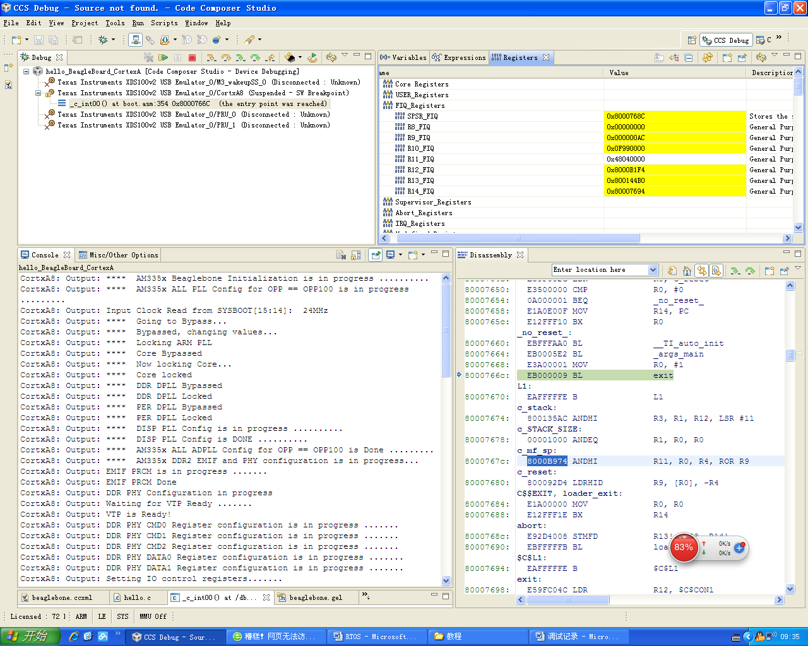
显示进入DEBUG模式

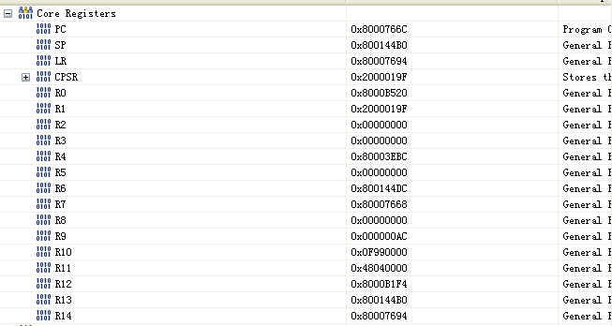
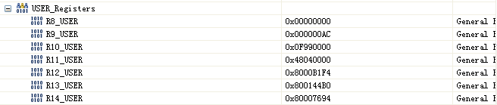
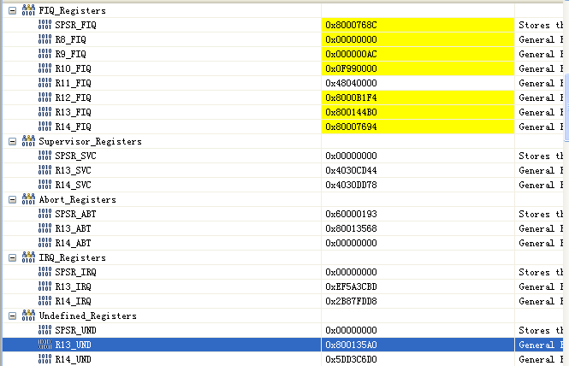
几种运行模式：usr,fiq,svc,abt,und.
寄存器R13在ARM指令中常用作堆栈指针。由于处理器的每种运行模式都有自己独立的物理寄存器R13,在用户应用程序的初始化部分，一般都要初始化每种模式下的R13,使其指向该运行模式的栈空间，这样，当程序的运行进入异常模式时，可以将需要保护的寄存器放入R13指向的堆栈，当程序从异常模式返回时，则从对应的堆栈中恢复，采用这种模式可以保证一场发生后程序的正常执行。

R14也称作子程序连接寄存器或连接寄存器（LR）。当执行BL子程序调用指令时，R14得到R15的备份。
R16(CPSR,称为当前程序状态寄存器)，在任何运行模式下被访问。

每一种运行模式下都有一个专用的物理状态寄存器，称为SPSR（备份的程序状态寄存器），当异常发生时，SPSR用于保存CPSR的当前值，从异常退出时则可由SPSR来恢复CPCR。

ARM体系结构中包含一个当前程序状态寄存器（CPSR）和五个备份的程序状态寄存器（SPSRs）。SPSRs用来进行异常处理，功能包括：
- 保存ALU中的当前操作信息
- 控制允许和禁止中断
- 设置处理器的运行模式

Lr(R14)作用：
- 使用bl或者blx跳转到子过程的时候，r14保存了返回地址，可以在调用过程结尾恢复
- 异常中断发生时，这个异常模式特定的物理R14被设置成该异常模式将要返回的地址。

PC（R15）：程序计数器

协处理器：CP14,CP15
CP14:调试通信通道协处理
CP15:系统控制协处理，通过协处理指令MCR和MRC提供具体的寄存器来配置和控制caches、MMU、保护系统、配置时钟模式（在bootloader时钟初始化用到）。

ARM协处理器:可支持多达16个协处理器，作用：ARM处理器初始化，ARM和协处理器的数据处理操作，ARM的寄存器与协处理器的寄存器之间传送数据，以及ARM协处理器的寄存器和存储器之间传送数据。
CDP------协处理器数据操作指令
LDC------协处理器数据加载指令
STC------协处理器数据存储指令
MCR-----ARM的寄存器到协处理器的寄存器的数据传送
MRC-----协处理器的寄存器到ARM的寄存器的数据传送

GPMC用于external memory(片外存储器的访问)，GPMC的地址为0x00000000到0x1fffffff，最大支持512MB的片外存储器访问，GPMC寄存器的基地址为0x50000000,用于配置GPMC模块。

GPMC编程模式

Subdir_rules.mk
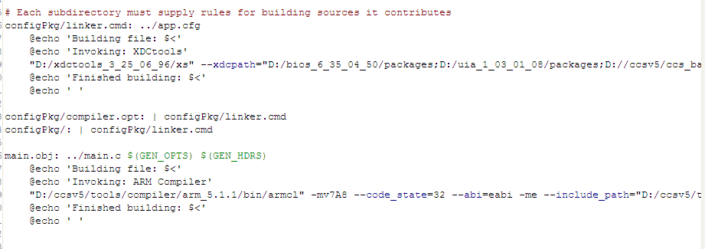

命令文件和主程序编译过程。

