**空间电荷层模拟与计算程序**

V 1.0

**用户文档**

2023-5-18

目录

1 Functional modules and key algorithms 1

1.1 Function module and calculation process 1

1.2 Key Algorithms 4

2 Operating environment and usage method 7

2.1 Operating environment 7

2.2 Parameter Preparation and Operation 7

2.2.1 Input files 7

2.2.2 Program Usage Flow(使用说明在这里写) 11

# Functional modules and key algorithms

## Function module and calculation process

**Module __init__.py**

This is the main functional module of the program, through the call of the constant module and the collection of material intrinsic properties module (mainly including 10 solid-state electrolyte (SSEs); Three categories represent oxide cathode (LiCoO2), oxide coating (LiNbO3) and sulfide cathode (LiTiS2) representatives. The main purpose of the module is to calculate the distribution of lithium-ions in the space charge layer between the cathode (the coating) and the SSE (shown as depletion of lithium ion concentration in the SSE), the change in the intensity of the electric field (mainly shown as rising from the SSE side towards the interface), the step size of each calculated step and the real-time change in the electric potential at the interface (also shown as rising). After the calculation of each iteration, the difference between the calculated potential and the potential of the SSE bulk (because it is electrically neutral, the default value is 0) will be compared. If the potential difference is less than 10-3 V, the convergence requirements will be met and the iteration will be withdrawn. Otherwise, the iteration continues. For systems that meet the convergence requirement, the lithium-ion concentration at each step is integrated into a one-dimensional array and the normalized space charge layer resistance (${\tilde{R}}_{SCL}$) is calculated to evaluate the interfacial compatibility.

**Module constants.py**

Some constants that may be used in the calculation are included, such as Boltzmann constant (kB), elementary charge (e), vacuum permittivity (ε0), molar gas constant (R) and Avogadro constant (NA).

**Module input_parameters.py**

The functions of the module are mainly divided into two categories: the properties of the cathode or coating; Properties of SSE. The properties of the positive electrode or coating are represented by the upper threshold of the potential at the interface (the MCFSS described above that reflect the Fermi level at the actual interface). MCFSS needs to extract the bond length and ion radius after optimizing the structure with the help of DFT, and use the crystal molecular orbital level program (MOLED-LLF) program to automatically identify the ligand environment and output the splitting coefficient of the corresponding ligand field structure. MCFSS can be obtained by combining ion radius, bond length and splitting coefficient. The SSE mainly includes the charge number of carriers (mainly lithium-ions, charge number =1), the concentration of carriers in the body phase, the area of the interface (set to 1nm2 by default), the permittivity of the SSE (calculated by adding the static and dynamic permittivity respectively by DFT), and the diffusivity (calculated by MSD or obtain from experiments).

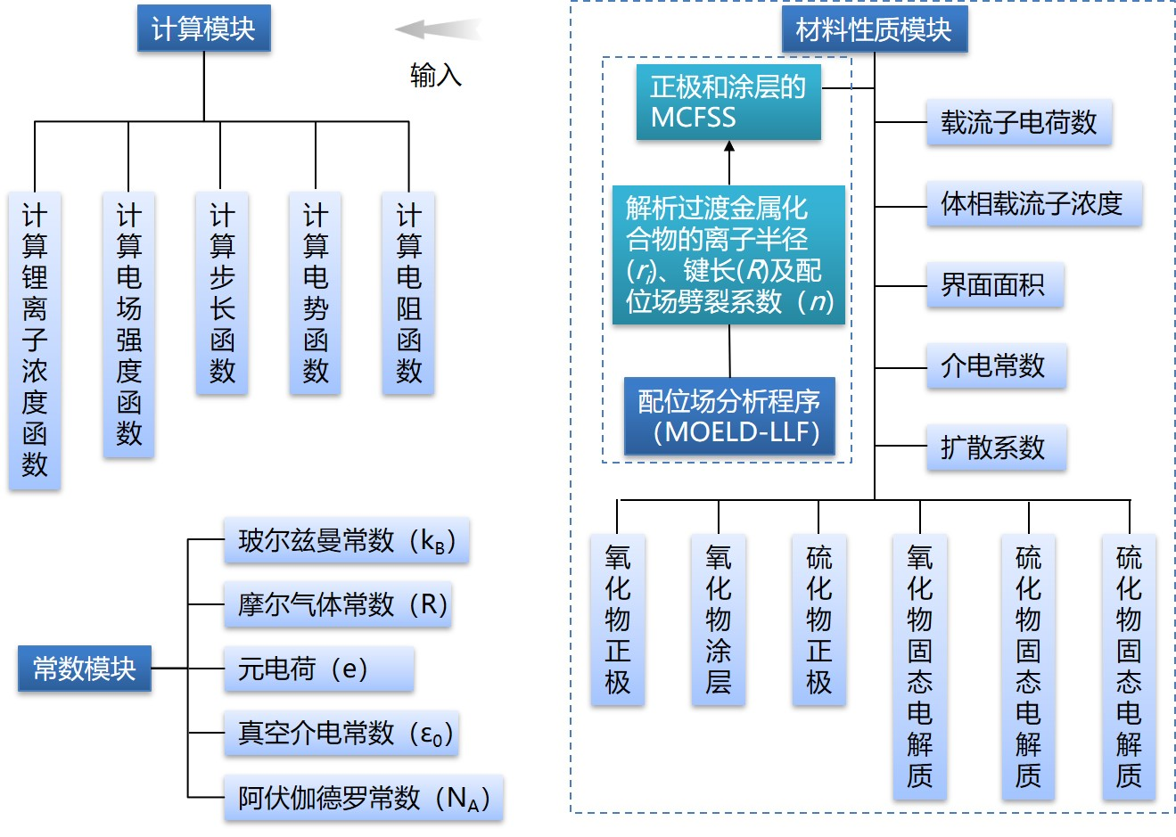

Figure 1. The module composition of the program

The calculation process of the program is shown in Figure 1. The overall process is divided into two sections. The ligand field is calculated first, and then the space charge layer is calculated. For the cathode or coating material, the corresponding surface structure needs to be built first. First, after determining the interface system between the cathode (coating) and SSE to be studied, the surface structure of the cathode or coating is constructed by Material Studio, and then the structure is optimized by using DFT. The bond length (*R*) of the corresponding transition metal ion and ligand ion is extracted from the optimized structure, and the ionic radius (*ri*) of the corresponding valence state transition metal ion is determined. At the same time, MOELD-LLF was used to identify the local ligand-field developed by the research group to automatically identify the ligand structure in the surface structure and output the corresponding splitting coefficient (*n*). After obtaining the required parameters, the MCFSS of the corresponding material is calculated using the formula proposed above. For solid electrolyte materials, the charge carriers (usually lithium-ions) are first identified and the charge number of the carriers is obtained. Secondly, the DFT is used to optimize the crystal structure and calculate the carrier concentration, permittivity and diffusivity. Then, the calculated MCFSS were configured as interfacial potential thresholds and iteratively calculated carrier concentration distribution, electric field intensity, calculated step size, and interface potential evolution at the interface between the cathode (or coating) and the SSE. If meet the accuracy requirement as (Δ*ϕ* 10-3 V or less) the output parameters such as concentration, step length and calculate the normalized space charge layer resistance (${\tilde{R}}_{SCL}$, it is a dimensionless parameter, with LiCoO2/Li10GeP2S12 as a frame of reference). Otherwise, it continues to iterate over the next computation flow.

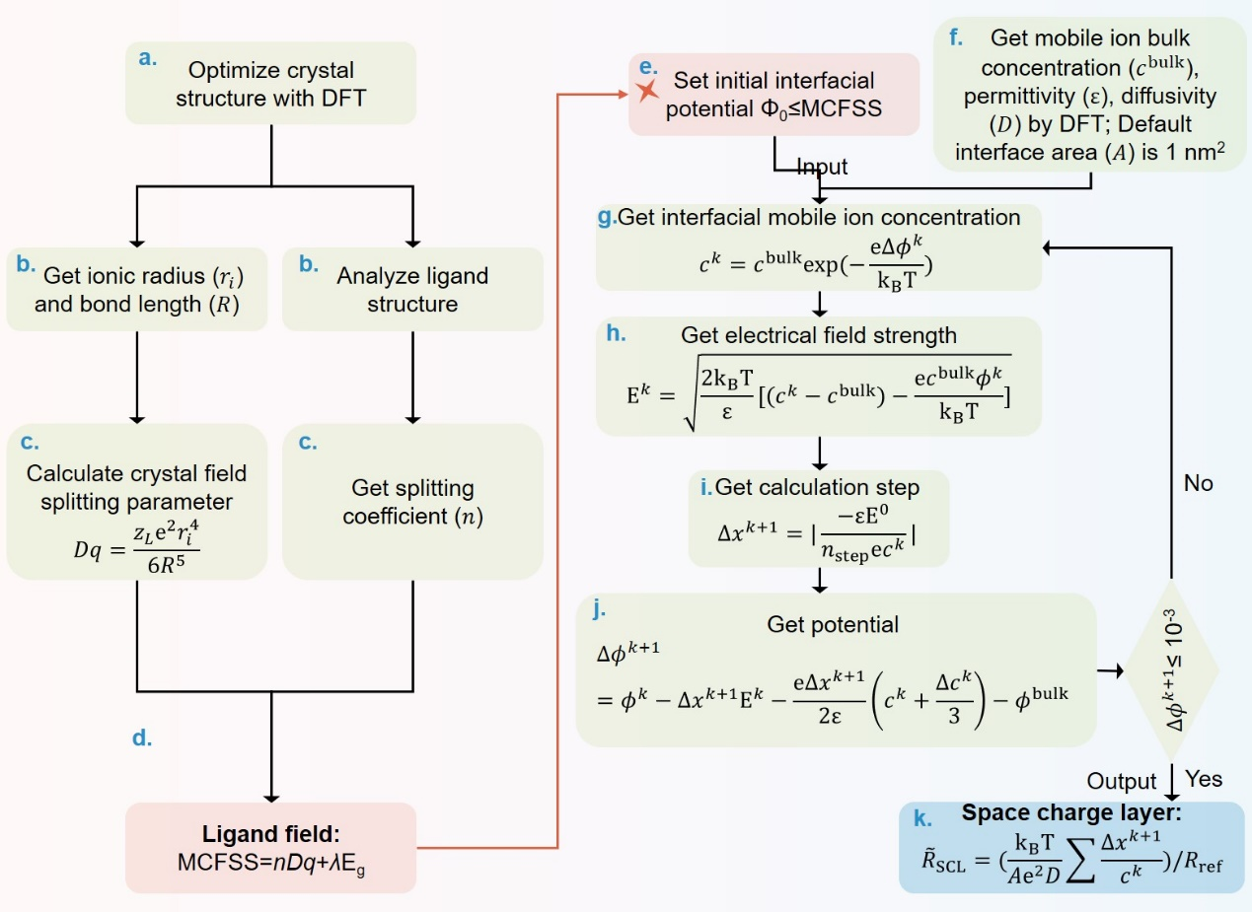

Figure 2. The calculation flow of the program

## Key algorithms

**Algorithm for calculating normalized space charge layer resistance**

Poisson-equation is the basic equation describing the charge distribution in space, *e.g.*, the redistribution of charges which lead to the formation of SCL. In order to simplify the model, we only consider the Poisson-equation in the one-dimensional state, which is expressed as follows

$$\begin{aligned}\frac{d^{2}ϕ}{dx^{2}}=-\frac{ρ}{ε}\#\left(1\right)\end{aligned}$$

where $ε$ is the permittivity. The charge density $ρ$ is a function of the carrieies concentration and is composed of both lithium-ion and electron, one can write

$$\begin{aligned}ρ=e\left(c_{{Li}^{+}}^{k}-c_{e^{-}}^{k}\right)=e(c_{{Li}^{+}}^{k}-c_{e^{-}}^{bulk})=e(c_{{Li}^{+}}^{k}-c_{{Li}^{+}}^{bulk})\#\left(2\right)\end{aligned}$$

where $c_{e^{-}}^{k}$ and $c_{e^{-}}^{bulk}$ is the electron concentration at position *k* and in bulk. Herein, the concentration of electrons is constant due to only the rearrangement of lithium-ions at the interface is considered, which equal to the concentration of lithium-ions in the bulk (because Li-atom can be divided into Li+ and e–).

It is necessary to introduce electric field intensity ($E$) to solve Poisson-equation numerically. $E$ is related to electric potential ($ϕ$):

$$\begin{aligned}\frac{d{(E)}^{2}}{dx}=\frac{d\left({\left(-\frac{dϕ}{dx}\right)}^{2}\right)}{dx}=2\frac{dϕ}{dx}\frac{d^{2}ϕ}{dx^{2}}=-\frac{2ρ}{ε}\frac{dϕ}{dx}\#\left(3\right)\end{aligned}$$

Assuming that the bulk material is electrically neutral, $E=0$ and $ϕ=0$, the relation between electric field intensity and interfacial potential can be obtained by integrating Eq. 3.

$$\begin{aligned}E^{k}=\sqrt{\frac{2k_{B}T}{ε}\left|\left(c_{{Li}^{+}}^{k}-c_{{Li}^{+}}^{bulk}\right)-\frac{ec_{{Li}^{+}}^{bulk}ϕ^{k}}{k_{B}T}\right|}\#\left(4\right)\end{aligned}$$

At this point, it is assumed that there is an intermediate process, that is, the depleted lithium-ion in SSE all gather on the surface of the cathode (that is, *k*=0), so the charge density of SCL can be obtained by calculating the electric field intensity at the interface ($E^{0}$).

$$\begin{aligned}ρ_{SCL}=\int_{0}^{bulk}{ec_{{Li}^{+}}^{k}dx}=-εE^{0}\#\left(5\right)\end{aligned}$$

The accumulated charge of the whole SCL ($ρ_{SCL}$) is calculated and divided in calculation steps ($n_{step}$) equally large quantities. The corresponding $Δx^{k+1}$ intervals can then be easily determined using the local charge density.

$$\begin{aligned}Δx^{k+1}=\left|\frac{ρ_{SCL}}{n_{step}ρ^{k}}\right|\#\left(6\right)\end{aligned}$$

The interfacial electric potential at the new $x+Δx$ coordinate is calculated according to a Taylor approximation of degree three.

$$\begin{aligned}ϕ^{k+1}≈ϕ^{k}+Δx^{k+1}\frac{dϕ}{dx}+\frac{{\left(Δx^{k+1}\right)}^{2}}{2}\frac{d^{2}ϕ}{dx^{2}}+\frac{{\left(Δx^{k+1}\right)}^{3}}{6}\frac{d^{3}ϕ}{dx^{3}}\#\left(7\right)\end{aligned}$$

$$\begin{aligned}Δρ^{k}=ρ^{k}-ρ^{k-1}≈\frac{dρ}{dx}Δx^{k+1}=-ε\frac{d^{3}ϕ}{dx^{3}}Δx^{k+1}=eΔc_{{Li}^{+}}^{k}\#\left(8\right)\end{aligned}$$

$ϕ^{k+1}$ can be expressed as follows.

$$\begin{aligned}ϕ^{k+1}≈ϕ^{k}+Δx^{k+1}E^{k}-\frac{e{\left(Δx^{k+1}\right)}^{2}}{2ε}\left(c_{{Li}^{+}}^{k}+\frac{Δc_{{Li}^{+}}^{k}}{3}\right)\#\left(9\right)\end{aligned}$$

Notably, if *k*=0 (the initial calculation), then $Δρ_{0}=Δc_{0}=0$. If the interfacial electric potential at $k+1$ position to meet convergence criteria ( $ϕ^{k+1}-ϕ^{bulk}<{10}^{-3}$ V), we then calculate the interfacial resistance resulting from SCL ($R_{SCL}$) and further propose a normalized SCL resistance (${\tilde{R}}_{SCL}$) based on the $R_{SCL}$ of representative LiCoO2/Li10GeP2S12 interface to facilitate the observation of the relative compatibility trend of different interface systems.

$$\begin{aligned}σ=\frac{e^{2}z^{2}}{k_{B}T}cD\#\left(10\right)\end{aligned}$$

$$\begin{aligned}R_{SCL}=\frac{1}{A}\int_{0}^{bulk}{\frac{1}{σ}dx}=\frac{k_{B}T}{Ae^{2}D}\sum{\frac{Δx^{k+1}}{c_{{Li}^{+}}^{k}}}\#\left(11\right)\end{aligned}$$

$$\begin{aligned}{\tilde{R}}_{SCL}=\frac{R_{SCL}^{Cathode (or coating)/SSE}}{R_{SCL}^{LiCoO_{2}/LGPS}}\#\left(12\right)\end{aligned}$$

where $σ$ is the lithium-ion conductivity, $D$ is the diffusivity and *A* is the surface area (the default value is 1 nm2). Otherwise, the first step is returned and the lithium-ion concentration at the next position ($c_{{Li}^{+}}^{k+1}$) is solved.

# Operating environment and usage method

## Operating environment

Hardware requirements:

* Processor: Intel or AMD dual-core, main frequency above 1GHz
* Memory: 4G

Software requirements:

* Operating system: Windows 7 and above
* Python 3.8
* Numpy 1.21.0
* Scipy 1.7.0
* Pandas 1.3.0

## Parameter preparation and operation

First-principles approximation method based on density functional theory (DFT) was calculated, VASP program package was used, generalized gradient approximation (GGA) was used for exchange approximation, The Perdew-Burke-Ernzerhof expression is adopted. projected augmented wave (PAW) method is used to describe the interaction between electrons and ions. The relevant parameters of this document are calculated using the Self-Improvement 4000 platform of Shanghai University.

### Input files

**Structure optimization**

Four related files need to be prepared in advance when optimizing the structure, namely POTCAR, POSCAR, KPONTS and INCAR. Take the energy calculation of Li as an example:

**INCAR**

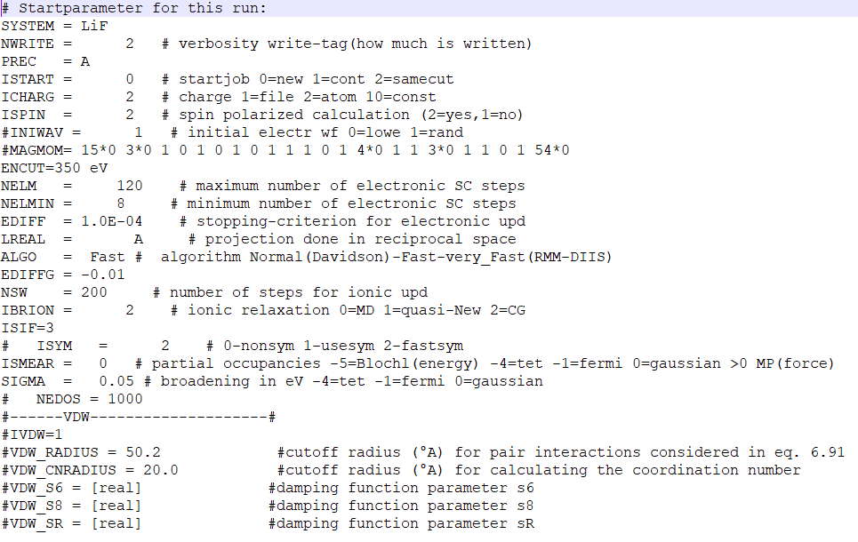

Figure 3. INCAR file

The general parameters that INCAR needs are listed here, but not all of them need to be changed. Some of the more important parameters are: ALGO is the electron optimization method, ISTRAT is whether to use wave function, ICHARGE is the selection of initial charge density, NELM is the number of steps that allow electron self-consistent iteration, IBRION is the mode of atomic relaxation or mobility, EDIFF is the standard of electron self-consistent convergence, NSW is the maximum number of relaxation steps, and ENCUT is the size of cut-off energy. INCAR parameters are too many to be introduced in detail. The expected energy value can be obtained only by setting the above parameters.

**POTCAR**

The POTCAR file is the pseudopotential file (the approximate function used to simplify the calculation of electron charge density in the inner core region of an atom), and the Li_sv pseudopotential file in the PBE pseudopotential file package can be renamed POTCAR.

**POSCAR**

The POSCAR file is the Li structure information file. Open Li's.cif file (crystal information file) with vesta software, and open it with Vasp (POSCAR; *.vasp) form output can be obtained.

**KPOINTS**

Using Li as an example, the KPIONTS file is written as follows:

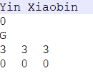

Figure 4. KPOINTS 文件图

where the first line is a comment line, the second line 0 is the automatic generation of K points, the third line G is the way to generate K points, phase diagram calculation is generally volume phase calculation, G mode can be universal. The fourth is K points generated in the three coordinate directions. During editing, the product of K points and lattice constants in the three directions should be less than 20, and the product should be consistent as far as possible, so that the calculation can reach a certain precision and not take too long.

**The acquisition of splitting coefficient of ligand-field**

When obtaining the splitting coefficient of the coordination field, it is necessary to prepare the previously optimized structure diagram, identify the local coordination field structure based on the MOELD-LLF program, and output the corresponding splitting coefficient and molecular orbital configuration, as shown in Figure xx.

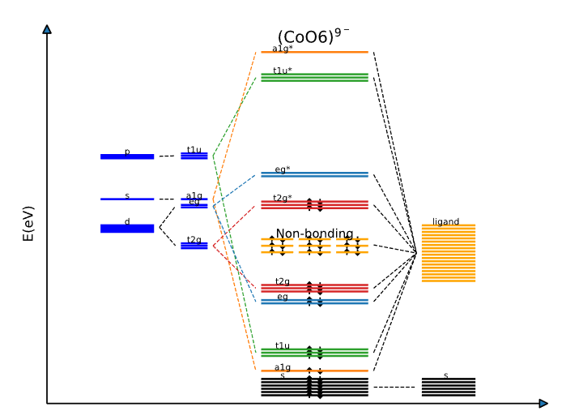

Figure 5. Ligand field splitting with octahedral field as an example

**Calculation of splitting properties of coordination field**

It can be seen from eq (6) that the upper limit of electric potential at the cathode/SSE interface is affected by the Fermi level of cathode, which has been previously reported to be determined by crystal field splitting strength (CFSS).

$$CFSS=nDq=n\frac{z_{L}e^{2}〈r^{4}〉}{{6R}^{5}}$$

where n is the splitting coefficient, which is determined by the structure of M-ligand, *Dq* is the M-d orbitals splitting strength, $z_{L}$ is the charge on the ligand, $〈r^{4}〉$ is the fourth power of the average core-electron distance, in which r can be replaced by ionic radius *ri* and *R* is the M-ligand distance. However, CFSS is suitable for electrochemically active materials such as OCA and SCA. For inactive materials, such as OCO, the effect of band gap should be considered, because the place where it receives electrons is in CBM. Based on this, an interfacial ligand-field parameter for evaluating the upper limit of interface electric potential difference is proposed, in which $λ=0$ for cathodes and $λ=1$ for coatings.

$$MCFSS=CFSS+λE_{g}$$

Then, MCFSS is introduced into the SCL model as the initial interface potential to simulate the dynamic evolution of ion concentration, electric field strength and electric potential in different regions of the interface.

### Program usage flow

**Space charge layer calculation procedure**

**Input**：

1. Crystal structure: the structure after DFT optimization.

2. Definition of material parameters: including Li bulk concentration, permittivity, lithium-ion conductivity and diffusivity.

**Output**

1. Ligand-field splitting coefficient. The crystal structure file (POSCAR) was analyzed, and the ligand field splitting coefficient n was output to calculate MCFSS.

2. Using LiCoO2/Li10GeP2S12 system as reference frame, the ${\tilde{R}}_{SCL}$ of different interfacial systems at 300 K can be calculated.

Table 1. Relative interface resistance of 310 interfaces

|  |  |  |  |  |  |  |  |  |  |  |
| --- | --- | --- | --- | --- | --- | --- | --- | --- | --- | --- |
|  | LGPS | LPS | LPSCl | LLZO | LLTO | LOCl | LTP | LiPON | LYCl | LInCl |
| LiMnO2 | 2.602582961 | 118.903146 | 7.51762438 | 0.150599 | 0.19347046 | 0.015653415 | 0.290425494 | 0.026228389 | 0.111249355 | 0.053650779 |
| LiFeO2 | 3.48239748 | 159.098873 | 10.0589901 | 0.15490675 | 0.199004505 | 0.016101167 | 0.298732849 | 0.026978628 | 0.114431541 | 0.05518541 |
| LiCoO2 | 1 | 45.686592 | 2.8885244 | 0.13530732 | 0.173825649 | 0.014063982 | 0.260935959 | 0.023565183 | 0.099953199 | 0.048203128 |
| LiNiO2 | 1.175145015 | 53.6883708 | 3.39443505 | 0.13578326 | 0.174437079 | 0.014113452 | 0.2618538 | 0.023648073 | 0.100304784 | 0.048372683 |
| NCM333 | 19.13817712 | 874.358089 | 55.2810915 | 0.19228778 | 0.247026895 | 0.019986589 | 0.370820993 | 0.033488924 | 0.142045369 | 0.068502371 |
| NCM523 | 36.597438 | 1672.01222 | 105.712593 | 0.20708517 | 0.266036703 | 0.021524645 | 0.399357303 | 0.036066044 | 0.152976386 | 0.073773931 |
| NCM622 | 93.36784551 | 4265.65866 | 269.6953 | 0.23307599 | 0.299426404 | 0.024226157 | 0.449479789 | 0.040592616 | 0.172176127 | 0.08303314 |
| NCM811 | 178.5542772 | 8157.53641 | 515.758386 | 0.25105941 | 0.322529218 | 0.026095372 | 0.484160258 | 0.043724617 | 0.185460704 | 0.08943972 |
| Li2MnO3 | 0.587862592 | 13.4287192 | 0.84902772 | 0.1134052 | 0.145688582 | 0.011787452 | 0.218698393 | 0.019750699 | 0.083773827 | 0.040400513 |
| Li4V3O8 | 0.612311659 | 13.9872165 | 0.88433858 | 0.11602616 | 0.149055662 | 0.012059878 | 0.223752837 | 0.020207167 | 0.085709965 | 0.041334229 |
| LiMn2O4 | 0.990877403 | 22.6349058 | 1.43108678 | 0.12794709 | 0.164370155 | 0.013298951 | 0.246741975 | 0.022283321 | 0.094516102 | 0.04558105 |
| NMO | 23.60598686 | 1078.47709 | 68.186469 | 0.1972805 | 0.253440913 | 0.020505538 | 0.380449307 | 0.034358459 | 0.145733556 | 0.070281026 |
| LiFePO4 | 0.00427062 | 0.19511005 | 0.01233579 | 0.06872785 | 0.088292802 | 0.007143643 | 0.132539514 | 0.011969672 | 0.050770114 | 0.024484242 |
| Li4Ti5O12 | 0.004609933 | 0.10530606 | 0.01528805 | 0.07418848 | 0.095307926 | 0.007711226 | 0.14307017 | 0.012920698 | 0.05480395 | 0.026429588 |
| Li2ZrO3 | 0.004563344 | 0.10424182 | 0.01516478 | 0.07343872 | 0.094344728 | 0.007633295 | 0.141624278 | 0.012790119 | 0.054250092 | 0.026162486 |
| LiNbO3 | 0.004850413 | 0.11079942 | 0.01492847 | 0.07805857 | 0.10027973 | 0.008113488 | 0.150533525 | 0.013594715 | 0.057662836 | 0.027808305 |
| LiTaO3 | 0.005234494 | 0.1195731 | 0.01801087 | 0.08423965 | 0.1082204 | 0.008755956 | 0.162453551 | 0.014671215 | 0.062228879 | 0.006662483 |
| LiTiS2 | 0.005619856 | 0.12837602 | 0.01623309 | 0.09044135 | 0.116187546 | 0.009400566 | 0.174413321 | 0.015751305 | 0.066810145 | 0.032219659 |
| LiVS2 | 0.005403469 | 0.12343304 | 0.01560805 | 0.086959 | 0.111713867 | 0.009038607 | 0.167697721 | 0.015144817 | 0.064237692 | 0.030979075 |
| LiCrS2 | 0.005656353 | 0.12920975 | 0.01633851 | 0.09102871 | 0.116942113 | 0.009461617 | 0.175546029 | 0.0158536 | 0.067244036 | 0.032428906 |
| LiMnS2 | 0.005369978 | 0.122668 | 0.01551131 | 0.08642003 | 0.111021465 | 0.008982586 | 0.166658331 | 0.01505095 | 0.063839547 | 0.030787067 |
| LiFeS2 | 0.006019048 | 0.1374949 | 0.01738617 | 0.09686563 | 0.124440647 | 0.010068313 | 0.186802349 | 0.01687016 | 0.071555842 | 0.034508305 |
| LiCoS2 | 0.005704922 | 0.13031922 | 0.01647881 | 0.09181034 | 0.117946251 | 0.009542861 | 0.177053377 | 0.015989729 | 0.067821436 | 0.032707361 |
| LiNiS2 | 0.005499374 | 0.12562382 | 0.01588508 | 0.08850241 | 0.113696647 | 0.009199031 | 0.170674142 | 0.015413618 | 0.065377829 | 0.031528915 |
| LiCuS2 | 0.00624425 | 0.14263926 | 0.01803667 | 0.10048984 | 0.129096575 | 0.010445017 | 0.19379153 | 0.017501355 | 0.074233093 | 0.035799428 |
| LiZrS2 | 0.005670316 | 0.12952871 | 0.01637885 | 0.09125341 | 0.117230787 | 0.009484973 | 0.175979368 | 0.015892735 | 0.06741003 | 0.032508958 |
| LiNbS2 | 0.005494856 | 0.12552063 | 0.01587203 | 0.08842971 | 0.113603253 | 0.009191475 | 0.170533945 | 0.015400957 | 0.065324126 | 0.031503016 |
| LiMoS2 | 0.005439391 | 0.12425361 | 0.01571181 | 0.08753709 | 0.112456527 | 0.009098695 | 0.168812554 | 0.015245498 | 0.064664736 | 0.03118502 |
| LiHfS2 | 0.005718425 | 0.13062768 | 0.01651781 | 0.09202765 | 0.118225422 | 0.009565448 | 0.17747245 | 0.016027575 | 0.067981965 | 0.032784777 |
| LiTaS2 | 0.00550489 | 0.12574983 | 0.01590101 | 0.08859118 | 0.113810687 | 0.009208258 | 0.170845333 | 0.015429079 | 0.065443405 | 0.031560539 |
| LiWS2 | 0.005659016 | 0.12927057 | 0.0163462 | 0.09107155 | 0.116997158 | 0.009466071 | 0.175628659 | 0.015861062 | 0.067275688 | 0.032444171 |