Assignment 2, A Form entry application development

Use Case Scenario:

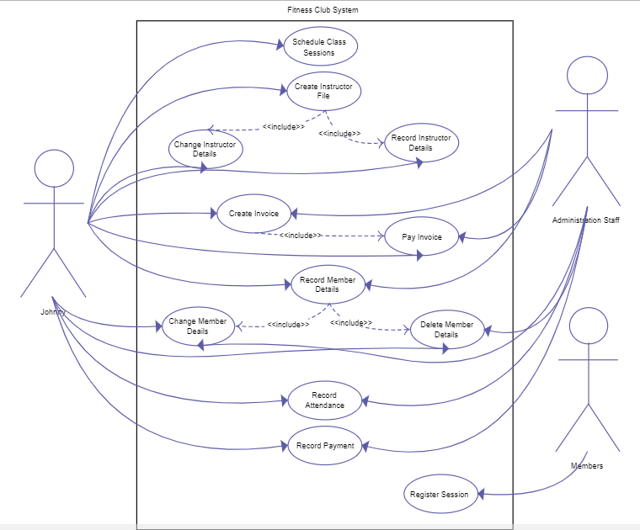

This assignment is asking you to practice the android sdk programming, more specifically development using activities, views, widgets, intent and http access libraries such as retrofit.

Requirements:

Features:

1, Login-in for user authentication

2, A form allow user to key in structured information such as User Sign-up Information.

3, Validation of user entries

4, Post the form information to back end with http request

5, Retrieve data from backend by calling a http request service

6,Displaying a set of information(e.g, personal trainer list) with RecyclerView and CardView.

Delivery:

1, You need to archive the project to a github or publicly available repository.

2, Providing a report of team members, API specification and Running results

2, Hand in due to 2018 - 11 - 15