Assignment3, More functions adding to GymClub App

Use Case Scenario:
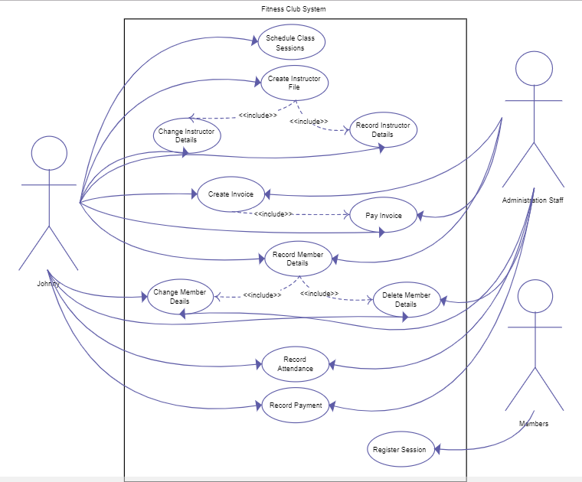
Suppose the gym club intends to add more functions to its android app, this time they focus on delivering information with multimedia. The functions you are asked to implement include the following,

Function1, As a gym club app user, he/she can watch the training video online. Primary needs for this function include a video list where each video item consists of a picture as well as short explanation and/or may be click through rate, and a video player that can be opened by click each video item on list.

Implementation of this function needs to be online, you can either install a stream server or simply make use of web server that accept video download.

Function 2, As an app user, when he/she is browsing the private trainer list, he/she may want to send a email or leave a SMS message or take a call according to the contacts provided in the list.

Optional Function3, As an app user, he/she likes to use a geolocation service (e.g, Google map or Baidu map) so that he/she can find the place of a specified gym, user hopes the map function can be integrated to the gym club app.

Delivery:
1, You need to archive the project to a github or publicly available repository.
2, Providing a report of team members, technical design and Running results
2, Hand in due to 2018 - 11 - 29

Assignment 3, File Sharing and DB cache functions adding to Travel Service App

This assignment is asking you to practice the android sdk programming, more specifically APIs for file sharing and local data cache with DB such as SQLlite.

Requirements

Business Scenario:
Based on the 2nd assignment given, more features are asked to put into this travel service app. They are,
1, Travel agents want to attach PDF document in their travel plans.
2, App users can still retrieve the travel plan information even the network is not available.

Features:
1, A file upload/download service may be needed for testing purpose.
2, Using retrofit to download/upload PDF file.
3, Sharing downloaded PDF with PDF reader by using FileProvider.
4, Travel plans data is cached at local, preferably using database.

Delivery:
1, You need to archive the project to a github or publicly available repository.
2, Providing a report of team members, API specification and Running results
2, Hand in due to 2018 - 4 - 25

