Assignment4, Refactoring your GymClub App with Offline Caching

Use Case Scenario:
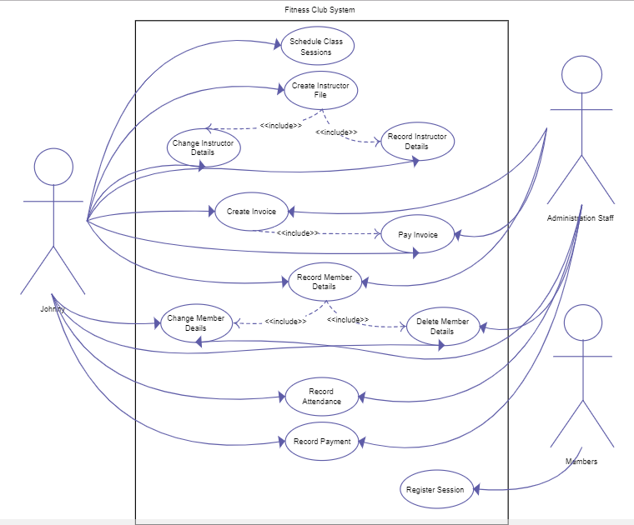
As per requirements from our client, users hope the app will enable them to query the private trainer information as well as the training material offline.

Function1, As a User, I hope to Access private trainer information offline.

Function 2, As a User, I hope to Access training articles offline.

Requirements:
You are asked to implement the offline cache with a ContentProvider with SqlLite DB or using the Room API

Delivery:
1, You need to archive the project to a github or publicly available repository.
2, Providing a report of team members, technical design and Running results
2, Hand in due to 2018 - 12 - 29

