Assignment5, Refactoring your GymClub App with Social Login

Use Case Scenario:
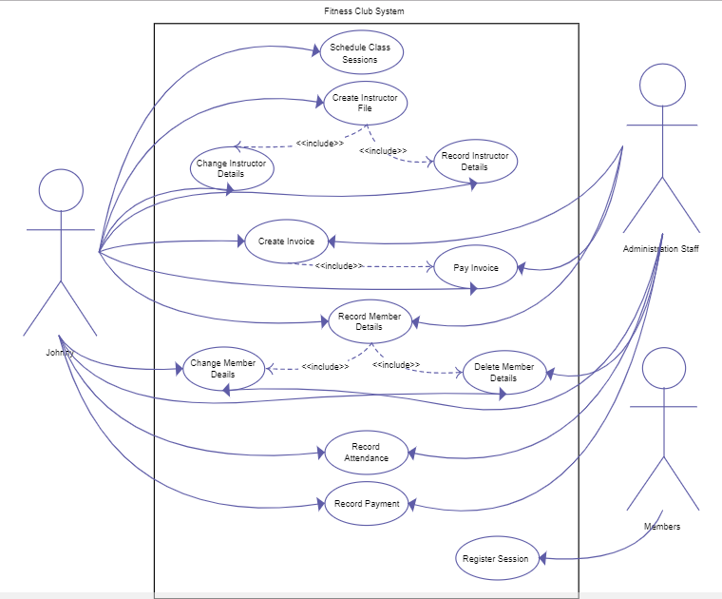
As per requirements from our client, users hope the app will enable them to login to the gymclub app with their social account in QQ, Wechat, Facebook and etc.

Function1, As a User, I hope to be able to sign in the app with my Wechat/QQ/other social account .

Delivery:
1, You need to archive the project to a github or publicly available repository.
2, Providing a report of team members, technical design and Running results
2, Hand in due to 2018 - 12 - 29

