**ELI 080C/40376**

**Reading & Vocabulary**

**Pace University**

**Group Project**

**Summer II**

**Cyborg**



**Prof. Ms. Judy Wong**

**Team:**

**Tianqi Yang**

**Toga**

Our product is a system which aims to make human beings stronger by merging human brains with robots and transfer our consciousness to robots. To achieve this goal, this project is carried out in two ways, consciousness transfer and intelligence improvement. The system is made up of 3 parts: local storage, cloud service center and terminal.

1. Consciousness Transfer Principle

The system needs to connect man’s neural system then it can code nerve impulses into codes. So a user who intends to transfer his or hers consciousness to robots need to lay in a freezer filled with liquid medium which can receive the user’s nerve signals from his or hers brain. The signal will be transferred to the center processing system by the liquid and coded to one of the machine languages. Then the consciousness code will be encrypted in the transmission module and then send to the cloud service center. After being processed and backup, the data will be finally sent to the robot.

The detailed introduction of every module and processes is as followed.

Authentication

Data Center

Cipher

Cloud

CPU

Local Storage

Intelligence Center

Relay

Transmission

Compiler

Terminal

* 1. Local storage

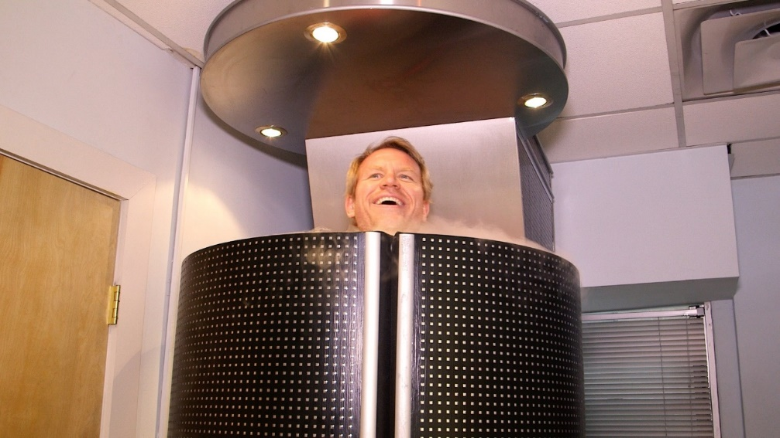

Freezer

The device which is interacted with people directly is a freezer which is used to store user’s body, receive and compile brain signal and send the compiled code to the cloud when the user is enjoying the transfer. The freezer is filled with liquid which consists of neurotransmitters. A user has to lay in the freezer and sink himself into the liquid. In this way can the user connect his neural system to the machine. The liquid keeps delivering brain impulses to the compiler and the compiler compiles the signals into one of the machine languages, then the code is sent to the transmission module. In the transmission module, this code is encrypted and then sent to the cloud.

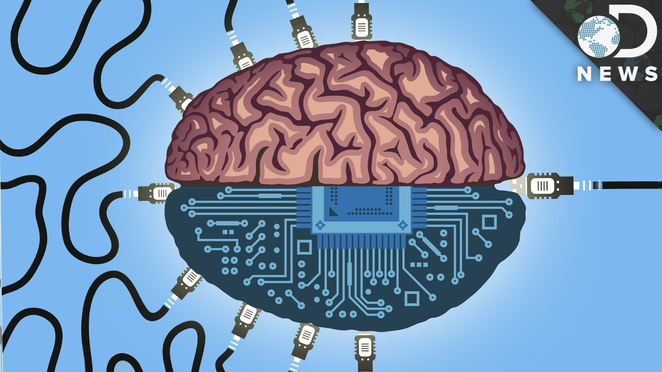

Liquid Medium

Before connect to the cloud, it needs to certify the identification of the user. The authentication process is carried out by the cloud authentication module. After certified, the user can send consciousness to cloud.

* 1. Cloud Service Center

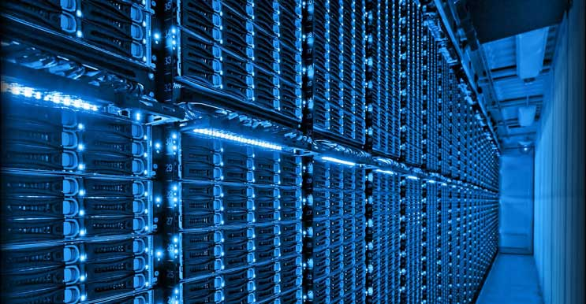

Cloud Service Center

Cloud service center is a place to relay data, store data and provide intelligence.

* + 1. Data Center

Data center is a place consists of hard discs which store all the consciousness, more precisely, Memory from all the users. This center must be constructed in multiple extraordinarily safe places to keep people’s memory safe.

* + 1. Authentication Module

Authentication module is used to certify users’ identifications. It will search for an identification match from the database of users’ information. It is very important to prevent users’ privacies.

* + 1. Relay Module

The cloud service center also acts as a relay node which processes the users’ data then send it to robots. It also transfer feedback data from robots to users.

* + 1. Intelligence Center

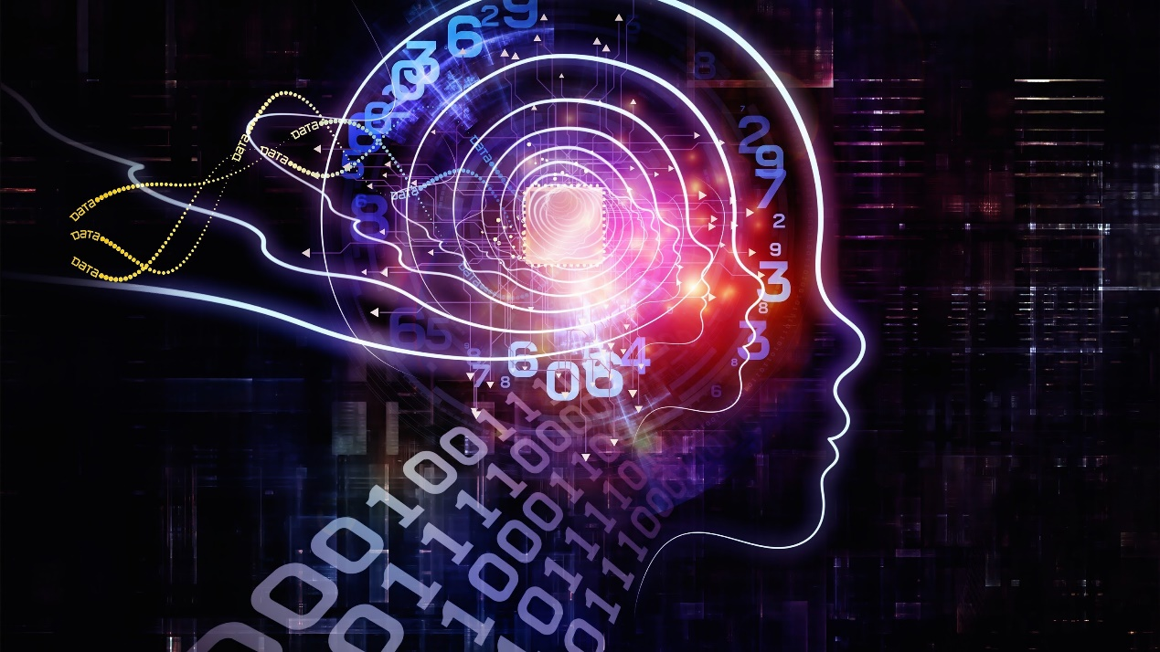

The intelligence Center provides amazing intelligence improvement function which we will talk in the next chapter.

* 1. Terminal

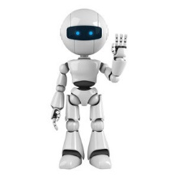

Robot

The terminal is a customized robot for the particular user who paid for this service. It has a coding module to decipher code and compile it into readable commands. Besides, it has a CPU to execute cloud-sent commands which are exactly what the related user wants to do. However, the robot has no original thinking, it can only do what the people command it to do. This is because we don’t want robots become real human. These commands are generated by the user and the intelligence center together.

1. Intelligence Improvement Principle

We found out a safe and effective way to improve people’s intelligence, instead of inserting something into brains or changing the brain structure. We make it possible by constructing the intelligence center. Users’ consciousness is sent to the cloud and then it will be processed by the intelligence center using a bunch of powerful computers. These computers enrich the original consciousness and make decisions more correctly by searching information and analyzing users’ habits.

* 1. AI Module

AI module records and analyzes users’ habits, thoughts and robots’ feedback. In this way, the system will know what user’ need most and gives better results.

* 1. Combination Module

This module is responsible for combining the original consciousness and the processed data which is used to improve the original thinking. This combination is not only applied in robots, but also truly improves the user’s mind when it is sent to the user.

1. Reference
   1. The 5 Types Of Organizational Structures: <https://www.forbes.com/sites/jacobmorgan/2015/07/15/the-5-types-of-organizational-structures-part-4-flatarchies/#7ef5c6a66707>
   2. Wiki: <https://en.wikipedia.org/wiki/Powered_exoskeleton#Applications>
   3. Wiki: <https://en.wikipedia.org/wiki/Human%E2%80%93machine_system>
   4. Elon Musk launches Neuralink, a venture to merge the human brain with AI: <https://www.theverge.com/2017/3/27/15077864/elon-musk-neuralink-brain-computer-interface-ai-cyborgs>