**Reference**

Introduction to Mean Shift Algorithm

https://saravananthirumuruganathan.wordpress.com/2010/04/01/introduction-to-mean-shift-algorithm/

Meanshift Algorithm

http://www.cnblogs.com/liqizhou/archive/2012/05/12/2497220.html

Machine Learning, Mean Shift Algorithm

http://blog.csdn.net/hjimce/article/details/45718593

Mean Shift Segmentation

http://blog.csdn.net/ttransposition/article/details/38514127

Y. Cheng, “Mean shift, mode seeking, and clustering,” IEEE Tans. Pattern Analysis and

Machine Intelligence, Vol. 17, No. 8, pp. 790-799, August 1995

D. Comaniciu and P. Meer, “Robust analysis of feature spaces: color image segmentation,”

Proc. IEEE Computer Vision and Pattern Recognition, pp. 750-755, June 1997

**Algorithm flow**

Discontinuity preserving filtering: choose pixels in a window of size hs * hs and find the densest point **y** in BGR space. Update the value of the pixel with the value of **y.**

Clustering: update values of pixels if their distance of space domain is less than hs and that of range domain is less than hr.

Eliminating small regions: classify all the regions first, then eliminate small regions which has less than p pixels by combining it in to bigger one.

Edge detectiong: an edge exists between two pixels with different color value.

**Output**

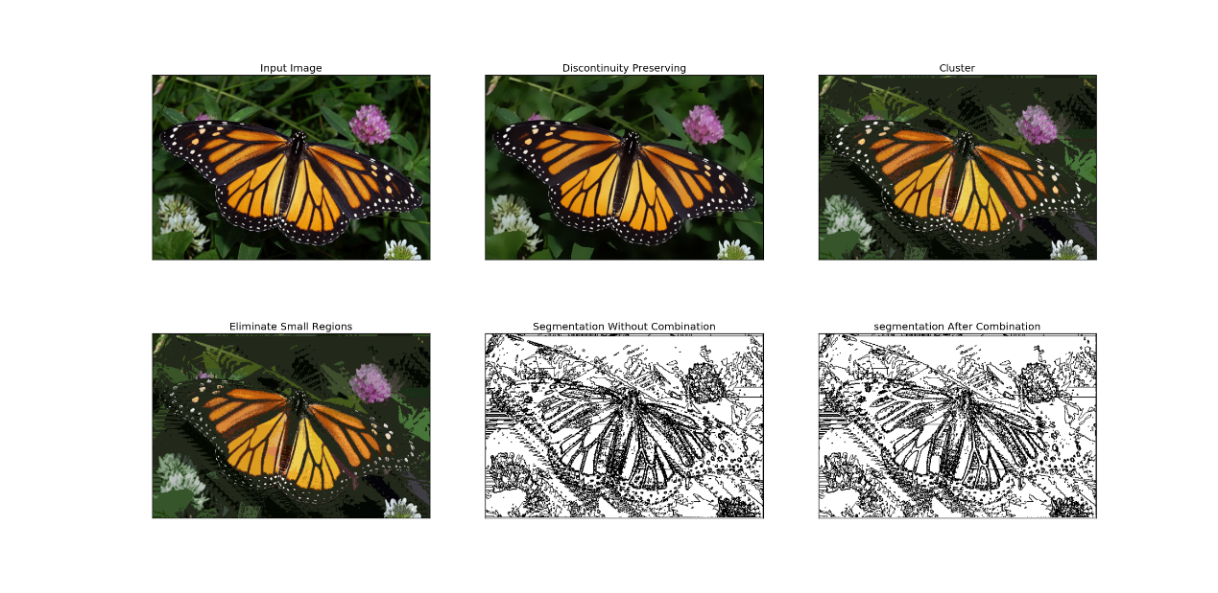

When hs =8, hr = 28, p = 200, Clustering makes segmentations more distinct but missing some regions. Edge detection goes good.

We haven’t finished optimization of our algorithm so that the running time is considerable. So we take a smaller image to display the output with difference parameters

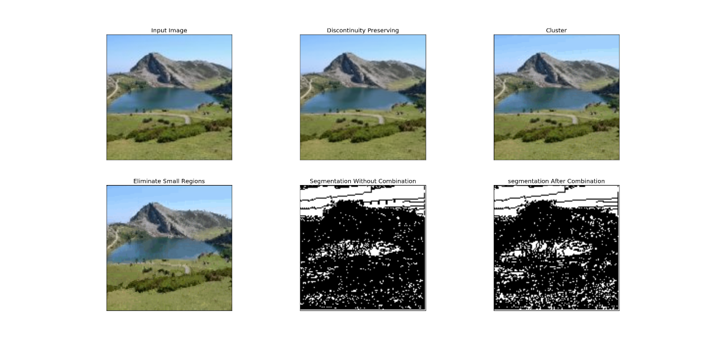

hs = 8, hr = 8, p = 100

We can see when hs = 8, hr = 8, p = 100, the result of discontinuity preserving filtering and clustering are very smooth, but it doesn’t do well in edge detection because multiple similar modes existing.

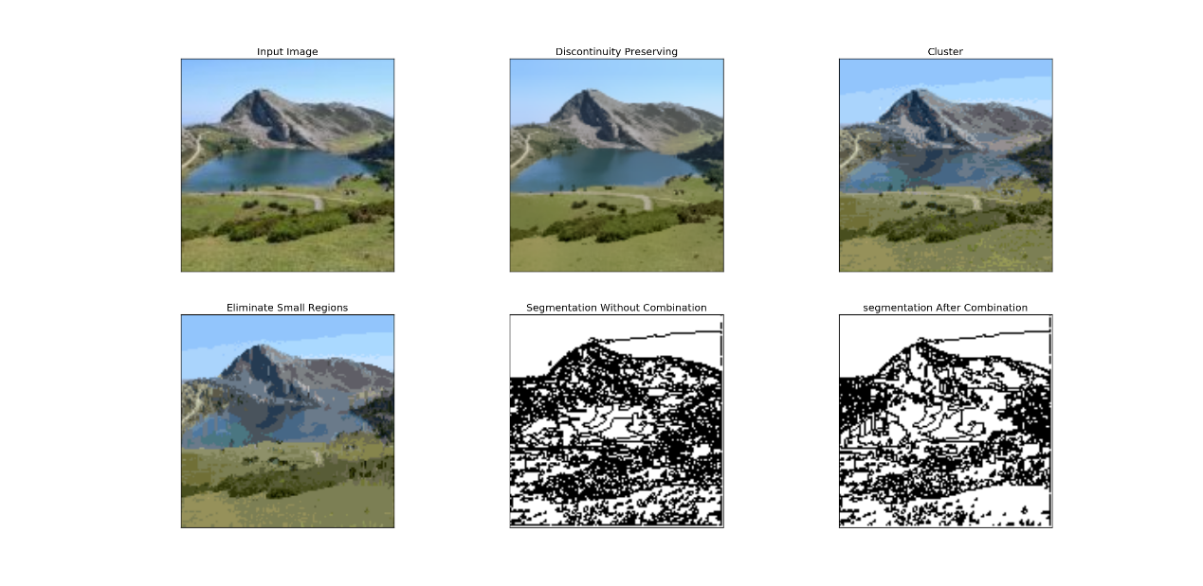

hs =8, hr = 28, p = 200

When hs =8, hr = 28, p = 200, edge detection goes better, but it still trivial. Clustering makes segmentations more distinct.

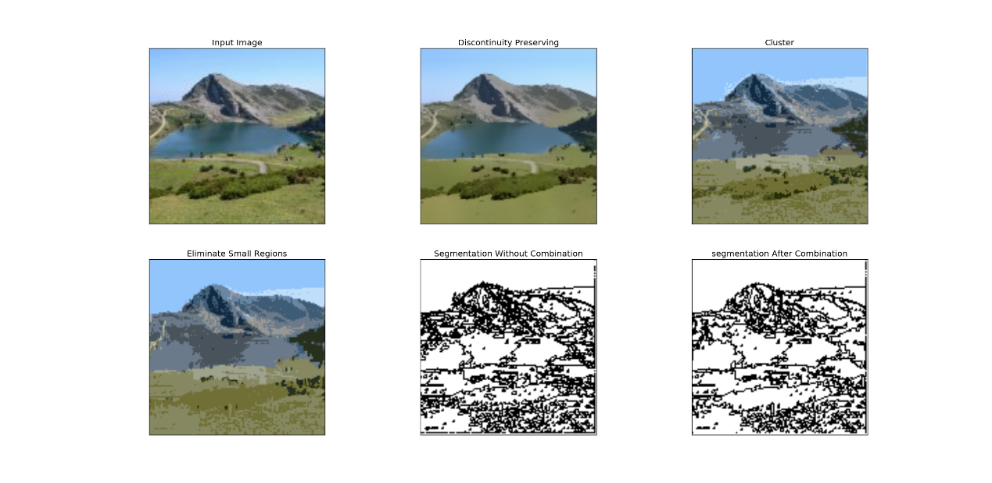

hs =8, hr = 50, p = 200

When hs =8, hr = 50, p = 200, edge detection goes much better. Clustering makes segmentations more distinct and eliminate some big regions.

The reason why we didn’t change hs is this parameter have a great impact on running time.

This code can’t process gray level image because we focus on color image so that we don’t fit the code to gray level. But it is easy to change it to fit but we don’t have enough time to do that.