CEILNet: a Cascaded Edge and Image Learning Network
(the first to solve the challenging layer- separation problem of reflection removal from single images using deep learning techniques)
Article | Key | Data | Comments | Why
Fan, Q., Yang, J., Hua, G., Chen, B., & Wipf, D. (2017). A generic deep architecture for single image reflection removal and image smoothing. In Proceedings of the IEEE International Conference on Computer Vision (pp. 3238-3247). | Main:  Propose a deep neural network structure that exploits edge information in addressing representative low- level vision tasks.(layer separation and image filtering)  Problems and Methods:  - single image reflection removal (layer separation):  - a mild reflection smoothness assumption using neural network  - a novel synthetic data generation method that acts as a type of weak supervision to generate enough trainnig data  - image smoothing (image filtering)  Background:  The old methods are simply infeasible in many practical situations.  Why edge based solutions:  One exploitable property in the reflection removal problem is that the gradients or perceptual structures of the two layers exhibit different distributions, since reflections often display a greater degree of blurring | - Network Structure  Steps:  1. predicting the edge maps of the target images via a deeply supervised sub-network  2. reconstructing the target images by leveraging the predicted edge maps  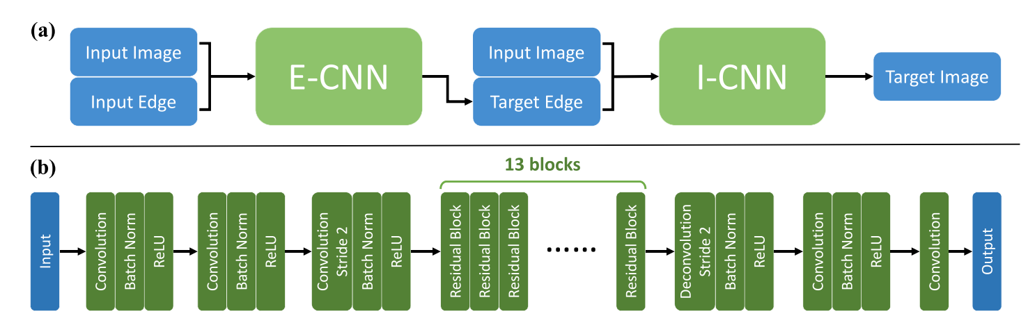  - CNN:  - Effective edge representation: the mean absolute color difference between a center pixel and its four- connected neighbors  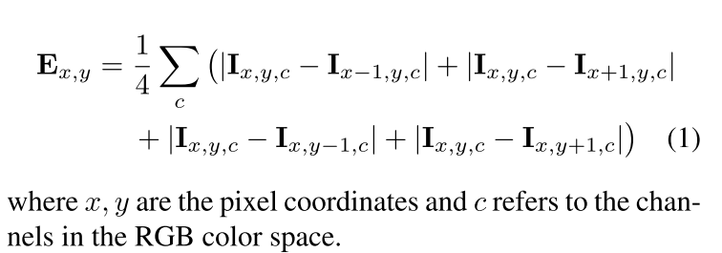  - The source image with its edge map as an additional channel for input: the edge map of the source image is a part of the image which also underlines the edge features of the source image  - CNN:  - The input image and the target edge are combined to be a 4-channel tensor as input, similar to E-CNN  - Training  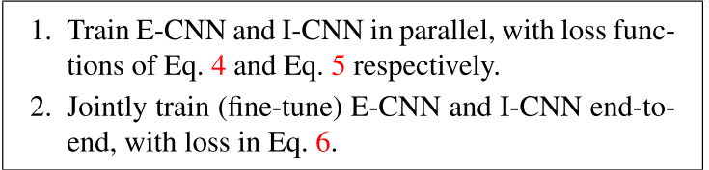  Loss:  - E-CNN：  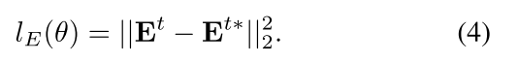  - I-CNN:  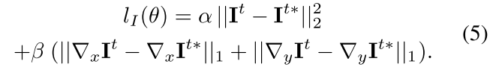  - CEILNet:  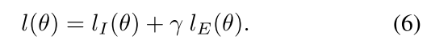  - Data Generation  Reflection is blurry relative to the background layer but can have large intensity  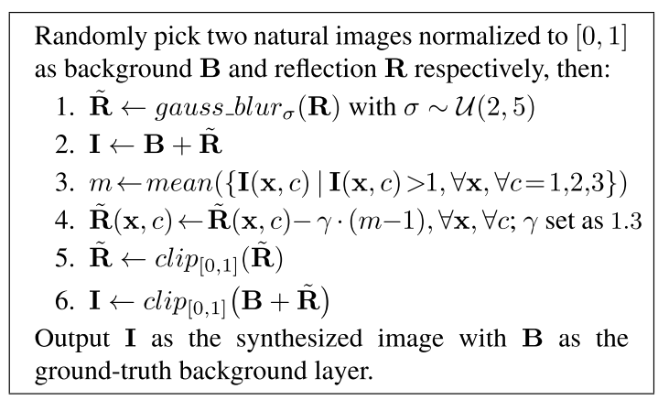  四、Data  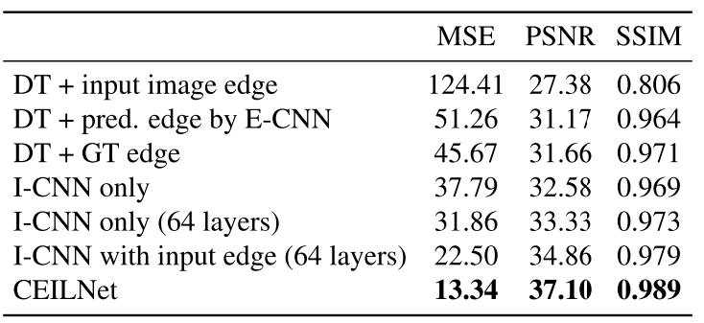 | TODO:  - color attenuation issue observed in deep networks?  --another two papers to read  ‘Accurate image super-resolution using very deep convolutional networks’ and ‘Deeply-recursive convolutional network for image super-resolution’  Idea:  - Use both input image and edge map as the whole input which underline the edge information  - First get the target edge map then get target image  - Training each network seperately and then  Train both of them together  - Exploit a new way to synthesize the data based on the principle of glass reflection | Learn the background of the research

Reflection separation with three special losses
Article | Key | Data | Comments | Why
Zhang, X., Ng, R., & Chen, Q. (2018). Single image reflection separation with perceptual losses. In Proceedings of the IEEE conference on computer vision and pattern recognition (pp. 4786-4794). | Main:  Create a fully convolutional net- work trained end-to-end with losses that exploit low-level and high-level image information to solve the problem of separating reflection from a single image  Problems and Methods:  single image reflection removal (layer separation):  Three novel loss functions Background:  The old methods are simply infeasible in many practical situations. | - Network Structure  Input: 1472(hypercolumn features from VGG 19) + 3 dimensions --> 1*1 convolution to reduce feature to 64 dimensions --> 8 layers 3*3 dilated convolutions(The dilation rate varies from 1 to 128)  - Training  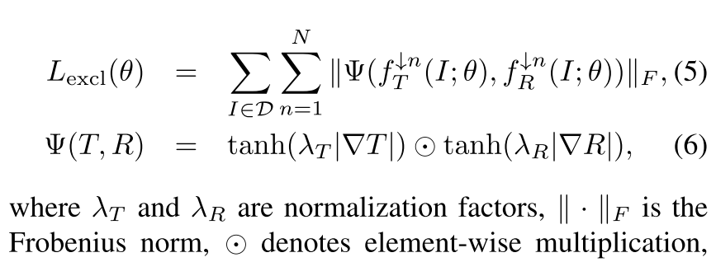  - Feature loss 3. Exclusion loss  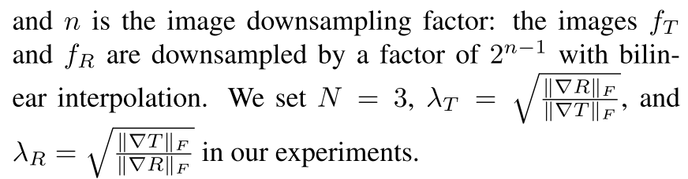  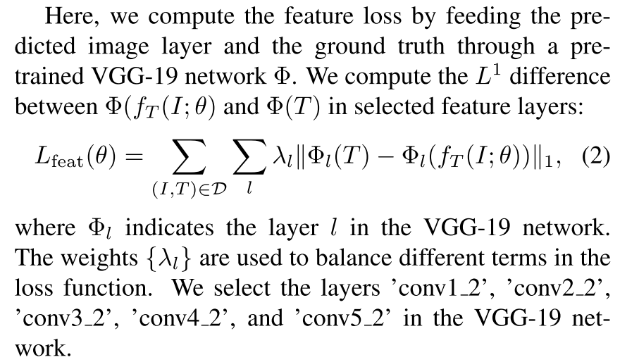  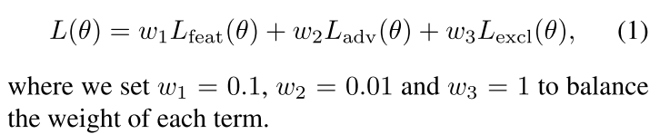  - Adversarial loss 4. All  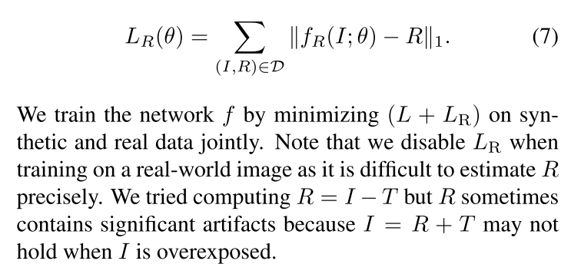  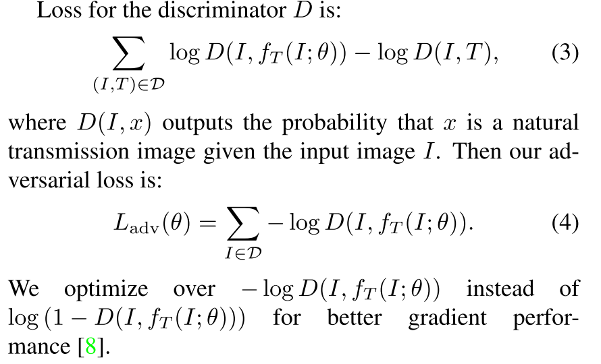  - Data  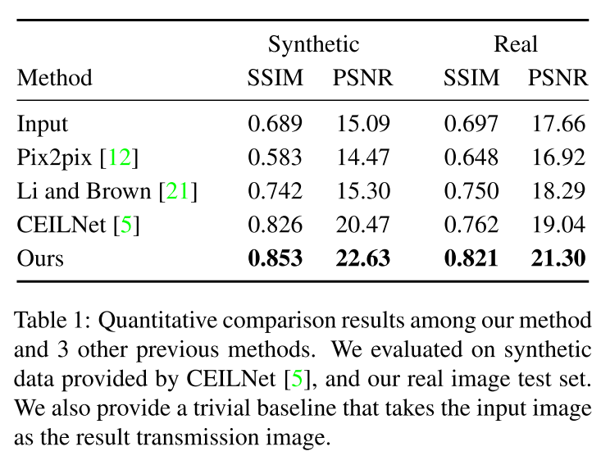  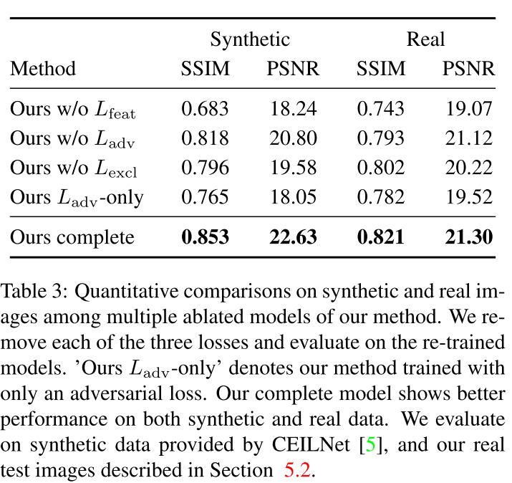 | - Feature loss makes use of the image feature information;  Exclusion loss makes use of the edge information on pixel level;  Use GAN to generate a loss function; And all of this three loss functions is inspiring and creative.  - Use tanh as jump function to minimize the correlation between the predicted transmission and reflection layers in the gradient domain. | Learn the background of the research

CRRN
Article | Key | Data | Comments | Why
Wan, R., Shi, B., Duan, L. Y., Tan, A. H., & Kot, A. C. (2018). Crrn: Multi-scale guided concurrent reflection removal network. In Proceedings of the IEEE Conference on Computer Vision and Pattern Recognition (pp. 4777-4785). | Main:  Propose a network integrating image appearance information and multi-scale gradient information with human perception inspired loss function  Problems and Methods:  single image reflection removal (layer separation):  A network makes use of both gradient features and image appearance features  Background:  The old methods are simply infeasible in many practical situations. | - Network Structure  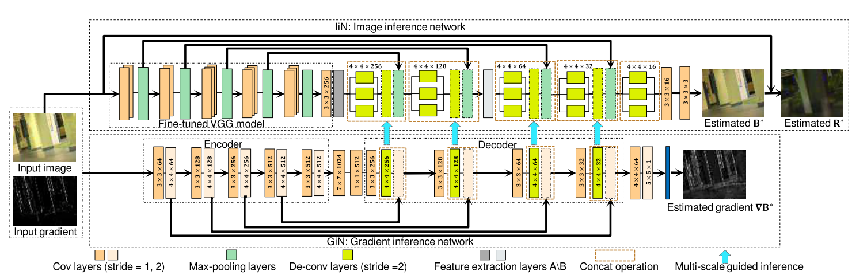  GiN is designed to learn the gradient features, while IiN uses a well-trained VGG16 the ‘Reduction- A/B layers’ from Inception-ResNet-v2 to extract appearance features.Moreover, a residual network structure is applied at the end of the network to get the R.  - Training(synthesis dataset)  GiN(independent, learning rate = 0.0001, epochs = 40) --> entire network(learining rate = 0.0001, epochs = 50) --> entire network(learning rate = 0.00001, epochs = 30)  Loss for IiN:  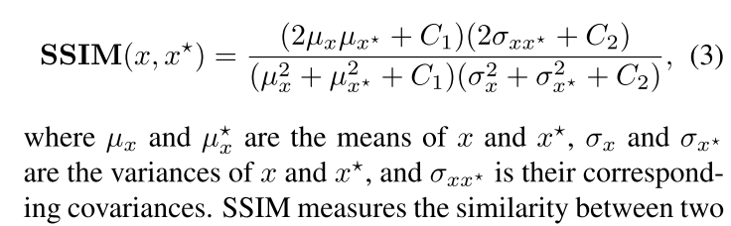    SSIM may cause changes of brightness and shifts of colors which makes the final results become dull. Therefore, MAE is used as L1 loss.  Loss for GiN:  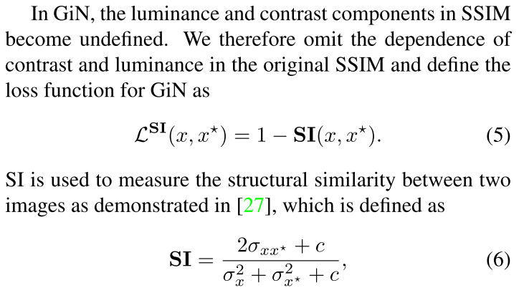  Loss for all:  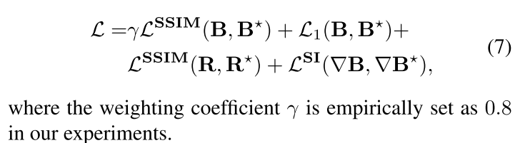  - Data  Subscript ‘r’ represents the ‘regional’  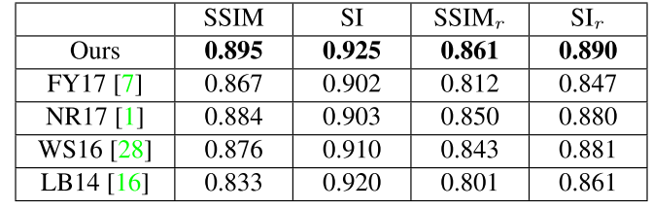  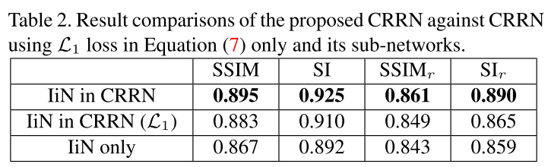 | TODO:  - Use SSIM as loss function, instead of evaluation， which may not be better than the perceptual loss in Single image reflection separation with perceptual losses in my opinion. This needs experiments.  - Understanding why ‘SSIM may cause changes of brightness and shifts of colors which makes the final results become dull.’  --another paper needs to be read ‘Loss functions for image restoration with neural networks’  Idea:  - The concatenation of CNN layers to enhance connection. | Learn the background of the research

Reflection separation with a deep and bidirectional network
Article | Key | Data | Comments | Why
Yang, J., Gong, D., Liu, L., & Shi, Q. (2018). Seeing deeply and bidirectionally: A deep learning approach for single image reflection removal. In Proceedings of the European Conference on Computer Vision (ECCV) (pp. 654-669). | Main:  Propose a cascade deep neural network, which estimates both the background image and the reflection and makes use of the result to refine the estimation.  It considers the case when the reflections do not have strong blurry or have similar brightness and structure with the background.  Problems and Methods:  single image reflection removal (layer separation):  A cascade deep neural network based on the assumption that reflection may not be blurred.  Background:  The old methods are simply infeasible in many practical situations. | - Network Structure  14 layers --> 10 layers --> 10 layers  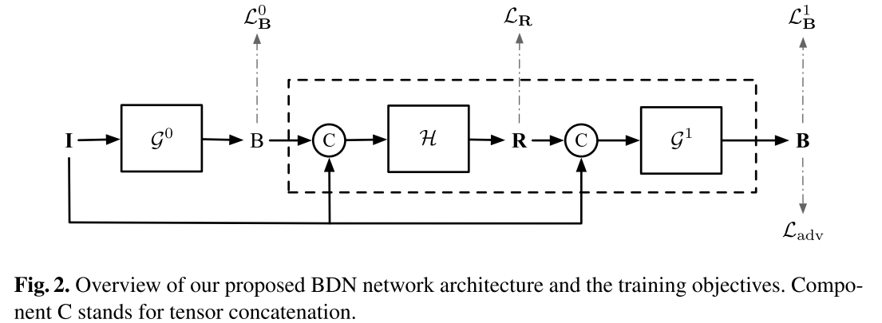  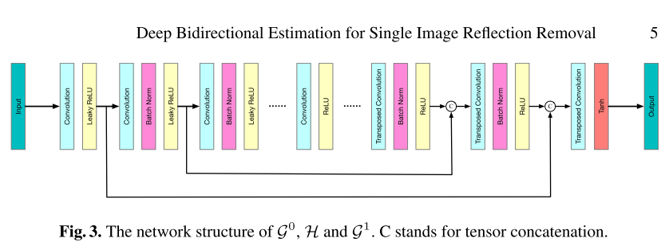  Encoder: all convolution layers are followed by BatchNorm layer and leaky ReLU with slope 0.2, except for the first convolution layer  Decoder: each transposed convolution with stride 2 which upsamples the feature  - All the kernel size of the filters are 4*4 and the skip connections concatenate each channel from layer i to layer n-i where n is the number of layers  - Trainning(synthesis dataset)  Training end to end and training independently are both tested.  Loss for pixel-wise difference：  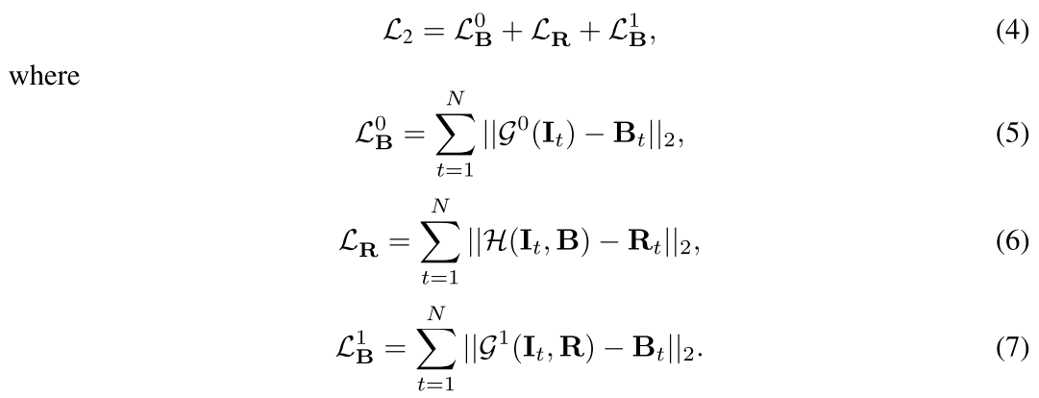  Loss for perceptual difference(by GAN):  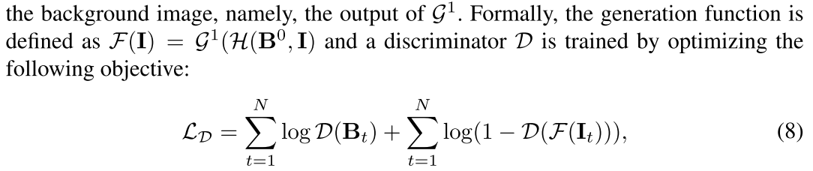  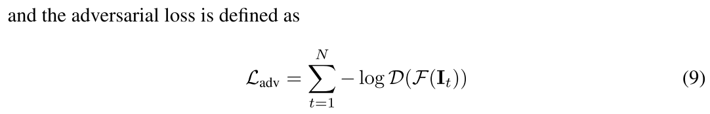  Loss for all:  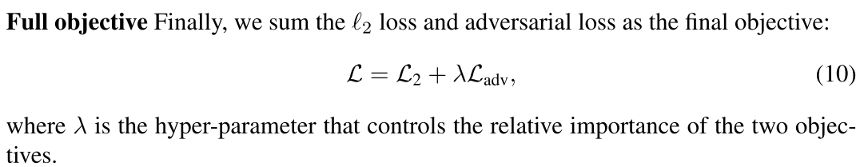  - Data  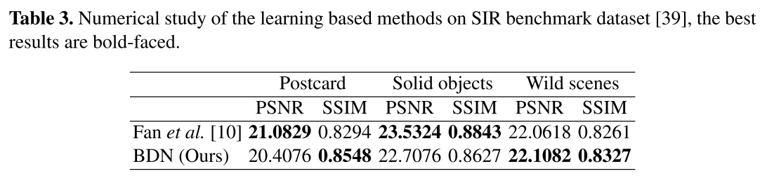  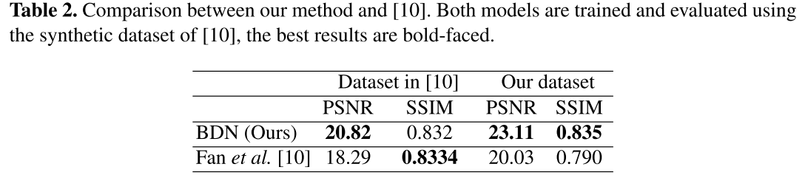  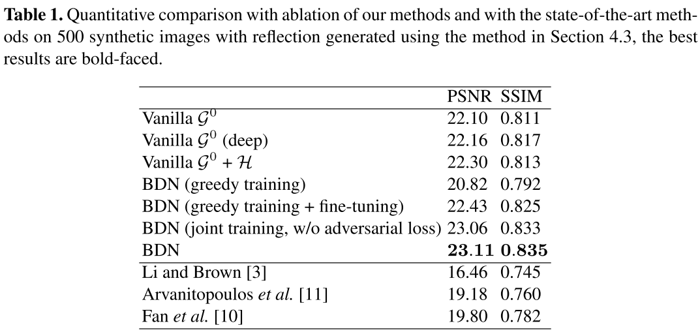 | - Bidirectional network  - Adversarial loss like ‘Single image reflection separation with perceptual losses’ | Learn the background of the research

Reflection removal exploiting misaligned training data and network enhancements
Article | Key | Data | Comments | Why
Wei, K., Yang, J., Fu, Y., Wipf, D., & Huang, H. (2019). Single image reflection removal exploiting misaligned training data and network enhancements. In Proceedings of the IEEE/CVF Conference on Computer Vision and Pattern Recognition (pp. 8178-8187). | Main:  Augment a baseline network architecture by embedding context encoding modules and  introduce an alignment-invariant loss function that facilitates exploiting misaligned real-world training data  Problems and Methods:  single image reflection removal (layer separation):  A cascade deep neural network based on the assumption that reflection may not be blurred.  Background:  The old methods are simply infeasible in many practical situations. | Network Structure  Trainning(synthesis dataset)  Data |  | Learn the background of the research

