CEILNet: a Cascaded Edge and Image Learning Network
(the first to solve the challenging layer- separation problem of reflection removal from single images using deep learning techniques)
Article | Key | Data | Comments | Why
Fan, Q., Yang, J., Hua, G., Chen, B., & Wipf, D. (2017). A generic deep architecture for single image reflection removal and image smoothing. In Proceedings of the IEEE International Conference on Computer Vision (pp. 3238-3247). | Aim:  Propose a deep neural network structure that exploits edge information in addressing representative low- level vision tasks.(layer separation and image filtering)  Problems and Methods:  - single image reflection removal (layer separation):  - a mild reflection smoothness assumption using neural network  - a novel synthetic data generation method that acts as a type of weak supervision to generate enough trainnig data  - image smoothing (image filtering)  Background:  The old methods are simply infeasible in many practical situations.  Why edge based solutions:  One exploitable property in the reflection removal problem is that the gradients or perceptual structures of the two layers exhibit different distributions, since reflections often display a greater degree of blurring | - Network Structure  Steps:  1. predicting the edge maps of the target images via a deeply supervised sub-network  2. reconstructing the target images by leveraging the predicted edge maps  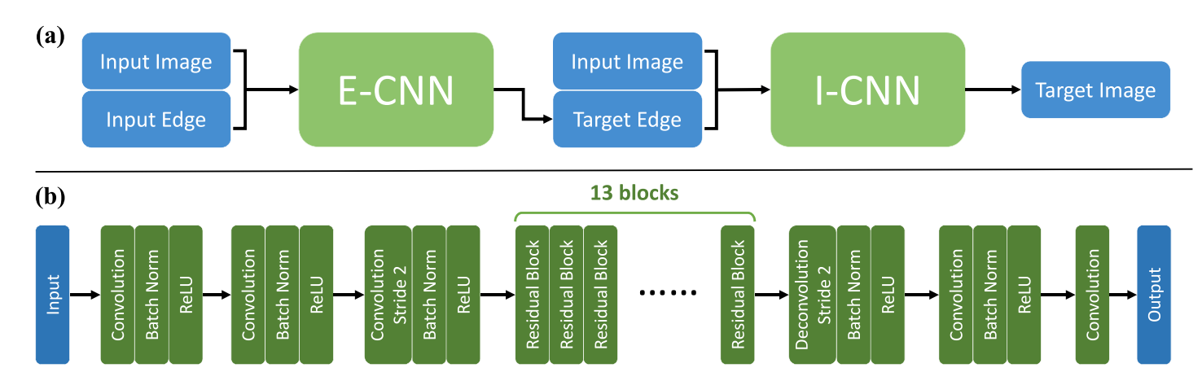  - CNN:  - Effective edge representation: the mean absolute color difference between a center pixel and its four- connected neighbors  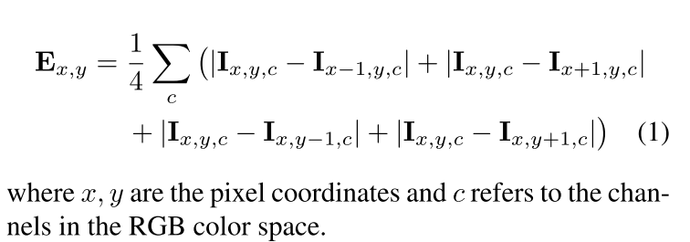  - The source image with its edge map as an additional channel for input: the edge map of the source image is a part of the image which also underlines the edge features of the source image  - CNN:  - The input image and the target edge are combined to be a 4-channel tensor as input, similar to E-CNN  - Training  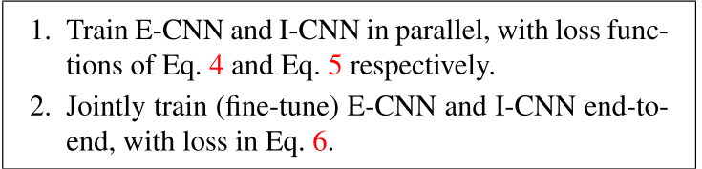  Loss:  - E-CNN：  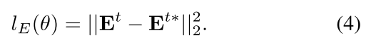  - I-CNN:  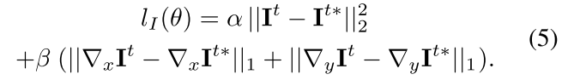  - CEILNet:  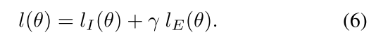  - Data Generation  Reflection is blurry relative to the background layer but can have large intensity  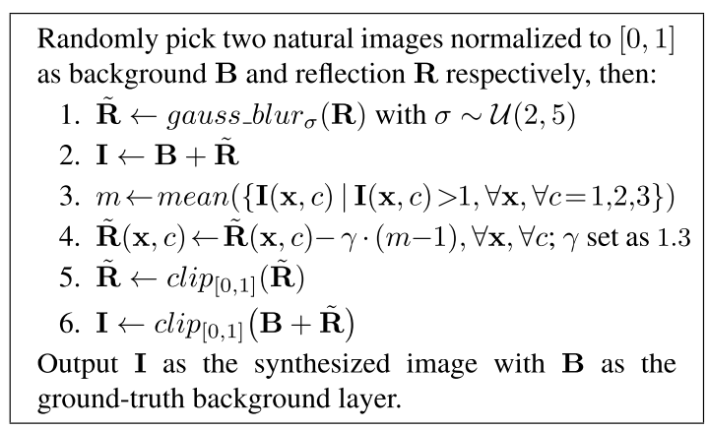  四、Data  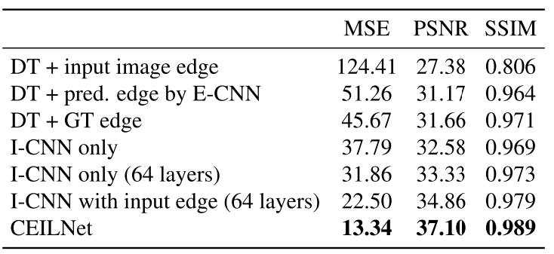 | TODO:  color attenuation issue observed in deep networks?  The generation model, how to clip? | Learn the background of the research

Article | Key | Data | Comments | Why
47). | Aim:  Propose a deep neural network structure that exploits edge information in addressing representative low- level vision tasks.(layer separation and image filtering)  Problems and Methods:  - single image reflection removal (layer separation):  - a mild reflection smoothness assumption using neural network  - a novel synthetic data generation method that acts as a type of weak supervision to generate enough trainnig data  - image smoothing (image filtering)  Background:  The old methods are simply infeasible in many practical situations.  Why edge based solutions:  One exploitable property in the reflection removal problem is that the gradients or perceptual structures of the two layers exhibit different distributions, since reflections often display a greater degree of blurring |  | TODO:  color attenuation issue observed in deep networks?  The generation model, how to clip? | Learn the background of the research

