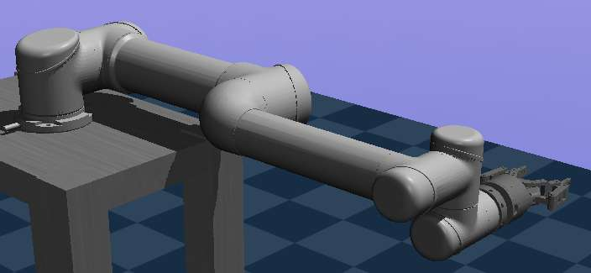

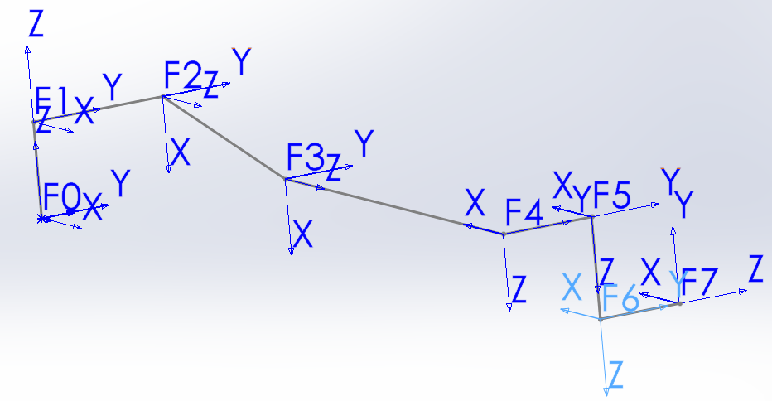

|  |  |  |  |  |  |
| --- | --- | --- | --- | --- | --- |
| 连杆参数（连杆i相对于坐标Fi的值） | | | | | |
| 编号i | 长度 | 质心 | 质量 | 惯量 | 备注 |
| 0 | 0 0 0.089159 | 0 0 0 | 4 | 0.00443333156, 0.00443333156, 0.0072 | base |
| 1 | 0 0.13585 0 | 0 0 0 | 3.7 | 0.010267495893, 0.010267495893, 0.00666 |  |
| 2 | 0 -0.1197 0.425 | 0 0 0.28 | 8.393 | 0.22689067591, 0.22689067591, 0.0151074 |  |
| 3 | 0 0 0.39225 | 0 0 0.25 | 2.275 | 0.049443313556, 0.049443313556, 0.004095 |  |
| 4 | 0 0.093 0 | 0 0 0 | 1.219 | 0.111172755531, 0.111172755531, 0.21942 |  |
| 5 | 0 0 0.09465 | 0 0 0 | 1.219 | 0.111172755531, 0.111172755531, 0.21942 |  |
| 6 | 0 0.0823 0 | 0 0 0 | 0.1879 | 0.0171364731454, 0.0171364731454, 0.033822 |  |
| 7 | 不重要 | 0 0 0.069871 | 1.3 | 0.00800113 0.00972386 0.00176438 | gripper |

该水平平衡状态下各关节力矩

mujoco内部计算：[ 0.00000000e+00 -6.95931875e+01 -2.06861927e+01 -3.55271368e-15 0.00000000e+00 1.77635684e-15]

即[0 -69.5931 -20.6861 0 0 0]

kdl内部计算：[-9.86076e-32 -72.7679 -23.8609-1.87768e-16 2.56238e-16-1.85783e-17]

即[0 72.7679 -23.8609 0 0 0]