# JAVA

## 1.日期获取

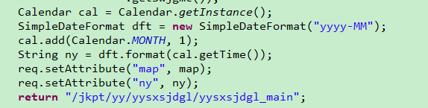

Calendar cal = Calendar.*getInstance*();

SimpleDateFormat dft = **new** SimpleDateFormat("yyyy-MM");

cal.add(Calendar.*MONTH*, 1);

String ny = dft.format(cal.getTime());

# oracle

## 拼接字符串

SELECT DT_DM,

SJDLX_DM,

SJDLX_MC,

LRRY,

LRRQ,

LISTAGG(KSSJ || '-' || JZSJ, '&lt;br&gt;') WITHIN GROUP(ORDER BY KSSJ) SJD

FROM DT_YYRQ_SJDGL

WHERE DT_DM = #{dtDm, jdbcType = VARCHAR}

GROUP BY DT_DM, SJDLX_DM, SJDLX_MC, LRRY, LRRQ

# JS

## 获取当前日期，格式为YY-MM-DD

//获取当前时间，格式YYYY-MM-DD

function getNowFormatDate() {

var date = new Date();

var seperator1 = "-";

var year = date.getFullYear();

var month = date.getMonth() + 1;

var strDate = date.getDate();

if (month >= 1 && month <= 9) {

month = "0" + month;

}

if (strDate >= 0 && strDate <= 9) {

strDate = "0" + strDate;

}

var currentdate = year + seperator1 + month + seperator1 + strDate;

return currentdate;

}