**Hong Kong Institute of Vocational Education Department of Information and Communications Technology ITP4501 – Programming Techniques for Mobile Systems Android Networking & Threading – Laboratory**

**NOTE**: Remember to grant the Internet access permission to your applications by adding the line below to AndroidManifests.xml.

<uses-permission android:name="android.permission.INTERNET"/>

**...**

**Q3.** Write an Android application to read a JSON string from your own API server:

<https://labq-mobileasignment-dcoxpupbge.cn-hongkong.fcapp.run>

The JSON string returned is shown below:

{

"title": "IVE", "campuses": [

{"code": "TY"},

{"code": "MH"},

{"code": "TM"},

{"code": "ST"},

{"code": "CW"},

{"code": "LWL"},

{"code": "KT"},

{"code": "HW"},

{"code": "KC"}

]

}

Your application parses the JSON string and extract the campus codes (TY, MH, …). The campus codes are then displayed with a ListView.

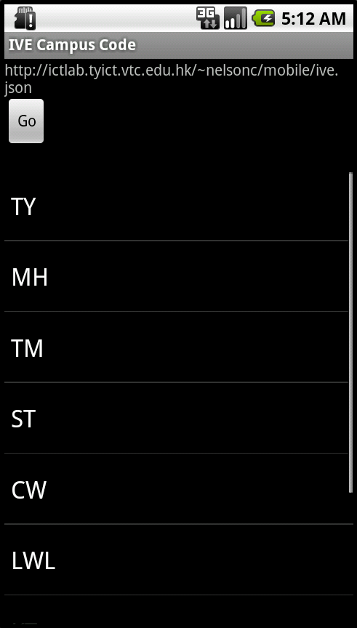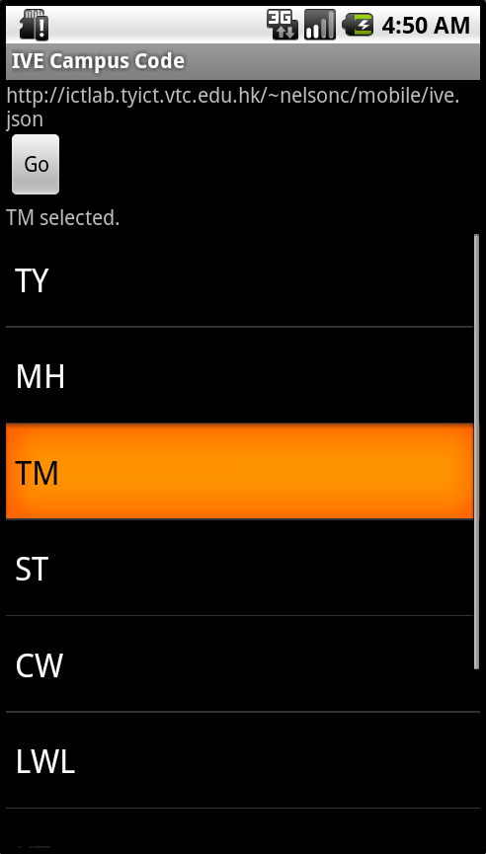

**NOTE**:

➢ The JSON string above contains a JSONArray labeled as "campuses". Each element in the array is an JSONObject. Each such JSONObject contains a string (e.g. "TY") labeled as "code".

➢ If you want to learn more about JSON, visit <https://www.json.org>

[<LinearLayout xmlns:android="http://schemas.android.com/apk/res/android"](http://schemas.android.com/apk/res/android) [xmlns:tools="http://schemas.android.com/tools"](http://schemas.android.com/tools) android:layout_width="match_parent"

android:layout_height="match_parent"

android:orientation="vertical" tools:context=".MainActivity">

<TextView android:id="@+id/textViewUrl" android:layout_width="match_parent" android:layout_height="wrap_content" android:text="@string/ive_code_url" />

<Button android:id="@+id/buttonGo" android:layout_width="wrap_content" android:layout_height="wrap_content" android:text="Go" />

<TextView android:id="@+id/textViewResult" android:layout_width="wrap_content" android:layout_height="wrap_content" />

<ListView android:id="@+id/listViewCode" android:layout_width="match_parent" android:layout_height="match_parent" android:drawSelectorOnTop="false" />

</LinearLayout>