2013-2014 Twenty LDA topics

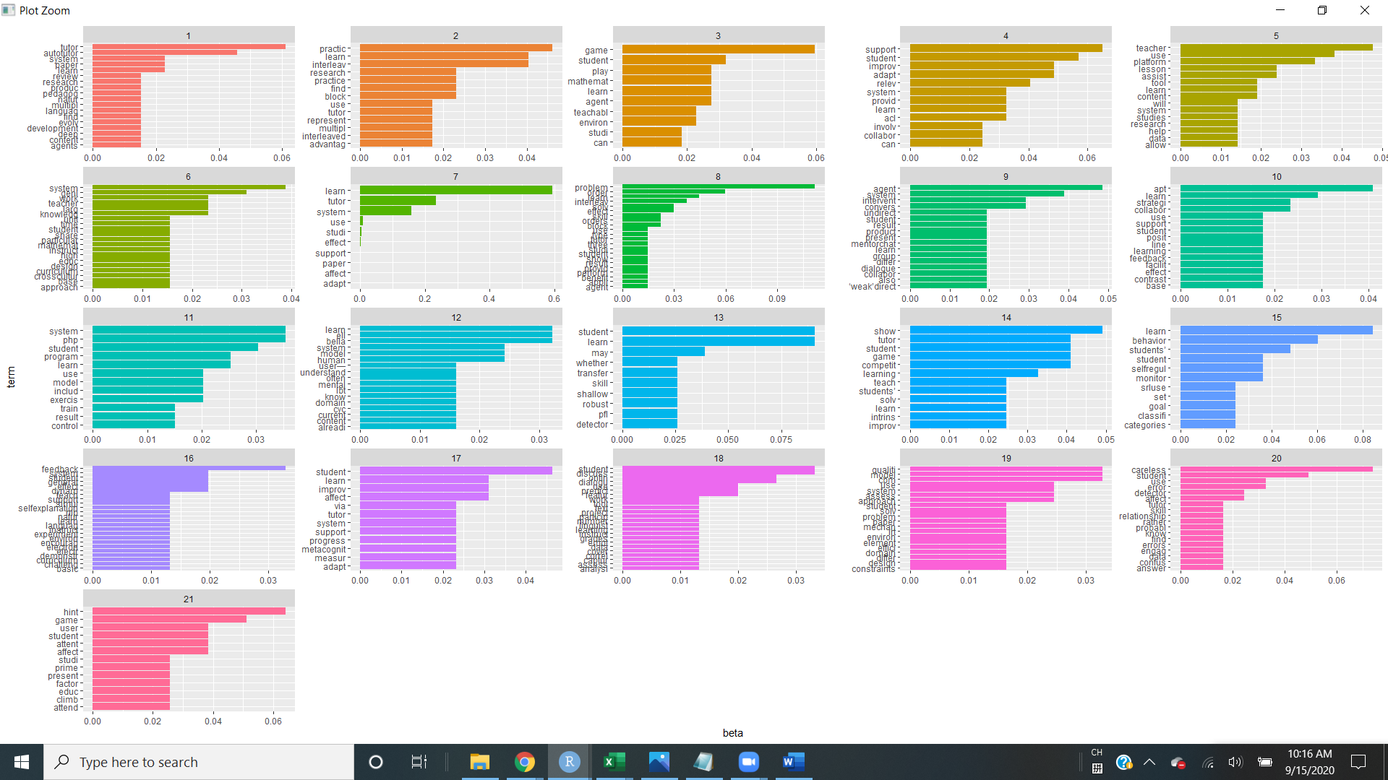

2015-2016 Twenty LDA topics

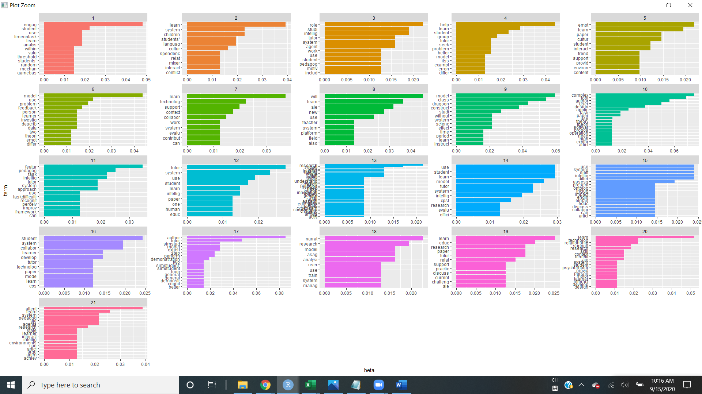

2017-2018 Twenty LDA topics

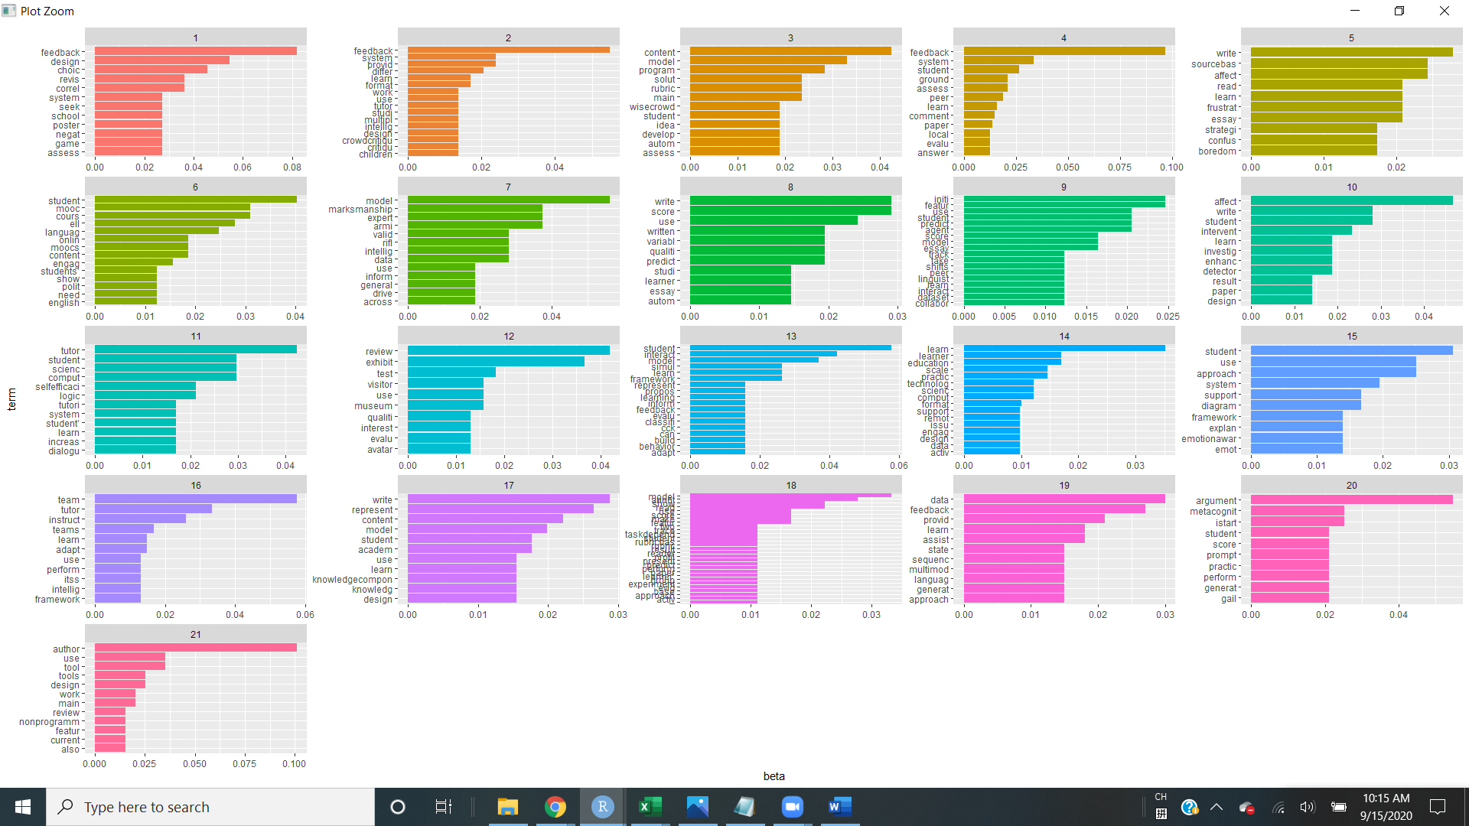

2019-2020 Twenty LDA topics

