Observation-Scale Forcing Errors Can Substantially Degrade LSTM Rainfall-Runoff Predictions: A Multi-Level Adversarial Stress Test
Y. Sun
College of Hydrology and Water Resources, Hohai University, Nanjing, China
Corresponding author: Y. Sun (sunyiq@hhu.edu.cn)

Abstract
Deep learning models, particularly Long Short-Term Memory (LSTM) networks, have demonstrated strong predictive skill in rainfall-runoff modeling. As these models move toward operational deployment, their robustness to input uncertainty becomes a critical concern. Yet existing assessments often rely on random noise or single-step adversarial methods (FGSM), which may underestimate worst-case vulnerability. Here we present a multi-level adversarial stress test of a 531-basin CAMELS-US benchmark LSTM, applying a spectrum of perturbation methods from random noise through iterative optimization, three constraint levels of increasing plausibility, targeted attacks on flood and pre-event windows, and a minimum-perturbation analysis. These perturbations are not intended to reproduce the empirical distribution of real-world forcing errors; rather, they serve as constrained worst-case stress tests within observation-error-scale uncertainty budgets. Two robustness findings are our primary result. First, the model is substantially more fragile than random-noise testing suggests: at $ε=0.1$, iterative scheduled-step PGD causes a median NSE degradation of 0.38, against 0.024 for a structure-matched random-sign search of comparable sampling budget, a ratio of about 16:1; single-step FGSM (0.30) is nearly as damaging, so the decisive conclusion change is between random and gradient-based testing rather than between single-step and iterative gradient methods. Second, and most consequential for operations, perturbations that preserve each input variable’s mean and standard deviation evade quality-control screens that check only those two statistics by construction, yet still retain 78% of the unconstrained degradation. This exposes a blind spot in mean-and-standard-deviation screening. These failure modes are hydrologically structured rather than a pure machine-learning artifact. An optimizer-free occlusion analysis shows that the model’s forcing dependence reorganizes across catchments—precipitation-dominated in rain basins and temperature-dominated in snow basins (partial rank correlation of the temperature-dependence share with snow fraction $+0.84$, $N=531$)—and the adversarial attack aligns with this structure: in snow catchments it concentrates on the temperature (snowmelt) forcing and suppresses predicted flood peaks about twice as strongly as in rain catchments, consistent with hydrologically interpretable sensitivity along snowmelt-related forcing pathways. Robustness assessment for standard hydrological deep-learning configurations therefore requires multi-level stress testing and quality control that checks temporal and cross-variable structure, not only marginal means and standard deviations: random-noise sensitivity analysis substantially underestimates the vulnerability that gradient-based adversarial attacks reveal.
Keywords: Rainfall-runoff modeling; Long short-term memory; Adversarial robustness; Input uncertainty; Quality control; Streamflow prediction

Highlights
- Gradient-based stress testing finds about 16 times the loss of matched random noise
- Mean- and variance-preserving input errors evade those checks yet keep 78
- Failures concentrate on temperature inputs and snowmelt flood peaks in snow basins

1 Introduction
Long Short-Term Memory (LSTM) networks have transformed hydrological prediction over the past decade. Beginning with the pioneering work of Kratzert et al. (2018), deep learning models have consistently matched or exceeded the performance of process-based hydrological models on standardized benchmarks such as CAMELS (Addor et al. 2017), achieving median Nash-Sutcliffe Efficiency (NSE) values above 0.7 across hundreds of catchments (Kratzert et al. 2019; Gauch et al. 2021). These advances have catalyzed growing interest in deploying LSTM-based models in operational forecasting systems (Nearing et al. 2021).
As deployment moves forward, a fundamental question demands attention: how reliable are these models when confronted with imperfect input data? In practice, meteorological forcings are never exactly known. Rain gauge measurements carry systematic biases of 5–15% (Sevruk 1982; Groisman and Legates 1994). Gridded products such as Daymet, Maurer, ERA5, and CHIRPS introduce additional uncertainty through spatial interpolation, with temperature errors of 1–2 $​^{∘}$C and precipitation errors that can exceed 2 mm/day in complex terrain (Thornton et al. 2021; Hersbach et al. 2020). Input and forcing error has long been recognized as a first-order control on hydrological prediction uncertainty (Beven 2006; Kavetski, Kuczera, and Franks 2006; Renard et al. 2010; Clark et al. 2008; McMillan et al. 2012). If model predictions are highly sensitive to such perturbations, then predictive accuracy on clean benchmarks may overstate operational reliability.
The conventional approach to testing input sensitivity, adding random Gaussian noise to the forcings, provides a measure of average-case robustness. However, random perturbations distribute their probe equally in all directions and are unlikely to land on the particular forcing-error pattern to which the trained model is most sensitive. Adversarial robustness analysis, borrowed from the machine-learning security literature (Goodfellow, Shlens, and Szegedy 2015; Madry et al. 2018), offers a more systematic alternative: it uses gradient information from the trained model itself to identify, within a given uncertainty budget, the forcing perturbation that would most damage the streamflow prediction, and so provides a lower bound on worst-case performance. In this study, such perturbations are not treated as literal samples from the empirical forcing-error distribution. They are constrained stress tests that ask whether harmful error patterns exist at all within plausible uncertainty budgets, not whether such patterns dominate observed forcing errors.
Yang et al. (2026) applied adversarial robustness analysis to hydrological models using the Fast Gradient Sign Method (FGSM; Goodfellow, Shlens, and Szegedy (2015)), evaluating LSTM and HBV models across 1,347 German catchments from the CAMELS-DE dataset. Their findings were encouraging: LSTMs demonstrated greater robustness than HBV models, catastrophic failure was reported as rare, and model responses scaled approximately linearly with perturbation magnitude.
However, FGSM is a single-step attack: it evaluates the model’s gradient once at the clean forcing and takes one maximum-sized push along the resulting sign direction. While computationally efficient, single-step methods are known in the adversarial machine-learning literature to systematically overestimate model robustness, because they implicitly linearize the model’s response to forcing perturbations around the clean operating point. Iterative methods such as Projected Gradient Descent (PGD; Madry et al. (2018)) and its scheduled-step variants (Croce and Hein 2020) refine the perturbation over many smaller steps and so capture the nonlinearities in the model’s response, generally finding more harmful forcing patterns than single-step probes. The gap between single-step and iterative methods is not merely quantitative; it can qualitatively change conclusions about whether a model is “robust” or “vulnerable” (Carlini et al. 2019). Yang et al. (2026) themselves noted the need for additional test scenarios and perturbation methods. This raises the questions we take up here. Within observation-error-scale forcing uncertainty, does random-noise testing underestimate a standard LSTM’s worst-case fragility? Can small but structured input errors that leave each forcing variable’s mean and standard deviation unchanged—and so pass a quality-control check that inspects only those two statistics—still severely degrade the streamflow forecast? And do the resulting failures fall on hydrologically meaningful forcing variables and streamflow events?
To answer this question, we construct a multi-level adversarial stress-testing framework and apply it to a standard LSTM model on the 531-basin CAMELS-US benchmark. The framework comprises three components: (i) a perturbation spectrum spanning methods of increasing optimization strength, from random noise through single-step FGSM to iterative scheduled-step PGD; (ii) a constraint hierarchy controlling perturbation plausibility, including a statistical constraint that preserves input-feature means and standard deviations; and (iii) operationally motivated analyses, comprising targeted flood/low-flow attacks, a causal-trigger analysis restricting perturbations to pre-event windows, a minimum-perturbation analysis quantifying per-catchment safety margins, and a distributional-detectability test. While Yang et al. (2026) focused on comparing model architectures under a single attack method, our study takes a complementary perspective: we hold the model fixed and systematically vary the attack to characterize how the strength and structure of the stress test affect the conclusions drawn about model robustness. We further ask whether the resulting failures are hydrologically interpretable rather than a pure machine-learning artifact: using an optimizer-free occlusion analysis, we show that the model’s learned forcing dependence reorganizes across catchments in a process-consistent way—precipitation-dominated in rain basins, temperature-dominated in snow basins—and that the adversarial attack concentrates on the same channels, so its failure modes fall on hydrologically meaningful pathways and events rather than at random.

2 Methods

2.1 Study Area and Target Model
We evaluate a single-layer LSTM model (Kratzert et al. 2018) with 256 hidden units and 27 static catchment attributes, implemented in the neuralhydrology framework (Kratzert et al. 2022). We deliberately use this standard configuration as the victim model so that the analysis isolates attack-method effects rather than architectural differences. The model was trained on the CAMELS-US dataset (Newman et al. 2015; Addor et al. 2017) with five dynamic input features from the Maurer forcing product: precipitation (mm/day), minimum and maximum temperature ($​^{∘}$C), shortwave radiation (W/m$​^{2}$), and vapor pressure (Pa). In the Maurer product the daily minimum and maximum temperature inputs are identical, so the five raw channels carry four independent dynamic degrees of freedom; the perturbation treats the two temperature channels as a single shared variable throughout (Section 2.2).
The target model reproduces the 531-basin CAMELS-US benchmark of Kratzert et al. (2019): the same 531 basins are used for training and testing over disjoint periods. We use the dataset’s reverse temporal split, training on 1 October 1999–30 September 2008 and testing on 1 October 1989–30 September 1999, with a 270-day input sequence and a single-step (last-day) prediction target. The trained model attains a test-period median NSE of 0.733 across the 531 basins, matching the benchmark of Kratzert et al. (2019). Adversarial evaluation pins the epoch-30 checkpoint; reproducibility details and run paths are provided in Supporting Information Text S1.

2.2 Perturbation Methods
We employ perturbation methods that span a spectrum of increasing optimization strength (Table 1). All methods operate on the standardized forcing time series, with each variable rescaled to zero mean and unit variance over the training period. The perturbation budget $ε$ caps the shift, in standardized units, of any single timestep–variable component. Table 2 translates $ε$ back into physical units (mm/day, $​^{∘}$C, etc.). The attack perturbs a single shared forcing series per basin: the same per-day, per-feature perturbation is applied to every overlapping input window, so the result is a realizable tampering of the forcing record rather than an independent per-window perturbation. Because the two Maurer temperature channels are identical, they are perturbed together as one variable in every method.
This design is diagnostic rather than predictive. The random and adversarial perturbations are not intended to reproduce the empirical distribution of operational forcing errors; they test whether, within a specified uncertainty budget and plausibility constraints, structured input errors that materially degrade model performance can be constructed at all.
Perturbation methods used in this study, ordered by optimization strength.
Method | Type | Gradient | Iter. | Role
Random sign | Random baseline | None | 0 | Structure-matched control
Gaussian noise | Random baseline | None | 0 | Interior random noise
FGSM | Single-step adv. | Single | 1 | Bridge; used by Yang et al. (2026)
Scheduled-step PGD | Iterative adv. | Iterative | 50 | Worst-case lower bound
Min. perturbation | Safety margin | Iterative | – | Per-basin $L_{2}$ margin
Causal trigger | Temporally constr. | Iterative | 50 | Pre-event vulnerability

2.2.1 Random Noise Baselines
Two random perturbation methods serve as baselines. For each we draw 100 independent random samples per evaluation and retain the sample with the largest NSE drop, so that each baseline reflects the worst case identified by a light random search rather than a single arbitrary draw. Random sign sets each timestep–variable component to $±ε$ with equal probability; because the worst-case linear perturbation under an $L_{∞}$ budget lies at such a $±ε$ corner, random sign occupies the same $±ε$ corners of the budget as the gradient attacks and is therefore the structure-matched random control. Gaussian noise samples i.i.d. values from $N\left(0,ε^{2}\right)$ at every timestep and forcing variable, clipped to $\left[−ε,ε\right]$, and represents white sensor noise that places most of its energy in the interior of the budget. Neither uses gradient information from the model. We use random sign as the primary random baseline because it isolates the effect of using the gradient from the unrelated effect of where in the budget the perturbation places its energy; Gaussian noise is reported alongside it to show that the interior-versus-corner placement changes the random damage only marginally relative to the gradient gap.

2.2.2 FGSM (Single-Step Adversarial)
The Fast Gradient Sign Method (FGSM) seeks the worst single-step perturbation within the budget. Backpropagation through the trained model returns, at every timestep and for every forcing variable, the partial derivative of the loss with respect to that input value. The sign of this derivative indicates whether shifting the value upward or downward degrades the prediction; FGSM applies a perturbation of magnitude $ε$ in this unfavorable direction at every component simultaneously,
$$x_{adv}=x+ε⋅sign​\left(∇_{x}L\left(f\left(x\right),y\right)\right),$$
where $L$ is the negative NSE loss, $f$ is the trained model, and $y$ is the observed streamflow. FGSM requires a single forward pass and a single backward pass, and corresponds to the worst forcing-error pattern that a linearization of the model around the clean input would predict.

2.2.3 Scheduled-Step PGD (Iterative Adversarial)
FGSM implicitly linearizes the model around the clean forcing. For small budgets this linearization is accurate, and a single sign step nearly saturates the achievable damage. For larger budgets the model’s response curves away from the linear approximation within the $ε$ neighborhood, so the direction picked at the clean input is no longer the worst direction within the budget. We therefore use an iterative scheduled-step projected gradient method (Croce and Hein 2020): rather than one step of size $ε$, it takes many smaller steps, recomputes the gradient at each new candidate forcing, and projects the result back into the budget whenever a component would otherwise leave it,
$$x_{t+1}=Π_{B\left(x,ε\right)}\left[x_{t}+α_{t}⋅sign​\left(∇_{x}L\left(f\left(x_{t}\right),y\right)\right)\right].$$
Here $Π_{B\left(x,ε\right)}$ denotes projection onto the $ε$-neighborhood around the clean input, implemented by clipping any component that exceeds the budget back to the boundary, and $α_{t}$ is a step size that starts at $2ε$ and is halved at preset checkpoints. We use 50 iterations from a single random initialization within the $ε$-neighborhood. This is a deliberately conservative iterative attack: it uses no momentum and no multi-restart, so it is, if anything, a lower bound on what a stronger iterative method could achieve. We refer to it as scheduled-step PGD throughout.

2.2.4 Minimum-Perturbation (Safety Margin) Attack
Whereas FGSM and scheduled-step PGD quantify the maximum damage achievable under a fixed perturbation budget, the minimum-perturbation analysis quantifies the dual quantity: the smallest perturbation, measured by its $L_{2}$ norm in standardized units, required to drive a basin’s test-period NSE below zero. This converts the analysis from an attack-magnitude axis to a per-catchment safety-margin axis. We compute it by bisection on the $L_{2}$ radius: for each candidate radius we maximize damage within the $L_{2}$ ball by projected gradient ascent and test whether NSE crosses zero, then bisect to the smallest breaking radius. Catchments that require a large $L_{2}$ perturbation before NSE drops below zero have a wide margin against forcing error of any structure; catchments broken by a small $L_{2}$ perturbation are operationally fragile. This analysis is run on a 76-basin subset (every seventh benchmark basin) for computational cost.

2.2.5 Causal Trigger Attack
The causal trigger attack quantifies how much of the iterative damage is achievable by perturbations confined to the period most relevant for flood early warning. The days immediately preceding a flood peak are operationally consequential: forecast skill is most valuable in this window, and input data are most often degraded by sensor failure or telemetry latency. We identify flood peaks as local maxima of the observed discharge exceeding its 95th percentile, separated by at least 14 days (a median of 46 peaks per basin). Perturbations are restricted to a window of 1, 3, 7, or 14 days before each identified peak; outside these windows the forcing is unperturbed. Within the perturbation windows, scheduled-step PGD optimizes the squared error of the peak-day predictions. We report two quantities: the degradation of an NSE computed on the peak days alone ($Δ{NSE}_{peak}$), which measures how badly the flood-peak predictions themselves can be corrupted from pre-event days, and the degradation of the overall test-period NSE ($Δ{NSE}_{overall}$), which measures the share of total vulnerability reachable from pre-event windows alone. At a 14-day window the pre-event interval can reach a preceding peak, so the windows are not strictly disjoint at the longest setting.

2.3 Constraint Hierarchy
The same $ε$ budget can describe forcing-error patterns of very different physical realism. To make this explicit, we evaluate scheduled-step PGD under three nested constraints, ordered from most permissive to most restrictive.
The first level, the magnitude constraint, only requires that no single timestep–variable component be perturbed by more than $ε$ in standardized units. This is the default constraint used throughout the perturbation literature; it admits forcing patterns that may be physically implausible (negative precipitation, unrealistically extreme temperatures) so long as each individual deviation stays within the budget.
The second level, the physical constraint, additionally clips each forcing variable to a physically admissible range: non-negative precipitation, shortwave radiation bounded below the solar constant, non-negative vapor pressure, and temperatures bounded to climatologically reasonable extremes, following Yang et al. (2026). This rules out patently unphysical forcing patterns while leaving the magnitude budget unchanged.
The third level, the statistical constraint, additionally requires the perturbed forcing series to preserve, for each variable, the same mean and standard deviation as the clean series over the whole evaluation period. This is intended as a proxy for input data that has already passed a simple quality-control screen comparing each variable’s mean and standard deviation to climatology: any QC pipeline based only on those two per-variable statistics would, by construction, fail to flag perturbations satisfying this constraint. The constraint pins only the whole-period mean and standard deviation; it does not pin the same statistics within individual 270-day input windows, which the recurrent model actually consumes, nor distributional shape or temporal ordering.

2.4 Mapping $ε$ to Physical Units
Table 2 maps $ε$ values to physical units using training-period standard deviations. At $ε=0.1$, perturbations correspond to approximately $±0.7$ mm/day for precipitation and $±1.1$ $​^{∘}$C for temperature, values within the typical error range of gridded products such as Maurer (Maurer et al. 2002; Thornton et al. 2021). Our primary analyses focus on $ε=0.1$ as a realistic worst-case scenario.
Feature | $σ$ | $ε=0.05$ | $ε=0.1$ | $ε=0.2$ | Typical obs. error
Precip. (mm/day) | 6.96 | $±$0.35 | $±$0.70 | $±$1.39 | Gauge: 0.2–0.5
$T_{max}=T_{min}$ ($​^{∘}$C) | 10.73 | $±$0.54 | $±$1.07 | $±$2.15 | Station: 0.2–0.5
Radiation (W/m$​^{2}$) | 131.18 | $±$6.6 | $±$13.1 | $±$26.2 | Pyranometer: 5–10
Vap. pres. (Pa) | 631.72 | $±$31.6 | $±$63.2 | $±$126 | Hygrometer: 20–50

2.5 Evaluation Metrics
Our primary robustness metric is $Δ$NSE $=$ NSE$​_{adv}−$ NSE$​_{clean}$, where negative values indicate degradation caused by the perturbation. Because the per-basin distribution of $Δ$NSE is heavy-tailed toward harm, we report medians and interquartile ranges across catchments rather than means; we treat the median $Δ$NSE as the headline statistic, because the fraction of basins driven below a fixed NSE threshold conflates attack damage with baseline skill. Supplementary metrics include $Δ$KGE for the Kling–Gupta Efficiency and a Kolmogorov–Smirnov (KS) two-sample $p$-value comparing the clean and perturbed marginal distribution of each forcing variable, used as a measure of how detectable a perturbation would be under a distributional QC check. The NSE computed by the attack on the concatenated last-day predictions matches the official benchmark per-basin NSE to within $3×{10}^{−7}$. All 531 benchmark basins yield finite NSE and $Δ$NSE over the test period, so all headline statistics are reported over the full 531 basins; the constraint-ablation, targeted, causal, and detectability analyses use a 107-basin subset (every fifth basin of the 531-basin benchmark list, taken in list order) for cost.

3 Results

3.1 Attack-Method Comparison and Vulnerability Distribution
Table 3 reports median $Δ$NSE across the 531 basins for each attack method at four perturbation budgets. Three features merit comment: (i) the dominant gap is between methods that use the trained model’s gradient (FGSM, scheduled-step PGD) and methods that perturb the forcing without reference to the model (the random baselines), rather than between iterative and single-step gradient methods; (ii) the gap between single-step FGSM and iterative PGD increases monotonically with $ε$; and (iii) the underlying $Δ$NSE distribution is heavy-tailed, with the at-risk tail widening with $ε$.
Method | $N$ | $ε=0.01$ | $ε=0.05$ | $ε=0.1$ | $ε=0.2$
Scheduled-step PGD | 531 | $−$0.026 [$−$0.034, $−$0.018] | $−$0.153 [$−$0.209, $−$0.106] | $−$0.381 [$−$0.539, $−$0.251] | $−$1.097 [$−$1.714, $−$0.684]
FGSM | 531 | $−$0.025 [$−$0.034, $−$0.018] | $−$0.141 [$−$0.196, $−$0.099] | $−$0.301 [$−$0.448, $−$0.197] | $−$0.643 [$−$1.107, $−$0.382]
Random sign | 531 | $−$0.0019 | $−$0.0107 | $−$0.0239 | $−$0.0592
Gaussian | 531 | $−$0.0014 | $−$0.0075 | $−$0.0162 | $−$0.0378
PGD / random sign |  | 13.2$×$ | 14.2$×$ | 15.9$×$ | 18.5$×$
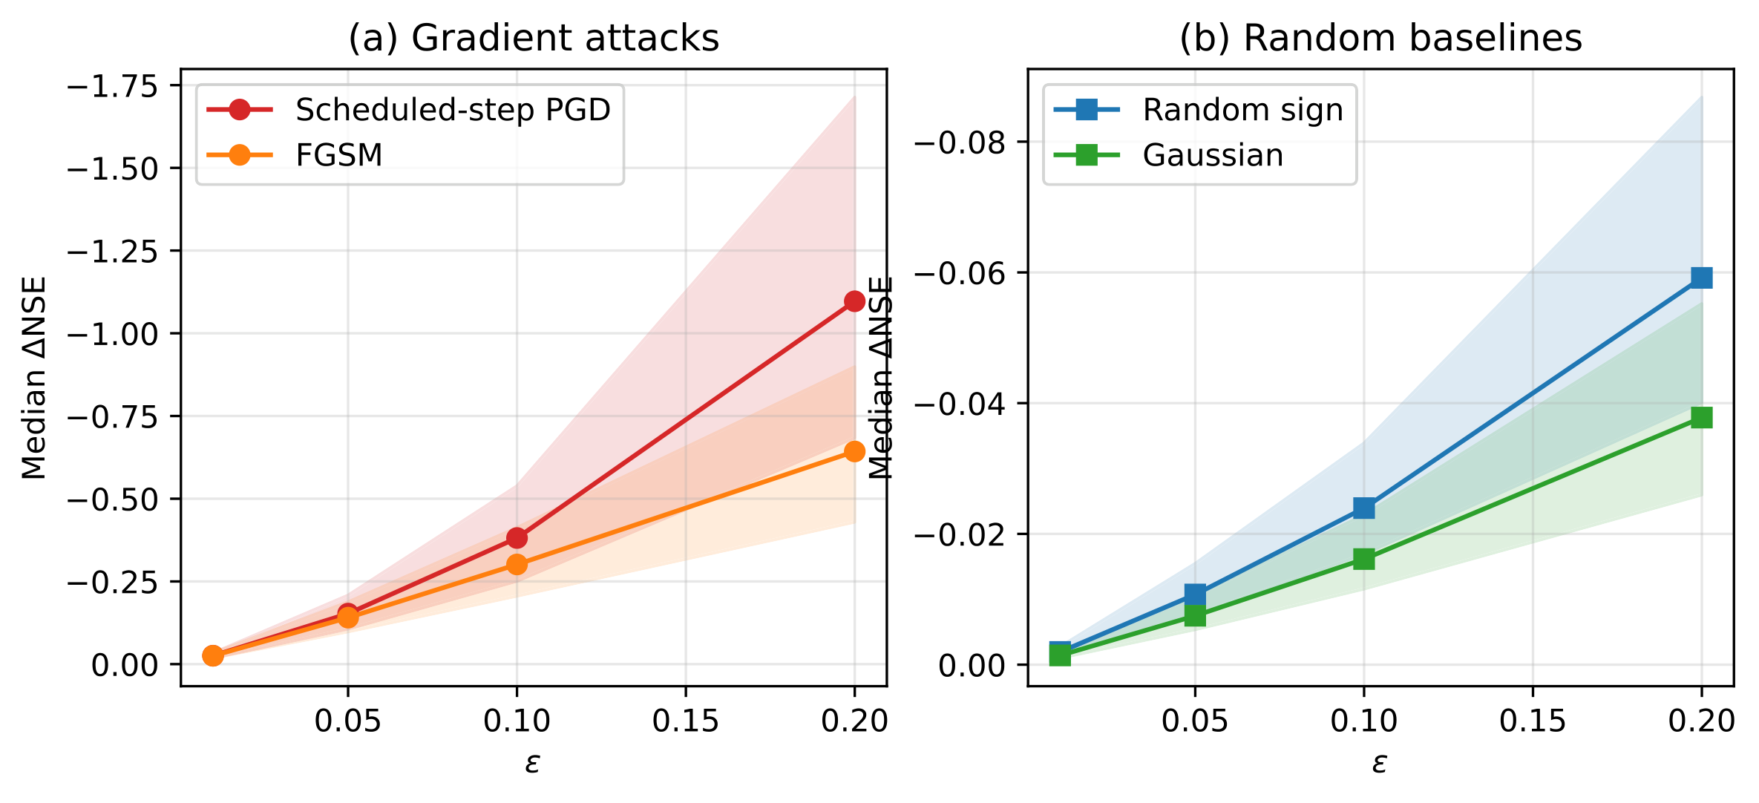
Median $Δ$NSE as a function of $ε$ for the gradient attacks and the random baselines, with IQR shown as shaded bands. (a) Adversarial attacks: scheduled-step PGD and FGSM. (b) Random-noise baselines. Note the different $y$-axis scales between panels.
At $ε=0.1$, the median $Δ$NSE under scheduled-step PGD is $−0.381$, against $−0.301$ for FGSM and $−0.024$ for random sign. Both random baselines are an order of magnitude weaker than either gradient method (random sign $−0.024$, Gaussian $−0.016$), and they differ from each other by far less than either differs from the gradient attacks, confirming that the dominant factor distinguishing methods is the use of gradient information rather than where in the budget a model-blind perturbation places its energy. The PGD-to-random-sign ratio at $ε=0.1$ is 15.9$×$, more than an order of magnitude larger than the PGD-to-FGSM ratio of 1.27$×$. The ratio of medians and the median of per-basin ratios agree to within one unit, and scheduled-step PGD exceeds random sign for every one of the 531 basins at every budget (Wilcoxon signed-rank $p<{10}^{−80}$, one-sided, across 531 basins).
The PGD-to-FGSM ratio grows monotonically with $ε$: 1.01$×$ at $ε=0.01$, 1.09$×$ at $ε=0.05$, 1.27$×$ at $ε=0.1$, and 1.71$×$ at $ε=0.2$ (Figure 1). At small budgets the model’s response is approximately linear within the $ε$ neighborhood, so a single gradient step nearly saturates the achievable damage; at larger budgets the response curves away from this approximation, and iterative refinement uncovers worse forcing-error patterns than the single-step probe. The PGD-to-random-sign ratio also grows with $ε$ (13.2$×$, 14.2$×$, 15.9$×$, 18.5$×$), so random-noise sensitivity analysis underestimates worst-case vulnerability most severely at the budgets that matter most for stress testing.

3.1.1 Distribution-Level View at $ε=0.1$
Figure 2 shows the per-basin distribution of $Δ$NSE under scheduled-step PGD at $ε=0.1$. The distribution is right-skewed: the 10th percentile is $−0.755$, the median is $−0.381$, and the 90th percentile is $−0.179$. The distance between the 10th percentile and the median ($0.37$) is about twice the distance between the median and the 90th percentile ($0.20$), so the median statistic alone hides a tail of more severely vulnerable basins.
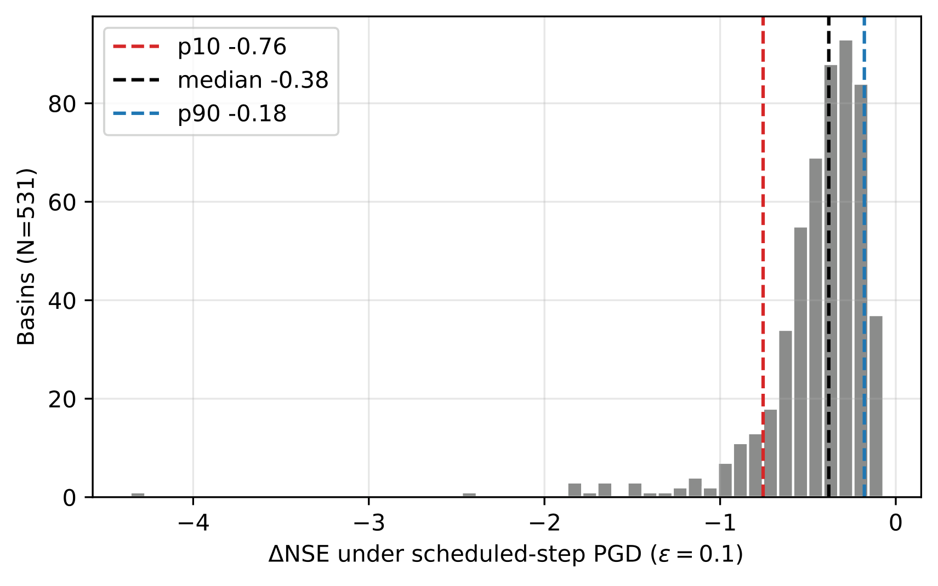
Distribution of per-catchment $Δ$NSE under scheduled-step PGD at $ε=0.1$ ($N=531$ basins). Dashed lines mark the 10th percentile ($−0.76$), median ($−0.38$), and 90th percentile ($−0.18$).
The size of this tail differs sharply across attack types. The fraction of basins with adversarial NSE below zero is 15.4% (82 of 531) under scheduled-step PGD, 9.4% (50) under FGSM, and 0.6% (3) under Gaussian noise. Under the stricter $Δ$NSE $<−1$ threshold, scheduled-step PGD produces severe degradation in 25 of 531 basins (4.7%). Even single-step FGSM identifies an at-risk population an order of magnitude larger than random noise. The below-zero fraction is, however, strongly skill-dependent: it ranges from 78.6% among the 14 basins with clean NSE below 0.3 to 2.8% among the 143 basins with clean NSE above 0.8. The gradient-versus-random ratio, by contrast, is stable across skill levels (9.7$×$ to 16.2$×$ across clean-NSE bins, and 15.4$×$ even among the most skillful basins), so the conclusion that gradient attacks far exceed random noise is not an artifact of a few low-skill catchments. We therefore report median $Δ$NSE, not the below-zero fraction, as the headline statistic.

3.2 Damage Varies Systematically with Catchment Character
The per-basin damage is not hydrologically random. No catchment class escapes: the median $Δ$NSE under scheduled-step PGD at $ε=0.1$ is $−0.38$ across all 531 basins, and even the most robust class—the 31 rain-driven, flashy catchments (flow-duration-curve slope above 2)—still loses a median of $0.27$. But severity varies systematically with catchment character. Relating per-basin damage to CAMELS catchment attributes (Addor et al. 2017), the single strongest predictor is the snow fraction of precipitation: more snow-influenced catchments are more vulnerable (Spearman $ρ=0.52$), and the association strengthens after partialling out clean-data skill ($ρ=0.61$ controlling for clean NSE, $p<{10}^{−50}$, $N=531$; Figure 3). Snow-influenced catchments (snow fraction above 0.2, $N=152$) thus combine high clean skill with high adversarial damage: median clean NSE 0.77 versus 0.72 elsewhere, yet median $Δ$NSE $−0.51$ versus $−0.32$. The damage is not a restatement of low skill—the raw damage–skill correlation is only $−0.26$ and the snow association survives controlling for it. A gradient of storage-related attributes accompanies it: damage rises with mean half-flow date, elevation, and baseflow index, and falls with mean precipitation (all $\left|ρ\right|>0.27$ after skill control), consistent with sensitivity along storage-release and snowmelt-related forcing pathways. We do not read the damage magnitude as a surprising fragility—much of it tracks the model’s larger input gradient in these catchments—and instead ask, next, which forcing the model depends on and whether the attack exploits it, using an optimizer-free occlusion analysis and a per-channel attack attribution.
A second, weaker regularity runs from wet to dry, already visible in attenuated form in the precipitation term above. With snow fraction and clean skill both controlled, damage rises toward the dry, low-yield end of the attribute space: the partial Spearman correlation of damage is $+0.18$ with aridity (the ratio of mean potential evapotranspiration to precipitation, so that larger values are drier), $−0.26$ with mean precipitation, $−0.25$ with runoff ratio, and $−0.28$ with mean specific discharge (the area-normalized mean daily flow in mm day$​^{−1}$; all $p<5×{10}^{−5}$, $N=531$). The mean-precipitation term is weaker here than it appears above because part of it was snow-mediated: its partial correlation with damage falls from $−0.37$ under skill control alone to $−0.26$ once snow fraction is also held fixed. We deliberately do not read the residual gradient as a second, drought-specific mechanism, for two reasons. First, the climate and flow-magnitude descriptors involved are mutually correlated ($\left|ρ\right|=0.60$–$0.94$ among aridity, mean precipitation, runoff ratio, and mean specific discharge), and additionally conditioning on mean specific discharge flips the aridity partial from $+0.18$ to $−0.13$: in this design, climatic dryness cannot be separated from the small mean flows of dryland rivers—and from the correspondingly small variance of observed flow, which forms the denominator of the Nash–Sutcliffe efficiency and makes a given absolute error cost more NSE in a low-mean-flow river. Second, unlike snow, the dry end shows no distinctive attack signature (Section 3.3). We therefore report the wet–dry gradient as a consistent descriptive feature of this correlated climate–flow-magnitude axis and reserve the mechanistic claim for the snow regime (full statistics and identifiability checks in Text S4 and Table S4).
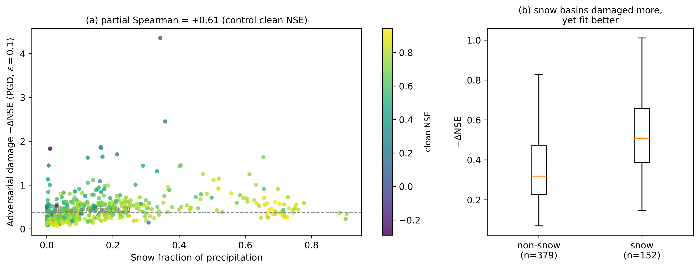
Adversarial damage ($−Δ$NSE, scheduled-step PGD, $ε=0.1$) versus snow fraction across the 531 basins. (a) Per-basin damage rises with snow fraction; points colored by clean NSE, dashed line at the all-basin median. Partial Spearman $ρ=0.61$ after controlling for clean NSE. (b) Snow-dominated catchments (snow fraction above 0.2) are damaged more than the rest, despite being fit better on clean data.

3.3 Which Forcing the Attack Exploits, and What It Does to the Hydrograph
If the failures are hydrologically structured, the attack should exploit the forcing the model most depends on in each regime. We test this on the 107-basin subset with two diagnostics of the untargeted attack at $ε=0.1$: a per-forcing-variable attribution of the achieved perturbation, and its effect on the predicted flood hydrograph.
Attribution. We quantify how much of the adversarial damage each forcing channel carries by a leave-one-out measure: zeroing the achieved perturbation on one channel and re-evaluating the loss (temperature is treated as the single tied degree of freedom of the Maurer product). The channel attribution shifts systematically with snow regime (Figure 4a). In rain-dominated catchments precipitation dominates: it carries a median 46% of the damage against 31% for temperature, and temperature is the leading channel in only 6 of 71 basins. In snow-influenced catchments the temperature channel gains leverage—its absolute leave-one-out attribution more than doubles (median 0.27 versus 0.11 for rain basins), while precipitation’s absolute attribution is unchanged across regimes (0.21 versus 0.21). Temperature thereby rises to co-dominance in snow catchments (median share 0.45 versus 0.35 for precipitation) and is the leading channel in 23 of 36 of them. The temperature share rises with snow fraction at a partial Spearman correlation of $+0.68$ (controlling for clean NSE, $p<{10}^{−15}$, $N=107$). Because it is temperature gaining absolute leverage rather than precipitation losing it, the shift is not an artifact of the share normalization. Snow fraction is collinear with elevation and slope in CAMELS ($ρ=0.70$ and $0.60$), so the association attenuates but survives when elevation is held fixed ($+0.39$, $p<{10}^{−4}$); we therefore read it as a snow-regime—physically, a snowmelt-temperature—effect that cannot be cleanly separated from the cold, high, steep character of these catchments.
Hydrological consequence. We next compare the clean and adversarial predictions around each observed flood peak (Figure 4b). The untargeted attack suppresses the predicted peak magnitude for the median basin by 11%, and about $2.4×$ more strongly in snow-influenced catchments ($−18\%$) than in rain-dominated ones ($−7\%$); this snow enhancement survives controlling for overall NSE damage (partial Spearman $−0.24$, $p=0.01$). Suppression is the majority but not the universal response: 74 of 107 basins have their peaks damped (86% of snow basins against 61% of rain basins), while 33 have them amplified. The attack largely rescales peaks rather than relocating them—for 79% of peaks the predicted timing is unchanged and the local clean-versus-adversarial hydrograph-shape correlation exceeds 0.97—but the exception is telling: the 9 basins whose predicted peak timing does shift, by a median of 1–5 days, are all snow-influenced, the catchments where the attack can move the melt-driven peak as well as damp it. A minor water-balance signature accompanies this: the attack lifts the median water-year runoff coefficient from 0.37 to 0.44 and pushes a small fraction of snow-catchment water-years past the physical ceiling of unity (5% under attack versus 2% clean). This last effect is confined to catchments whose water balance already sits near that ceiling and is best read as tipping borderline balances over the line rather than manufacturing large volumes of water; it is reported with that caveat.
Both diagnostics single out the snow regime. Along the wet–dry gradient of Section 3.2 the attack does not shift its leverage between forcings: the precipitation share of the damage in the driest non-snow catchments (aridity above 1.5, $N=7$) is indistinguishable from that in the remaining non-snow basins ($N=64$; median 0.46 versus 0.46), though the share does tend to rise with aridity across the non-snow population (partial Spearman $+0.36$ controlling for snow fraction and clean skill, $p=2×{10}^{−3}$, $N=71$). Within that non-snow population we likewise find no significant differential flood-peak signature (peak-magnitude partial $−0.20$, $p=0.09$, $N=71$); a low-flow-specific signature is inconclusive, the low-flow-targeted damage share being if anything relatively smaller toward the dry end. Two limits bound these nulls: the subset contains only seven dry non-snow basins, so only very large contrasts would be detectable, and low-flow diagnostics are intrinsically weak in intermittent rivers, where an NSE-based damage measure assigns low-flow days negligible weight. Snow-influenced catchments remain the only regime in which the attack demonstrably re-aims its perturbation.
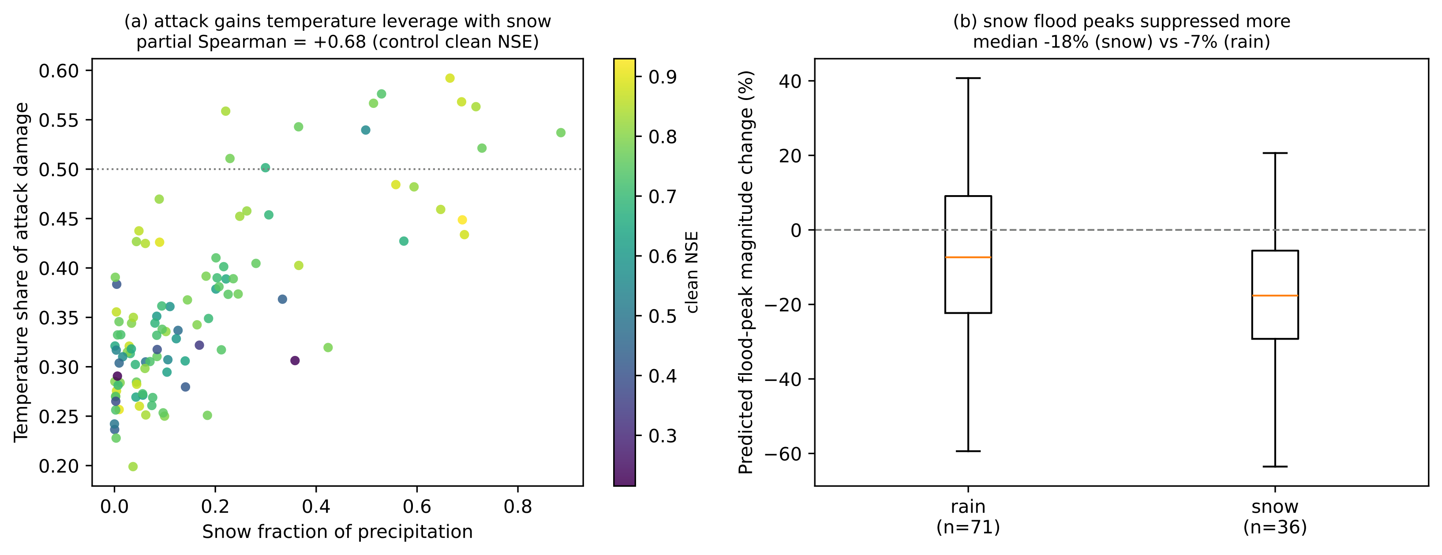
Process attribution and hydrological consequence of the untargeted attack at $ε=0.1$ (107-basin subset). (a) Share of adversarial damage carried by the temperature channel (leave-one-out attribution) versus snow fraction; points colored by clean NSE. Temperature gains leverage with snow (partial Spearman $+0.68$, controlling for clean NSE). (b) Change in predicted flood-peak magnitude, rain versus snow catchments; snow flood peaks are suppressed about $2.4×$ more strongly (median $−18\%$ versus $−7\%$).

3.4 What the Model Depends On: An Optimizer-Free View
The attack attribution above is gradient-based, so it could in principle reflect the optimizer rather than the model, and it is computed on the 107-basin subset. We therefore measure the model’s input dependence directly, without any attack, on all 531 basins. For each basin and each forcing channel we replace that channel’s test-period series with a temporally permuted version of itself—preserving its marginal distribution but destroying its timing—and record the resulting drop in test-period NSE, averaged over three permutations (temperature, tied across $T_{min}$ and $T_{max}$, is permuted as one channel). The drop measures how much the model’s skill relies on that channel’s temporal information; normalizing the four channel drops to sum to one gives a per-basin dependence share, and the drop when all forcing is permuted (total dependence) measures the model’s overall reliance on the forcing sequence. This is a forward-pass diagnostic that uses no gradient and no adversarial optimization; observed streamflow enters only to score the drop in prediction skill.
The model’s learned forcing dependence reorganizes systematically across catchments. The temperature-dependence share rises steeply with snow fraction: the partial rank correlation of the temperature share with snow fraction is $+0.84$ ($p<{10}^{−140}$, $N=531$) after controlling for clean NSE and total dependence, and it holds within both humid and arid subsets ($+0.87$ and $+0.64$, same control set). Grouped for illustration at a snow-fraction threshold of 0.2, the median temperature share rises from 0.15 in the 379 low-snow basins to 0.54 in the 152 snow-influenced ones, while the precipitation share falls symmetrically (0.80 to 0.38). This is a compositional shift—which forcing the model uses—and it is nearly orthogonal to how much the model uses forcing at all (Spearman between temperature share and total dependence $+0.09$). Total dependence instead falls along the wet–dry gradient (partial Spearman with aridity $−0.55$, controlling snow fraction and clean NSE, $N=531$): the 43 driest non-snow basins (aridity above 1.5) lose a median of only 0.57 in NSE when all forcing is permuted, against about 1.0 in humid and snow basins, consistent with reduced reliance on the forcing sequence there. We report this arid contrast as a descriptive observation only: it coincides with low clean skill (median NSE 0.50) and cannot be cleanly separated from the smaller Nash–Sutcliffe denominator at low mean flow. Crucially, the optimizer-free temperature share agrees with the gradient-based attack attribution of Section 3.3 (Spearman $+0.56$, $p<{10}^{−9}$): the attack concentrates on the same channels the model actually depends on. We read this as evidence that the failure modes are hydrologically interpretable—the model’s learned reliances follow the physically dominant control on runoff in each regime—and, consistent with textbook temperature-index snow hydrology, not as a newly discovered mechanism.

3.5 Statistically Constrained Perturbations Remain Effective
Table 4 presents the constraint-ablation results for scheduled-step PGD under the three plausibility levels. The physical constraint (non-negative precipitation, bounded temperatures and radiation) reduces median degradation by only about 3% relative to the magnitude-only baseline at $ε=0.1$ (from $−0.383$ to $−0.372$), indicating that the most damaging adversarial forcing patterns are often already physically plausible: forcing the model into worst-case behavior does not require negative precipitation or unrealistic temperatures.
The statistical constraint, which additionally requires the perturbed forcing to preserve the per-variable whole-period mean and standard deviation of the clean series, reduces median degradation by 22% (to $−0.299$ at $ε=0.1$), so it still retains 78% of the unconstrained damage. The reduction is modest because the constraint pins only the whole-period mean and standard deviation: within the 270-day windows that the recurrent model actually consumes, the perturbation can still redistribute local mean and variance, and it remains free to alter temporal ordering and cross-variable structure.
Constraint | $N$ | $ε=0.05$ | $ε=0.1$ | $ε=0.2$
Magnitude | 107 | $−$0.156 ($−$0.172) | $−$0.383 ($−$0.448) | $−$1.095 ($−$1.602)
Physical | 107 | $−$0.145 ($−$0.164) | $−$0.372 ($−$0.429) | $−$1.050 ($−$1.565)
Statistical | 107 | $−$0.128 ($−$0.139) | $−$0.299 ($−$0.333) | $−$0.736 ($−$0.887)
The residual degradation under the statistical constraint is operationally significant and grows with $ε$: from $−0.128$ at $ε=0.05$ to $−0.299$ at $ε=0.1$ to $−0.736$ at $ε=0.2$. The ratio of statistical-constraint to magnitude-only degradation stays near $0.7$–$0.8$ across budgets. The practical implication is direct: forcing data that passes a quality-control screen checking only the climatological mean and standard deviation of each variable can still contain structured errors that substantially degrade model performance. Mean-and-standard-deviation checks alone therefore cannot rule out harmful forcing-error patterns within an observation-error-scale budget.

3.6 Targeted Attacks and Pre-Event Vulnerability
Table 5 presents the results of targeted attacks. Flood-targeted attacks produce degradation comparable to, though slightly less than, untargeted attacks, while low-flow-targeted attacks are much weaker. The flood/low-flow contrast is about 6.8:1 by median $Δ$NSE, indicating that vulnerability is concentrated in high-flow regimes; the same ordering holds in $Δ$KGE.
Target | $N$ | Median $Δ$NSE [IQR] | Median $Δ$KGE [IQR]
Untargeted | 107 | $−$0.383 [$−$0.551, $−$0.241] | $−$0.155 [$−$0.231, $−$0.091]
Flood | 107 | $−$0.322 [$−$0.478, $−$0.225] | $−$0.149 [$−$0.216, $−$0.094]
Low-flow | 107 | $−$0.048 [$−$0.079, $−$0.016] | $−$0.016 [$−$0.055, $+$0.018]
Figure 5 shows the causal-trigger results. Restricting perturbations to progressively longer pre-event windows yields a monotonic increase in damage. Measured on the flood-peak predictions alone, the median $Δ{NSE}_{peak}$ grows from $−0.077$ for a 1-day pre-event window to $−0.148$ (3 days), $−0.229$ (7 days), and $−0.331$ (14 days): perturbing only the fourteen days before each flood peak degrades the peak-flow predictions by a third of an NSE unit. Measured on the overall test-period NSE, the same restricted attacks cause median $Δ{NSE}_{overall}$ of $−0.014$, $−0.029$, $−0.049$, and $−0.075$, so pre-event windows alone recover roughly a fifth of the unrestricted overall degradation. Both views identify the days immediately before flood peaks, the operationally critical forecasting window, as disproportionately consequential.
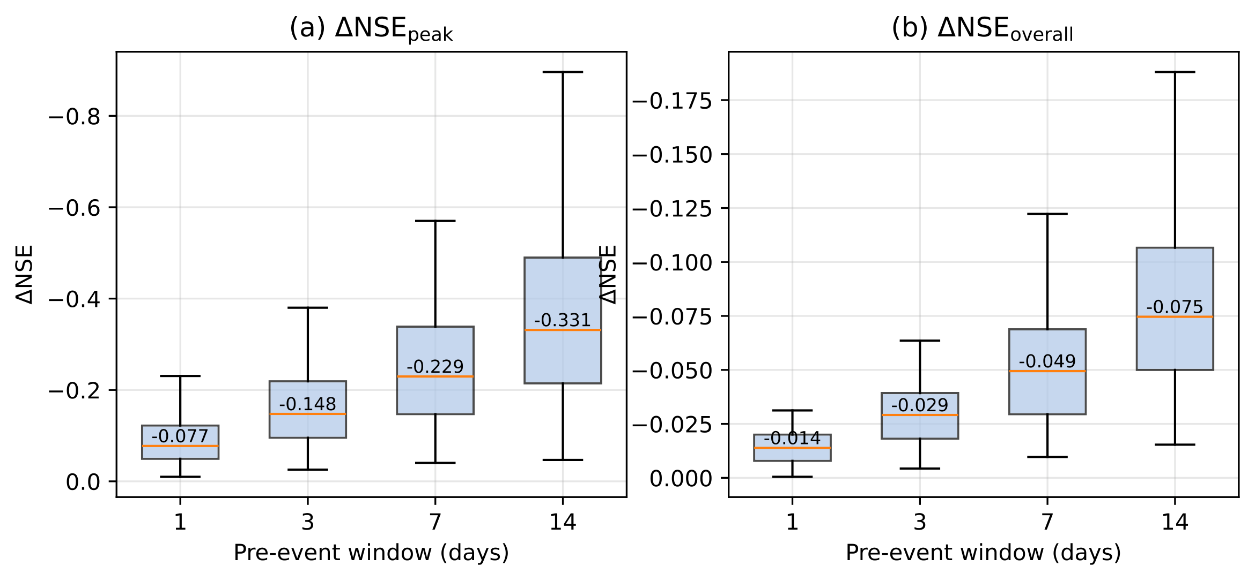
Causal trigger: pre-event window length versus $Δ$NSE ($ε=0.1$), measured on the flood-peak predictions ($Δ{NSE}_{peak}$) and on the overall test-period NSE ($Δ{NSE}_{overall}$). Box plots over the 107-basin subset; median values are annotated.

3.7 Safety Margins and Detectability
Two complementary analyses characterize how silently the model can be degraded: the minimum perturbation required to break it, and the detectability of harmful perturbations under standard distribution tests on the forcings.
The minimum-perturbation analysis identifies, for each basin, the smallest $L_{2}$ perturbation that drives test-period NSE below zero (Figure 6). Of 76 basins evaluated, 62 (82%) could be broken within the search budget, with a median minimum $L_{2}$ of 5.27 standardized units [Q25 4.14, Q75 6.09]. Because this $L_{2}$ is summed over the whole perturbed forcing series (about $1.6×{10}^{4}$ effective timestep–feature components), it corresponds to a small per-component perturbation, of order $0.04$ standardized units root-mean-square; a coordinated perturbation far below the per-component $ε$ budget is sufficient to break a majority of basins. The 14 basins not broken within the budget have wider safety margins, generally the more skillful catchments.
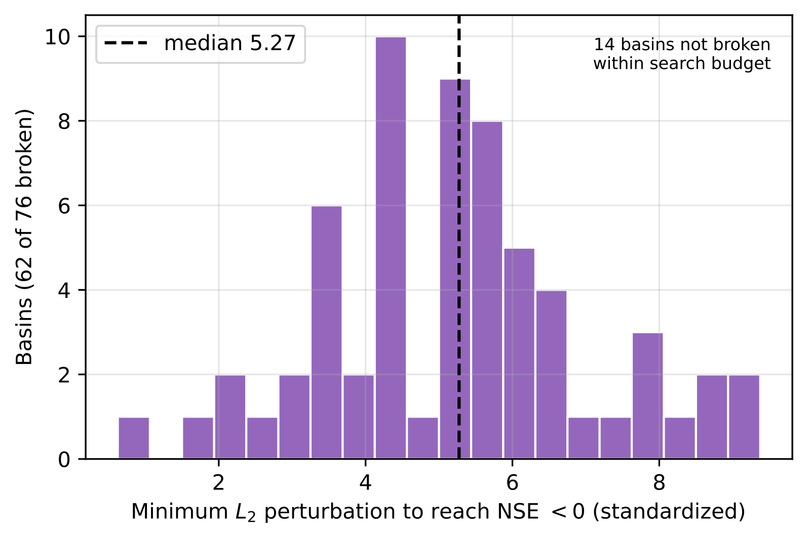
Distribution of the minimum $L_{2}$ perturbation required to reduce NSE below zero, over the 76-basin subset. 62 of 76 basins are breakable within the search budget; the 14 unbroken basins are annotated.
Detectability is assessed by a Kolmogorov–Smirnov (KS) two-sample test between the clean and perturbed whole-period marginal of each forcing variable for the magnitude-constrained adversary, paired with the achieved $\left|ΔNSE\right|$ (Figure 7). Here the result is unambiguous in the opposite direction from a naive expectation: the unconstrained adversarial perturbation shifts the marginal of every forcing variable enough that the KS test rejects equality of distributions for all 107 basins (smallest-feature $p<{10}^{−50}$ in every case), even though most of these same perturbations are physically plausible (Section 3.5). A whole-period distributional QC therefore would flag the unconstrained attack. The vulnerability that survives quality control is not the unconstrained attack but the attack that preserves the checked mean and standard deviation: by construction the statistical-constraint adversary leaves each feature’s mean and standard deviation unchanged, so a mean-and-standard-deviation screen cannot see it, yet it still retains 78% of the damage (Section 3.5). The operationally relevant gap is thus between checks based only on mean and standard deviation, which this constrained adversary evades by design, and full-distribution monitoring, which catches the unconstrained attack.
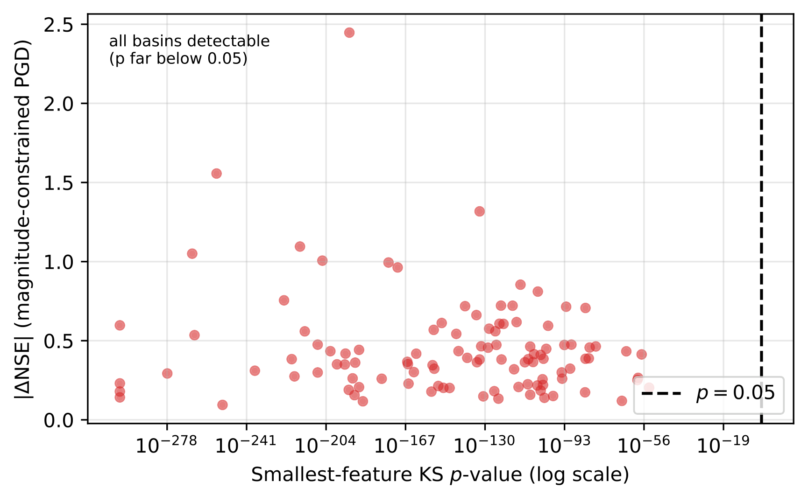
Attack effectiveness ($\left|ΔNSE\right|$, magnitude-constrained scheduled-step PGD) versus statistical detectability (smallest-feature KS $p$-value) at $ε=0.1$. Every basin falls far to the detectable side of $p=0.05$ (red dashed line); the unconstrained attack is statistically conspicuous even where it is most damaging.
The two analyses together delineate where input-side defenses can and cannot help. An unconstrained adversarial perturbation is damaging but statistically conspicuous, so a distributional QC on the forcings is a meaningful defense against it. A perturbation that preserves those checked statistics is, by construction, invisible to checks based only on the mean and standard deviation of each feature, while retaining most of the damage; detecting it would require diagnostics that go beyond the feature-marginal mean and standard deviation, such as temporal autocorrelation checks, cross-feature consistency tests, or residual checks on the predicted streamflow against an independent reference.

4 Discussion

4.1 Relation to Prior Adversarial Assessment of Hydrological LSTMs
The closest precedent for this study is the FGSM-based robustness analysis of Yang et al. (2026), who applied single-step adversarial perturbations to LSTM and HBV models across 1,347 CAMELS-DE catchments and reported that LSTMs were more robust than HBV, that catastrophic failure was rare, and that model responses scaled approximately linearly with perturbation magnitude. Our CAMELS-US results qualify rather than contradict that picture, and the comparison is necessarily qualitative: the two studies differ in dataset (US vs. DE), attack (iterative scheduled-step PGD vs. single-step FGSM), budget, and metric, so we draw only direction-of-effect comparisons and avoid cross-dataset fragility rankings.
Two of the three qualitative claims of Yang et al. (2026) are reproduced here. Random noise remains a much weaker probe than gradient-based attack, and the response to single-step FGSM is approximately monotonic in $ε$ across our budget range. The claim most sensitive to method choice is the third. On our victim, the iterative attack roughly doubles the FGSM degradation at the largest budget (PGD-to-FGSM ratio rising to 1.71$×$ at $ε=0.2$), so the severity of degradation, though not its qualitative existence, depends on whether an iterative method is used. This is consistent with the broader adversarial machine-learning literature, in which single-step methods systematically overestimate robustness (Carlini et al. 2019); our results transpose that pattern from image classification to a regression task on physical time series. We also note that our attack is, if anything, a conservative iterative method (no momentum, single restart), so the gap we report is a lower bound on what a stronger iterative attack could reveal.
A complementary comparison uses the Kling–Gupta Efficiency that Yang et al. (2026) reported. On our victim, the untargeted iterative attack at $ε=0.1$ produces a median $Δ$KGE of $−0.155$ from a clean median KGE of 0.773, a relative degradation of about 20%. This is comparable to, if anything larger than, the relative KGE degradation in Yang et al. (2026), despite our using a smaller normalized budget and an attack optimized for NSE rather than KGE. We treat this as a qualitative reference only, given the stacked differences in dataset, budget, attack, and target metric; it should not be read as a quantitative cross-dataset fragility ranking.

4.2 Mechanisms Underlying the Attack-Method Hierarchy
The hierarchy among the methods at $ε=0.1$—scheduled-step PGD ahead of FGSM, with the random baselines an order of magnitude behind—admits a unified explanation. Random methods perturb each timestep and forcing variable independently and are exponentially unlikely to align with the directions of greatest model sensitivity; a best-of-$K$ random search closes this gap only as $\sqrt{lnK}$, so even extrapolating the random baseline to $K={10}^{9}$ samples leaves scheduled-step PGD about seven times more damaging (Supporting Information). FGSM uses the gradient at the clean operating point to identify an aligned direction but takes only one step, so where the model’s response curves within the $ε$ neighborhood, this direction is no longer the worst attainable. Scheduled-step PGD tracks the curvature iteratively.
The adversarial-to-random gap (15.9$×$ at $ε=0.1$) far exceeds the FGSM-to-PGD gap (1.27$×$), revealing the relative importance of the two methodological refinements: using gradient information at all matters far more than refining how that gradient is followed. The corresponding recommendation is asymmetric: a single-step gradient-based attack should be a minimum requirement for any future hydrological robustness assessment, whereas iterative refinement is the natural gold standard for deployment-grade evaluations.
The constraint-ablation experiment provides a further mechanistic clue, but it must be read carefully. Pinning each feature’s whole-period mean and standard deviation removes only about a fifth of the damage, so most of the harmful signal does not live in those two whole-period statistics. It is carried instead by structure those statistics do not constrain: within-window redistribution of local mean and variance, temporal ordering of wet and dry days, and cross-variable correlations, all of which the recurrent state is sensitive to. We emphasize that preserving the whole-period mean and standard deviation is a weaker constraint than preserving them in every input window; a constraint that pinned the same statistics for every input window would remove more damage, and our result bounds only what the whole-period version leaves available.

4.3 The Failure Modes Are Hydrologically Interpretable
The catchment-attribute, occlusion, and channel-attribution analyses together turn the attack into a probe of the model’s learned input dependence, and the picture is process-consistent rather than random. The optimizer-free occlusion analysis (Section 3.4) shows that the model’s forcing dependence reorganizes with catchment type—precipitation-dominated where streamflow follows storms, temperature-dominated where it follows snowmelt—and the adversarial attack concentrates on the same channels: in snow catchments it shifts its leverage onto the temperature forcing that drives snowmelt and preferentially suppresses, and in the snowiest basins retimes, the melt-driven flood peaks. The model’s weak points therefore fall on the forcings and events each catchment’s streamflow physically depends on, not at random—which is what makes the vulnerability a hydrological rather than a purely numerical concern. We deliberately do not read the damage magnitude across catchments as a distinct fragility mechanism: it largely tracks the size of the model’s input gradient, which is greatest where discharge integrates the most forcing, so “most fragile where the fit is best” is close to a restatement of that gradient rather than an independent finding. Nor do we claim to observe the internal integration itself: the occlusion and attribution results are input–output measurements, consistent with sensitivity along storage-release and snowmelt-related pathways but not a direct probe of the recurrent state. The weaker wet–dry regularity of Section 3.2—lower overall input dependence in arid basins—cannot be disentangled from mean specific discharge and the smaller Nash–Sutcliffe denominator at low mean flow, and we report it only as a descriptive observation.

4.4 Implications for Operational Hydrological Deployment
These findings should not be read as evidence against operational deployment of LSTM rainfall-runoff models. The adversarial perturbations are diagnostic rather than predictive: they test whether harmful error structures exist within observation-error-scale uncertainty budgets, not whether those exact perturbations are likely to occur. A model that fails under such constrained stress tests cannot, however, be assumed robust on the basis of average-case random-noise experiments alone, because the stress test reveals harm that the random analysis is structurally unable to find.
A first implication concerns reporting conventions. We suggest that an adversarial $Δ$NSE at $ε=0.1$ accompany clean-data skill summaries whenever a model is proposed for operational use. The marginal cost is modest—a single iterative pass per catchment over the test period—and the diagnostic power is qualitatively beyond what random-noise sensitivity analysis provides. This complements, rather than replaces, the uncertainty-quantification and reliability diagnostics increasingly reported for hydrological deep-learning models (Klotz et al. 2022; Frame et al. 2022; Lees et al. 2021).
A second implication concerns input quality control. Marginal range, mean, and variance checks against climatology are a common first-line screen for meteorological forcing, so a blind spot in such checks is of practical concern; we emphasize, however, that the blind spot is specific to screening based on these marginal statistics—operational pipelines that already include higher-order or cross-variable diagnostics would narrow it. Mean-and-variance checks are well-suited to detecting gross sensor failure, and our detectability analysis shows that distributional screening would also flag an unconstrained adversarial perturbation, which shifts the forcing marginals conspicuously. Their blind spot is the perturbation that preserves the checked statistics, which by construction leaves those statistics unchanged while retaining most of the damage. Closing that blind spot requires higher-order input validation—temporal autocorrelation checks, cross-feature consistency tests, or model-side reconstruction residuals—rather than feature-marginal checks alone.
A third implication concerns the temporal structure of forecasting risk. The causal-trigger experiment shows that perturbations restricted to the fourteen days before a flood peak degrade the peak-flow predictions by a median of 0.33 NSE units and recover about a fifth of the unrestricted overall degradation. In operational flood forecasting this is precisely the window in which input data are most consequential and most often degraded by sensor failure or telemetry latency. Robustness budgets and data-quality monitoring should therefore be tightened around such pre-event windows rather than applied uniformly across the record.

4.5 Caveats and Avenues for Future Work
Several caveats bound the generality of these conclusions. The victim model is a single-layer LSTM with 256 hidden units and a fixed set of 27 static catchment attributes. Entity-aware LSTMs, sequence Transformers, and state-space architectures such as Mamba may interact with adversarial perturbations differently; a systematic architectural sweep on the same 531-basin benchmark is the natural next step. The dataset is CAMELS-US at daily resolution with the Maurer forcing, in which the minimum and maximum temperature inputs are identical; sub-daily datasets, other forcings, and non-CONUS hydroclimates may shift both the median and the tail of the vulnerability distribution. Our iterative attack is deliberately conservative (no momentum, single restart), so the degradations we report are lower bounds on what a stronger attack could achieve.
Defense strategies were intentionally outside the scope of this study. Adversarial training, ensemble averaging across model seeds, and input-side denoising each make a different methodological commitment, and a rigorous evaluation of these strategies—ideally against the same multi-level stress test rather than against FGSM alone—is a natural follow-up. The fact that statistically constrained perturbations retain most of the unconstrained damage suggests that input-side denoising is unlikely to suffice on its own.
A final interpretive caveat is the diagnostic-not-predictive framing noted above. The adversarial perturbations provide a worst-case bound within an observation-error-scale budget; they do not estimate the empirical frequency of such forcing-error patterns. Their magnitude, however, is realistic. Comparing the $ε=0.1$ budget to the day-to-day disagreement among the Daymet, Maurer, and NLDAS forcing products over the same 531 basins and test period, the precipitation perturbation ($±0.70$ mm/day) is only 0.45 times the median inter-product spread (1.57 mm/day), and the temperature perturbation ($±1.07 ^{∘}$C) is comparable to it (1.36 times the $0.79 ^{∘}$C spread); the three products’ daily range exceeds the budget on 52% of days for precipitation and 70% for temperature. Errors of this size are therefore routine in real gridded forcing. What is not realistic is their structure: the damage comes from the adversarial temporal coordination of these individually plausible errors, which ordinary product disagreement does not supply. Closing the remaining gap would require coupling the attack to a calibrated input-error model or comparing the adversarial $Δ$NSE distribution to that induced by historical input-error events; both are open directions.

5 Conclusions
We investigated how the choice of perturbation method affects adversarial robustness conclusions for a standard LSTM rainfall-runoff configuration, evaluating methods spanning the spectrum from random noise to iterative gradient-based optimization across the 531-basin CAMELS-US benchmark. The experiments support five principal findings. First, attack-method choice is decisive: iterative adversarial perturbations produce a median degradation about sixteen times that of structure-matched random noise of comparable sampling budget at $ε=0.1$, and even single-step FGSM, while weaker than the iterative attack at larger budgets, far exceeds any random baseline. Second, the gradient-versus-random gap is not a low-skill artifact: it is stable across clean-skill levels and remains about fifteenfold (15.4$×$) even among the most skillful catchments, while the below-zero failure fraction (15.4% of basins at $ε=0.1$) is strongly skill-dependent and is reported only as a secondary statistic. Third, perturbations that preserve the per-variable mean and standard deviation of the forcing retain 78% of the unconstrained damage while evading checks based only on those statistics, indicating that mean-and-standard-deviation screening alone is insufficient to rule out harmful forcing patterns. Fourth, pre-event data quality is disproportionately important: perturbations confined to the fourteen days preceding a flood peak degrade the peak-flow predictions by a median of 0.33 NSE units, in the operational forecasting window where input data are most consequential and most often degraded. Fifth, the failures are hydrologically structured rather than random: an optimizer-free occlusion analysis shows that the model’s forcing dependence reorganizes across catchments—precipitation-dominated in rain basins, temperature-dominated in snow basins—and the attack concentrates on the same broad channels, suppressing melt-driven flood peaks about twice as strongly in snow catchments as in rain catchments. Snow-influenced basins combine high clean skill with high adversarial damage, so clean-data skill alone is not a reliable indicator of robustness; we attribute the elevated damage magnitude there mainly to the model’s larger input gradient rather than to a distinct snowmelt-fragility mechanism.
Taken together, these findings indicate that robustness assessment for standard hydrological deep-learning configurations requires multi-level stress testing that extends beyond random noise and single-step adversarial probes. We recommend iterative adversarial evaluation at observation-error-scale budgets as a standard diagnostic component of hydrological stress-testing workflows. Broader architectural generalization, evaluation of defense strategies, and the coupling of adversarial bounds to calibrated forcing-error models remain natural follow-ups.

Open Research
All code for adversarial attacks, evaluation, and analysis is available at https://github.com/[repository]. The LSTM model was trained using the open-source neuralhydrology framework (Kratzert et al. 2022). CAMELS-US data are publicly available from the USGS (Newman et al. 2015; Addor et al. 2017).

Acknowledgments
[Acknowledgments to be added.]

References
Addor, Nans, Andrew J Newman, Naoki Mizukami, and Martyn P Clark. 2017. “The CAMELS Data Set: Catchment Attributes and Meteorology for Large-Sample Studies.” Hydrology and Earth System Sciences 21 (10): 5293–313.
Beven, Keith. 2006. “A Manifesto for the Equifinality Thesis.” Journal of Hydrology 320 (1–2): 18–36.
Carlini, Nicholas, Anish Athalye, Nicolas Papernot, Wieland Brendel, Jonas Rauber, Dimitris Tsipras, Ian Goodfellow, Aleksander Madry, and Alexey Kurakin. 2019. “On Evaluating Adversarial Robustness.” arXiv Preprint arXiv:1902.06705.
Clark, Martyn P, Andrew G Slater, David E Rupp, Ross A Woods, Jasper A Vrugt, Hoshin V Gupta, Thorsten Wagener, and Lauren E Hay. 2008. “Framework for Understanding Structural Errors in Rainfall-Runoff Models.” Water Resources Research 44 (9): W09401.
Croce, Francesco, and Matthias Hein. 2020. “Reliable Evaluation of Adversarial Robustness with an Ensemble of Attacks.” In International Conference on Machine Learning, 2206–16.
Frame, Jonathan M, Frederik Kratzert, Daniel Klotz, Martin Gauch, Guy Shalev, Oren Gilon, Logan M Qualls, Hoshin V Gupta, and Grey S Nearing. 2022. “Deep Learning Rainfall-Runoff Predictions of Extreme Events.” Hydrology and Earth System Sciences 26 (13): 3377–92.
Gauch, Martin, Frederik Kratzert, Daniel Klotz, Grey Nearing, Jimmy Lin, and Sepp Hochreiter. 2021. “Rainfall-Runoff Prediction at Multiple Timescales with a Single Long Short-Term Memory Network.” Hydrology and Earth System Sciences 25 (4): 2045–62.
Goodfellow, Ian J, Jonathon Shlens, and Christian Szegedy. 2015. “Explaining and Harnessing Adversarial Examples.” In International Conference on Learning Representations.
Groisman, Pavel Ya, and David R Legates. 1994. “The Accuracy of United States Precipitation Data.” Bulletin of the American Meteorological Society 75 (2): 215–28.
Hersbach, Hans, Bill Bell, Paul Berrisford, et al. 2020. “The ERA5 Global Reanalysis.” Quarterly Journal of the Royal Meteorological Society 146 (730): 1999–2049.
Kavetski, Dmitri, George Kuczera, and Stewart W Franks. 2006. “Bayesian Analysis of Input Uncertainty in Hydrological Modeling: 2. Application.” Water Resources Research 42 (3): W03408.
Klotz, Daniel, Frederik Kratzert, Martin Gauch, Alden Keefe Sampson, Johannes Brandstetter, Günter Klambauer, Sepp Hochreiter, and Grey Nearing. 2022. “Uncertainty Estimation with Deep Learning for Rainfall-Runoff Modeling.” Hydrology and Earth System Sciences 26 (6): 1673–93.
Kratzert, Frederik, Martin Gauch, Grey Nearing, and Daniel Klotz. 2022. “NeuralHydrology—A Python Library for Deep Learning Research in Hydrology.” Journal of Open Source Software 7 (71): 4050.
Kratzert, Frederik, Daniel Klotz, Claire Brenner, Karsten Schulz, and Mathew Herrnegger. 2018. “Rainfall-Runoff Modelling Using Long Short-Term Memory (LSTM) Networks.” Hydrology and Earth System Sciences 22 (11): 6005–22.
Kratzert, Frederik, Daniel Klotz, Guy Shalev, Günter Klambauer, Sepp Hochreiter, and Grey Nearing. 2019. “Towards Learning Universal, Regional, and Local Hydrological Behaviors via Machine Learning Applied to Large-Sample Datasets.” Hydrology and Earth System Sciences 23 (12): 5089–5110.
Lees, Thomas, Marcus Buber, Simon Cobbe, Frederik Kratzert, Tom Sherborne, and Sean Anderson. 2021. “Benchmarking Data-Driven Rainfall-Runoff Models in Great Britain: A Comparison of LSTM-Based Models with Four Lumped Conceptual Models.” Hydrology and Earth System Sciences 25 (10): 5517–34.
Madry, Aleksander, Aleksandar Makelov, Ludwig Schmidt, Dimitris Tsipras, and Adrian Vladu. 2018. “Towards Deep Learning Models Resistant to Adversarial Attacks.” In International Conference on Learning Representations.
Maurer, Edwin P, Andrew W Wood, Jennifer C Adam, Dennis P Lettenmaier, and Bart Nijssen. 2002. “A Long-Term Hydrologically Based Dataset of Land Surface Fluxes and States for the Conterminous United States.” Journal of Climate 15 (22): 3237–51. https://doi.org/10.1175/1520-0442(2002)015<3237:ALTHBD>2.0.CO;2.
McMillan, Hilary, Bethanna Jackson, Martyn Clark, Dmitri Kavetski, and Ross Woods. 2012. “Rainfall Uncertainty in Hydrological Modelling: An Evaluation of Multiplicative Error Models.” Journal of Hydrology 400 (1–2): 83–94.
Nearing, Grey S, Frederik Kratzert, Alden K Sampson, et al. 2021. “What Role Does Hydrological Science Play in the Age of Machine Learning?” Water Resources Research 57 (1): e2020WR028091.
Newman, Andrew J, Martyn P Clark, Kevin Sampson, et al. 2015. “Development of a Large-Sample Watershed-Scale Hydrometeorological Data Set for the Contiguous USA.” Water Resources Research 51 (12): 10040–66.
Renard, Benjamin, Dmitri Kavetski, George Kuczera, Mark Thyer, and Stewart W Franks. 2010. “Understanding Predictive Uncertainty in Hydrologic Modeling: The Challenge of Identifying Input and Structural Errors.” Water Resources Research 46 (5): W05521.
Sevruk, Boris. 1982. “Methods of Correction for Systematic Error in Point Precipitation Measurement for Operational Use.” Operational Hydrology Report No. 21. World Meteorological Organization.
Thornton, Michele M, Rupesh Shrestha, Yaxing Wei, Peter E Thornton, Shih-Chieh Kao, and Bruce E Wilson. 2021. “Daymet: Daily Surface Weather Data on a 1-Km Grid for North America, Version 4 R1.” ORNL DAAC.
Yang, Yang, Joseph Janssen, Hoshin Gupta, and Ting Fong May Chui. 2026. “On the Adversarial Robustness of Hydrological Models.” arXiv Preprint arXiv:2602.05237.

