Prompt-Component Sensitivity Analysis
All results use the canonical dt10-k7 held-out test set (898 messages from 301 participants). The evaluated outcomes are Content, Coping, and Quitting, each reported separately.
Intervals are 95% percentile intervals from 2,000 participant-clustered bootstrap replicates. Directional metrics use low (1–2), neutral (3), and high (4–5).

Table 1. Domain-specific exact and ordinal performance
Domain | Model | Configuration | Exact accuracy (95% CI) | Macro-F1 (95% CI) | QWK (95% CI)
Content | GPT-4o-mini | PP + history + CBT/ACT | 0.343 [0.308, 0.378] | 0.170 [0.152, 0.189] | 0.139 [0.084, 0.192]
Content | GPT-4o-mini | PP + history (no CBT/ACT) | 0.344 [0.310, 0.380] | 0.168 [0.150, 0.188] | 0.125 [0.075, 0.176]
Content | GPT-4o-mini | History + ratings only | 0.341 [0.308, 0.375] | 0.162 [0.144, 0.180] | 0.085 [0.027, 0.143]
Content | GPT-4o-mini | History text only | 0.326 [0.292, 0.362] | 0.120 [0.106, 0.134] | 0.007 [-0.029, 0.044]
Content | GPT-5 | PP + history + CBT/ACT | 0.457 [0.419, 0.495] | 0.335 [0.290, 0.380] | 0.388 [0.310, 0.459]
Content | GPT-5 | PP + history (no CBT/ACT) | 0.438 [0.399, 0.475] | 0.324 [0.284, 0.363] | 0.355 [0.277, 0.429]
Content | GPT-5 | History + ratings only | 0.447 [0.412, 0.482] | 0.347 [0.300, 0.396] | 0.372 [0.290, 0.444]
Content | GPT-5 | History text only | 0.332 [0.301, 0.363] | 0.182 [0.164, 0.200] | 0.006 [-0.044, 0.059]
Content | Grok-4.3 | PP + history + CBT/ACT | 0.492 [0.453, 0.532] | 0.372 [0.325, 0.420] | 0.432 [0.352, 0.502]
Content | Grok-4.3 | PP + history (no CBT/ACT) | 0.490 [0.452, 0.528] | 0.362 [0.316, 0.410] | 0.424 [0.344, 0.491]
Content | Grok-4.3 | History + ratings only | 0.479 [0.439, 0.517] | 0.342 [0.306, 0.378] | 0.401 [0.317, 0.475]
Content | Grok-4.3 | History text only | 0.326 [0.294, 0.360] | 0.159 [0.139, 0.181] | 0.022 [-0.027, 0.070]
Content | Gemini-2.5-Pro | PP + history + CBT/ACT | 0.441 [0.402, 0.479] | 0.310 [0.266, 0.355] | 0.338 [0.265, 0.409]
Content | Gemini-2.5-Pro | PP + history (no CBT/ACT) | 0.457 [0.419, 0.494] | 0.322 [0.282, 0.361] | 0.337 [0.261, 0.413]
Content | Gemini-2.5-Pro | History + ratings only | 0.450 [0.412, 0.488] | 0.353 [0.305, 0.399] | 0.330 [0.251, 0.408]
Content | Gemini-2.5-Pro | History text only | 0.321 [0.288, 0.354] | 0.182 [0.160, 0.204] | 0.030 [-0.031, 0.091]
Coping | GPT-4o-mini | PP + history + CBT/ACT | 0.261 [0.230, 0.292] | 0.186 [0.163, 0.212] | 0.164 [0.118, 0.209]
Coping | GPT-4o-mini | PP + history (no CBT/ACT) | 0.262 [0.232, 0.291] | 0.161 [0.143, 0.180] | 0.141 [0.096, 0.187]
Coping | GPT-4o-mini | History + ratings only | 0.255 [0.225, 0.286] | 0.154 [0.135, 0.174] | 0.051 [0.003, 0.097]
Coping | GPT-4o-mini | History text only | 0.219 [0.192, 0.248] | 0.131 [0.114, 0.149] | 0.031 [-0.006, 0.069]
Coping | GPT-5 | PP + history + CBT/ACT | 0.398 [0.359, 0.436] | 0.359 [0.316, 0.401] | 0.489 [0.423, 0.552]
Coping | GPT-5 | PP + history (no CBT/ACT) | 0.360 [0.324, 0.399] | 0.333 [0.290, 0.376] | 0.434 [0.360, 0.503]
Coping | GPT-5 | History + ratings only | 0.373 [0.339, 0.408] | 0.351 [0.312, 0.388] | 0.465 [0.396, 0.531]
Coping | GPT-5 | History text only | 0.244 [0.214, 0.273] | 0.144 [0.127, 0.161] | -0.007 [-0.058, 0.046]
Coping | Grok-4.3 | PP + history + CBT/ACT | 0.429 [0.390, 0.467] | 0.386 [0.342, 0.428] | 0.510 [0.437, 0.579]
Coping | Grok-4.3 | PP + history (no CBT/ACT) | 0.412 [0.375, 0.450] | 0.377 [0.331, 0.420] | 0.506 [0.434, 0.571]
Coping | Grok-4.3 | History + ratings only | 0.408 [0.371, 0.445] | 0.375 [0.332, 0.415] | 0.484 [0.411, 0.552]
Coping | Grok-4.3 | History text only | 0.232 [0.203, 0.261] | 0.145 [0.128, 0.164] | -0.016 [-0.070, 0.041]
Coping | Gemini-2.5-Pro | PP + history + CBT/ACT | 0.404 [0.369, 0.440] | 0.358 [0.315, 0.398] | 0.429 [0.352, 0.502]
Coping | Gemini-2.5-Pro | PP + history (no CBT/ACT) | 0.415 [0.379, 0.453] | 0.371 [0.328, 0.412] | 0.421 [0.345, 0.495]
Coping | Gemini-2.5-Pro | History + ratings only | 0.382 [0.347, 0.419] | 0.345 [0.305, 0.381] | 0.409 [0.329, 0.483]
Coping | Gemini-2.5-Pro | History text only | 0.262 [0.231, 0.296] | 0.152 [0.134, 0.172] | -0.007 [-0.066, 0.054]
Quitting | GPT-4o-mini | PP + history + CBT/ACT | 0.294 [0.261, 0.327] | 0.224 [0.195, 0.252] | 0.248 [0.188, 0.305]
Quitting | GPT-4o-mini | PP + history (no CBT/ACT) | 0.297 [0.267, 0.329] | 0.202 [0.177, 0.224] | 0.235 [0.174, 0.291]
Quitting | GPT-4o-mini | History + ratings only | 0.275 [0.244, 0.306] | 0.178 [0.156, 0.200] | 0.124 [0.071, 0.173]
Quitting | GPT-4o-mini | History text only | 0.225 [0.198, 0.254] | 0.148 [0.129, 0.168] | 0.051 [0.003, 0.100]
Quitting | GPT-5 | PP + history + CBT/ACT | 0.427 [0.393, 0.464] | 0.403 [0.361, 0.443] | 0.534 [0.472, 0.591]
Quitting | GPT-5 | PP + history (no CBT/ACT) | 0.410 [0.374, 0.449] | 0.387 [0.343, 0.427] | 0.491 [0.425, 0.554]
Quitting | GPT-5 | History + ratings only | 0.385 [0.350, 0.422] | 0.368 [0.327, 0.406] | 0.483 [0.417, 0.544]
Quitting | GPT-5 | History text only | 0.219 [0.192, 0.249] | 0.158 [0.137, 0.180] | 0.009 [-0.034, 0.058]
Quitting | Grok-4.3 | PP + history + CBT/ACT | 0.448 [0.412, 0.486] | 0.410 [0.369, 0.450] | 0.548 [0.480, 0.610]
Quitting | Grok-4.3 | PP + history (no CBT/ACT) | 0.432 [0.396, 0.469] | 0.401 [0.355, 0.442] | 0.538 [0.471, 0.602]
Quitting | Grok-4.3 | History + ratings only | 0.450 [0.412, 0.487] | 0.426 [0.381, 0.468] | 0.532 [0.463, 0.597]
Quitting | Grok-4.3 | History text only | 0.225 [0.196, 0.255] | 0.145 [0.126, 0.164] | 0.017 [-0.035, 0.067]
Quitting | Gemini-2.5-Pro | PP + history + CBT/ACT | 0.435 [0.398, 0.474] | 0.389 [0.346, 0.431] | 0.479 [0.408, 0.547]
Quitting | Gemini-2.5-Pro | PP + history (no CBT/ACT) | 0.415 [0.381, 0.454] | 0.367 [0.326, 0.408] | 0.456 [0.384, 0.526]
Quitting | Gemini-2.5-Pro | History + ratings only | 0.432 [0.396, 0.470] | 0.390 [0.350, 0.429] | 0.479 [0.409, 0.540]
Quitting | Gemini-2.5-Pro | History text only | 0.243 [0.211, 0.275] | 0.127 [0.109, 0.145] | 0.021 [-0.034, 0.079]

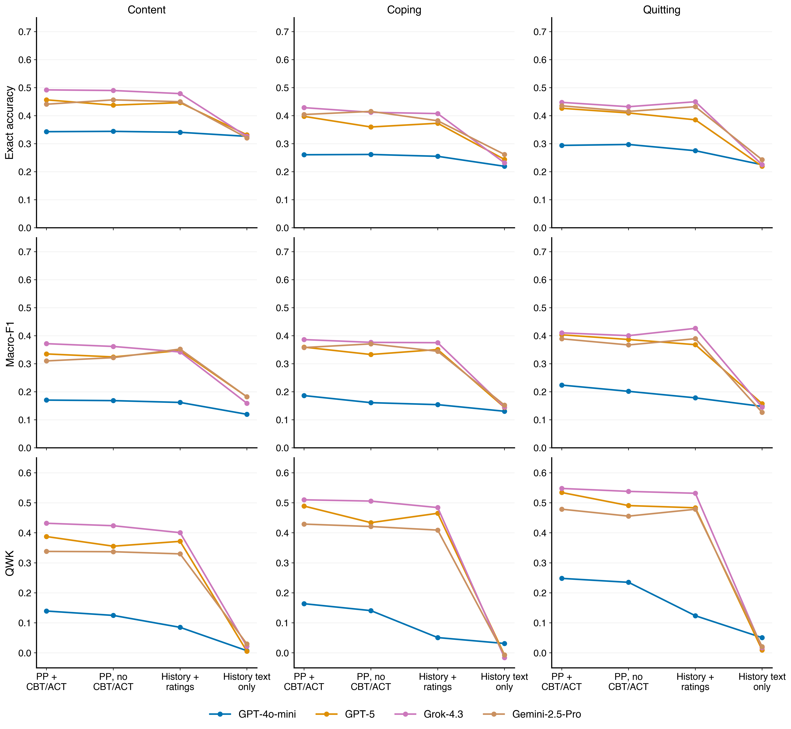
Figure 1. Exact accuracy, macro-F1, and QWK by rating domain. Lines connect configurations evaluated on the same canonical test messages; 95% intervals are given in Tables 1–3.

Table 2. Domain-specific directional performance
Domain | Model | Configuration | Directional accuracy (95% CI) | Directional macro-F1 (95% CI)
Content | GPT-4o-mini | PP + history + CBT/ACT | 0.611 [0.573, 0.650] | 0.330 [0.309, 0.352]
Content | GPT-4o-mini | PP + history (no CBT/ACT) | 0.627 [0.590, 0.666] | 0.343 [0.322, 0.367]
Content | GPT-4o-mini | History + ratings only | 0.619 [0.581, 0.660] | 0.316 [0.293, 0.339]
Content | GPT-4o-mini | History text only | 0.643 [0.603, 0.682] | 0.295 [0.275, 0.317]
Content | GPT-5 | PP + history + CBT/ACT | 0.669 [0.632, 0.708] | 0.486 [0.435, 0.536]
Content | GPT-5 | PP + history (no CBT/ACT) | 0.648 [0.613, 0.684] | 0.486 [0.435, 0.533]
Content | GPT-5 | History + ratings only | 0.654 [0.618, 0.689] | 0.501 [0.453, 0.547]
Content | GPT-5 | History text only | 0.631 [0.591, 0.673] | 0.299 [0.277, 0.322]
Content | Grok-4.3 | PP + history + CBT/ACT | 0.709 [0.671, 0.745] | 0.525 [0.472, 0.574]
Content | Grok-4.3 | PP + history (no CBT/ACT) | 0.719 [0.682, 0.754] | 0.524 [0.469, 0.573]
Content | Grok-4.3 | History + ratings only | 0.693 [0.654, 0.729] | 0.526 [0.467, 0.579]
Content | Grok-4.3 | History text only | 0.616 [0.576, 0.654] | 0.311 [0.286, 0.339]
Content | Gemini-2.5-Pro | PP + history + CBT/ACT | 0.685 [0.646, 0.722] | 0.462 [0.410, 0.513]
Content | Gemini-2.5-Pro | PP + history (no CBT/ACT) | 0.679 [0.642, 0.716] | 0.462 [0.414, 0.512]
Content | Gemini-2.5-Pro | History + ratings only | 0.648 [0.611, 0.684] | 0.477 [0.430, 0.522]
Content | Gemini-2.5-Pro | History text only | 0.618 [0.579, 0.654] | 0.318 [0.293, 0.343]
Coping | GPT-4o-mini | PP + history + CBT/ACT | 0.354 [0.324, 0.387] | 0.331 [0.298, 0.364]
Coping | GPT-4o-mini | PP + history (no CBT/ACT) | 0.391 [0.361, 0.423] | 0.330 [0.299, 0.363]
Coping | GPT-4o-mini | History + ratings only | 0.386 [0.354, 0.420] | 0.299 [0.272, 0.327]
Coping | GPT-4o-mini | History text only | 0.305 [0.276, 0.336] | 0.252 [0.226, 0.279]
Coping | GPT-5 | PP + history + CBT/ACT | 0.622 [0.585, 0.661] | 0.533 [0.494, 0.571]
Coping | GPT-5 | PP + history (no CBT/ACT) | 0.565 [0.526, 0.605] | 0.476 [0.436, 0.514]
Coping | GPT-5 | History + ratings only | 0.573 [0.536, 0.611] | 0.494 [0.458, 0.531]
Coping | GPT-5 | History text only | 0.404 [0.371, 0.440] | 0.312 [0.284, 0.342]
Coping | Grok-4.3 | PP + history + CBT/ACT | 0.645 [0.606, 0.684] | 0.537 [0.492, 0.576]
Coping | Grok-4.3 | PP + history (no CBT/ACT) | 0.640 [0.600, 0.680] | 0.536 [0.493, 0.577]
Coping | Grok-4.3 | History + ratings only | 0.641 [0.603, 0.680] | 0.551 [0.509, 0.592]
Coping | Grok-4.3 | History text only | 0.391 [0.359, 0.423] | 0.315 [0.287, 0.344]
Coping | Gemini-2.5-Pro | PP + history + CBT/ACT | 0.629 [0.591, 0.667] | 0.485 [0.440, 0.526]
Coping | Gemini-2.5-Pro | PP + history (no CBT/ACT) | 0.631 [0.596, 0.667] | 0.499 [0.460, 0.539]
Coping | Gemini-2.5-Pro | History + ratings only | 0.594 [0.556, 0.632] | 0.485 [0.444, 0.526]
Coping | Gemini-2.5-Pro | History text only | 0.468 [0.434, 0.503] | 0.339 [0.309, 0.371]
Quitting | GPT-4o-mini | PP + history + CBT/ACT | 0.462 [0.424, 0.498] | 0.418 [0.377, 0.456]
Quitting | GPT-4o-mini | PP + history (no CBT/ACT) | 0.487 [0.450, 0.524] | 0.415 [0.375, 0.452]
Quitting | GPT-4o-mini | History + ratings only | 0.450 [0.417, 0.486] | 0.362 [0.329, 0.395]
Quitting | GPT-4o-mini | History text only | 0.341 [0.311, 0.372] | 0.302 [0.272, 0.332]
Quitting | GPT-5 | PP + history + CBT/ACT | 0.664 [0.627, 0.702] | 0.578 [0.539, 0.616]
Quitting | GPT-5 | PP + history (no CBT/ACT) | 0.630 [0.593, 0.667] | 0.548 [0.509, 0.587]
Quitting | GPT-5 | History + ratings only | 0.619 [0.582, 0.656] | 0.542 [0.503, 0.581]
Quitting | GPT-5 | History text only | 0.314 [0.285, 0.346] | 0.289 [0.260, 0.320]
Quitting | Grok-4.3 | PP + history + CBT/ACT | 0.674 [0.636, 0.713] | 0.568 [0.525, 0.609]
Quitting | Grok-4.3 | PP + history (no CBT/ACT) | 0.660 [0.622, 0.699] | 0.552 [0.509, 0.592]
Quitting | Grok-4.3 | History + ratings only | 0.682 [0.644, 0.719] | 0.595 [0.554, 0.633]
Quitting | Grok-4.3 | History text only | 0.391 [0.359, 0.423] | 0.322 [0.292, 0.351]
Quitting | Gemini-2.5-Pro | PP + history + CBT/ACT | 0.665 [0.629, 0.701] | 0.529 [0.487, 0.572]
Quitting | Gemini-2.5-Pro | PP + history (no CBT/ACT) | 0.654 [0.616, 0.691] | 0.513 [0.472, 0.555]
Quitting | Gemini-2.5-Pro | History + ratings only | 0.650 [0.615, 0.686] | 0.541 [0.503, 0.579]
Quitting | Gemini-2.5-Pro | History text only | 0.504 [0.464, 0.543] | 0.318 [0.288, 0.350]

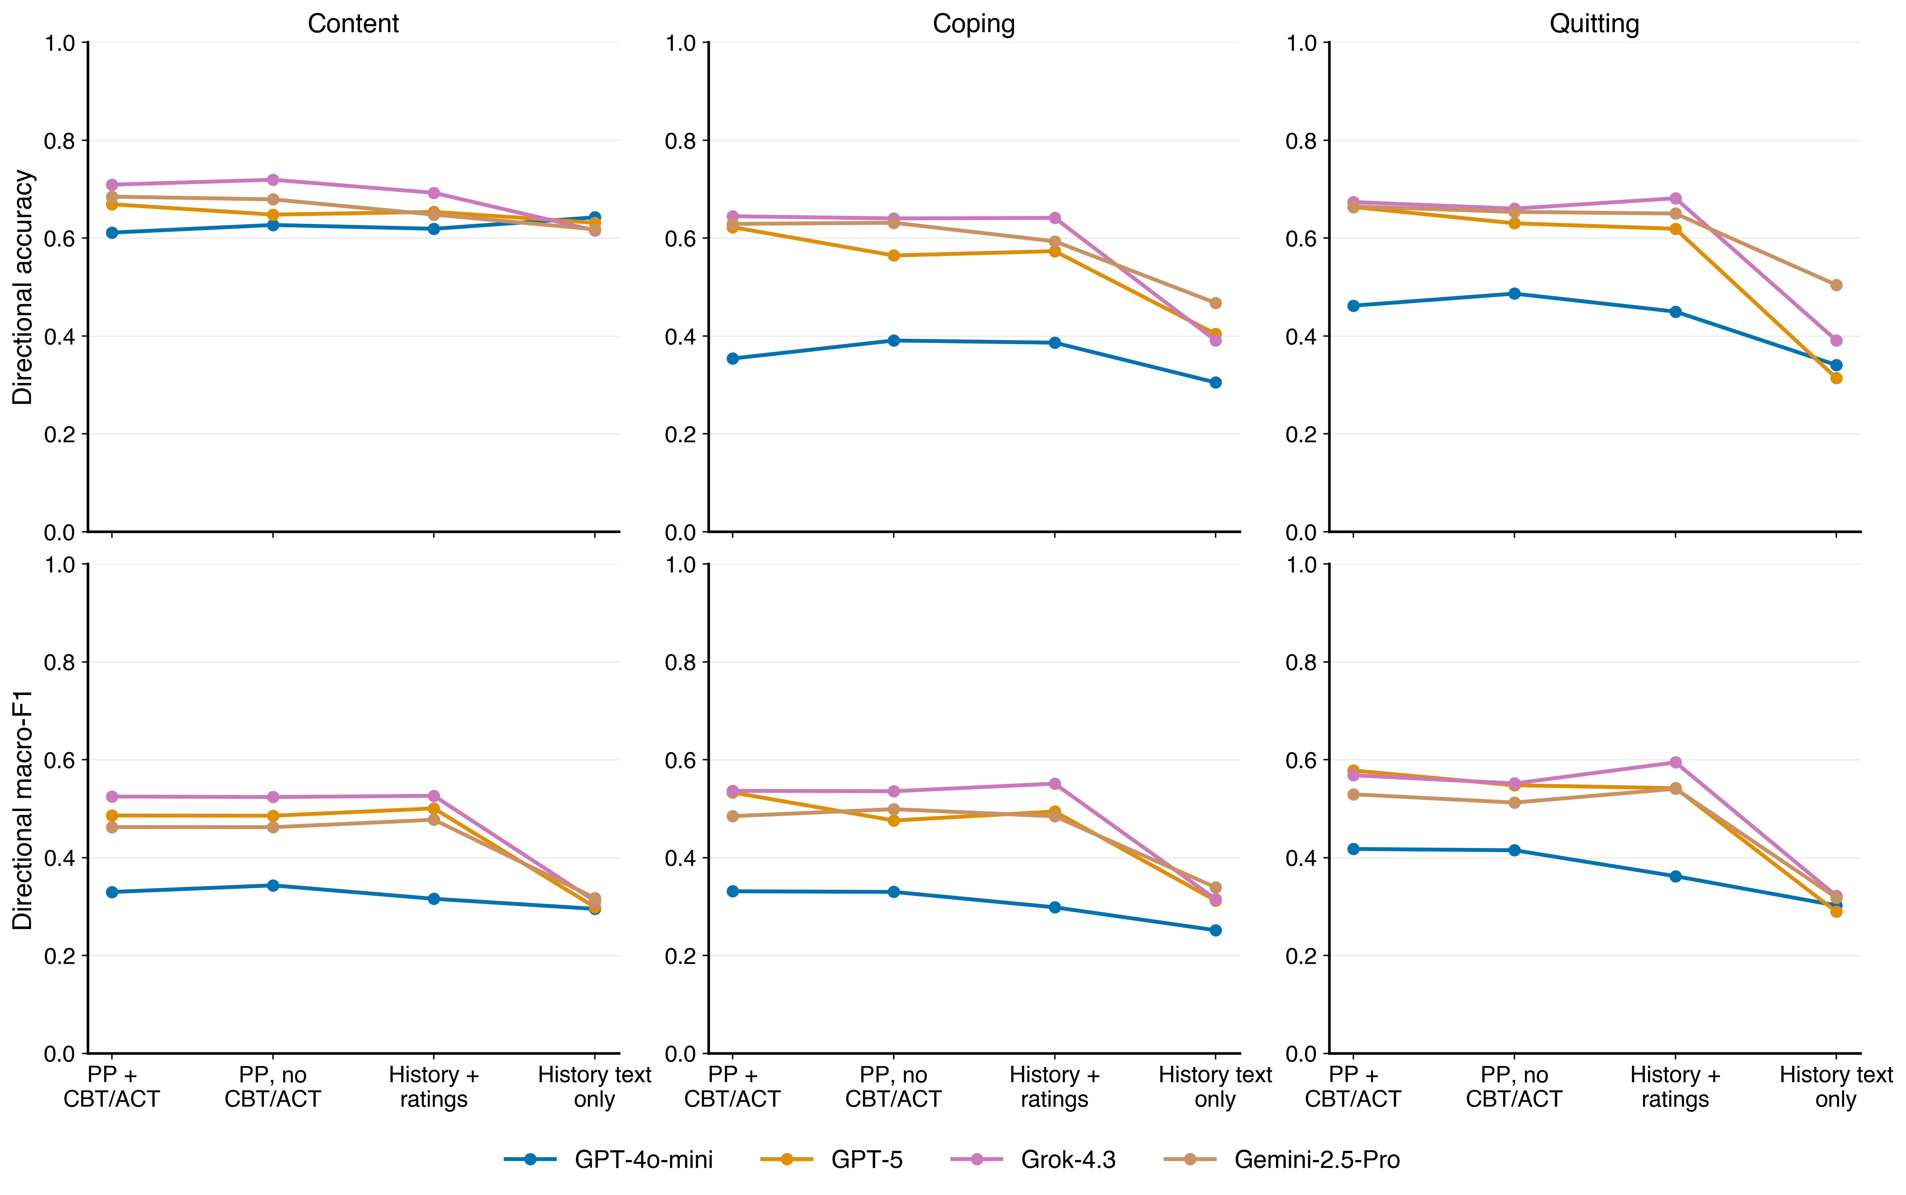
Figure 2. Directional accuracy and directional macro-F1 by rating domain. Direction is low (1–2), neutral (3), or high (4–5).

Table 3. Paired domain-specific changes from PP + history + CBT/ACT
Domain | Model | Compared configuration | Δ accuracy (95% CI) | Δ macro-F1 (95% CI) | Δ QWK (95% CI)
Content | GPT-4o-mini | PP + history (no CBT/ACT) | +0.001 [-0.018, +0.020] | -0.002 [-0.017, +0.014] | -0.015 [-0.059, +0.032]
Content | GPT-4o-mini | History + ratings only | -0.002 [-0.023, +0.018] | -0.008 [-0.025, +0.008] | -0.054 [-0.109, +0.001]
Content | GPT-4o-mini | History text only | -0.017 [-0.038, +0.006] | -0.051 [-0.069, -0.032] | -0.132 [-0.184, -0.079]
Content | GPT-5 | PP + history (no CBT/ACT) | -0.019 [-0.046, +0.008] | -0.011 [-0.033, +0.013] | -0.032 [-0.070, +0.003]
Content | GPT-5 | History + ratings only | -0.010 [-0.037, +0.017] | +0.012 [-0.022, +0.053] | -0.016 [-0.056, +0.024]
Content | GPT-5 | History text only | -0.125 [-0.165, -0.085] | -0.153 [-0.203, -0.108] | -0.382 [-0.457, -0.302]
Content | Grok-4.3 | PP + history (no CBT/ACT) | -0.002 [-0.025, +0.020] | -0.010 [-0.043, +0.017] | -0.008 [-0.039, +0.021]
Content | Grok-4.3 | History + ratings only | -0.013 [-0.038, +0.012] | -0.030 [-0.070, +0.008] | -0.031 [-0.065, +0.002]
Content | Grok-4.3 | History text only | -0.166 [-0.213, -0.119] | -0.213 [-0.265, -0.162] | -0.410 [-0.497, -0.319]
Content | Gemini-2.5-Pro | PP + history (no CBT/ACT) | +0.016 [-0.011, +0.044] | +0.012 [-0.015, +0.040] | -0.001 [-0.040, +0.043]
Content | Gemini-2.5-Pro | History + ratings only | +0.009 [-0.019, +0.038] | +0.042 [+0.005, +0.082] | -0.008 [-0.067, +0.050]
Content | Gemini-2.5-Pro | History text only | -0.120 [-0.169, -0.073] | -0.128 [-0.175, -0.082] | -0.308 [-0.396, -0.217]
Coping | GPT-4o-mini | PP + history (no CBT/ACT) | +0.001 [-0.026, +0.027] | -0.025 [-0.050, -0.001] | -0.023 [-0.060, +0.016]
Coping | GPT-4o-mini | History + ratings only | -0.006 [-0.039, +0.028] | -0.032 [-0.059, -0.006] | -0.113 [-0.159, -0.066]
Coping | GPT-4o-mini | History text only | -0.041 [-0.071, -0.012] | -0.056 [-0.084, -0.029] | -0.133 [-0.182, -0.083]
Coping | GPT-5 | PP + history (no CBT/ACT) | -0.038 [-0.062, -0.013] | -0.026 [-0.053, +0.002] | -0.055 [-0.090, -0.022]
Coping | GPT-5 | History + ratings only | -0.024 [-0.052, +0.001] | -0.008 [-0.039, +0.022] | -0.024 [-0.059, +0.011]
Coping | GPT-5 | History text only | -0.154 [-0.198, -0.108] | -0.215 [-0.258, -0.170] | -0.496 [-0.570, -0.416]
Coping | Grok-4.3 | PP + history (no CBT/ACT) | -0.017 [-0.045, +0.011] | -0.010 [-0.039, +0.017] | -0.004 [-0.039, +0.029]
Coping | Grok-4.3 | History + ratings only | -0.021 [-0.049, +0.007] | -0.011 [-0.037, +0.014] | -0.026 [-0.062, +0.011]
Coping | Grok-4.3 | History text only | -0.197 [-0.245, -0.153] | -0.241 [-0.285, -0.193] | -0.526 [-0.608, -0.438]
Coping | Gemini-2.5-Pro | PP + history (no CBT/ACT) | +0.011 [-0.015, +0.038] | +0.013 [-0.016, +0.045] | -0.008 [-0.049, +0.033]
Coping | Gemini-2.5-Pro | History + ratings only | -0.022 [-0.051, +0.007] | -0.013 [-0.044, +0.019] | -0.020 [-0.069, +0.031]
Coping | Gemini-2.5-Pro | History text only | -0.143 [-0.192, -0.095] | -0.206 [-0.254, -0.156] | -0.436 [-0.521, -0.347]
Quitting | GPT-4o-mini | PP + history (no CBT/ACT) | +0.003 [-0.022, +0.031] | -0.022 [-0.047, +0.004] | -0.013 [-0.055, +0.030]
Quitting | GPT-4o-mini | History + ratings only | -0.019 [-0.050, +0.014] | -0.046 [-0.076, -0.015] | -0.124 [-0.176, -0.075]
Quitting | GPT-4o-mini | History text only | -0.069 [-0.106, -0.032] | -0.076 [-0.109, -0.043] | -0.198 [-0.263, -0.130]
Quitting | GPT-5 | PP + history (no CBT/ACT) | -0.017 [-0.046, +0.010] | -0.017 [-0.045, +0.011] | -0.044 [-0.077, -0.009]
Quitting | GPT-5 | History + ratings only | -0.041 [-0.066, -0.017] | -0.035 [-0.062, -0.006] | -0.051 [-0.082, -0.019]
Quitting | GPT-5 | History text only | -0.207 [-0.255, -0.159] | -0.246 [-0.292, -0.198] | -0.525 [-0.593, -0.451]
Quitting | Grok-4.3 | PP + history (no CBT/ACT) | -0.016 [-0.040, +0.008] | -0.010 [-0.038, +0.016] | -0.010 [-0.045, +0.025]
Quitting | Grok-4.3 | History + ratings only | +0.002 [-0.021, +0.025] | +0.016 [-0.011, +0.041] | -0.016 [-0.048, +0.017]
Quitting | Grok-4.3 | History text only | -0.223 [-0.270, -0.173] | -0.265 [-0.310, -0.219] | -0.531 [-0.609, -0.451]
Quitting | Gemini-2.5-Pro | PP + history (no CBT/ACT) | -0.020 [-0.045, +0.004] | -0.022 [-0.050, +0.007] | -0.023 [-0.066, +0.018]
Quitting | Gemini-2.5-Pro | History + ratings only | -0.003 [-0.031, +0.026] | +0.000 [-0.031, +0.037] | -0.000 [-0.047, +0.046]
Quitting | Gemini-2.5-Pro | History text only | -0.193 [-0.242, -0.142] | -0.263 [-0.307, -0.215] | -0.458 [-0.543, -0.371]

Positive differences favor the comparison configuration. Every interval is paired within the same participant-bootstrap replicate.

Table 4. Which configuration is best, and which are statistically comparable to it
For each model, domain, and metric: the configuration with the highest point estimate, the configurations whose paired 95% interval against it includes zero (comparable), and those whose interval excludes zero (significantly worse). Differences are reported as best minus other. No multiplicity correction is applied.
Metric | Domain | Model | Best configuration | Estimate | Comparable to best (Δ, 95% CI) | Significantly worse than best (Δ, 95% CI)
accuracy | Content | GPT-4o-mini | PP + history (no CBT/ACT) | 0.344 | PP + history + CBT/ACT (+0.001 [-0.018, +0.020]); History + ratings only (+0.003 [-0.017, +0.023]); History text only (+0.018 [-0.002, +0.039]) | none
accuracy | Content | GPT-5 | PP + history + CBT/ACT | 0.457 | PP + history (no CBT/ACT) (+0.019 [-0.008, +0.046]); History + ratings only (+0.010 [-0.017, +0.037]) | History text only (+0.125 [+0.085, +0.165])
accuracy | Content | Grok-4.3 | PP + history + CBT/ACT | 0.492 | PP + history (no CBT/ACT) (+0.002 [-0.020, +0.025]); History + ratings only (+0.013 [-0.012, +0.038]) | History text only (+0.166 [+0.119, +0.213])
accuracy | Content | Gemini-2.5-Pro | PP + history (no CBT/ACT) | 0.457 | PP + history + CBT/ACT (+0.016 [-0.011, +0.044]); History + ratings only (+0.007 [-0.025, +0.036]) | History text only (+0.136 [+0.092, +0.180])
accuracy | Coping | GPT-4o-mini | PP + history (no CBT/ACT) | 0.262 | PP + history + CBT/ACT (+0.001 [-0.026, +0.027]); History + ratings only (+0.007 [-0.013, +0.028]) | History text only (+0.042 [+0.018, +0.067])
accuracy | Coping | GPT-5 | PP + history + CBT/ACT | 0.398 | History + ratings only (+0.024 [-0.001, +0.052]) | PP + history (no CBT/ACT) (+0.038 [+0.013, +0.062]); History text only (+0.154 [+0.108, +0.198])
accuracy | Coping | Grok-4.3 | PP + history + CBT/ACT | 0.429 | PP + history (no CBT/ACT) (+0.017 [-0.011, +0.045]); History + ratings only (+0.021 [-0.007, +0.049]) | History text only (+0.197 [+0.153, +0.245])
accuracy | Coping | Gemini-2.5-Pro | PP + history (no CBT/ACT) | 0.415 | PP + history + CBT/ACT (+0.011 [-0.015, +0.038]) | History + ratings only (+0.033 [+0.004, +0.063]); History text only (+0.154 [+0.104, +0.203])
accuracy | Quitting | GPT-4o-mini | PP + history (no CBT/ACT) | 0.297 | PP + history + CBT/ACT (+0.003 [-0.022, +0.031]); History + ratings only (+0.022 [-0.000, +0.043]) | History text only (+0.072 [+0.042, +0.103])
accuracy | Quitting | GPT-5 | PP + history + CBT/ACT | 0.427 | PP + history (no CBT/ACT) (+0.017 [-0.010, +0.046]) | History + ratings only (+0.041 [+0.017, +0.066]); History text only (+0.207 [+0.159, +0.255])
accuracy | Quitting | Grok-4.3 | History + ratings only | 0.450 | PP + history + CBT/ACT (+0.002 [-0.021, +0.025]); PP + history (no CBT/ACT) (+0.018 [-0.004, +0.039]) | History text only (+0.225 [+0.177, +0.272])
accuracy | Quitting | Gemini-2.5-Pro | PP + history + CBT/ACT | 0.435 | PP + history (no CBT/ACT) (+0.020 [-0.004, +0.045]); History + ratings only (+0.003 [-0.026, +0.031]) | History text only (+0.193 [+0.142, +0.242])
directional_accuracy | Content | GPT-4o-mini | History text only | 0.643 | PP + history (no CBT/ACT) (+0.016 [-0.006, +0.036]) | PP + history + CBT/ACT (+0.031 [+0.009, +0.053]); History + ratings only (+0.023 [+0.006, +0.042])
directional_accuracy | Content | GPT-5 | PP + history + CBT/ACT | 0.669 | PP + history (no CBT/ACT) (+0.021 [-0.001, +0.044]); History + ratings only (+0.016 [-0.006, +0.038]) | History text only (+0.038 [+0.003, +0.074])
directional_accuracy | Content | Grok-4.3 | PP + history (no CBT/ACT) | 0.719 | PP + history + CBT/ACT (+0.010 [-0.008, +0.028]) | History + ratings only (+0.027 [+0.007, +0.047]); History text only (+0.104 [+0.070, +0.136])
directional_accuracy | Content | Gemini-2.5-Pro | PP + history + CBT/ACT | 0.685 | PP + history (no CBT/ACT) (+0.006 [-0.018, +0.028]) | History + ratings only (+0.037 [+0.009, +0.062]); History text only (+0.067 [+0.033, +0.100])
directional_accuracy | Coping | GPT-4o-mini | PP + history (no CBT/ACT) | 0.391 | History + ratings only (+0.004 [-0.022, +0.030]) | PP + history + CBT/ACT (+0.037 [+0.004, +0.068]); History text only (+0.086 [+0.054, +0.117])
directional_accuracy | Coping | GPT-5 | PP + history + CBT/ACT | 0.622 | none | PP + history (no CBT/ACT) (+0.058 [+0.034, +0.082]); History + ratings only (+0.049 [+0.026, +0.075]); History text only (+0.218 [+0.176, +0.262])
directional_accuracy | Coping | Grok-4.3 | PP + history + CBT/ACT | 0.645 | PP + history (no CBT/ACT) (+0.004 [-0.019, +0.028]); History + ratings only (+0.003 [-0.022, +0.028]) | History text only (+0.254 [+0.209, +0.299])
directional_accuracy | Coping | Gemini-2.5-Pro | PP + history (no CBT/ACT) | 0.631 | PP + history + CBT/ACT (+0.002 [-0.022, +0.027]) | History + ratings only (+0.038 [+0.012, +0.065]); History text only (+0.164 [+0.123, +0.204])
directional_accuracy | Quitting | GPT-4o-mini | PP + history (no CBT/ACT) | 0.487 | PP + history + CBT/ACT (+0.024 [-0.006, +0.058]) | History + ratings only (+0.037 [+0.011, +0.062]); History text only (+0.146 [+0.106, +0.185])
directional_accuracy | Quitting | GPT-5 | PP + history + CBT/ACT | 0.664 | none | PP + history (no CBT/ACT) (+0.033 [+0.010, +0.059]); History + ratings only (+0.045 [+0.020, +0.069]); History text only (+0.350 [+0.299, +0.399])
directional_accuracy | Quitting | Grok-4.3 | History + ratings only | 0.682 | PP + history + CBT/ACT (+0.008 [-0.013, +0.028]); PP + history (no CBT/ACT) (+0.021 [+0.000, +0.041]) | History text only (+0.291 [+0.247, +0.336])
directional_accuracy | Quitting | Gemini-2.5-Pro | PP + history + CBT/ACT | 0.665 | PP + history (no CBT/ACT) (+0.011 [-0.011, +0.034]); History + ratings only (+0.014 [-0.012, +0.040]) | History text only (+0.160 [+0.124, +0.199])
directional_macro_f1 | Content | GPT-4o-mini | PP + history (no CBT/ACT) | 0.343 | PP + history + CBT/ACT (+0.013 [-0.005, +0.033]) | History + ratings only (+0.027 [+0.008, +0.048]); History text only (+0.048 [+0.026, +0.070])
directional_macro_f1 | Content | GPT-5 | History + ratings only | 0.501 | PP + history + CBT/ACT (+0.014 [-0.019, +0.053]); PP + history (no CBT/ACT) (+0.015 [-0.019, +0.052]) | History text only (+0.202 [+0.149, +0.252])
directional_macro_f1 | Content | Grok-4.3 | History + ratings only | 0.526 | PP + history + CBT/ACT (+0.002 [-0.031, +0.033]); PP + history (no CBT/ACT) (+0.003 [-0.022, +0.029]) | History text only (+0.215 [+0.153, +0.272])
directional_macro_f1 | Content | Gemini-2.5-Pro | History + ratings only | 0.477 | PP + history + CBT/ACT (+0.015 [-0.028, +0.060]); PP + history (no CBT/ACT) (+0.015 [-0.023, +0.052]) | History text only (+0.160 [+0.110, +0.209])
directional_macro_f1 | Coping | GPT-4o-mini | PP + history + CBT/ACT | 0.331 | PP + history (no CBT/ACT) (+0.001 [-0.029, +0.031]); History + ratings only (+0.033 [-0.004, +0.070]) | History text only (+0.080 [+0.041, +0.118])
directional_macro_f1 | Coping | GPT-5 | PP + history + CBT/ACT | 0.533 | none | PP + history (no CBT/ACT) (+0.057 [+0.031, +0.083]); History + ratings only (+0.039 [+0.011, +0.067]); History text only (+0.221 [+0.173, +0.268])
directional_macro_f1 | Coping | Grok-4.3 | History + ratings only | 0.551 | PP + history + CBT/ACT (+0.015 [-0.018, +0.047]); PP + history (no CBT/ACT) (+0.015 [-0.015, +0.045]) | History text only (+0.236 [+0.188, +0.282])
directional_macro_f1 | Coping | Gemini-2.5-Pro | PP + history (no CBT/ACT) | 0.499 | PP + history + CBT/ACT (+0.014 [-0.019, +0.051]); History + ratings only (+0.015 [-0.018, +0.049]) | History text only (+0.160 [+0.106, +0.212])
directional_macro_f1 | Quitting | GPT-4o-mini | PP + history + CBT/ACT | 0.418 | PP + history (no CBT/ACT) (+0.003 [-0.032, +0.037]) | History + ratings only (+0.056 [+0.018, +0.091]); History text only (+0.115 [+0.065, +0.162])
directional_macro_f1 | Quitting | GPT-5 | PP + history + CBT/ACT | 0.578 | none | PP + history (no CBT/ACT) (+0.030 [+0.002, +0.059]); History + ratings only (+0.036 [+0.008, +0.065]); History text only (+0.289 [+0.235, +0.337])
directional_macro_f1 | Quitting | Grok-4.3 | History + ratings only | 0.595 | PP + history + CBT/ACT (+0.026 [-0.002, +0.053]) | PP + history (no CBT/ACT) (+0.043 [+0.014, +0.070]); History text only (+0.273 [+0.224, +0.322])
directional_macro_f1 | Quitting | Gemini-2.5-Pro | History + ratings only | 0.541 | PP + history + CBT/ACT (+0.011 [-0.024, +0.048]); PP + history (no CBT/ACT) (+0.028 [-0.011, +0.065]) | History text only (+0.223 [+0.177, +0.267])
macro_f1 | Content | GPT-4o-mini | PP + history + CBT/ACT | 0.170 | PP + history (no CBT/ACT) (+0.002 [-0.014, +0.017]); History + ratings only (+0.008 [-0.008, +0.025]) | History text only (+0.051 [+0.032, +0.069])
macro_f1 | Content | GPT-5 | History + ratings only | 0.347 | PP + history + CBT/ACT (+0.012 [-0.022, +0.053]); PP + history (no CBT/ACT) (+0.023 [-0.007, +0.056]) | History text only (+0.165 [+0.116, +0.216])
macro_f1 | Content | Grok-4.3 | PP + history + CBT/ACT | 0.372 | PP + history (no CBT/ACT) (+0.010 [-0.017, +0.043]); History + ratings only (+0.030 [-0.008, +0.070]) | History text only (+0.213 [+0.162, +0.265])
macro_f1 | Content | Gemini-2.5-Pro | History + ratings only | 0.353 | PP + history (no CBT/ACT) (+0.031 [-0.006, +0.069]) | PP + history + CBT/ACT (+0.042 [+0.005, +0.082]); History text only (+0.170 [+0.120, +0.222])
macro_f1 | Coping | GPT-4o-mini | PP + history + CBT/ACT | 0.186 | none | PP + history (no CBT/ACT) (+0.025 [+0.001, +0.050]); History + ratings only (+0.032 [+0.006, +0.059]); History text only (+0.056 [+0.029, +0.084])
macro_f1 | Coping | GPT-5 | PP + history + CBT/ACT | 0.359 | PP + history (no CBT/ACT) (+0.026 [-0.002, +0.053]); History + ratings only (+0.008 [-0.022, +0.039]) | History text only (+0.215 [+0.170, +0.258])
macro_f1 | Coping | Grok-4.3 | PP + history + CBT/ACT | 0.386 | PP + history (no CBT/ACT) (+0.010 [-0.017, +0.039]); History + ratings only (+0.011 [-0.014, +0.037]) | History text only (+0.241 [+0.193, +0.285])
macro_f1 | Coping | Gemini-2.5-Pro | PP + history (no CBT/ACT) | 0.371 | PP + history + CBT/ACT (+0.013 [-0.016, +0.045]); History + ratings only (+0.026 [-0.004, +0.058]) | History text only (+0.219 [+0.169, +0.266])
macro_f1 | Quitting | GPT-4o-mini | PP + history + CBT/ACT | 0.224 | PP + history (no CBT/ACT) (+0.022 [-0.004, +0.047]) | History + ratings only (+0.046 [+0.015, +0.076]); History text only (+0.076 [+0.043, +0.109])
macro_f1 | Quitting | GPT-5 | PP + history + CBT/ACT | 0.403 | PP + history (no CBT/ACT) (+0.017 [-0.011, +0.045]) | History + ratings only (+0.035 [+0.006, +0.062]); History text only (+0.246 [+0.198, +0.292])
macro_f1 | Quitting | Grok-4.3 | History + ratings only | 0.426 | PP + history + CBT/ACT (+0.016 [-0.011, +0.041]) | PP + history (no CBT/ACT) (+0.026 [+0.001, +0.052]); History text only (+0.281 [+0.233, +0.328])
macro_f1 | Quitting | Gemini-2.5-Pro | History + ratings only | 0.390 | PP + history + CBT/ACT (+0.000 [-0.031, +0.037]); PP + history (no CBT/ACT) (+0.022 [-0.004, +0.051]) | History text only (+0.263 [+0.218, +0.307])
qwk | Content | GPT-4o-mini | PP + history + CBT/ACT | 0.139 | PP + history (no CBT/ACT) (+0.015 [-0.032, +0.059]); History + ratings only (+0.054 [-0.001, +0.109]) | History text only (+0.132 [+0.079, +0.184])
qwk | Content | GPT-5 | PP + history + CBT/ACT | 0.388 | PP + history (no CBT/ACT) (+0.032 [-0.003, +0.070]); History + ratings only (+0.016 [-0.024, +0.056]) | History text only (+0.382 [+0.302, +0.457])
qwk | Content | Grok-4.3 | PP + history + CBT/ACT | 0.432 | PP + history (no CBT/ACT) (+0.008 [-0.021, +0.039]); History + ratings only (+0.031 [-0.002, +0.065]) | History text only (+0.410 [+0.319, +0.497])
qwk | Content | Gemini-2.5-Pro | PP + history + CBT/ACT | 0.338 | PP + history (no CBT/ACT) (+0.001 [-0.043, +0.040]); History + ratings only (+0.008 [-0.050, +0.067]) | History text only (+0.308 [+0.217, +0.396])
qwk | Coping | GPT-4o-mini | PP + history + CBT/ACT | 0.164 | PP + history (no CBT/ACT) (+0.023 [-0.016, +0.060]) | History + ratings only (+0.113 [+0.066, +0.159]); History text only (+0.133 [+0.083, +0.182])
qwk | Coping | GPT-5 | PP + history + CBT/ACT | 0.489 | History + ratings only (+0.024 [-0.011, +0.059]) | PP + history (no CBT/ACT) (+0.055 [+0.022, +0.090]); History text only (+0.496 [+0.416, +0.570])
qwk | Coping | Grok-4.3 | PP + history + CBT/ACT | 0.510 | PP + history (no CBT/ACT) (+0.004 [-0.029, +0.039]); History + ratings only (+0.026 [-0.011, +0.062]) | History text only (+0.526 [+0.438, +0.608])
qwk | Coping | Gemini-2.5-Pro | PP + history + CBT/ACT | 0.429 | PP + history (no CBT/ACT) (+0.008 [-0.033, +0.049]); History + ratings only (+0.020 [-0.031, +0.069]) | History text only (+0.436 [+0.347, +0.521])
qwk | Quitting | GPT-4o-mini | PP + history + CBT/ACT | 0.248 | PP + history (no CBT/ACT) (+0.013 [-0.030, +0.055]) | History + ratings only (+0.124 [+0.075, +0.176]); History text only (+0.198 [+0.130, +0.263])
qwk | Quitting | GPT-5 | PP + history + CBT/ACT | 0.534 | none | PP + history (no CBT/ACT) (+0.044 [+0.009, +0.077]); History + ratings only (+0.051 [+0.019, +0.082]); History text only (+0.525 [+0.451, +0.593])
qwk | Quitting | Grok-4.3 | PP + history + CBT/ACT | 0.548 | PP + history (no CBT/ACT) (+0.010 [-0.025, +0.045]); History + ratings only (+0.016 [-0.017, +0.048]) | History text only (+0.531 [+0.451, +0.609])
qwk | Quitting | Gemini-2.5-Pro | PP + history + CBT/ACT | 0.479 | PP + history (no CBT/ACT) (+0.023 [-0.018, +0.066]); History + ratings only (+0.000 [-0.046, +0.047]) | History text only (+0.458 [+0.371, +0.543])

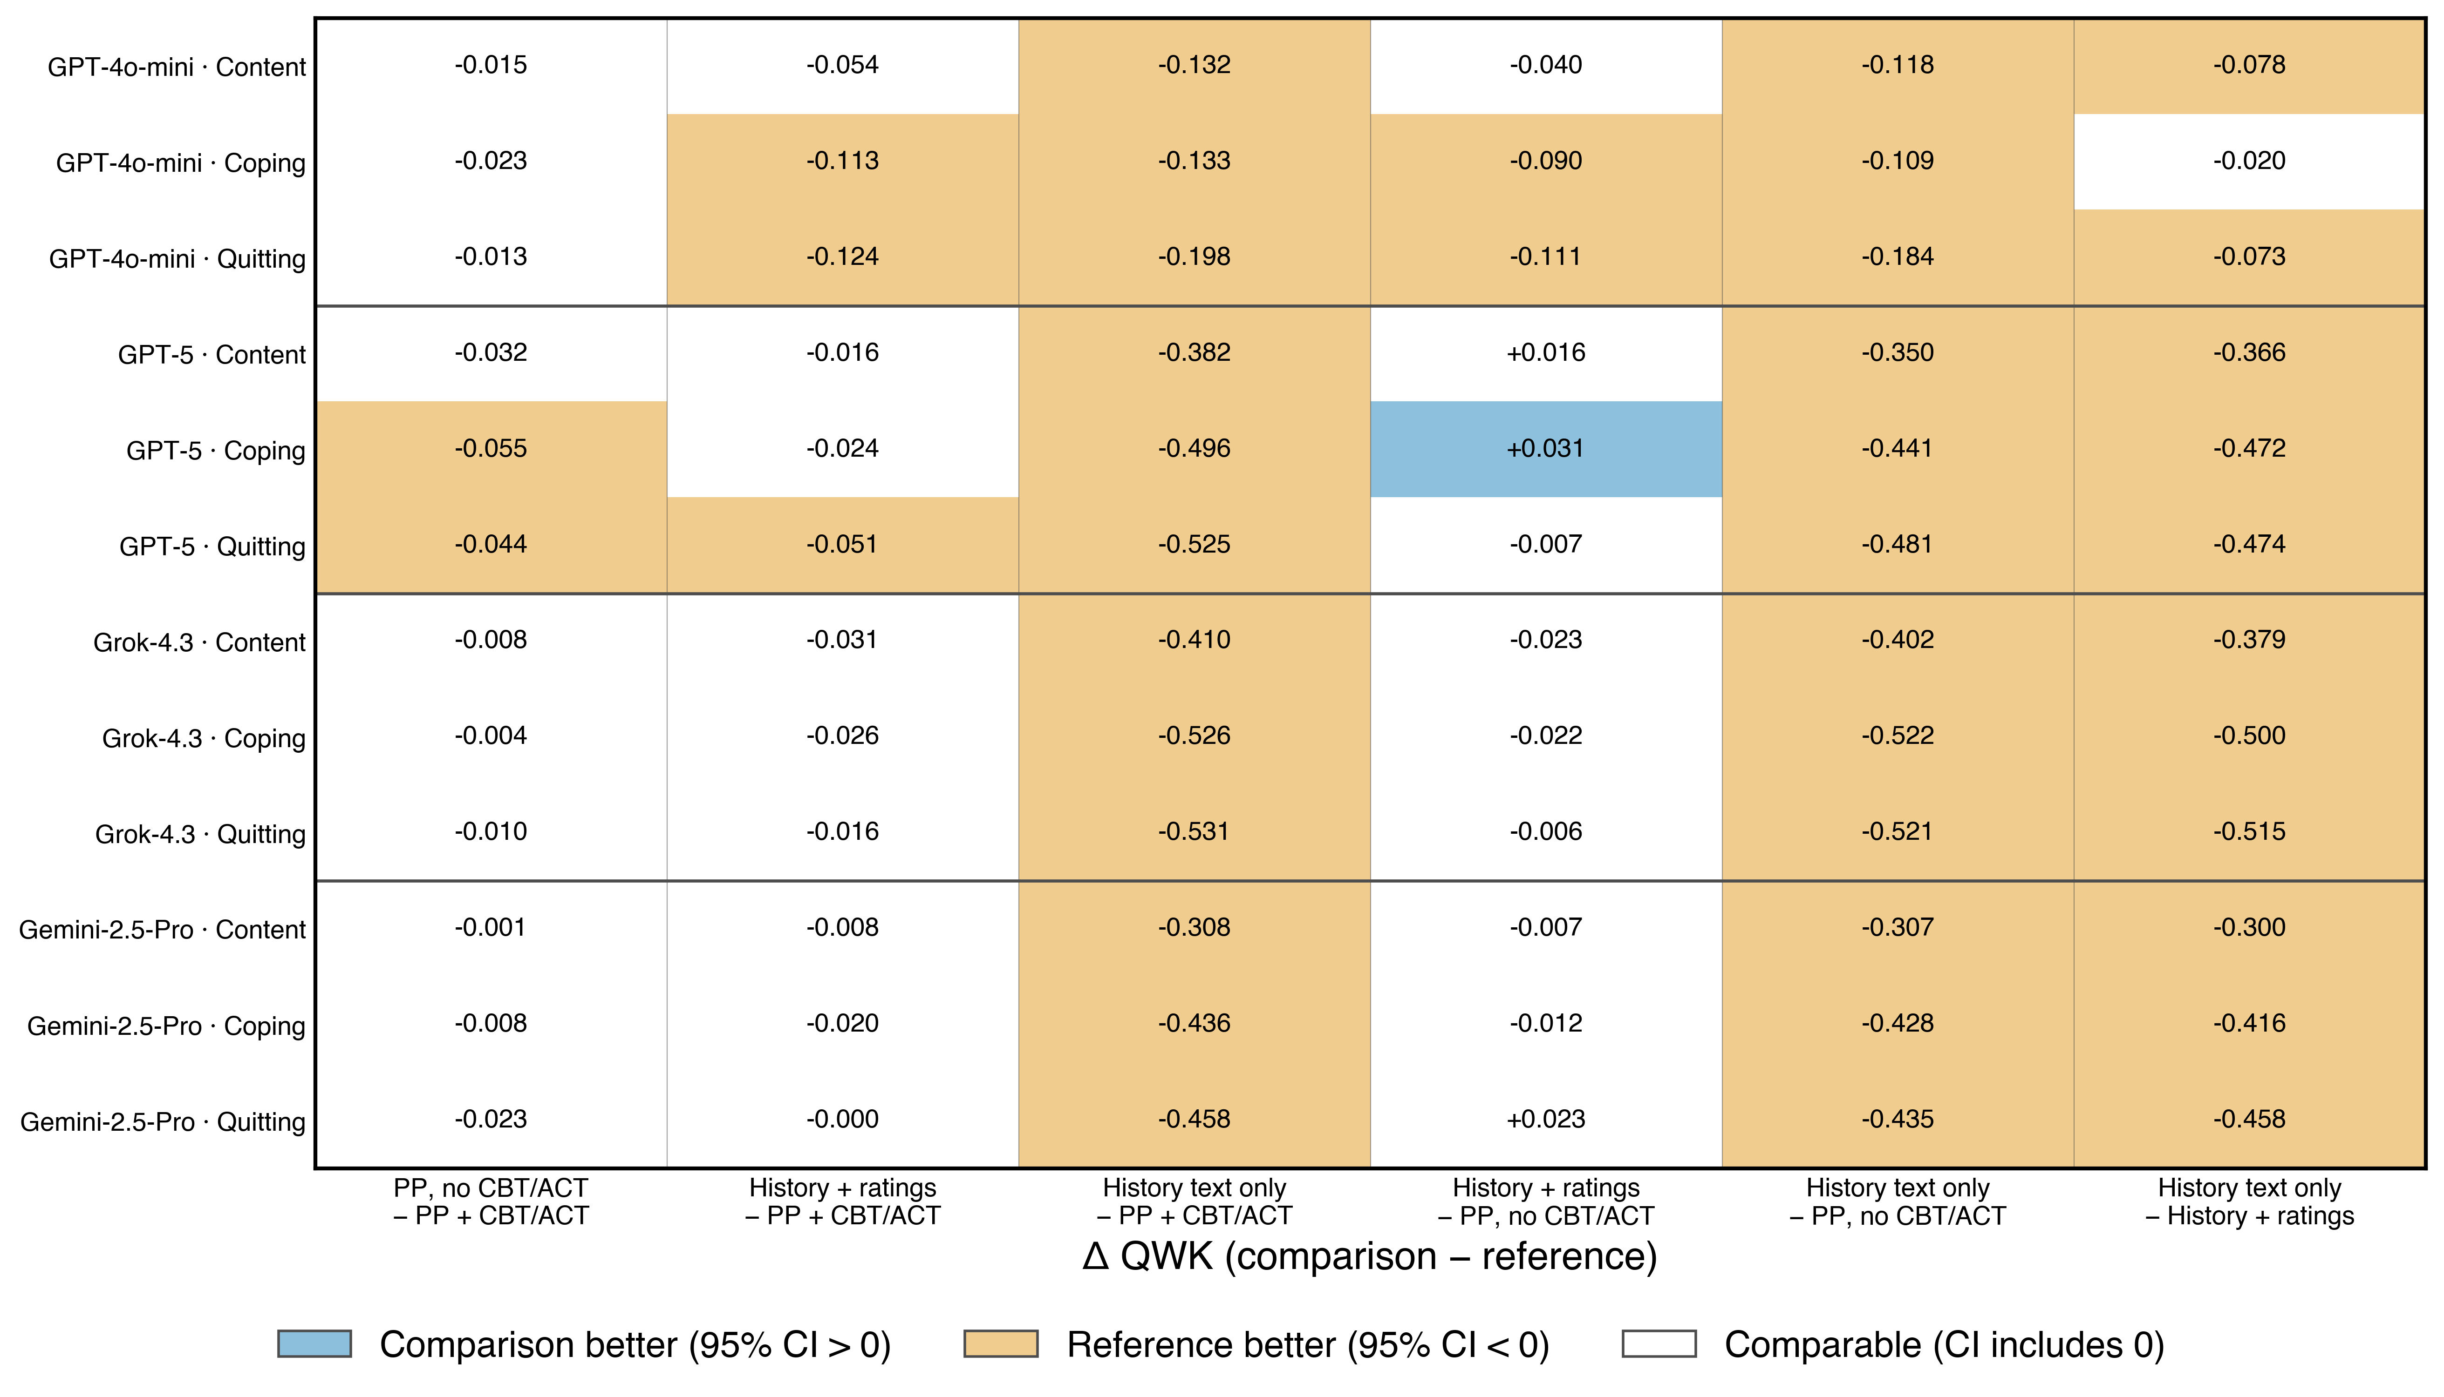
Figure 3. Paired QWK differences for all six configuration pairs (comparison minus reference). Shaded cells have 95% intervals excluding zero; white cells are statistically comparable.

Table 5. Distribution of predicted ratings
Mean and SD of observed and predicted ratings, bias (predicted minus observed), mean absolute error, and the share of messages predicted exactly or within one level, per configuration and domain.
Domain | Model | Configuration | Observed mean (SD) | Predicted mean (SD) | Bias | MAE | Exact | Within 1
Content | GPT-4o-mini | PP, no CBT/ACT | 3.90 (1.05) | 3.83 (0.43) | -0.08 | 0.80 | 0.344 | 0.878
Content | GPT-4o-mini | History + ratings | 3.90 (1.05) | 3.88 (0.42) | -0.03 | 0.81 | 0.341 | 0.875
Content | GPT-4o-mini | History text only | 3.90 (1.05) | 3.92 (0.28) | +0.01 | 0.82 | 0.326 | 0.883
Content | GPT-4o-mini | PP + CBT/ACT | 3.90 (1.05) | 3.82 (0.45) | -0.08 | 0.80 | 0.343 | 0.876
Content | GPT-5 | PP, no CBT/ACT | 3.90 (1.05) | 3.86 (0.85) | -0.04 | 0.74 | 0.438 | 0.859
Content | GPT-5 | History + ratings | 3.90 (1.05) | 3.84 (0.89) | -0.06 | 0.73 | 0.447 | 0.856
Content | GPT-5 | History text only | 3.90 (1.05) | 4.29 (0.64) | +0.39 | 0.94 | 0.332 | 0.788
Content | GPT-5 | PP + CBT/ACT | 3.90 (1.05) | 3.92 (0.82) | +0.02 | 0.70 | 0.457 | 0.873
Content | Grok-4.3 | PP, no CBT/ACT | 3.90 (1.05) | 4.03 (0.82) | +0.13 | 0.66 | 0.490 | 0.883
Content | Grok-4.3 | History + ratings | 3.90 (1.05) | 3.97 (0.85) | +0.07 | 0.68 | 0.479 | 0.870
Content | Grok-4.3 | History text only | 3.90 (1.05) | 3.92 (0.45) | +0.01 | 0.85 | 0.326 | 0.855
Content | Grok-4.3 | PP + CBT/ACT | 3.90 (1.05) | 3.99 (0.84) | +0.09 | 0.65 | 0.492 | 0.886
Content | Gemini-2.5-Pro | PP, no CBT/ACT | 3.90 (1.05) | 4.17 (0.86) | +0.27 | 0.74 | 0.457 | 0.847
Content | Gemini-2.5-Pro | History + ratings | 3.90 (1.05) | 3.98 (0.93) | +0.07 | 0.77 | 0.450 | 0.829
Content | Gemini-2.5-Pro | History text only | 3.90 (1.05) | 4.06 (0.63) | +0.16 | 0.91 | 0.321 | 0.824
Content | Gemini-2.5-Pro | PP + CBT/ACT | 3.90 (1.05) | 4.17 (0.84) | +0.27 | 0.75 | 0.441 | 0.857
Coping | GPT-4o-mini | PP, no CBT/ACT | 3.61 (1.28) | 3.28 (0.57) | -0.34 | 1.07 | 0.262 | 0.698
Coping | GPT-4o-mini | History + ratings | 3.61 (1.28) | 3.39 (0.56) | -0.22 | 1.10 | 0.255 | 0.678
Coping | GPT-4o-mini | History text only | 3.61 (1.28) | 3.22 (0.50) | -0.40 | 1.16 | 0.219 | 0.648
Coping | GPT-4o-mini | PP + CBT/ACT | 3.61 (1.28) | 3.14 (0.58) | -0.47 | 1.09 | 0.261 | 0.671
Coping | GPT-5 | PP, no CBT/ACT | 3.61 (1.28) | 3.46 (1.09) | -0.15 | 0.92 | 0.360 | 0.787
Coping | GPT-5 | History + ratings | 3.61 (1.28) | 3.44 (1.11) | -0.18 | 0.89 | 0.373 | 0.794
Coping | GPT-5 | History text only | 3.61 (1.28) | 3.39 (0.66) | -0.23 | 1.16 | 0.244 | 0.685
Coping | GPT-5 | PP + CBT/ACT | 3.61 (1.28) | 3.57 (1.02) | -0.04 | 0.82 | 0.398 | 0.829
Coping | Grok-4.3 | PP, no CBT/ACT | 3.61 (1.28) | 3.64 (1.11) | +0.03 | 0.82 | 0.412 | 0.827
Coping | Grok-4.3 | History + ratings | 3.61 (1.28) | 3.61 (1.12) | -0.00 | 0.84 | 0.408 | 0.820
Coping | Grok-4.3 | History text only | 3.61 (1.28) | 3.30 (0.77) | -0.31 | 1.22 | 0.232 | 0.664
Coping | Grok-4.3 | PP + CBT/ACT | 3.61 (1.28) | 3.64 (1.10) | +0.02 | 0.80 | 0.429 | 0.836
Coping | Gemini-2.5-Pro | PP, no CBT/ACT | 3.61 (1.28) | 3.84 (1.14) | +0.22 | 0.89 | 0.415 | 0.787
Coping | Gemini-2.5-Pro | History + ratings | 3.61 (1.28) | 3.64 (1.21) | +0.02 | 0.95 | 0.382 | 0.769
Coping | Gemini-2.5-Pro | History text only | 3.61 (1.28) | 3.50 (0.78) | -0.12 | 1.17 | 0.262 | 0.690
Coping | Gemini-2.5-Pro | PP + CBT/ACT | 3.61 (1.28) | 3.85 (1.09) | +0.24 | 0.88 | 0.404 | 0.794
Quitting | GPT-4o-mini | PP, no CBT/ACT | 3.63 (1.29) | 3.38 (0.65) | -0.25 | 1.00 | 0.297 | 0.736
Quitting | GPT-4o-mini | History + ratings | 3.63 (1.29) | 3.42 (0.60) | -0.20 | 1.06 | 0.275 | 0.707
Quitting | GPT-4o-mini | History text only | 3.63 (1.29) | 3.20 (0.60) | -0.43 | 1.18 | 0.225 | 0.648
Quitting | GPT-4o-mini | PP + CBT/ACT | 3.63 (1.29) | 3.29 (0.70) | -0.34 | 1.02 | 0.294 | 0.716
Quitting | GPT-5 | PP, no CBT/ACT | 3.63 (1.29) | 3.44 (1.13) | -0.19 | 0.86 | 0.410 | 0.794
Quitting | GPT-5 | History + ratings | 3.63 (1.29) | 3.38 (1.17) | -0.24 | 0.89 | 0.385 | 0.794
Quitting | GPT-5 | History text only | 3.63 (1.29) | 3.12 (0.65) | -0.50 | 1.24 | 0.219 | 0.618
Quitting | GPT-5 | PP + CBT/ACT | 3.63 (1.29) | 3.55 (1.09) | -0.08 | 0.79 | 0.427 | 0.836
Quitting | Grok-4.3 | PP, no CBT/ACT | 3.63 (1.29) | 3.63 (1.12) | +0.00 | 0.79 | 0.432 | 0.837
Quitting | Grok-4.3 | History + ratings | 3.63 (1.29) | 3.61 (1.16) | -0.01 | 0.79 | 0.450 | 0.825
Quitting | Grok-4.3 | History text only | 3.63 (1.29) | 3.31 (0.73) | -0.31 | 1.21 | 0.225 | 0.663
Quitting | Grok-4.3 | PP + CBT/ACT | 3.63 (1.29) | 3.66 (1.12) | +0.03 | 0.77 | 0.448 | 0.842
Quitting | Gemini-2.5-Pro | PP, no CBT/ACT | 3.63 (1.29) | 3.87 (1.18) | +0.24 | 0.89 | 0.415 | 0.791
Quitting | Gemini-2.5-Pro | History + ratings | 3.63 (1.29) | 3.67 (1.27) | +0.04 | 0.87 | 0.432 | 0.791
Quitting | Gemini-2.5-Pro | History text only | 3.63 (1.29) | 3.67 (0.71) | +0.04 | 1.14 | 0.243 | 0.723
Quitting | Gemini-2.5-Pro | PP + CBT/ACT | 3.63 (1.29) | 3.89 (1.17) | +0.26 | 0.85 | 0.435 | 0.806

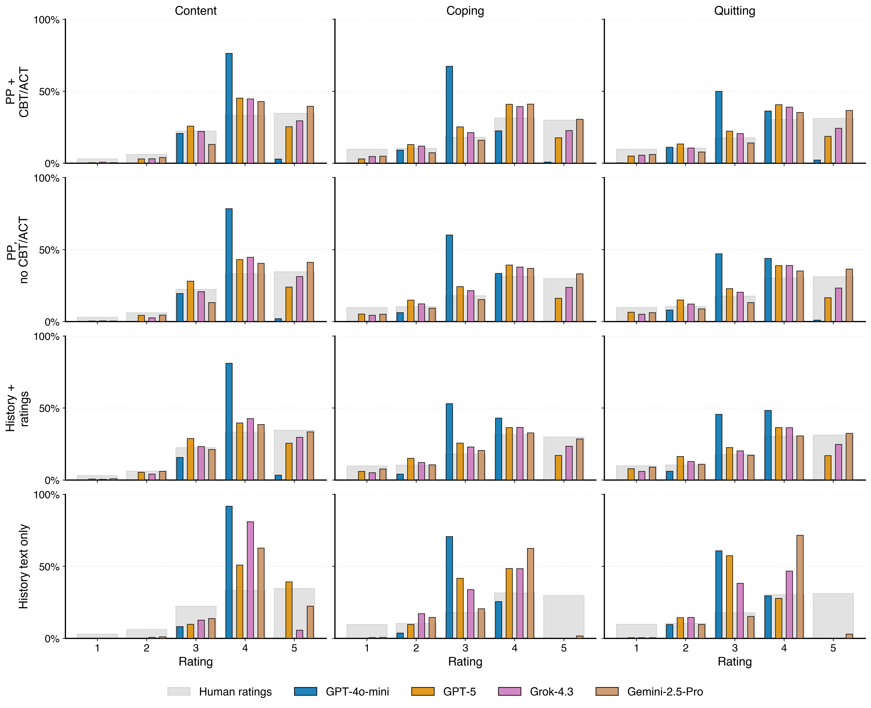
Figure 4. Human versus predicted rating distributions on the 898 held-out messages, by prompt configuration and domain. Gray background bars are the human ratings; coloured bars are each model's predictions.

