How to run:

After the compile, you need to run the next command: ./<name_of_execution_file> <path_of_directory>
Example:
In this example, the name of execution file is out, and the name of the directory on which we want to run the program is “dir”

To check if the output is correct, you need to run the “stat” command for every file in the directory and pay attention to file name, type and Inode:

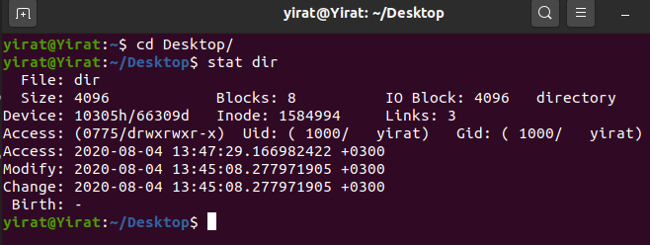
stat <name_of_file>

