The running output for the specified example:

At first, we created the directories and files according to the commands brought by the lecturer:
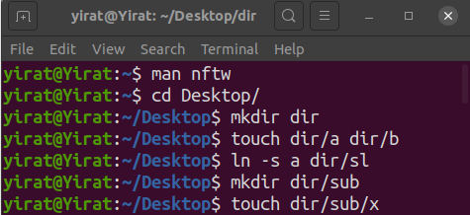

Then, we ran the program on the “dir” directory.
Here is the output of the program:
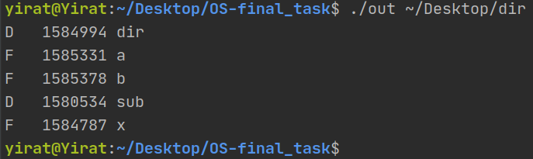

Now, to know that the output is correct, we ran the “stat” command:
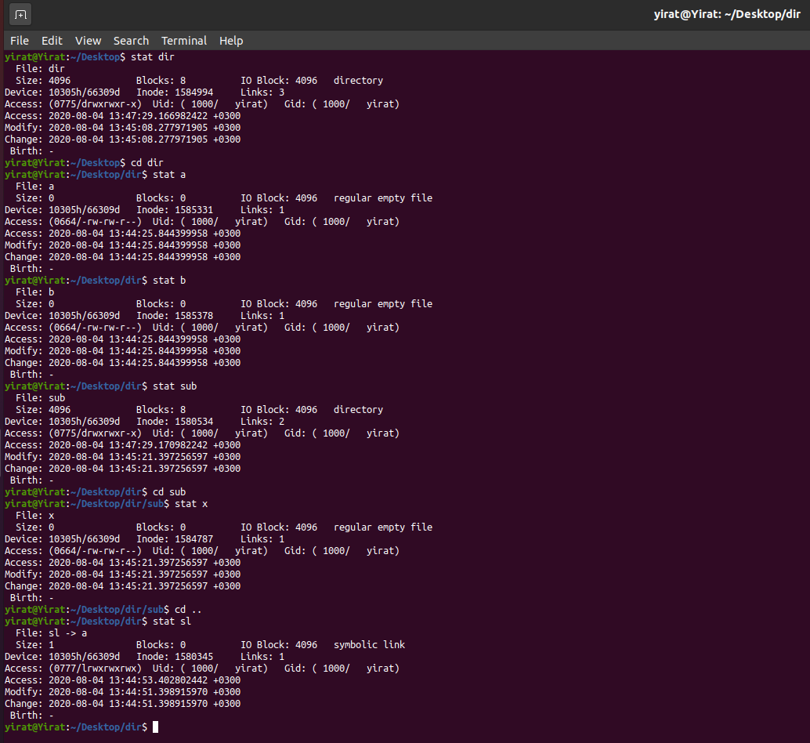
As we can see, the stat command shows us, among other things, the file name (in the yellow square), the file type (in the green square), and the Inode of the file (in the red square).
Now, we knows that the output is correct:
All file types appear in the output except for the “sl” file, whose type is symbolic link (which we were asked not to print).

