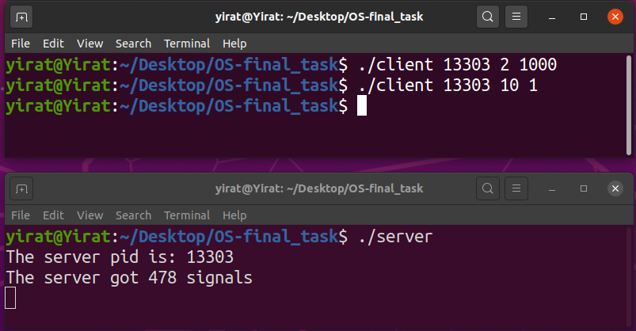
1. We will show that not all signals accepted :

Explanation:
First, we ran the server for receive signals from the client.
After that ,we saw the server pid that was printed from the server.
The client sent to the server the SIGINT signal (the number 2) for 1000 times.
After that, The client sent to the server the SIGUSR1 signal (the number 10) for 1 time
As a result, the server typed the amount of signals it was actually able to receive.
It can be seen from the print of the server that only 478 signals were received out of the 1000 signals sent to him.
This is what shows us that not all signals accepted.

2. The advantages and disadvantages of standard signals and real time signals:

Standard signals:

Advantages:

- standard signals have predefined meanings, i.e. they have default behavior.
- If both standard and real-time signals are pending for a process, POSIX leaves it unspecified which is delivered first. Linux, like many other implementations, gives priority to standard signals in this case.

Disadvantages:

- If multiple standard signals are pending for a process, the order in which the signals are delivered is unspecified.

- Standard signals do not queue. If multiple instances of a standard signal are generated while that signal is blocked, then only one instance of the signal is marked as pending (and the signal will be delivered just once when it is unblocked).

Real time signals:

Advantages:

- Multiple instances of real-time signals can be queued.

- If the signal is sent using sigqueue(3), an accompanying value (either an integer or a pointer) can be sent with the signal. If the receiving process establishes a handler for this signal using the SA_SIGINFO flag to sigaction(2), then it can obtain this data via the si_value field of the siginfo_t structure passed as the second argument to the handler. Furthermore, the si_pid and si_uid fields of this structure can be used to obtain the PID and real user ID of the process sending the signal.

- Real-time signals are delivered in a guaranteed order. Multiple real-time signals of the same type are delivered in the order they were sent. If different real-time signals are sent to a process, they are delivered starting with the lowest-numbered signal. (I.e., low-numbered signals have highest priority.)

Disadvantages:

Real time signals are difficulties to use:
- The real time signal queue can overflows.
- Real time signals have no predefined meanings: the entire set of real-time signals can be used for application-defined purposes.
- The default action for an unhandled real-time signal is to terminate the receiving process.

