Question 1:

1. Question: Where is allocated? char globBuf[65536];
Answer: BSS-uninitialized data
proof: we can see that after execute the “nm” command we got the type of “globBuf” to be B, that means according to “man” that “globBuf” is a global symbol and it’s found in BSS:
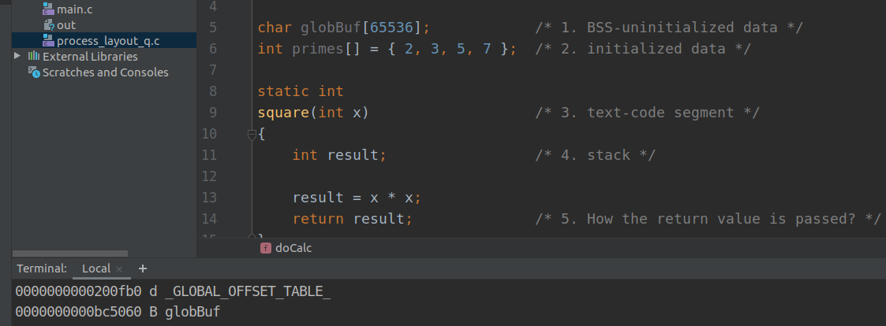

2. Question: Where is allocated? int primes[] = { 2, 3, 5, 7 };
Answer: initialized data
proof: we can see that after execute the “nm” command we got the type of “primes” to be D, that means according to “man” that “primes” is a global symbol and it’s found in initialized data:
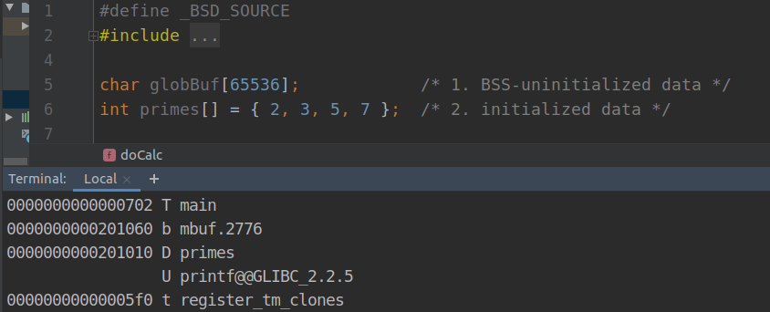

3. Question: Where is allocated? square(int x)
Answer: text-code segment
proof: we can see that after execute the “nm” command we got the type of “square” to be t, that means according to “man” that “square” is a local symbol and it’s found in text-code segment :
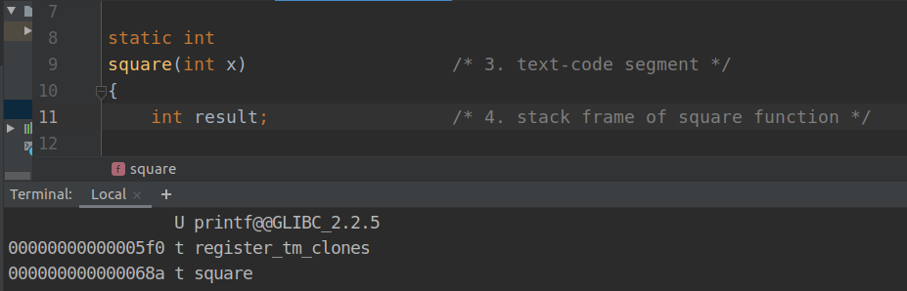

4. Question: Where is allocated? int result;
Answer: stack frame of square function
Proof: we can see that after execute the “objdump -d” command, we received the code of our program in Assembly Language.
We can be sure that -0x14(%rbp) hold the value of x variable because the
“mov %edi, - 0x14(%rbp)” command.
The “result=x*x” command can be seen in the yellow square.
It can be seen that after the calculation of x * x is performed, the value passed by the rbp- base pointer register, which points to the base of the square stack frame.
The -0x4(%rbp) signals us that space has been allocated in a square stack frame the size of 4 bytes, which is exactly the size of the result variable.
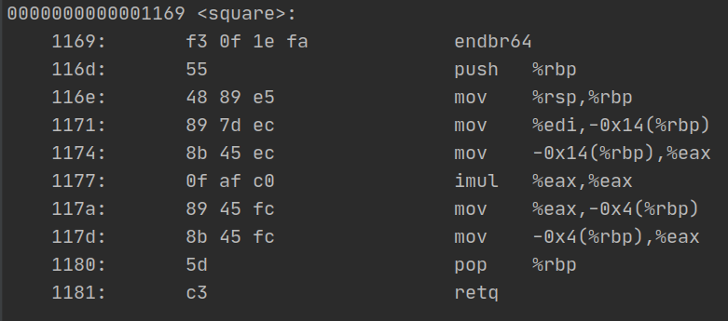

In addition, a screenshot is attached that proves to us that the “result=x*x” command is indeed translated into the yellow square command (by the “godbolt” website).
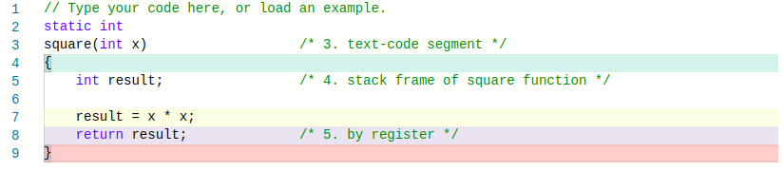

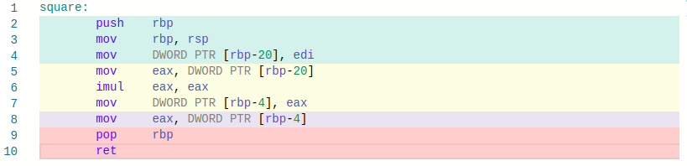

5. Question: How the return value is passed? return result;
Answer: by register
Proof: we can see that after execute the “objdump -d” command, we received the code of our program in Assembly Language.
The “return result” command can be seen in the yellow square.
It can be seen that after the calculation of x * x is performed, it is passed to the eax register which is responsible among other things for the return values ​​from the function, so we can be sure that the result value is returned by register.

In addition, a screenshot is attached that proves to us that the “return result” command is indeed translated into the yellow square command (by the “godbolt” website).

6. Question: Where is allocated? doCalc(int val)
Answer: text-code segment
proof: we can see that after execute the “nm” command we got the type of “doCalc” to be t, that means according to “man” that “doCalc” is a local symbol and it’s found in text-code segment :
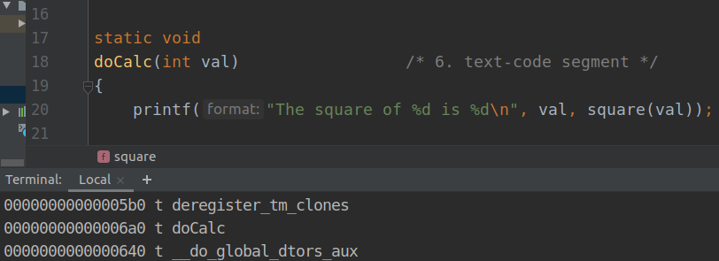

7. Question: Where is allocated? int t;
Answer: stack frame of doCalc function
Proof: we can see that after execute the “objdump -d” command, we received the code of our program in Assembly Language.
The “t=val*val*val” command can be seen in the yellow square.
We can be sure that -0x14(%rbp) hold the value of val variable because the
“mov %edi, - 0x14(%rbp)” command.
This value passed into eax register.
After that, the value of eax multiplied by itself and saved into eax register.
Now, the value of -0x14(%rbp) passed into edx register.
After that, the value of eax multiplied by edx and saved into eax register.
At last, eax register hold the value of val*val*val, ans this value copied into -0x4(%rbp).
That prove that t variable is allocated on the doCalc stack frame.
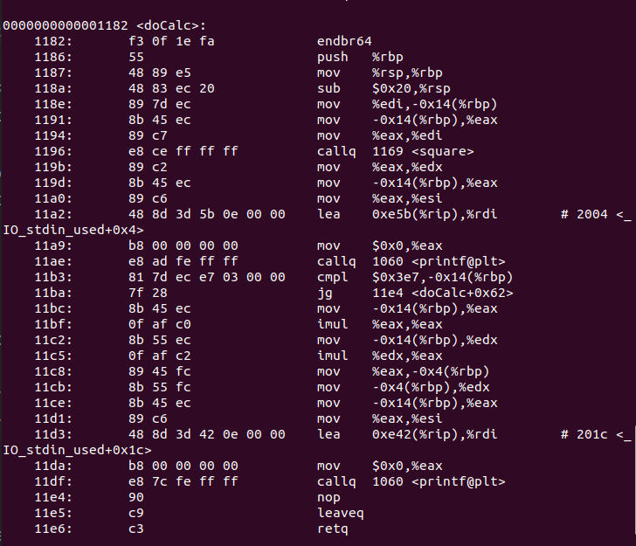

In addition, a screenshot is attached that proves to us that the “t=val*val*val” command is
indeed translated into the yellow square command (by the “godbolt” website).

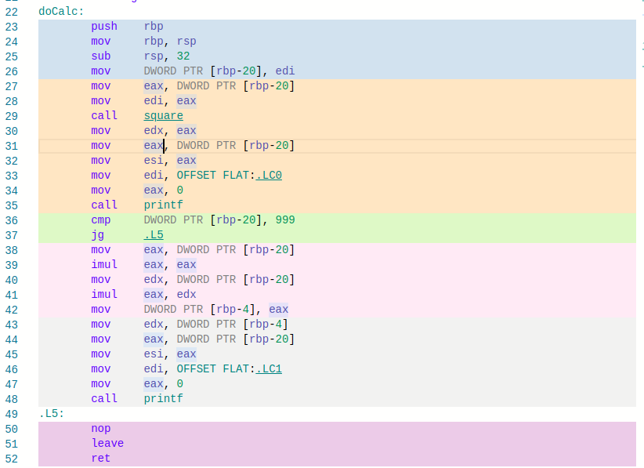

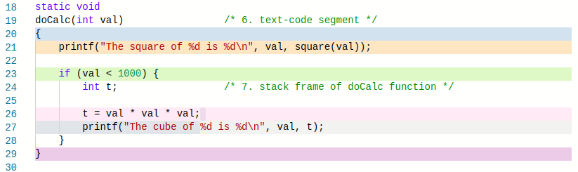

8. Question: Where is allocated? main(int argc, char*\ argv[])
Answer: text-code segment
Proof: we can see that after execute the “nm” command we got the type of “main” to be T, that means according to “man” that “main” is a global symbol and it’s found in text-code segment :
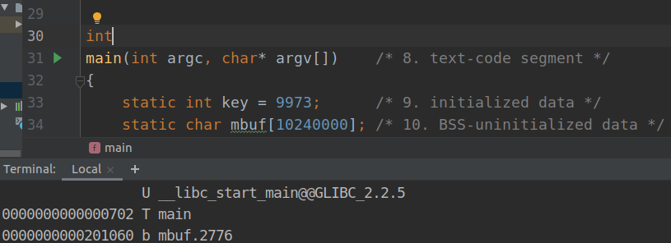

9. Question: Where is allocated? static int key = 9973;
Answer: initialized data
proof: we can see that after execute the “nm” command we got the type of “key” to be d, that means according to “man” that “key” is a local symbol and it’s found in initialized data :
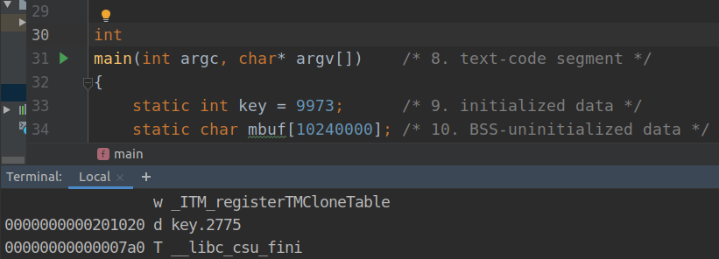

10. Question: Where is allocated? static char mbuf[10240000];
Answer: BSS-uninitialized data
proof: we can see that after execute the “nm” command we got the type of “mbuf” to be b, that means according to “man” that “mbuf” is a local symbol and it’s found in BSS :
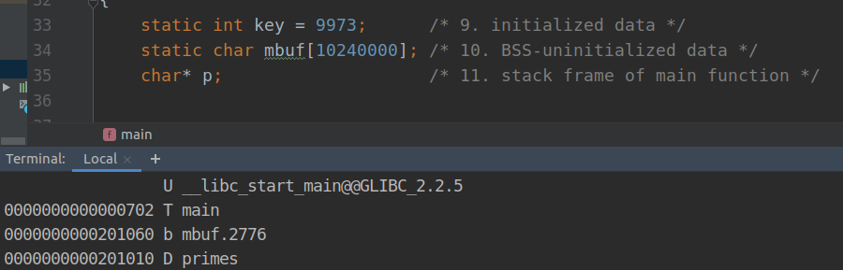

11. Question: Where is allocated? char* p;
Answer: stack frame of main function

