The output of commands confirming changed values:
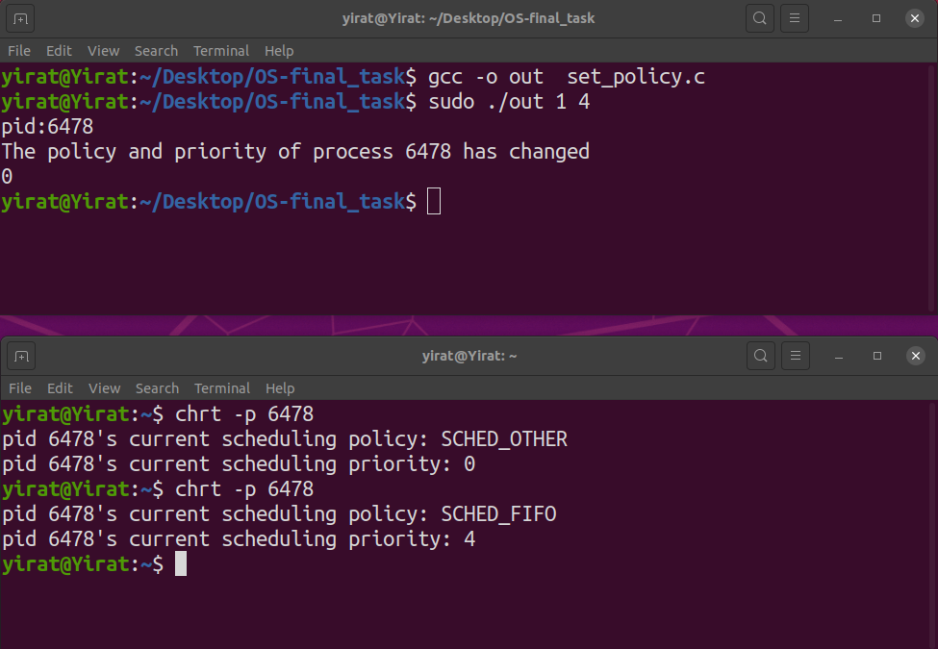

As we can see, the first terminal contains the execute command : sudo ./out 1 4
The first value (1) represent the new scheduling policy that we want set to our process (enum).
The second value (4) represent the new scheduling priority that we want set to our process.
After the execution and before activating the change , we printed the pid of our process.
Now, the second terminal contains the command : chrt -p 6478 which 6478 is the pid from the first terminal.
This command give us the scheduling policy and scheduling priority of pid 6478.
We got the scheduling policy to be SCHED_OTHER because is the default scheduling policy.
We got the scheduling priority to be zero.
After we received the message that the policy and priority of process 6478 has changed (in the first terminal), we executed the command chrt -p 6478 again in the second terminal.
Now, we can see that the scheduling policy of pid 6478 is SCHED_FIFO ,which prove us that the
scheduling policy of pid 6478 was changed according to the first value (1).
The scheduling priority of pid 6478 is 4 ,which prove us that the
scheduling priority of pid 6478 was changed according to the second value (4).

